**Instructions:**

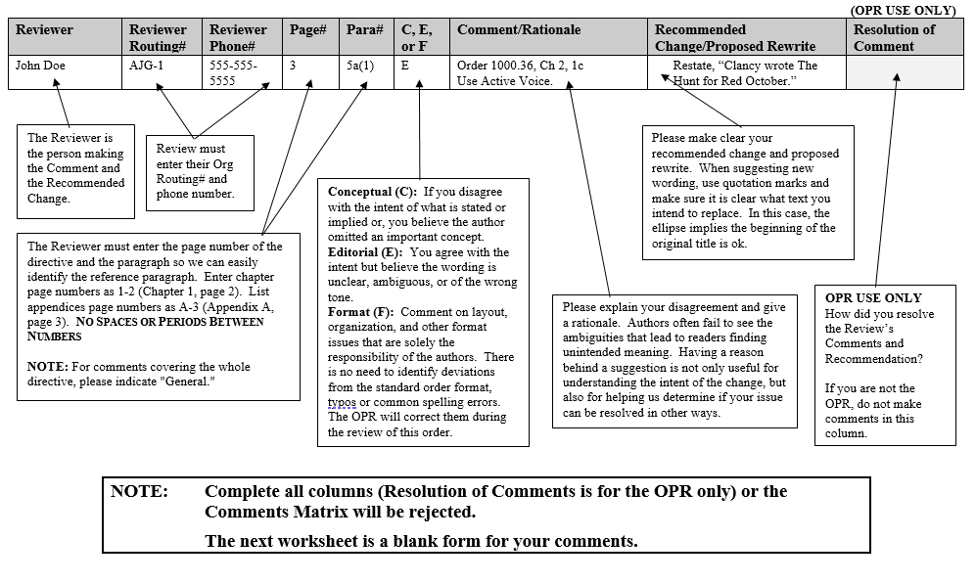

**Instructions:**

(OPR USE ONLY)

| **Reviewer** | **Reviewer Routing#** | **Reviewer Phone#** | **Page#** | **Para#** | **C, E, or F** | **Comment/Rationale** | **Recommended Change/Proposed Rewrite** | **Resolution of Comment** |
| --- | --- | --- | --- | --- | --- | --- | --- | --- |
| **Note 1** | **Note 2** | **Note 2** | **Note 3** | **Note 3** | **Note 4** | **Note 5** | **Note 6** | **Note 7** |

**Notes:**

**1.** The Reviewer is the person making the Comment and the Recommended Change.

**2.** Review must enter their Org Routing# and phone number.

**3.** The Reviewer must enter the page number of the directive and the paragraph so we can easily identify the reference paragraph. Enter chapter page numbers as 1-2 (Chapter 1, page 2). List appendices page numbers as A-3 (Appendix A, page 3).

**No Spaces or Periods Between Numbers**

**NOTE:** For comments covering the whole directive, please indicate "General."

**4.** **Conceptual (C):** If you disagree with the intent of what is stated or implied or, you believe the author omitted an important concept.

**Editorial (E):** You agree with the intent but believe the wording is unclear, ambiguous, or of the wrong tone.

**Format (F):** Comment on layout, organization, and other format issues that are solely the responsibility of the authors. There is no need to identify deviations from the standard order format, typos or common spelling errors. The OPR will correct them during the review of this order.

**5.** Please explain your disagreement and give a rationale. Authors often fail to see the ambiguities that lead to readers finding unintended meaning. Having a reason behind a suggestion is not only useful for understanding the intent of the change, but also for helping us determine if your issue can be resolved in other ways.

**6.** Please make clear your recommended change and proposed rewrite. When suggesting new wording, use quotation marks and make sure it is clear what text you intend to replace. In this case, the ellipse implies the beginning of the original title is ok.

**7.** **OPR USE ONLY** How did you resolve the Review’s Comments and Recommendation? If you are not the OPR, do not make comments in this column.

**NOTE: Complete all columns (Resolution of Comments is for the OPR only) or the Comments Matrix will be rejected.**

**The next worksheet is a blank form for your comments.**

**(OPR USE ONLY)**

| **Reviewer** | **Reviewer Routing#** | **Reviewer Phone#** | **Page#** | **Para#** | **C, E, or F** | **Comment/Rationale** | **Recommended Change/Proposed Rewrite** | **Resolution of Comment** |
| --- | --- | --- | --- | --- | --- | --- | --- | --- |
|  |  |  |  |  |  |  |  |  |
|  |  |  |  |  |  |  |  |  |
|  |  |  |  |  |  |  |  |  |
|  |  |  |  |  |  |  |  |  |
|  |  |  |  |  |  |  |  |  |
|  |  |  |  |  |  |  |  |  |
|  |  |  |  |  |  |  |  |  |
|  |  |  |  |  |  |  |  |  |
|  |  |  |  |  |  |  |  |  |
|  |  |  |  |  |  |  |  |  |
|  |  |  |  |  |  |  |  |  |
|  |  |  |  |  |  |  |  |  |
|  |  |  |  |  |  |  |  |  |
|  |  |  |  |  |  |  |  |  |
|  |  |  |  |  |  |  |  |  |
|  |  |  |  |  |  |  |  |  |