AIRPORTS EARLY PROJECT COORDINATION
Purpose: identify issues with design and construction

AIRPORT LOC ID:  CITY, STATE: |  | CONSTRUCTION MONTH/ YEAR:
PROJECT: West Ramp Reconstruction AERONAUTICAL STUDY NUMBER:
AIP NUMBER:
POI 4
POI 3
POI 1
POI 2
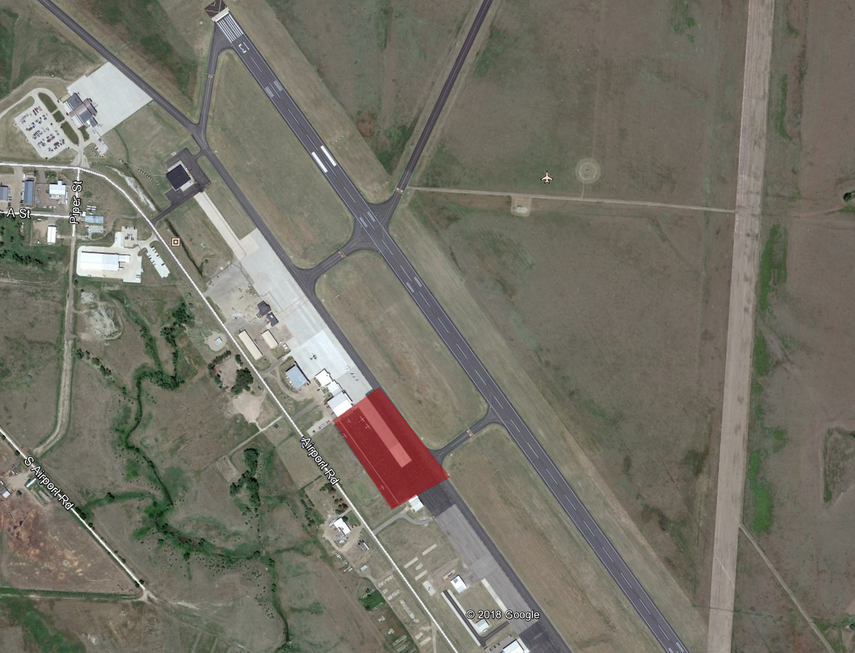
Include POI details in a table.
PROJECT SCOPE:
Proposed project scope with approximate limits and description of work. Adding sketch pages is acceptable. Provide information including:
  - Rehab or reconstruction - with estimated depth of work, height above ground, and horizontal limits.
  - Planned drainage, utility, lighting improvements.
  - Whether line of sight analysis is going to be provided.
  - Potential concerns of which the other LOBs should be aware.
  - Provide as accurate point of interest (POI) information as possible. Show POIs on sketch & include table as needed. See AC 150/5300-20, Submission of On-Airport Proposals for Aeronautical Study.

Example: The West Ramp is going to be reconstructed in-place to a depth of 12 inches.
No drainage or utility work will occur. No lighting improvements are planned.
Potential concern with location of ASOS at the south end of West Ramp.

PROJECT PHASING:
- Changes to aircraft and air traffic operations that could impact the NAS (for example, surface closures and approximate duration).
- NAVAID shutdowns
ANM ADO Project Manager:
Date Issued:

