Registration Instructions:
FAA Academy online courses for non-federal technicians

April 22, 2025

Questions? Please contact Non-Federal-Program@faa.gov

This is not an official FAA Academy document. It was created by the Non-federal Program as a courtesy, to help non-federal technicians navigate the process of registering for the Academy’s web-based courses. The Non-federal Program and Academy are separate entities.

If you discover any issues with the following instructions, please use the email address above to let us know.

Note: The Academy’s registration process may not work if you’re using a:
- Government issued computer;
- Government issued cell phone; or
- VPN

STEP 1a. – Access the Registration Form:
https://av-info.faa.gov/DsgReg/Sections.aspx
(You will probably need to use the Chrome browser.)

STEP 1b. – Click “Login”

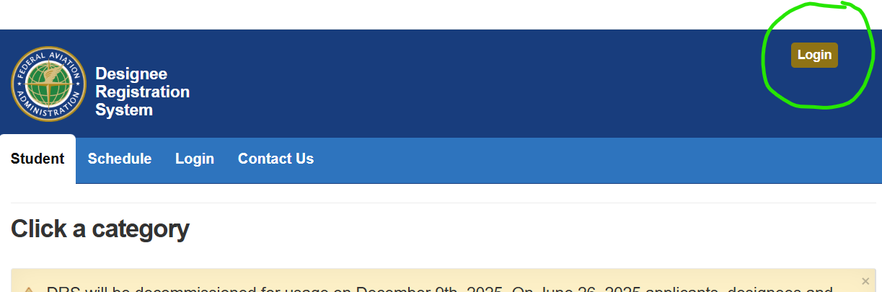

STEP 1c. – Click the red “Sign Up” button.

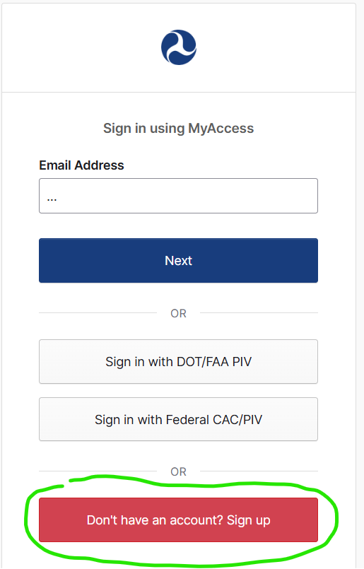

STEP 2. – Fill out the Registration Form

(!) The Academy’s system will not let you use an email address ending in .gov

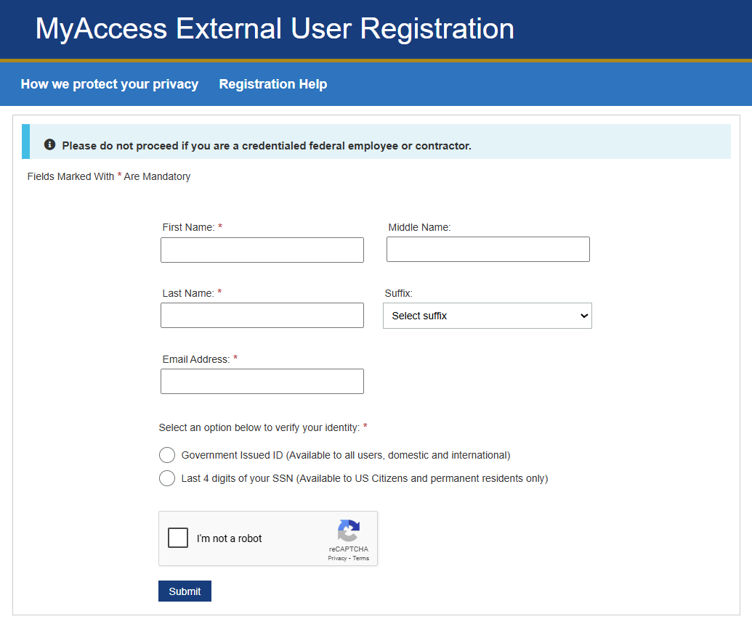

STEP 3 – Finish the registration process.

- When prompted, complete the multi-factor authentication (MFA), if any.
- Check your inbox for an activation email and click its link.
- The link will open a page where you will be prompted to choose a password.
- Next you will be prompted to set up a security method, such as txt mssg verification.
- Then you will be prompted to update your profile.
- That should conclude the registration process.

STEP 4 – Enroll in classes.

To enroll, contact the Out-of-Agency Training Coordinator:

Regina.Strain@faa.gov
(405) 954-5737

After Regina enrolls you, she will provide you with instructions on how to pay.

STEP 5 – Accessing eLMS & Web-Based Training (WBT) courses.

If your course’s delivery method is either “WBT” or “eLMS” you must register for an eLMS account. The Out-of-Agency Coordinator (Regina Strain) will send you a login ID and add your courses to your eLMS “learning plan.” Then the system will automatically send you a welcome email, overnight, after it creates your account.

- The email will come from this address, or a similar one:
donotreply_elms@faa.ns2cloud.com

If you do not receive the automated email, please ask Regina to have the eLMS Technical Lead (Daniel Del Balzo) send you a password.
The email contains a link to set up your password. Open the link.
- If you’re using a VPN, you’ll need to turn it off to open the link.
- Regardless, the link may be slow to load. Please be patient.

The Out-of-Agency Coordinator will send you instructions on how to finish setting up your eLMS account. Once you do so, you’ll be able to access your WBT and eLMS courses.

For your future reference, the eLMS portal where you will log in is: https://hcm03.ns2cloud.com/sf/start/login

STEP 6 – Accessing Blackboard courses. (If applicable.)

If your course’s delivery method is via Blackboard, please follow these instructions:

- Login at https://av-info.faa.gov/DsgReg/Sections.aspx

- Accept the Rules of Behavior, if you’re prompted to.

- Go to the “Student” tab.

- Select Pay Now (if applicable) and then make your payment.

- Select “Your Enrollments.”

- You should see all the course(s) that you are enrolled in.

- Select “Go To Online Course.”

- The online “Blackboard” platform will open.

- Select “My Blackboard Courses.”

- Select your course and begin.

