 |  |  | Advisory Circular
U.S. Department
of Transportation
Federal Aviation
Administration
Subject: Surface Drainage Design |  | Date: 9/30/2008  Initiated by: AAS-100 |  | AC No: 150/5320-5C  Change: 1
- PURPOSE. Change 1 to Advisory Circular (AC) 150/5320-5C provides guidance for engineers, airport managers, and the public about the design and construction of subsurface drainage facilities for paved runways, taxiways, and aprons. The criteria is limited to situations where the water can be drained from the pavement structure by gravity flow and primarily addresses with elimination of water that enters the pavement through the surface.
- APPLICATION. The guidelines and recommendations contained in this AC are recommended by the Federal Aviation Administration (FAA) for the design and construction of subsurface drainage facilities. This AC offers general guidance for these systems and is not binding or regulatory.
- PRINCIPAL CHANGES. This change incorporates a new Appendix G, Design of Subsurface Pavement Drainage Systems.

Page Control Chart
Remove Pages | Dated | Insert Pages | Dated
 |  | G1–G42 | 9/30/08

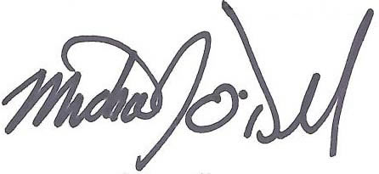

Michael J. O’Donnell
Director, Airport Safety and Standards

This page intentionally blank.

APPENDIX G

DESIGN OF SUBSURFACE PAVEMENT DRAINAGE SYSTEMS

G-1 INTRODUCTION
G-1.1 Purpose. This chapter provides guidance for the design and construction of subsurface drainage facilities for airfield runways, taxiways, and aprons.
G-1.2 Scope. The criteria within this chapter apply to paved runways, taxiways, and aprons. The criteria is limited to situations where the water can be drained from the pavement structure by gravity flow and is mainly concerned with elimination of water that enters the pavement through the surface.
G-1.3 Definitions. Several terms in this chapter have a unique usage within the chapter or may not be in common usage. Paragraphs G-1.3.1 through G-1.3.16 define these terms.
G-1.3.1 Apparent Opening Size (AOS). The AOS is a measure of the opening size of a geotextile. AOS is the sieve number corresponding to the sieve size at which 95 percent of the single-size glass beads pass the geotextile (O₉₅) when tested in accordance with ASTM D 4751.
G-1.3.2 Coefficient of Permeability (). The coefficient of permeability is a measure of the rate at which water passes through a unit area of material in a given amount of time under a unit hydraulic gradient.
G-1.3.3 Choke Stone. A choke stone is a small-size stone used to stabilize the surface of an open-graded material (OGM). For a choke stone to be effective, the ratio of d₁₅ of the coarse aggregate to the d₁₅ of the choke stone must be less than 5, and the ratio of the d₅₀ of the coarse aggregate to d₅₀ of the choke stone must be greater than 2.
G-1.3.4 Drainage Layer. A drainage layer is a layer in the pavement structure that is specifically designed to allow rapid horizontal drainage of water from the pavement structure. The layer is also considered to be a structural component of the pavement and may serve as part of the base or subbase.
G-1.3.5 Effective Porosity. The effective porosity is defined as the ratio of the volume of voids that will drain under the influence of gravity to the total volume of a unit of aggregate. The difference between the porosity and the effective porosity is the amount of water that will be held by the aggregate. For materials such as the rapid draining material (RDM) and OGM, the water held by the aggregate will be small; thus, the difference between the porosity and effective porosity will be small (less than 10 percent). The effective porosity may be estimated by computing the porosity from the unit dry weight of the aggregate and the specific gravity of the solids, which then should be reduced by 5 percent to allow for water retention in the aggregate.
G-1.3.6 Geocomposite Edge Drain. A geocomposite edge drain is a manufactured product using geotextiles, geogrids, geonets, and/or geomembranes in laminated or composite form, which can be used as an edge drain in place of trench-pipe construction.
G-1.3.7 Geotextile. A geotextile is a permeable textile used in geotechnical projects. For this AC, geotextile will refer to a nonwoven needle punch fabric that meets the requirements of the AOS, grab strength, and puncture strength specified for the particular application.
G-1.3.8 Hazen’s Effective Particle Diameter. The Hazen’s effective particle diameter is the particle size, in millimeters, that corresponds to 10 percent passing on the grain-size distribution curve. This parameter is one of the major parameters in determining the permeability of a soil.
G-1.3.9 Open-Graded Material (OGM). An OGM is a granular material having a very high permeability (greater than 1,500 m/day (5,000 ft/day)) which may be used for a drainage layer. Such a material will normally require stabilization for construction stability or for structural strength to serve as a base in a flexible pavement.
G-1.3.10 Pavement Structure. Pavement structure is the combination of subbase, base, and surface layers constructed on a subgrade.
G-1.3.11 Permeable Base. An open-graded, granular material with most of the fines removed (e.g., less than 10 percent passing the No. 16 sieve) to provide high permeability 305 m/day (1,000 ft/day or more) for use in a drainage layer.
G-1.3.12 Porosity. Porosity refers to the volume of voids in a material and is expressed as the ratio of the volume of voids to the total volume.
G-1.3.13 Rapid Draining Material (RDM). A granular material having a sufficiently high permeability (300 to 1,500 m/day (1,000 to 5,000 ft/day)) to serve as a drainage layer and also having the stability to support construction equipment and the structural strength to serve as a base and/or a subbase.
G-1.3.14 Separation Layer. A separation layer is a layer provided directly beneath the drainage layer to prevent fines from infiltration or pumping into the drainage layer and to provide a working platform for construction and compaction of the drainage layer.
G-1.3.15 Stabilization. Stabilization refers to either mechanically or chemically stabilizing the drainage layer to increase the stability and strength to withstand construction traffic and/or design traffic. Mechanical stabilization is accomplished by the use of a choke stone and compaction. Chemical stabilization is accomplished by the use of either portland cement or asphalt.
G-1.3.16 Subsurface Drainage. The process of collecting and removing water from the pavement structure. Subsurface drainage systems are categorized by function: those that drain surface infiltration water and those that control groundwater.
G-1.4 Bibliography. In recent years, subsurface drainage has received increasing attention, particularly in the area of highway design. A number of studies have been conducted by state highway agencies and by the Federal Highway Administration that have resulted in a large number of publications on the subject of subsurface drainage. Appendix A provides a list of publications that contain information pertaining to the design of subsurface drainage for pavements.
G-1.5 Effects of Subsurface Water. Water has a detrimental effect on pavement performance, primarily by either weakening subsurface materials or eroding material by free water movement. For flexible pavements, the weakening of the base, subbase, or subgrade when saturated with water is one of the main causes of pavement failures. In rigid pavement, free water, trapped between the concrete surface and an impermeable layer directly beneath the concrete, moves due to pressure caused by loadings. This movement of water (referred to as pumping) erodes the subsurface material, creating voids under the concrete surface. In frost areas, subsurface water will contribute to frost damage by heaving during freezing and loss of subgrade support during thawing. Poor subsurface drainage can also contribute to secondary damage such as “D” cracking or swelling of subsurface materials.
G-1.6 Traffic Effects. The type, speed, and volume of traffic will influence the criteria used in the design of pavement drainage systems. For rigid pavements, pumping is greatly increased as the volume and speed of the traffic increases. For flexible pavements, the buildup of pore pressures as a result of high-volume, high-speed traffic is a primary cause of the weakening of the pavement structure. For these reasons, the criteria for a subsurface under airfield runways and taxiways will be more stringent than for airfield parking aprons or other pavements that have low-volume and low-speed traffic.
G-1.7 Sources of Water. The two types of water to be considered are water from infiltration and subterranean water. Infiltration is the most important source of water and is the source of most concern in this document. Subterranean water is important in frost areas and areas of very high water table or areas of artesian water. In many areas, perched water may develop under pavements due to a reduced rate of evaporation of the water from the surface. In frost areas, free water collects under the surface by freeze/thaw action.
G-1.7.1 Infiltration. Infiltration is surface water that enters the pavement from the surface through cracks or joints in the pavement, through the joint between the pavement and shoulder, through pores in the pavement, and through shoulders and adjacent areas. Since surface infiltration is the principal source of water, it is the source needing greatest control measures. Groundwater tables rise and fall depending upon the relation between infiltration, absorption, evaporation, and groundwater flow. Seasonal fluctuations are normal because of differences in the amount of precipitation and maybe relatively large in some localities. Prolonged drought or wet periods will cause large fluctuations in the groundwater level.
G-1.7.2 Subterranean Water. Subterranean water can be a source of water from a high water table, capillary forces, artesian pressure, and freeze-thaw action. This source of water is particularly important in areas of frost action when large volumes of water can be drawn into the pavement structure during the formation of ice lenses. For large paved areas, the evaporation from the surface is greatly reduced, which causes saturation of the pavement structure by capillary forces. Also, if impervious layers exist beneath the pavement, perched water can be present or develop from water entering the pavement through infiltration. This perched water then becomes a subterranean source of water. In general, the presence of near surface subterranean water must be identified during soil exploration, and drainage facilities must be designed to mitigate the influence of such water.
G-1.7.3 Freeze-Thaw. Freeze–thaw action can result in large amounts of water being drawn into the pavement structure. In freeze-thaw conditions, water flows to the freeze front by capillary action. Repeated cycles of freeze-thaw result in the growth of ice lenses that can cause heave in the pavement structure. It is not uncommon to note heaves in soils as great as 60 percent; under laboratory conditions, heaves of as much as 300 percent have been recorded. The formation of ice lenses in the pavement structure has two very detrimental effects on the pavement. One effect is that the formation of the ice lenses causes a loss of density of the pavement materials, resulting in strength loss. A second effect is that thawing of the ice results in a large volume of free water that must be drained from the pavement. Because thawing usually occurs simultaneously from both the top and bottom of the pavement structure, the free water can be trapped within the pavement structure. Providing adequate drainage will minimize pumping and promote the restoration of pavement strength. In the design of subdrain systems in frost areas, free water in both the upper and lower sections of the pavement must be considered.
G-1.7.4 Classification of Subdrain Facilities. Subdrain facilities can be categorized into two functional categories: those that control infiltration, and those that control groundwater. An infiltration control system is designed to intercept and remove water that enters the pavement from precipitation or surface flow. An important function of this system is to keep water from being trapped between impermeable layers. A groundwater control system is designed to reduce water movement into subgrades and pavement sections by controlling the flow of groundwater or by lowering the water table. Often, subdrains are required to perform both functions, and the two subdrain functions can be combined into a single subdrain system. Figures G-1 and G-2 illustrate examples of infiltration and groundwater control systems, respectively.

Figure G-1. Collector Drain to Remove Infiltration Water

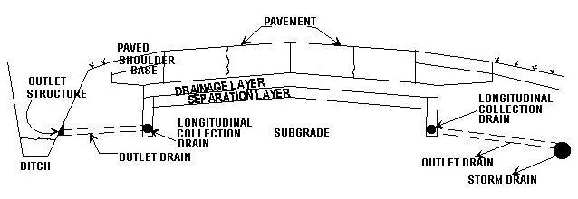
Figure G-2. Collector Drain to Intercept Seepage and Lower the
Groundwater Table

G-1.8 Subsurface Drainage Requirements. Determining the subsurface soil properties and water condition is a prerequisite for the satisfactory design of a subsurface drainage system. Field explorations and borings made in connection with the project design should include certain investigations pertinent to subsurface drainage. A topographic map of the proposed area and the surrounding vicinity should be prepared; the map should indicate all streams, ditches, wells, and natural reservoirs. Analyzing aerial photographs of the areas selected for construction may furnish valuable information on general soil and groundwater conditions. An aerial photograph presents a graphic record of the extent, boundaries, and surface features of soil patterns occurring at the surface of the ground. The presence of vegetation, the slopes of a valley, the colorless monotony of sand plains, the farming patterns, the drainage pattern, gullies, eroded lands, and evidences of human works are revealed in detail by aerial photographs. The use of aerial photographs may supplement both the detail and knowledge gained in topographic survey and ground explorations. The sampling and exploratory work can be made more rapid and effective after an analysis of aerial photographs has developed the general soil features. The location and depth of permanent and perched groundwater tables may be sufficiently shallow to influence the design. The season of the year and rainfall cycle will measurably affect the depth to the water table. In many locations, information may be obtained from residents of the surrounding areas regarding the behavior of wells and springs and other evidences of subsurface water. The soil properties investigated for other purposes in connection with the design will supply information that can be used for the design of the drainage system. It may be necessary to supplement these explorations at locations of subsurface drainage structures and in areas where soil information is incomplete for design of the drainage system.
G-1.9 Laboratory Tests. The design of subsurface drainage structures requires knowledge of these soil properties: strength, compressibility, swell and dispersion characteristics, the in situ and compacted unit dry weights, the coefficient of permeability, the in situ water content, specific gravity, grain-size distribution, and the effective void ratio. These soil properties may be satisfactorily determined by experienced soil technicians through laboratory tests. The final selected soil properties for design purposes may be expressed as a range, one extreme representing a maximum value and the other a minimum value. The true value should be between these two extremes, but it may approach or equal one or the other, depending on the variation within a soil stratum.
G-1.10 Drainage of Water from Soil. The quantity of water removed by a drain will vary depending on the type of soil and location of the drain with respect to the groundwater table. All of the water contained in a given specimen cannot be removed by gravity flow because water retained as thin films adhering to the soil particles and held in the voids by capillarity will not drain. Consequently, to determine the volume of water that can be removed from a soil in a given time, the effective porosity as well as the permeability must be known. Limited effective porosity test data for well-graded base-course materials, such as bank-run sands and gravels, indicate a value for effective porosity of not more than 0.15. Uniformly graded soils such as medium coarse sands, may have an effective porosity of not more than 0.25. Open-graded aggregate used for drainage layers will have an effective porosity of between 0.25 and 0.35.
G-2 PRINCIPLES OF PAVEMENT DRAINAGE
G-2.1 Flow of Water through Soils. The flow of water through soils is expressed by Darcy’s empirical law, which states that the velocity of flow ($v$) is directly proportional to the hydraulic gradient ($i$). This law can be expressed as:
$v=k⋅i$ (G-1)
Where $k$ is the coefficient of proportionality known as the coefficient-of-permeability. Equation G-1 can be expanded to obtain the rate of flow through an area of soil (A). The equation for the rate of flow ($Q$) is:
$Q=k⋅i⋅A$ (G-2)
According to Darcy’s law, the velocity of flow and the quantity of discharge through a porous media are directly proportional to the hydraulic gradient. For this condition to be true, flow must be laminar or non-turbulent. Investigations have indicated that Darcy’s law is valid for a wide range of soils and hydraulic gradients; however, in developing criteria for subsurface drainage, liberal margins have been applied to allow for turbulent flow. The criteria and uncertainty depend heavily on the permeability of the soils in the pavement structure. It is therefore useful to examine the influence of various factors on the permeability of soils. In examining permeability of soils in regard to pavement drainage, the materials of most concern are base and subbase aggregate and aggregate used as drainage layers.
G-2.2 Factors Affecting Permeability
G-2.2.1 Coefficient of Permeability. The value of permeability depends primarily on the characteristics of the permeable materials, but it is also a function of the properties of the fluid. An equation (after Taylor) demonstrating the influence of the soil and pore fluid properties on permeability was developed based on flow through porous media similar to flow through a bundle of capillary tubes. This equation is given here as Equation G-3:
$k=D_{s}^{2}⋅C⋅\left(\frac{γ⋅e^{3}}{μ⋅\left(1−e\right)}\right)$ (G-3)
where
$k$ = the coefficient of permeability
$D_{s}$ = Hazen’s effective particle diameter
$C$ = shape factor
$γ$ = unit weight of pore fluid
$μ$ = viscosity of pore fluid
$e$ = void ratio

G-2.2.2 Effect of Pore Fluid and Temperature. In the design of subsurface drainage systems for pavements, the primary pore fluid of concern is water. Therefore, when permeability is mentioned in this chapter, water is assumed to be the pore fluid. Equation G-3 indicates that the permeability is directly proportional to the unit weight of water and inversely proportional to the viscosity. The unit weight of water is essentially constant, but the viscosity of water will vary with temperature. Over the widest range of temperatures ordinarily encountered in seepage problems, viscosity varies about 100 percent. Although this variation seems large, it can be insignificant when considered in the context of the variations that can occur with changes in material properties.
G-2.2.3 Effect of Grain Size and Void Ratio. It is logical that the smaller the grain size the smaller the voids that constitute the flow channels, and hence, the lower the permeability. Equation G-3 suggests that permeability varies with the square of the effective particle diameter and the cube of the void ratio. Since for the most part the void ratio is a function of the material gradation, the influence of effective particle diameter will be magnified. Consider that according to Equation G-3, when the effective particle size increases from 0.075 mm (No. 200) to 1.18 mm (No. 16), the permeability would increase by a factor of approximately 250. Assuming the increase in effective particle size would result in an increase in the void ratio by a minimum of 2 times, the permeability due to the increase in void ratio would be by a factor of 8. Thus the total increase in permeability due to the increase in the effective particle size and increase in void ratio would be by a factor of approximately 2000.
Also, the shape of the void spaces has a marked influence on the permeability. As a consequence, the relationships between grain size, void ratio, and permeability are complex. Intuition and experimental test data suggest that the finer particles in a soil have the most influence on permeability. The coefficient of permeability of sand and gravel materials, graded between limits usually specified for pavement bases and subbases, depends principally upon the percentage by weight of particles passing the 0.075 mm (No. 200) sieve. Table G-1 provides estimates of the permeability for these materials for various amounts of material finer than the 0.075 mm (No. 200) sieve.

Table G-1. Coefficient of Permeability for Sand and Gravel Materials
(Coefficient of 55)

Percent by Weight Passing  0.075 mm (No. 200) Sieve | Permeability for Remolded Samples
Percent by Weight Passing  0.075 mm (No. 200) Sieve | mm/sec | ft/min
3 | $$5×{\text{10}}^{−1}$$ | $${\text{10}}^{−1}$$
5 | $$5×{\text{10}}^{−2}$$ | $${\text{10}}^{−2}$$
10 | $$5×{\text{10}}^{−3}$$ | $${\text{10}}^{−3}$$
15 | $$5×{\text{10}}^{−4}$$ | $${\text{10}}^{−4}$$
20 | $$5×{\text{10}}^{−5}$$ | $${\text{10}}^{−5}$$

Figure G-3. Permeability Test Data (from Lambe and Whitman, with permission)

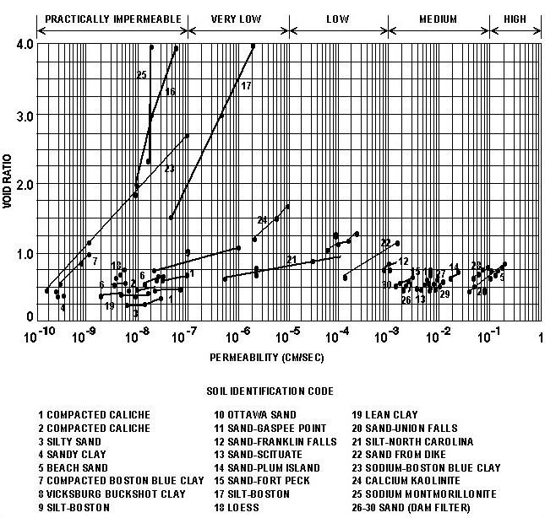
Figure G-3 presents the permeability for different soils as a function of the void ration. The amount of water that can be contained in a soil will directly relate to the void ratio. Not all water contained in a soil can be drained by gravity flow because water retained as thin films adhering to the soil particles and held by capillarity will not drain. Consequently, to determine the volume of water that can be removed from a soil, the effective porosity (n_{e}) must be known. The effective porosity is defined as the ratio of the volume of the voids that can be drained under gravity flow to the total volume of soil, and can be expressed mathematically as
(G-4)
where
$γ_{d}$ = dry density of the soil
$G_{S}$ = specific gravity of solids
$γ_{W}$ = unit weight of water
$W_{e}$ = effective water content (after the soil has drained) expressed as a decimal fraction relative to dry weight
Limited effective porosity test data for well-graded, base-course materials, such as bank-run sands and gravels, indicate a value for effective porosity of not more than 0.15. Uniformly graded medium or coarse sands may have an effective porosity of not more than 0.25, while for a uniformly graded aggregate such as would be used in a drainage layer, the effective porosity may be above 0.25.
G-2.2.5 Effect of Structure and Stratification. Generally, in situ soils show a certain amount of stratification or a heterogeneous structure. Water-deposited soils usually exhibit a series of horizontal layers that vary in grain-size distribution and permeability, and generally these deposits are more permeable in the horizontal than in the vertical direction. In pavement construction, the subgrade, subbase, and base materials are placed and compacted in horizontal layers, which results in having a different permeability in the vertical direction than in the horizontal direction. The vertical drainage of water from a pavement can be disrupted by a single relatively impermeable layer. For most pavements, the subgrades have a very low permeability compared to the base and subbase materials. Therefore, water in the pavement structure can best be removed by horizontal flow. For a layered pavement system, the effective horizontal permeability is obtained from a weighted average of the layer permeability by the formula
$k=(k_{1}⋅d_{1}+\frac{k_{2⋅⋅d_{2}+k_{3}⋅d_{3}+\text{.}\text{.}\text{.})}}{(d_{1}+d_{2}+d_{3}+\text{.}\text{.}\text{.})}$ (G-5)
where
$k$ = the effective horizontal permeability
$k_{1},k_{2},k_{3}\text{.}\text{.}\text{.}$ = the coefficients of horizontal permeability of individual layers
$d_{1},d_{2},d_{3}\text{.}\text{.}\text{.}$ = the thicknesses of the individual layers
When a drainage layer is employed in the pavement section, the permeability of the drainage material will likely be several orders of magnitude greater than that of the other materials in the section. Since water flow is proportional to permeability, the flow of water from the pavement section can be computed based only on the characteristics of the drainage layer.
G-2.3 Quantity and Rate of Subsurface Flow. Water flowing from the pavement section may come from infiltration through the pavement surface and groundwater. Normally groundwater flows into collector drains from the subgrade and will be an insignificant flow compared to the flow coming from infiltration. The computation of the groundwater flow is beyond the scope of this manual; should it be necessary to compute the groundwater flow, consult a textbook on groundwater flow. The volume of infiltration water flow from the pavement will depend on factors such as the type and condition of the surface, the length and intensity of rainfall, the properties of the drainage layer, the hydraulic gradient, the time allowed for drainage, and the drained area. In the design of the subsurface drainage system, all of these factors must be considered.
G-2.3.1 Effects of Pavement Surface. The type and condition of the pavement surface will have considerable influence on the volume of water entering the pavement structure. In the design of surface drainage facilities, all rain falling on paved surfaces is assumed to be runoff. For new, well designed and constructed pavements, the assumption of 100 percent runoff is probably a good, conservative assumption for the design of surface drainage facilities. For design of the subsurface drainage facilities, the design should be based on the infiltration rate for a deteriorated pavement. Studies have shown that for badly deteriorated pavements, well over 50 percent of the rainfall can flow through the pavement surface. For well maintained pavements, the infiltration rate will be greatly reduced such that the run off will approach 100 percent.
G-2.3.2 Effects of Rainfall. It is only logical that the volume of water entering the pavement will be directly proportional to the intensity and length of the rainfall. Relatively low-intensity rainfalls can be used for designing the subsurface drainage facilities because high-intensity rainfalls do not greatly increase the adverse effect of water on pavement performance. The excess rainfall would, once the base and subbase were saturated, run off as surface drainage. For this reason, a seemingly non-conservative design rainfall can be selected.
G-2.3.3 Capacity of Drainage Layers. If water enters the pavement structure at a greater rate than the discharge rate, the pavement structure becomes saturated. The design of horizontal drainage layers for the pavement structure is based, in part, on the drainage layer serving as a reservoir for the excess water entering the pavement. The capacity of the drainage layer as a reservoir is a function of the storage capacity of the drainage layer plus the amount of water that drains from the layer during a rain event. The storage capacity of the drainage layer will be a function of the effective porosity of the drainage material and the thickness of the drainage layer. The storage capacity of the drainage layer, $q_{s}$, in terms of depth of water per unit area is computed by Equation G-6:
$q_{s}=n_{e}⋅h$ (G-6)
where
$n_{e}$ = the effective porosity
$h$ = the thickness of the drainage layer
In the equation, the dimensions of $q_{s}$ will be the same as the dimensions of h. If it is assumed that not all the water will be drained from the drainage layer, then the storage capacity will be reduced by the amount of water in the layer at the start of the rain event. The criterion for design of the drainage layer calls for 85 percent of the water to be drained from the drainage layer within 24 hours; therefore, it is conservatively assumed that only 85 percent of the storage volume will be available at the beginning of a rain event. To account for the possibility of water in the layer at the beginning of a rain event, Equation G-6 is modified to be
$q_{s}=0\text{.}\text{85}⋅n_{e}⋅h$ (G-7)
The amount of water $(q_{d})$that will drain from the drainage layer during the rain event may be estimated using Equation G-8:
$q_{d}=\frac{t⋅k⋅i⋅h}{2⋅L}$ (G-8)
where
$t$ = duration of the rain event
$L$ = length of the drain path
$k$ = permeability of the drainage layer
$i$ = slope of the drainage layer
$h$ = thickness of the drainage layer

G-2.3.3.1 In these equations, the dimensions of $q_{s},q_{d},t,k,h$, and $L$ should be consistent. The total capacity $(q)$ of the drainage layer will be the sum of $q_{s}$and $q_{d}$, resulting in this equation for the capacity:
$q=(0\text{.}\text{85}⋅n_{e}⋅h)+$$\left(\frac{t⋅k⋅i⋅h}{2⋅L}\right)$ (G-9)
G-2.3.3.2 Knowing the water entering the pavement, Equation G-9 can be used to estimate the thickness of the drainage layer such that the drainage layer will have the capacity for a given design rain event. For most situations, the amount of water draining from the drainage layer will be small compared to the storage capacity. Therefore, in most cases, Equation G-7 can be used in estimating the thickness required for the drainage layer.
G-2.3.4 Time for Drainage. The water should be drained from the base and subbase layers as rapidly as possible. The time for drainage of these layers is a function of the effective porosity, the length of the drainage path, the thickness of the layers, the slope of the drainage path, and the permeability of the layers. Past criterion has specified that the base and subbase obtain a degree of 50 percent drainage within 10 days. The equation for computing the time for 50 percent drainage is
$T_{\text{50}}=\frac{\left(n_{e}⋅D^{2}\right)}{\left(2⋅k⋅H_{o}\right)}$ (G-10)
where
$T_{\text{50}}$ = time for 50 percent drainage
$n_{e}$ = effective porosity of the soil
$k$ = coefficient of permeability
$D$, $H_{o}$, and $H$ = base and subbase geometry dimensions (illustrated in Figure G-4)
The dimensions of time $k$,$H_{o}$, $H$, and $D$ must be consistent. If in Figure G-4 the thickness of the drainage layer is small compared to the length of the drainage path, the slope of the drainage path ($i$) can represent the value of $\left(\frac{H_{o}}{D}\right)$ and Equation G-10 can be written as
$T_{\text{50}}=\frac{n_{e}⋅D}{2⋅i⋅k}$ (G-11)
Experience has shown that base and subbase materials, when compacted to densities required in pavement construction, seldom have sufficient permeability to meet the 10-day drainage criterion. In such pavements, the base and subbase materials become saturated, causing a reduced pavement life. When a drainage layer is incorporated into the pavement structure to improve pavement drainage, the criterion for design of the drainage layer is that the drainage layer must reach a degree of drainage of 85 percent within 24 hours. The time for 85 percent drainage is approximately twice the time for 50 percent drainage. The time for 85 percent drainage ($T_{\text{85}}$) is computed by
$T_{\text{85}}=\frac{n_{e}⋅D}{i⋅k}$ (G-12)
Figure G-4. Pavement Geometry for Computation of Time for Drainage

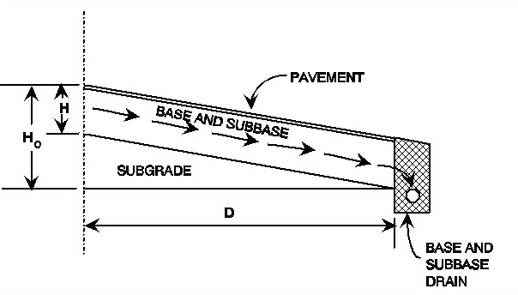
G-2.3.5 Length and Slope of the Drainage Path. As can be seen in Equation G-10, the time for drainage is a function of the square of the length of the drainage path. For this reason and the fact that for most pavement designs the length of the drainage path can be controlled, the drainage path length is an important parameter in the design of the drainage system. The length of the drainage path ($L$) may be computed from this equation:
$L=\frac{L_{t}⋅\sqrt{i_{t}^{2}+i_{e}^{2}}}{i_{t}}$ (G-13)
where
$L_{t}$ = the length of the transverse slope of the drainage layer
$i_{t}$ = the transverse slope of the drainage layer
$i_{e}$ = the longitudinal slope of the drainage layer
The slope of the drainage path ($i$) is a function of the transverse slope and the longitudinal slope of the drainage layer and is computed by Equation G-14:
$i=\sqrt{i_{t}^{2}+}i_{e}^{2}$ (G-14)
G-2.3.6 Rate of Flow. The edge drains for pavements having drainage layers must be designed to handle the maximum rate of flow from the drainage layer. This maximum rate of flow will be obtained when the drainage layer is flowing full and may be estimated using Equation G-2.
G-2.4 Use of Drainage Layers
G-2.4.1 Purpose of Drainage Layers. Special drainage layers may be used to promote horizontal drainage of water from pavements, prevent the buildup of hydrostatic water pressure, and facilitate the drainage of water generated by cycles of freeze-thaw.
G-2.4.2 Placement of Drainage Layers. In rigid pavements, the drainage layer will generally be placed directly beneath the concrete slab. In this location, the drainage layer will intercept water entering through cracks and joints and permit rapid drainage of the water away from the bottom of the concrete slab. In flexible pavements, the drainage layer will normally be placed beneath the dense graded aggregate base (DGA). Placing the drainage layer beneath the base will reduce the stresses on the drainage layer to an acceptable level and drainage will be provided for the base course.
G-2.4.3 Permeability Requirements for the Drainage Layer. The material for drainage layers in pavements must be of sufficient permeability to provide rapid drainage and to rapidly dissipate water pressure in addition to providing sufficient strength and stability to withstand load-induced stresses. There is a trade-off between strength or stability and permeability; therefore, the material for the drainage layers should have the minimum permeability for the required drainage application. For most applications, a material with a permeability of 300 m/day (1,000 ft/day) will provide sufficient drainage.
G-2.5 Use of Filters
G-2.5.1 Purpose of Filters in Pavement Structures. The purpose of filters in pavement structures is to prevent the movement of soil (piping) yet allow the flow of water from one material to another. The need for a filter is dictated by the existence of water flow from a fine grain material to a coarse grain material generating a potential for piping of the fine grain material. The principal location in the pavement structure for a flow from a fine grain material into a coarse grain material is where water flows from the base, subbase, or subgrade into the coarse aggregate surrounding the drain pipe. Thus, the principal use of a filter in a pavement system will be in preventing piping into the drain pipe. Although rare, the possibility exists for hydrostatic head forcing a flow of water upward from the subbase or subgrade into the pavement drainage layer. For such a condition, it would be necessary to design a filter to separate the drainage layer from the finer material.
G-2.5.2 Piping Criteria. The criteria for preventing movement of particles from the soil or granular material to be drained into the drainage material are:
$\frac{\text{15 percent size of drainage or filter material}}{\text{85 percent size of material to be drained}}≤5$
and
$\frac{\text{50 percent size of drainage or filter material}}{\text{50 percent size of material to be drained}}≤\text{25}$
These criteria will be used when protecting all soils except clays without sand or silt particles. For these soils, the 15 percent size of drainage or filterbv material may be as great as 0.4 mm and the d₅₀ criteria may be disregarded.
G-2.5.3 Permeability Requirements. To assure that the filter material is sufficiently permeable to permit passage of water without hydrostatic pressure buildup, this requirement should be met:
$\frac{\text{15 percent size of filter material}}{\text{15 percent size of material to be drained}}≥5$
G-2.6 Use of Separation Layers
G-2.6.1 Purpose of Separation Layers. When drainage layers are used in pavement systems, the drainage layers must be separated from fine grain subgrade materials to prevent penetration of the drainage material into the subgrade or pumping of fines from the subgrade into the drainage layer. The separation layer is different from a filter in that there is no requirement, except during frost thaw, to protect against water flowing from the subgrade through the layer into the drainage layer.
G-2.6.2 Requirements for Separation Layers. The main requirements of the separation layer are that the material for the separation layer have sufficient strength to prevent the coarse aggregate of the drainage layer from being pushed into the fine material of the subgrade and that the material have sufficient permeability to prevent buildup of hydrostatic pressure in the subgrade. To satisfy the strength requirements, the material of the separation layer should have a minimum CBR of 50. To allow for release of hydrostatic pressure in the subgrade, the separation layer should have a permeability greater than that of the subgrade. This would not normally be a problem because the permeability of subgrades are orders of magnitude less than the permeability of a 50 CBR material, but to ensure sufficient permeability, the permeability requirements of a filter would apply.
G-2.7 Use of Geotextiles
G-2.7.1 Purpose of Geotextiles. Geotextiles (engineering fabrics) may be used to replace either the filter or the separation layer. The principal use of geotextiles is for the filter around the pipe for the edge drain. Although geotextiles can be used as a replacement for the separation layer, a geotextile adds no structure strength to the pavement; therefore, this practice is not recommended.
G-2.7.2 Requirements of Geotextiles for Filters. When geotextiles are to serve as a filter lining the edge drain trench, the most important function of the filter is to keep fines from entering the edge drain system. For pavement systems having drainage layers, there is little requirement for water flow through the fabric; therefore, for most applications, it is better to have a heavier fabric than would normally be used as a filter. Since drainage layers have a very high permeability, geotextile fabric should never be placed between the drainage layer and the edge drain. The permeability of geotextiles is governed by the size of the openings in the fabric, which is specified in terms of the AOS in millimeters. For use as a filter for the trench of the edge drain, the geotextile should always have an AOS that is equal to or less than 0.212 mm. For geotextiles used as filters with drains installed to intercept groundwater flow in subsurface aquifers, the geotextile should be selected based on criteria similar to the criteria used to design a granular filter.
G-2.7.3 Requirements for Geotextiles Used for Separation. Geotextiles used as separation layers beneath drainage layers should be selected based primarily on survivability of the geotextiles, with slightly less emphasis placed on the AOS. When a geotextile is used as a separation layer, the geotextile’s survivability should be rated very high by the rating scheme in AASHTO M 28890, Standard Specification for Geotextiles, Asphalt Retention, and Area Change of Paving Engineering Fabrics. This would ensure survival of the geotextile under the stress of traffic during the life of the pavement. To ensure that fines will not pump into the drainage layer yet allow water flow to prevent hydrostatic pressure, the AOS of the geotextile must be equal to or less than 0.212 mm and also equal to or greater than 0.125 mm.
G-3 DESIGN OF THE PAVEMENT SUBSURFACE DRAINAGE SYSTEM. The design methodology contained in this chapter is for the design of a pavement subsurface drainage system for the rapid removal of surface infiltration water and water generated by freeze-thaw action. Although the primary emphasis will be on removing water from under the pavement, on occasion the system will also serve as an interceptor drain for groundwater.
G-3.1 Methods. For most pavement structures, water is to be removed by a special drainage layer that allows the rapid horizontal drainage of water. The drainage layer must be designed to handle surface infiltration from a design storm and withstand the stress of traffic. A separation layer must be provided to prevent intrusion of fines from the subgrade or subbase into the drainage layer and facilitate construction of the drainage layer. The drainage layer should feed into a collection system consisting of trenches with a drain pipe, backfill, and filter. The collection system must be designed to maintain progressively greater outflow capabilities in the direction of flow. The outlet for the subsurface drains should be properly located or protected to prevent backflow from the surface drainage system. Some pavements may not require a drainage system because the subgrade may have sufficient permeability for the water to drain vertically into the subgrade. In addition, some pavements designed for very light traffic may not justify the expense of a subsurface drainage system. Even for pavements designed for very light traffic, care must be taken to ensure that base and subbase material are free draining and that water will be not trapped in the pavement structure. For pavement without collection systems, the base and subbase must daylight at the shoulders.
G-3.2 Design Prerequisites. For the satisfactory design of a subsurface drainage system, the designer must have an understanding of environmental conditions, subsurface soil properties, and groundwater conditions.
G-3.2.1 Environmental Conditions. Temperature and rainfall data applicable to the local area should be obtained and studied. The depth of frost penetration is an important factor in the design of a subsurface drainage system. For most areas, the approximate depth of frost penetration can be determined by referring to AC 150/5320-6. Rainfall data are used to determine the volume of water to be handled by the subsurface drainage system. The data can be obtained from local weather stations, by using Figure G-5, or from the web at http://www.weather.gov/oh/hdsc/currentpf.htm.

Figure G-5. Design Storm Index, 1-Hour Rainfall Intensity-Frequency Data for
the Continental United States Excluding Alaska
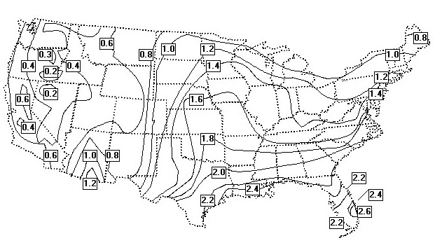
G-3.2.2 Subsurface Soil Properties. In most cases, the soil properties investigated for other purposes in connection with the pavement design will supply information that can be used for the design of the subsurface drainage system. The two properties of most interest are the coefficient of permeability and the frost susceptibility of the pavement materials.
G-3.2.3 Coefficient of Permeability. Knowing the coefficient of permeability of the existing subsurface soils is essential for determining if special horizontal drainage layers are necessary in the pavement. For pavements having subgrades with a high coefficient of permeability, the water entering the pavement will drain vertically and therefore horizontal drainage layers will not be required. For pavements having subgrades with a low coefficient of permeability, the water entering the pavement must be drained horizontally to the collector system or to edge drains.
G-3.2.4 Frost-Susceptible Soils. Soils susceptible to frost action are those that have the potential of ice formation when the soil is subjected to freezing conditions with water available. Ice formation takes place at successive levels as freezing temperatures penetrate into the ground. Soils possessing a high capillary rate and low cohesive nature act as a wick in feeding water to ice lenses. Soils are categorized according to their degree of frost susceptibility as shown in Table G-2. Because a large volume of free water is generated during the thaw of ice lenses, horizontal drainage layers are required to permit the escape of the water from the pavement structure and thus facilitate restoring the pavement strength.
Table G-2. Frost-Susceptible Soils

Typical Soil
Frost  Group | Type of Soil | Percent Finer than 0.02 mm  by Weight | Types Under Unified Soil  Classification System
F1 | Gravely soils | 6-10 | GW-GM, GP-GM,  GW-GC, GP-GC
F2 | (a) Gravely soils  (b) Sands | 3-20  6-15 | GM, GC, GM-GC  SM, SC, SW-SM,  SP-SM, SW-SC,  SP-SC, SM-SC
F3 | (a) Gravely soils  (b) Sands, except very fine  silty sands  (c) Clays (PI > 12) | > 20  > 15  -- | GM, GC, GM-GC  SM, SC, SM-SC  CL, CH, ML-CL
F4 | (a) Silts  (b) Very fine sands  (c) Clays (PI < 12)  (d) Varved clays and other  fine grained, with banded  sediments | --  > 15  --  -- | ML, MH, ML-CL  SM, SC, SM-SC  CL, ML-CL  CL or CH layered  ML, MH, SM, SC  SM-SC or ML-CL

G-3.2.5 Sources for Data. From the field explorations made in connection with the project design, include a topographic map of the proposed pavement facility and surrounding vicinity indicating all streams, ditches, wells, and natural reservoirs. Analyze aerial photographs for information on general soil and groundwater conditions. Borings taken during the soil exploration should provide depth to water tables and subgrade soil types. Obtain typical values of permeability for subgrade soils from Figure G-3. Although the value of permeability determined from Figure G-3 must be considered as an estimate only, the value should be sufficiently accurate to determine if subsurface drainage is required for the pavement. For the permeability of granular materials, determine estimates of the permeability from these equations:
in mm/sec (G-15)
or
in ft/day (G-16)
where
= porosity =
= specific gravity of solids (assumed 2.7)
= dry density of material
= density of water
= effective grain size at 10 percent passing in mm
= percent passing 0.075 mm (No. 200) sieve
For the most part, the permeability values needed for design of the drainage layer will be assigned based on the gradation of the drainage material. In some cases, laboratory permeability tests may be necessary; however, use caution and be aware that the permeability of very open granular materials is very sensitive to test methods, methods of compaction, and gradation of the sample. Because of this, use conservative drainage layer permeability values for design.
G-3.3 Criteria for Subsurface Drainage Systems
G-3.3.1 Criteria for Requiring a Subsurface Drainage System. Not all pavements will require a subsurface drainage system, either because the subgrade is sufficiently permeable to allow water to drain vertically into the subgrade or because the pavement structure does not justify the expense of a subsurface drainage system. For pavements in nonfrost areas and having a subgrade with permeability greater than 6 m/day (20 ft/day), one can assume that the vertical drainage will be sufficient such that no drainage system is required. In addition to this exemption for the requirement for drainage systems, flexible pavements that are in nonfrost areas and that have a total thickness of structure above the subgrade of 200 mm (8 in.) or less are not required to have a drainage system. All pavements not meeting these criteria are required to have a subsurface drainage system. Even if a pavement meets the exemption requirements, conduct a drainage analysis for possible benefits for including the drainage system. For rigid pavements in particular, take care to ensure that water is drained rapidly from the bottom of the slab and that the material directly beneath the concrete slab is not susceptible to pumping.
G-3.3.2 Design Water Inflow. Design the subsurface drainage of the pavement to handle infiltrated water from a design storm of 1-hour duration at an expected return frequency of 2 years. The design storm index for the continental United States can be obtained from Figure G-5. The inflow is determined by multiplying the design storm index () times an infiltration coefficient (). The infiltration coefficient will vary over the life of the pavement depending on the type of pavement, surface drainage, pavement maintenance, and the structural condition of the pavement. Since determining a precise value of the infiltration coefficient for a particular pavement is very difficult, a value of 0.5 may be assumed for design.
G-3.3.3 Length and Slope of the Drainage Path. The length of the drainage path is measured along the slope of the drainage layer from the crest of the slope to where the water will exit the drainage layer. In simple terms, the length of the drainage path is the maximum distance water will travel in the drainage layer. The length of the drainage path () in meters (feet) may be computed using Equation G-13, and the slope () of the drainage path may be computed using Equation G-14.
G-3.3.4 Thickness of the Drainage Layer. The thickness of the drainage layer is computed such that the capacity of the drainage layer will be equal to or greater than the infiltration from the design storm. When the length of the drainage path () is in meters (feet), the design storm index () is in meters/hour (feet/hour), the permeability of the drainage layer () is in meters/hour (feet/hour), and the length of the design storm () is in hours, the equation for computing the thickness () in meters (feet) is
(G-17)
The effective porosity (), the infiltration coefficient (), and the slope of the drainage path () are non-dimensional. If the term () is small compared to the term (), which would be the case for long drainage paths, i.e., for drainage paths longer than approximately 6 m (20 ft), then the required thickness of the drainage layer can be estimated by deleting the term () from Equation G-17 or
(G-18)
where the units are the same as in Equation G-17.
G-3.3.5 Drainage Criteria. The subsurface drainage criteria for airfield runways and taxiways require that, should the drainage layer become saturated, it should be capable of attaining 85 percent drainage within 24 hours. For airfield parking aprons and other pavement areas receiving only low-volume, low-speed traffic, the time for 85 percent drainage is 10 days. The time for 85 percent drainage is computed by the equation
(G-19)
where the dimensions of will be in days when is in meters (feet) and is in meters/day (feet/day). The time of drainage may be adjusted by changing the drainage material, the length of the drainage path, or the slope of the drainage path. Changing the drainage material will change both the effective porosity and the permeability, but the effective porosity will change, at the most, by a factor of 3, whereas the permeability may change by several orders of magnitude. Thus, providing a more open drainage material would decrease the time for drainage, but more open materials are less stable and more susceptible to rutting. It is therefore desirable to keep the drainage material as dense as possible. The drainage layer of a pavement is usually placed parallel to the surface; therefore, in most cases, the slope of the drainage path is governed by the geometry of the pavement surface. For large paved areas such as airfield apron areas, the time for drainage is best controlled by designing the collection system to minimize the length of the drainage path. For edge drains along airfield taxiways and runways, it may be difficult to reduce the length of the drainage path without resorting to placing drains under the pavement. Pavements having long longitudinal slopes may require transverse collector drains to prevent long drainage paths. Thus, designing the subsurface drainage system to meet the criteria for time of drainage involves matching the type of drainage material with the drainage path length and slope.
G-3.4 Placement of Subsurface Drainage Systems
G-3.4.1 Rigid Pavements. In the case of rigid pavements, the drainage layer, if required, should be placed directly beneath the concrete slab. In the structural design of the concrete slab, the drainage layer along with any granular separation layer is considered a base layer, and structural benefit may be realized from the layers.
G-3.4.2 Flexible Pavements. In the case of flexible pavements, the drainage layer should be placed either directly beneath the surface layer or beneath a graded, crushed aggregate base course. If the required thickness of the granular subbase is equal to or greater than the thickness of the drainage layer plus the thickness of the separation layer, the drainage layer is placed beneath the graded, crushed aggregate base. Where the total thickness of the pavement structure is less than 300 mm (12 in.), the drainage layer may be placed directly beneath the surface layer and the drainage layer used as a base. When the drainage layer is placed beneath an unbound aggregate base, take care to limit the material passing the 0.075 mm (No. 200) sieve in the aggregate base to 8 percent or less.
G-3.4.3 Separation Layer. The drainage layer must be protected from contamination of fines from the underlying layers by a separation layer placed directly beneath the drainage layer. In most cases, the separation layer should be a graded aggregate material meeting the requirements of a 50 CBR subbase and can, in fact, be considered as part of the subbase. For design situations where a firm foundation already exists and thickness of the separation layer is not needed in the structure for protection of the subgrade, a filter fabric may be substituted for the granular separation layer. In frost areas, the separation layer should be NFS and, in fact, some materials used as non-susceptible fill may qualify as a separation layer.
G-3.5 Material Properties
G-3.5.1 For Drainage Layers. The material for a drainage layer should be a hard, durable crushed aggregate to withstand degradation under construction traffic as well as in-service traffic. The gradation of the material should be such that the material has sufficient stability for the operation of construction equipment. While it is desirable for strength and stability to have the well-graded aggregate, the permeability of the material must be maintained. For most drainage layers, the drainage materials should have a minimum permeability of 300 m/day (1,000 ft/day). Two materials, an RDM and an OGM, have been identified for use in drainage layers. The RDM is a material that has a sufficiently high permeability (300 m/day (1,000 ft/day) to 1,500 m/day (5,000 ft/day)) to serve as a drainage layer and that also has the stability to support construction equipment and the structural strength to serve as a base and/or a subbase. The OGM is a material that has a very high permeability (greater than 1,500 m/day (5,000 ft/day)) and that can be used for a drainage layer. The OGM will normally require stabilization for construction stability and/or for structural strength to serve as a base in a flexible pavement. Gradation limits for the two materials are given in Table G-3, and the design properties are given in Table G-4. The gradations given in Table G-3 provide very wide bands, and it is possible to produce gradations within these bands that may not be sufficiently stable for construction without the use of chemical stabilization. Table G-5 provides the gradation specifications for three aggregate materials, each of which will meet the criteria for stability. These gradations were developed to produce the maximum density given maximum aggregate sizes of 1.5 in., 1 in., and 0.75 in., and a maximum of 4 percent passing the number 16 sieve. For drainage layer thicknesses less than 6 in., gradations number 1 or 2 may be used. For drainage layers 6 in. or more in thickness, any of the three gradations may be used, but the gradations with larger aggregates will produce the more stable aggregate. Each of the gradations would produce a drainage layer with a permeability of approximately 1000 ft/day.
Table G-3. Gradations of Materials for Drainage Layers and Choke Stone
Drainage Layer Material
Sieve Designation (mm) | Rapid Draining  Material | Open-Graded  Material | Choke Stone
38.0 (1-1/2 in.) | 100 | 100 | 100
25.0 (1 in.) | 70-100 | 95-100 | 100
19.0 (3/4 in.) | 55-100 | -- | 100
12.5 (1/2 in.) | 40-80 | 25-80 | 100
9.5 (3/8 in.) | 30-65 | -- | 80-100
4.75 (No. 4) | G-50 | 0-10 | G-100
2.4 (No. 8) | 0-25 | 0-5 | 5-40
1.2 (No. 16) | 0-5 | -- | 0-10

Table G-4. Properties of Materials for Drainage Layers

Property | Rapid Draining Material | Open-Graded Material
Permeability in m/sec  (ft/day) | 300-1,500  (1,000-5,000) | > 1,500  (> 5,000)
Effective Porosity | 0.25 | 0.32
Percent Fractured  Faces (Corps of Engineers method) | 90 percent for 80 CBR  75 percent for 50 CBR | 90 percent for 80 CBR  75 percent for 50 CBR
C_{v} | > 3.5 | --
LA Abrasion | < 40 | < 40
Note: C_{v} is the uniformity coefficient = D60/D10.

Table G-5. Material Gradations for Drainage Layer
Sieve Size | Gradation #1  ¾ inch max. |  | Gradation #2  1 inch max. |  | Gradation #3  1½ inch max
Sieve Size | Percent Passing | Tolerance | Percent Passing | Tolerance | Percent Passing | Tolerance
1 ½ in (37.0 mm) |  |  |  |  | 100 | -5
1 in (25 mm) |  |  | 100 | -5 | 79 | ±8
¾ in (19 mm) | 100 | -5 | 85 | ±8 | 66 | ±8
½ in (12.5 mm) | 78 | ±8 | 65 | ±8 | 52 | ±8
3/8 in (9.5 mm) | 63 | ±8 | 53 | ±8 | 42 | ±8
No. 4 (4.75mm) | 38 | ±8 | 32 | ±6 | 25 | ±6
No. 8 (2.36 mm) | 19 | ±6 | 16 | ±6 | 12 | ±4
No. 16 (1.18 mm) | 2 | ±2 | 2 | ±2 | 2 | ±2

G-3.5.2 Aggregate for Separation Layer. The separation layer serves to prevent fines from infiltrating or pumping into the drainage layer and to provide a working platform for construction and compaction of the drainage layer. The material for the separation layer should be a graded aggregate with a 50 CBR maximum except that the maximum aggregate size should not be greater than 0.25 the thickness of the separation layer. The permeability of the separation layer should be greater than the permeability of the subgrade, but the material should not be so open as to permit pumping of fines into the separation layer. To prevent pumping of fines, the ratio of d₁₅ of the separation layer to d₈₅ of the subgrade must be equal to or less than 5. The material property requirements for the separation layer are given in Table G-6.
Table G-6 Criteria for Granular Separation Layer

Maximum Aggregate Size | Lesser of 50 mm (2 in.)  or 0.25 of layer thickness
Maximum CBR | 50
Maximum Percent Passing 2.00 mm (No. 10) | 50
Maximum Percent Passing 0.075 mm (No. 200) | 15
Maximum Liquid Limit | 25
Maximum Plasticity Index | 5
d₁₅ of Separation Layer to d₈₅ of Subgrade | 5

G-3.5.3 Filter Fabric for Separation Layer. Although filter fabric provides protection against pumping, it does not provide extra stability for compaction of the drainage layer; therefore, fabric should be selected only when the subgrade provides adequate support for compaction of the drainage layer. The important characteristics of the fabric are strength for surviving construction and traffic loads, and AOS to prevent pumping of fines into the drainage layer. Filter fabric for separation should be a nonwoven needle punch fabric having a minimum grab strength in accordance with ASTM D-4632 of 0.8 Kilonewtons (kN) (180 lbs) at 50% elongation and a minimum puncture strength
in accordance with ASTM D-4833 of 0.35 kN (80 lbs). The AOS for the filter fabric is determined from Table G-7.
Table G-7. Criteria for Filter Fabric to be Used as a Separation Layer

Soil Type | Criteria | ASTM Test Method
Soil with 50% or Less  Passing No. 200 Sieve | AOS (mm) < 0.6 mm  Greater than No. 30 sieve | D-4751
Soil with Greater Than 50%  Passing No. 200 Sieve | AOS (mm) < 0.297  Greater than No. 50 sieve | D-4751

G-4 STABILIZATION OF DRAINAGE LAYER. Stabilization of OGM is normally required for stability and strength and for preventing degradation of the aggregate in handling and compaction. Stabilization may also be used when high-quality crushed aggregate is not available, and on occasions when stabilization of RDM is necessary. Stabilization may be accomplished mechanically by use of a choke stone or by the use of a binder such as asphalt or portland cement.
G-4.1 Choke Stone Stabilization. A choke stone is a small-size stone used to stabilize the surface of an OGM. The choke stone should be a hard, durable, crushed aggregate having 90 percent fractured faces. The ratio of d₁₅ of the coarse aggregate to the d₁₅ of the choke stone must be less than 5, and the ratio of the d₅₀ of the coarse aggregate to d₅₀ of the choke stone must be greater than 2. The gradation range for acceptable choke stone is given in Table G-3. Normally, ASTM No. 8 or No. 9 stone will meet the requirements of a choke stone for the OGM.
G-4.2 Asphalt Stabilization. Stabilization of the drainage material with asphalt is accomplished by using only enough asphalt as is required to coat the aggregate. Take care so that the voids are not filled by excess asphalt. The asphalt grade used for stabilization should be AC20 or higher. For stabilization of OGM, 2 to 2.5 percent asphalt by weight should be sufficient to coat the aggregate. Higher rates of application may be necessary when stabilization of less open aggregate such as RDM is necessary.
G-4.3 Cement Stabilization. As with asphalt stabilization, portland cement stabilization is accomplished by using only enough cement paste to coat the aggregate, and care should be taken so that the voids are not filled by excess paste. The amount of portland cement required should be approximately 170 kg/m³ (2 bags per cubic yard) depending on the gradation of the aggregate. The water-cement ratio should be just sufficient to provide a paste that will adequately coat the aggregate.
G-5 CONSTRUCTION OF THE DRAINAGE LAYER
G-5.1 Experience. Construction of drainage layers can present problems in handling, placement, and compaction. If the drainage material does not have adequate stability, major problems can develop in the placement of the surface layer above the drainage layer. Experience with highly permeable bases (drainage layers) both by the United States Army Corps of Engineers (USACE) and various state departments of transportation indicates that pavements containing such layers can be constructed without undue difficulties if necessary precautions are taken. The key to successful construction of the drainage layers is the training and experience of the construction personnel. Prior to the start of construction, the construction personnel should be taught how to handle and place the drainage material. Placing test strips is recommended for training construction personnel.
G-5.2 Placement of the Drainage Layer. The material for the drainage layer must be placed to prevent segregation and to obtain a layer of uniform thickness. The materials for the drainage layer will require extra care in stockpiling and handling. Placement of the RDM and OGM is best accomplished using an AC paver. To ensure good compaction, the maximum lift thickness should be no greater than 150 mm (6 in.). If choke stone is used to stabilize the surface of the OGM, place the choke stone after compaction of the final lift of OGM. Spread the choke stone in a thin layer no thicker than 10 mm (0.5 in.) using a spreader box or paver. Work the choke stone into the surface of the OGM by using a vibratory roller and by wetting. The choke stone remaining on the surface should not migrate into the OGM by the action of water or traffic.
G-5.3 Compaction. Compaction is a key element in the successful construction of the drainage layer. Compaction control normally used in pavement construction is not appropriate for materials such as the RDM and OGM. It is therefore necessary to specify compaction techniques and level of effort instead of the properties of the end product. It will be important to place the drainage material in relatively thin lifts of 150 mm (6 in.) or less and to have a good, firm foundation beneath the drainage material. The recommended method of determining the required compaction effort is to construct a test section and closely monitor the aggregate during compaction to determine when crushing of the aggregate appears excessive. Experience has indicated that sufficient compaction can be obtained by 6 passes or fewer of a vibratory roller loaded at approximately 9 metric tons (10 short tons). Material not being stabilized with asphalt or cement should be kept moist during compaction. Asphalt stabilized material for drainage layers must be compacted at a slightly lower temperature than a dense-graded asphalt material. In most cases, it will be necessary to allow an asphalt stabilized material to cool to less than 93 degrees Celsius (200 degrees Fahrenheit) before beginning compaction.
G-5.4 Protection after Compaction. After compaction, protect the drainage layer from contamination by fines from construction traffic and from the flow of surface water. The surface layer should be placed as soon as possible after placement of the drainage layer. Also, take precautions to protect the drainage layer from disturbance by construction equipment. Only tracked asphalt pavers should be allowed for paving over any RDM or OGM that has not been stabilized. Drivers should avoid rapid acceleration, hard braking, or sharp turning on the completed drainage layer. Although curing of cement-stabilized drainage layers is not critical, efforts should be made at curing until the surface layer is placed.
G-5.5 Proof Rolling. For airfields with runways over 1,524 m (5,000 ft), proof rolling is recommended on the graded, crushed-aggregate base even when the base is used over a drainage layer. Proof rolling the separation layer prior to placing the drainage layer is recommended. It is recommended that the proof rolling be accomplished using a rubber-tired roller load to provide a minimum tire force of 89 kN (20,000 lbs) and inflated to at least 620 kPa (90 lb/in.²). A minimum of 6 coverages should be applied, where a coverage is the application of one tire print over each point in the surface of the designated area. During proof rolling, action of the separation layer must be monitored for any sign of excessive movement or pumping that would indicate soft spots in the separation layer or the subgrade. Since the successful placement of the drainage layer depends on the stability of the separation layer, all weak spots must be removed and replaced with stable material. All replaced material must meet the appropriate material and construction specifications and upon replacement according to the appropriate specification, proof rolling as specified in this paragraph is recommended.
G-6 COLLECTOR DRAINS
G-6.1 Design Flow. Provide collector drains to collect and transport water from under the pavement. For pavements having drainage layers, collector drains are mandatory. The collector system should have the capacity to handle the water from the drainage layer plus water from other sources. The amount of water entering the collector system from the drainage layer is computed assuming the drainage layer is flowing full. Thus, the volume of water () in cubic millimeters per second per meter (cubic feet per day per foot) of length of collector pipe (assuming the drainage layer is only on one side of the collector) would be
$\text{in cubic mm per second per meter}$ (G-20)
or
$\text{in cubic ft per day per foot}$ (G-21)
where
= thickness of the drainage layer, mm (ft)
= slope of the drainage layer
= permeability of the material in the drainage layer, mm/sec (ft/day)
If the collector system has water entering from both sides, the volume of water entering the collector would be twice that given by Equation G-20.
G-6.2 Design of Collector Drains
G-6.2.1 Drainage System Layout. The collector drains are normally placed along the shoulder of the pavement as illustrated in Figure G-8. The system will consist of the drain pipe, flushing and observation risers, manholes, discharge laterals, filter fabric, and trench backfill. Since placing subsurface drains under pavements may result in differential settlement or heave, avoid this when possible. The drainage system for large areas of pavement may require placement of subsurface drains under the pavement. For these cases, place the subsurface drains to avoid high traffic areas. In areas of extreme cold temperatures and heavy snow buildup, place laterals to reduce the probability that they will become clogged with ice or snow. Also, in areas of extreme cold temperatures, placing the collector drains below the depth of frost penetration may not be possible; therefore, the collector pipe may be filled with ice while thawing is occurring near the surface. For this case, make provisions to drain the upper portion of the pavement either by daylighting the drainage layer or providing special laterals to drain the drainage layer.
Figure G-8. Plan View of Subsurface Drainage System
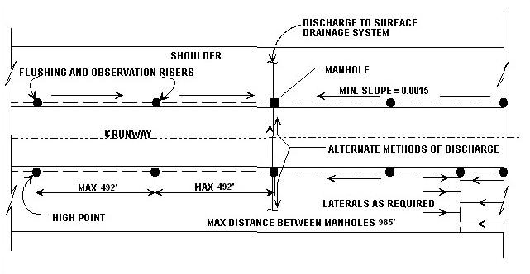

G-6.2.2 Collector Pipe. The collector pipe may be perforated flexible, acrylonitrile butadiene styrene (ABS), corrugated polyethylene (CPE), or smooth, rigid polyvinyl chloride pipe (PVC). Pipe should conform to the appropriate AASHTO specification. Most state highway agencies use either CPE or PVC. For CPE pipe, AASHTO specification M 252 is suggested, while for PVC pipe, AASHTO specification M 278 is recommended. Though asphalt-stabilized material is not recommended as backfill around pipe, if it is to be used, the pipe should be PVC 90 degrees Celsius electrical plastic conduit EPC-40 or EPC-80 conforming to the requirements of National Electrical Manufacturers Association (NEMA) Specification TC-2. Geocomposite edge drains (strip drains) may be used in special situations, but only with the approval of a modification to standards (FAA Order 5100.1) by AAS-100. Geocomposite edge drains should be considered only for pavements without a drainage layer.
G-6.2.3 Pipe Size and Slopes. The pipe must be sized, according to Equation G-22 or G-23, to have a capacity sufficient to collect the peak flow from under the pavement. Equations G-22 and G-23 are Manning equations for computing the capacity of a full-flowing circular drain. The equation for flow () in cubic feet per second is
(G-22)
where
= coefficient of roughness for the pipe
= area of the pipe, ft²
= pipe diameter, ft
= slope of the pipe invert
For metric units, the equation for flow in cubic meters per second is
$Q=\frac{1\text{.}0}{n}⋅\left(A\right)⋅{\left[\frac{d}{4}\right]}^{23}⋅\left(s^{12}\right)$ (G-23)
where
and are as defined in Equation G-22
= pipe area, m²
= pipe diameter, m
The coefficient of roughness for different pipe types can be obtained from Table G-8. Except for long intercepting lines and extremely severe groundwater conditions, 150-mm (6-in.) diameter drains should be satisfactory for most subsurface drainage installations. The minimum size pipe recommended for all collector drains is 150-mm (6-in.) diameter. The recommended minimum slope for subdrains is 0.15 percent.
Table G-8. Coefficient of Roughness for Different Types of Pipe

Type of Pipe | Coefficient of Roughness, n
Clay, concrete, smooth-wall plastic, and asbestos-cement | 0.013
Bituminous-coated, non-coated corrugated metal pipe or corrugated metal pipe | 0.024

G-6.3 Placement of the Drainage Layer and Collector Drains. In general, the drainage layer is placed below the concrete surface for a rigid pavement and below the base course for a flexible pavement. Typical designs details for placement of the drainage layer and the collector drains in non-frost areas are given in Figures G-9a, G-10a, G-11a, and G-12a. In most cases, the trench for the collector drains should be wide enough to provide 150 mm (6 in.) of clearance on each side of the pipe. The depth of the trench must be sufficient to provide a minimum 300 mm (12 in.) from the top of the pavement subgrade to the center of the pipe, plus 80 mm (3 in.) of clearance beneath the pipe. In frost areas, use extra care in placing subsurface drains. The typical design details for placement of the drainage layer and the collector drains for frost areas are given in Figures G-9b, G-9c, G-10b, G-11b, G-11c, and G-12b details (cross slopes varies in accordance with AC 150/5300-13). For F3 and F4 subgrades, always place a collector pipe such that there will be positive drainage for the drainage layer and any NFS fill. If possible, place the drains below the depth of frost penetration. For many locations, placing the drains below the depth of frost penetration will not be economically feasible and therefore the drains and backfill will be subject to freezing. In areas where the depth of frost penetration is greater than 1.2 m (4 ft) below the bottom of the drainage layer, the pipe need not be located deeper than 1.2 m (4 ft) from the bottom of the drainage layer. Because differential frost heave will cause pavement problems in frost areas, the sides of the trench must be sloped not steeper than 1 vertical on 10 horizontal for the depth of frost penetration. At the edge of the pavement where the pavement will not be subject to traffic, the sides of the trench may be sloped at a slope of 1 vertical on 4 horizontal. The sloping of the trench sides is not required for the parts of the trench in NFS materials or for F1 or S1 soils unless the pavement over the trench is subjected to high-speed traffic.
The placement of collector drains under the interior portion of a pavement in frost areas is a special case where the collector drain is not directly connected to the drainage layer by an OGM or an RDM. This case is illustrated in figures G-9b, G-9c, G-11b, and G-11c. The interior designs are based on the premise that NFS fill will have sufficient permeability to allow vertical drainage of the drainage layer into the collector pipes. Another premise is that the filter fabric will have sufficient area as not to impede the flow of water from the NFS fill to the collector pipe. The exception to the minimum requirement for the depth of the collector pipe below the surface of the subgrade is the interior case in a frost area for an F3 or F4 subgrade when the collector pipe is above the depth of frost penetration. For this case, keep the depth of the pipe below the surface of the subgrade to a minimum.
Figure G-9a. Typical Interior Subdrain Detail for Rigid Pavement
(Non-Frost Areas)
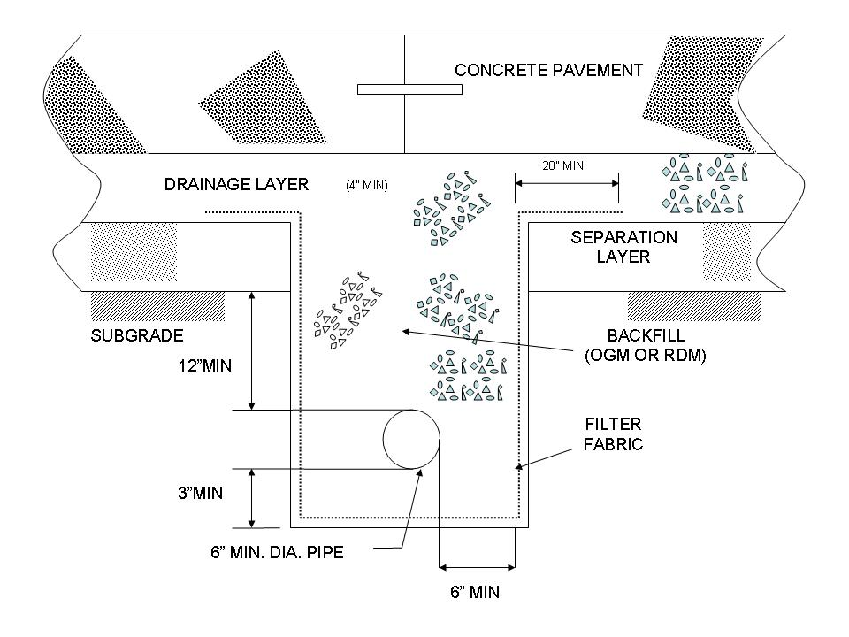

Figure G-9b. Typical Interior Subdrain for Rigid Pavement
(Frost Areas, Depth of Frost > Depth to Pipe)
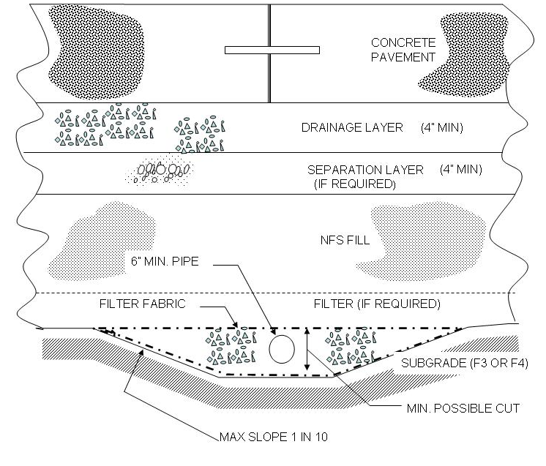
Figure G-9c. Typical Interior Subdrain for Rigid Pavement
(Frost Areas, Depth of Frost < Depth to Pipe)
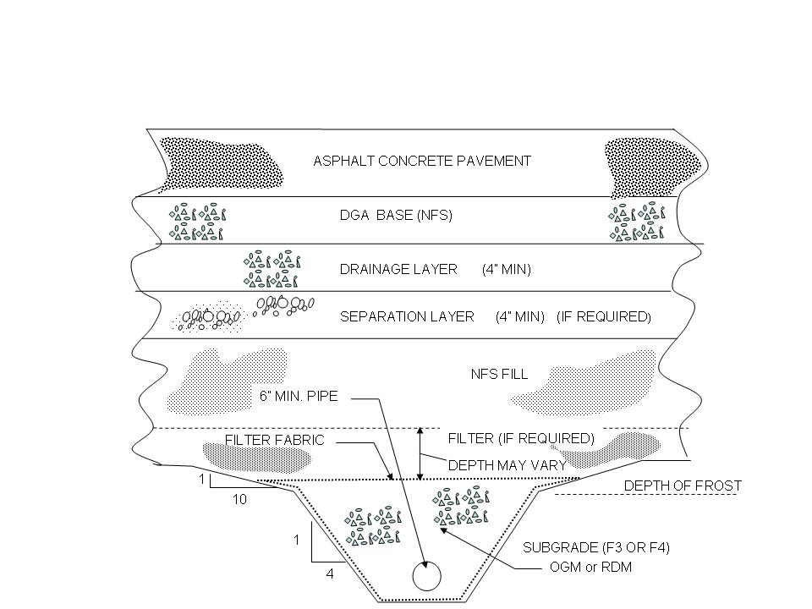

Figure G-10a. Typical Edge Subdrain Detail for Rigid Pavement
(Non-Frost Areas)
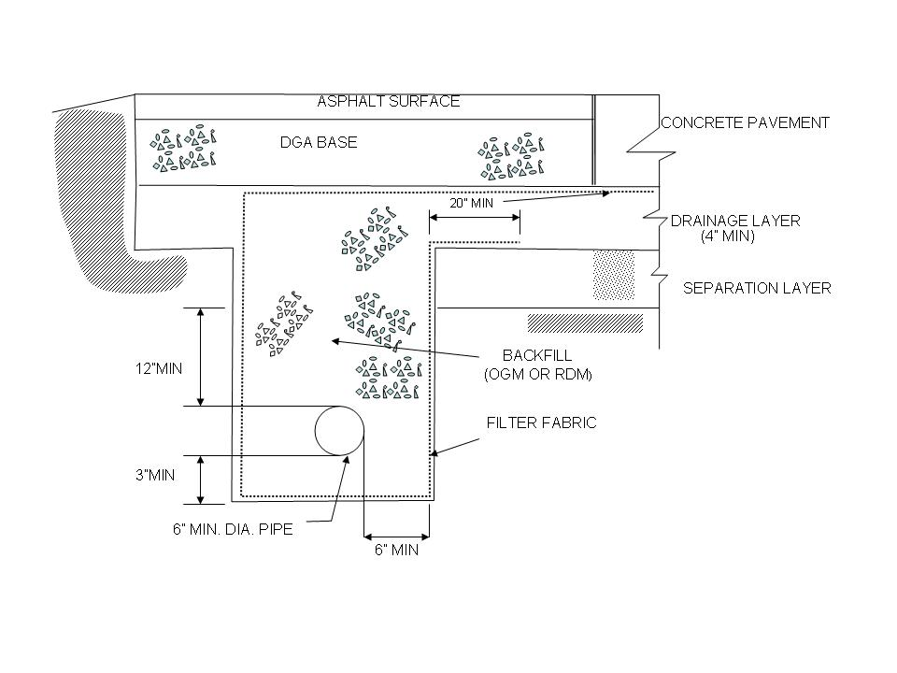
Figure G-10b. Typical Edge Subdrain Detail for Rigid Pavement (Frost Areas)
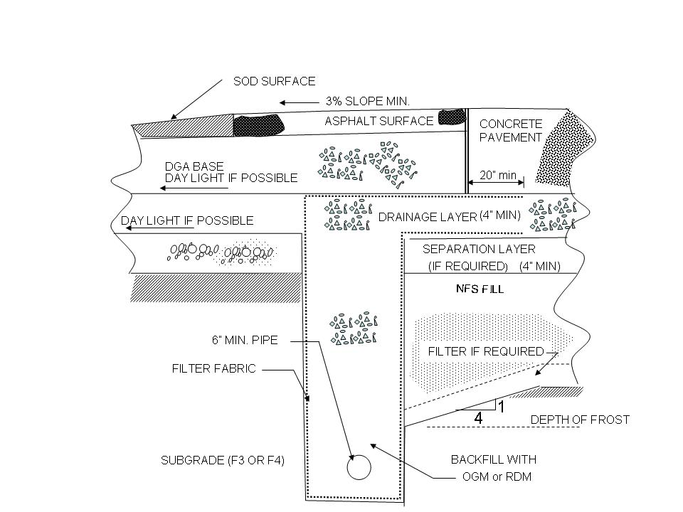

Figure G-11a. Typical Interior Subdrain Detail for Flexible Pavement
(Non-Frost Areas)
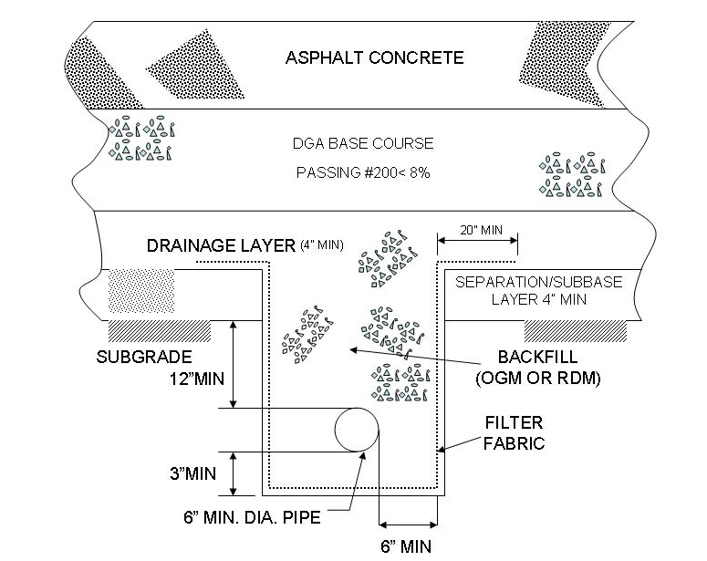

Figure G-11b. Typical Interior Subdrain Detail for Flexible Pavement
(Frost Areas, Depth of Frost > Depth of Pipe)
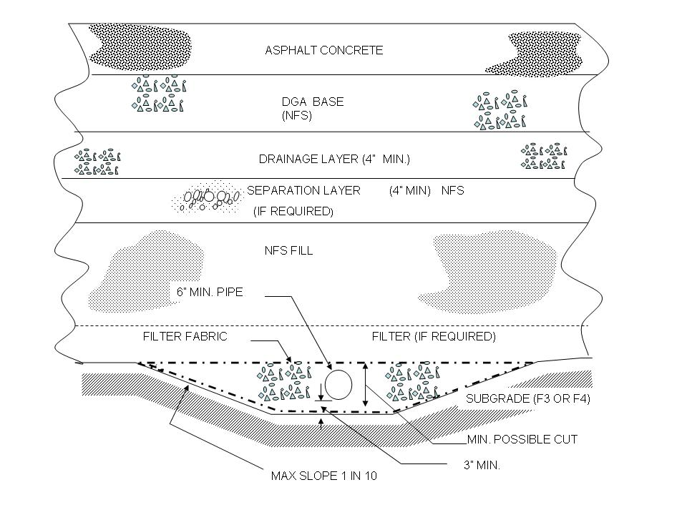
Figure G-11c. Typical Interior Subdrain Detail for Flexible Pavement
(Frost Areas, Depth of Frost < Depth of Pipe)
Figure G-12a. Typical Edge Subdrain Detail for Flexible Pavement
(Non-Frost Areas)
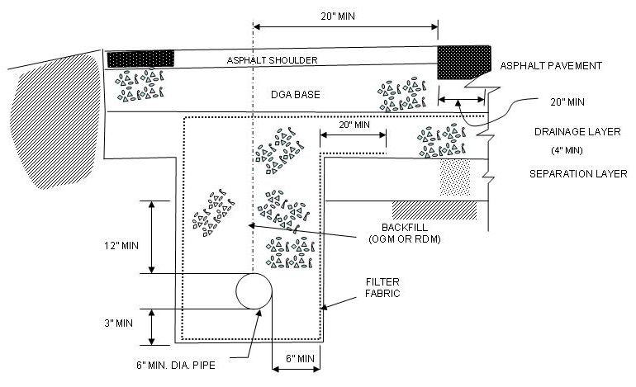
Figure G-12b. Typical Edge Subdrain Detail for Flexible Pavement (Frost Areas)
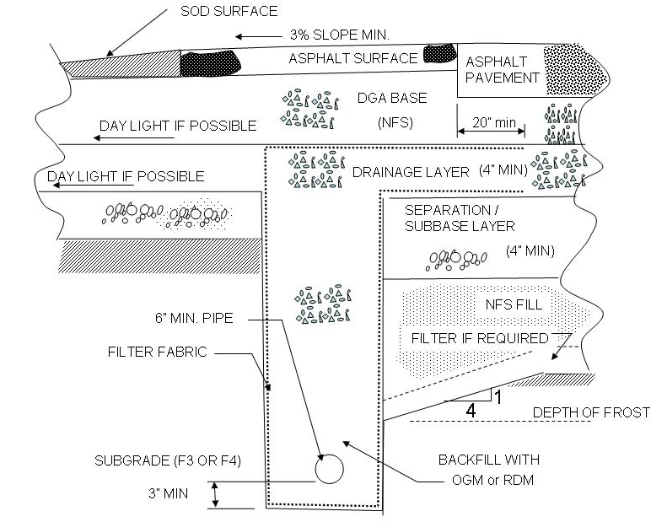
G-6.3.1 Backfill. The trench should be backfilled with a permeable material to rapidly convey water to the drainage pipe. The backfill material may be an OGM, RDM, or other uniformly graded aggregate. A minimum of 80 mm (3 in.) of aggregate should be placed beneath the drainage pipe. Proper compaction or chemical stabilization of the backfill is necessary to prevent settlement of the fill. In placing the backfill, compact it in lifts not exceeding 300 mm (6 in.). When using geocomposites in place of pipe, placing the geocomposites against the material to be drained should keep the backfill from conveying water. For this reason, the backfill for the geocomposites will not require the high permeability required for the backfill around the pipe drains; however, since the backfill for the geocomposites will be against the side of the trench, the backfill should meet the requirements of a granular filter.
G-6.3.2 Geotextiles in the Trench. Line the trench with a geotextile filter fabric as shown in Figures G-9 through G-12, which provide the typical. The filter fabric should be placed to separate the permeable backfill of the trench from the subgrade or subbase materials, but it must not impede the flow of water from the drainage layer to the drain pipe. The filter fabric must also protect from the infiltration of fines from any surface layers. This is particularly important for drains placed outside the pavement area where surface water can enter the drain through a soil surface. The filter fabric for the trench should be a nonwoven needle punch fabric meeting the criteria in Table G-9.
Table G-9. Criteria for Fabrics Used in Trench Construction

Soil or Fabric Characteristic | ASTM Test Method | Criteria
Soil with 50% or Less  Passing No. 200 Sieve | D 4751 | AOS < 0.6 mm  (Sieve No. 30)
Soil with Greater Than 50%  Passing No. 200 Sieve | D 4751 | AOS < 0.297 mm  (Sieve No. 50)
Minimum Grab Strength in kN (lbs)  at 50% Elongation | D 4632 | 0.6 (130)
Minimum Puncture Strength in kN (lbs) | D 4833 | 0.25 (55)

G-6.3.3 Trench Cap. Edge drains placed outside of a paved area should be capped with a layer of low-permeability material, such as an asphalt-stabilized surface, to reduce the infiltration of surface water into the subsurface drainage system. If the area above the edge drain is to be sod surfaced, a filter layer will be required between the drain layer and sod.
G-6.4 Lateral Outlet Pipe
G-6.4.1 Design. The lateral outlet pipe provides a means of getting water out of the edge drains and of cleaning and inspecting the system. Edge drains should be provided with lateral outlet pipes spaced at intervals (90 to 150 m) (300 to 500 ft) along the edge drains and at the low point of all vertical curves. To facilitate drain cleanout, the outlet pipes should be placed at approximately a 45-degree angle from the direction of flow in the collector drain. The lateral pipe should be a metal or rigid solid-walled pipe and should be equipped with an outlet structure. A 3-percent slope from the edge drain to the outlet structure is recommended. Where possible, outlet pipes should, be connected to existing storm drains or inlets to reduce outlet maintenance. For a lateral pipe flowing to a ditch, the invert of the outlet pipe should be a minimum of 150 mm (6 in.) above the 2-year design flow in the ditch. To prevent piping, the trench for the outlet pipes must be backfilled with a material of low permeability, or provided with a cutoff wall or diaphragm. Dual outlets are recommended for maintenance considerations, as shown in Figure G-13. The dual outlet system allows sections of collector drains to be flushed to clear any debris material blocking the free flow of water. Note these additional recommended design details for drainage outlets:
(a) Provide dual outlets with large-radius bends, as shown in Figure G-14.
(b) Use rigid walls, not perforated pipes. For pipe drains, use the same diameter pipe as the collector drains. For prefabricated, geocomposite drains, 102-mm to 152-mm- (4-in. to 6-in.-) diameter pipe should provide adequate hydraulic capacity. The flow capacity of the outlets must be greater than that of the collector drains. In general, because of the greater slope provided for outlet pipes, the hydraulic capacity is not a problem.
(c) Place the discharge end of the outlet pipe at least 150 mm (6 in.) above the G-year design flow in the drainage ditch (Figure G-15). This requirement applies even if the outlet is discharging into storm drain inlets.
(d) In frost areas, give special attention to the placement of the outlet pipes so they do not become clogged with ice or snow.
G-6.4.2 Outfall for Outlet Pipe. The outfall for the outlet pipe should be provided with a headwall to protect the outlet pipe from damage, prevent slope erosion, and facilitate the location of outlet pipes. Headwalls should be placed flush with the slope so that mowing operations are not impaired. Easily removable rodent screens should be installed at the pipe outlet. The headwall may be precast or cast in place. Figure G-16 is an example of a design for a headwall.

Figure G-13. Schematic of Dual Outlet System
Layout (Baumgardner 1998)

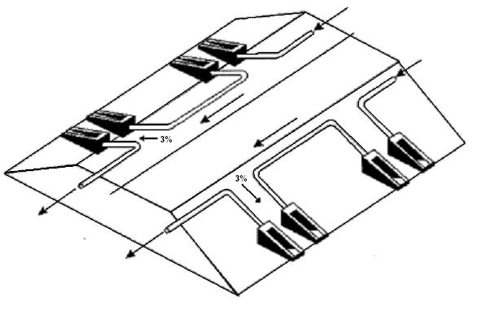

Figure G-14. Illustration of Large-Radius Bends
Recommended for Drainage Outlet

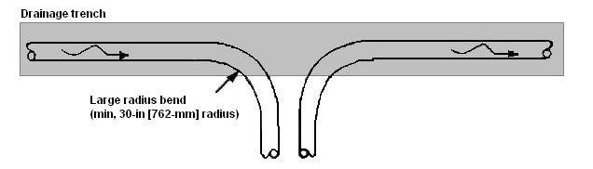

Figure G-15. Recommended Outlet Design Detail

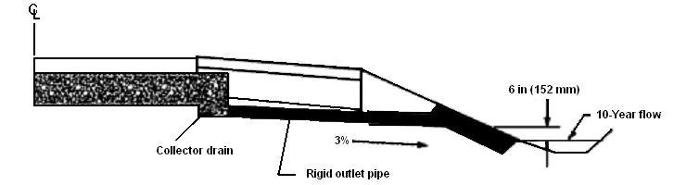

Figure G-16. Example Design for a Headwall

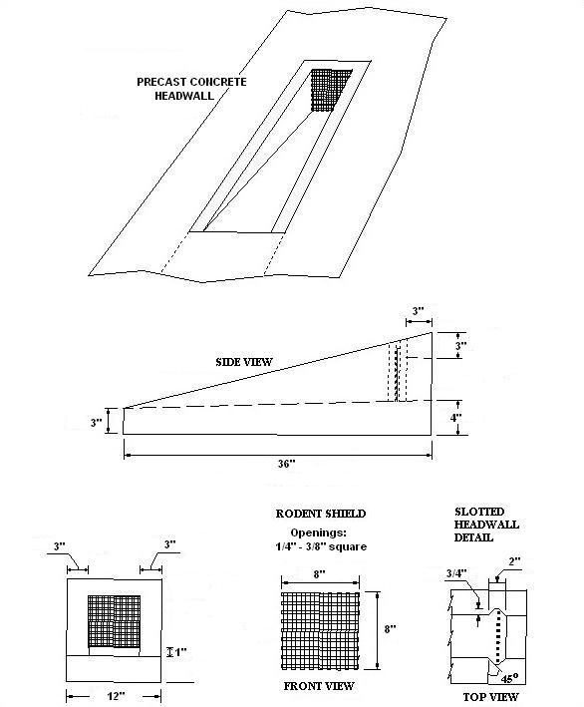
G-6.4.3 Reference Markers. Although not a requirement, reference markers are recommended for the outlets to facilitate maintenance and/or observation. A simple, flexible marker post or marking on the shoulder will suffice to mark the outlet.
G-6.5 Cross Drains. Cross drains may be required at locations where flow in the drainage layer is blocked, for steep longitudinal grades, or at the bottom of vertical curves. For example, cross drains may be required where pavements abut building foundations, at bridge approach slabs, or where drainage layers abut impermeable bases.
G-6.6 Manholes and Observation. Manholes, observation basins, and risers are installed on subsurface drainage systems for access to the system to observe its operation and to flush or rod the pipe for cleaning. When required, manholes on subgrade pipe drains should be located at intervals of not over 300 m (1,000 ft) with one flushing riser located between manholes and at dead ends. Manholes should be provided at principal junction points of several drains. Typical details of construction are provided in Chapter 4.
G-7 MAINTENANCE OF SUBSURFACE DRAINAGE SYSTEMS. Commitment to maintenance is as important as providing subsurface drainage systems. In fact, an improperly maintained drainage system can cause more damage to the pavement structure than if no drainage were provided at all. Poor maintenance leads to clogged or silted outlets and edge-drain pipes, missing rodent screens, excessive growth of vegetation blocking outlet pipes and openings on daylighted bases, and growth of vegetation in side ditches. These problems can potentially cause backing up of water within the pavement system, thereby defeating the purpose of providing the drainage system. Therefore, inspections and maintenance of subsurface drainage systems should be made an integral part of the policy of any agency installing these systems. The inspection process comprises of two parts: (a) visual inspection, and (b) video inspection.
G-7.1 Visual Inspection. The visual inspection process includes these items:
G-7.1.1 Evaluation of external drainage-related features, including measuring ditch depths and checking for crushed outlets, excessive vegetative growth, clogged and debris-filled daylighted openings, condition of headwalls, presence of erosion, and missing rodent screens. This operation should be performed at least once a year.
G-7.1.2 Pavement condition evaluation to check for moisture-related pavement distresses such as pumping, faulting, and D-cracking in PCC pavements and fatigue cracking and AC stripping in AC pavements. This operation could be either a full-scale PCI survey or a brief overview survey, depending on agency needs. The recommended frequency for this activity is once every 2 years.
G-7.2 Video Inspection. Video inspections play a vital role in monitoring in-service drainage systems. The video inspection process can be used to check for clogged drains due to silting and intrusion of surrounding soil as well as for any problems with the drainage system such as ruptured pipes and broken connections. Video inspections should be carried out on an as-needed basis whenever there is evidence of drainage-related problems. Table G-10 provides a detailed list of equipment used in a Federal Highway Administration (FHWA) study (Daleiden 1998). A video inspection system typically consists of a camera head, a long, flexible probe mounted on a frame for inserting the camera head into the pipe, and a data acquisition unit fitted with a video screen and a video recorder. This system can be used to detect and correct any construction problems before a project is accepted. The construction-related problems that are easily detected using video equipment include crushed or ruptured drainage pipes, improper connections between drainage pipes, and problems with the connection between the outlet pipe and headwall.
Table G-10. Equipment Description or FHWA Video Inspection Study (Daleiden 1998)

Camera: The camera is a Pearpoint flexiprobe high-resolution, high-sensitivity, waterproof color video camera engineered to inspect pipes 76 to 150 mm (3 to 6 in.) in diameter. The flexiprobe light head and camera has a physical size of 71 mm (2.8 in.) and is capable of negotiating 102-mm by 102-mm (4-in. by 4-in.) plastic tees. The light head incorporates 6 high-intensity lights. This lighting provides the ability to obtain a “true” color picture of the entire surface periphery of a pipe. The camera includes a detachable hard plastic ball that centers the camera during pipe inspections.
Camera Control Unit The portable color control unit includes a built-in 203-mm (8-in.) color monitor and controls including remote iris, focus, video input/output, audio in with built-in speaker, and light level intensity control. Two VCR input/output jacks are provided for video recording as well as tape playback verification through the built-in monitor.
Metal Coiler and Push Rod With Counter: The portable coiler contains 150 mm (6 in.) of integrated semi-rigid push rod, gold and rhodium slip rings, electro-mechanical cable counter, and electrical cable. The integrated push rod/electrical cable consists of a special epoxy glass reinforced rod with polypropylene sheathing material, which will allow for lengthy inspections due to the semi-rigid nature of this system.
Video Cassette Recorder: The video cassette recorder is a high-quality four-head industrial grade VHS recorder with audio dubbing, still frame, and slow speed capabilities.
Generator: A compact portable generator capable of providing 650 watts at 115 volts to power the inspection equipment.
Molded Transportation Case: A molded transportation case, specifically built for air transportation, encases the control unit, camera, and videocassette recorder.
Color Video Printer: A video printer is incorporated into the system to allow the technician to obtain color prints of pipe anomalies or areas of interest.

G-7.2 Maintenance Guidelines
G-7.2.1 Collector Drains and Outlets. The collector drains and outlets should be flushed periodically with high-pressure water jets to loosen and remove any sediment that has built up within the system. The key to this operation is having the appropriate outlet details that facilitate the process, such as the dual headwall system shown in Figure G-13. The area around the outlet pipes should be kept mowed to prevent any buildup of water. Missing rodent screens and outlet markers, and damaged pipes and headwalls need to be either repaired or replaced.
G-7.2.2 Daylighted Systems. Routine removal of roadside debris and vegetation clogging the daylighted openings of a permeable or dense-graded base is very important for maintaining the functionality of these systems.
G-7.2.3 Drainage Ditches. Drainage ditches should be kept mowed to prevent excessive vegetative growth. Debris and silt deposited at the bottom of the ditch should be cleaned periodically to maintain the ditch line and to prevent water from backing up into the pavement system.

