U.S. Department  of Transportation  Federal Aviation  Administration | Advisory  Circular
Subject: RUNWAY LENGTH REQUIREMENTS FOR AIRPORT DESIGN | Date: 7/1/2005  Initiated by: AAS-100 | AC No: 150/5325-4B  Change:

1. PURPOSE. This Advisory Circular (AC) provides guidelines for airport designers and planners to determine recommended runway lengths for new runways or extensions to existing runways.

- CANCELLATION. This AC cancels AC 150/5325-4A.

- APPLICATION. The standards and guidelines contained in this AC are recommended by the Federal Aviation Administration strictly for use in the design of civil airports. The guidelines, the airplane performance data curves and tables, and the referenced airplane manufacturer manuals are not to be used as a substitute for flight planning calculations as required by airplane operating rules. For airport projects receiving Federal funding, the use of this AC is mandatory.

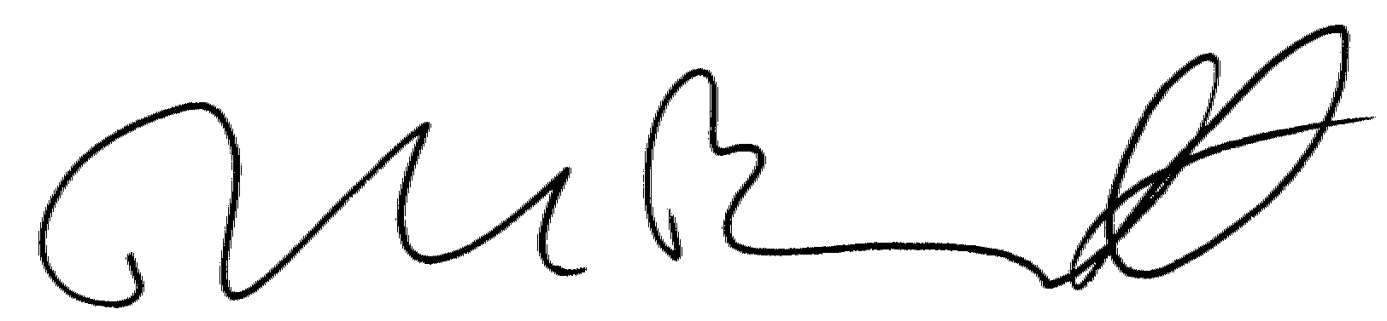

David L. Bennett
Director, Office of Airport Safety and Standards

Page intentionally blank
CONTENTS

Sections Page

Chapter 1 Introduction 1
101 Background 1
102 Determining Recommended Runway Lengths 1
103 Primary Runways 3
104 Crosswind Runways 3
105 Runway Length Based on Declared Distances Concept 4
106 Computer Program 4
107 Selected 14 Code of Federal Regulations Concerning Runway Length Requirements 4

Chapter 2 Runway Lengths for Small Airplanes with Maximum Certificated Takeoff Weight of 12,500 Pounds (5,670 Kg) or Less 5
201 Design Guidelines 5
202 Design Approach 5
203 Small Airplanes With Approach Speeds of Less than 30 Knots 5
204 Small Airplanes With Approach Speeds of 30 Knots or More but Less than 50 Knots 5
205 Small Airplanes With Approach Speeds of 50 Knots or More with Maximum Certificated Takeoff Weight of 12,500 Pounds (5,670 Kg) or Less 5
206 Development of the Runway Length Curves 6

Chapter 3 Runway Lengths for Airplanes within a Maximum Certificated Takeoff Weight of More than 12,500 Pounds (5,670 Kg) UpTo and Including 60,000 Pounds (27,200 Kg) 9
301 Design Guidelines 9
302 Design Approach 9
303 Percentage of Fleet and Useful Load Factor 9
304 Runway Length Adjustments 10
305 Precaution for Airports Located at High Altitudes 10
306 General Aviation Airports 11

Chapter 4 Runway Lengths for Regional Jets and those Airplanes with a Maximum Certificated Takeoff Weight of More than 60,000 Pounds (27,200 Kg) 17
401 Design Guidelines 17
402 Design Approach 17
403 Procedures For Determining Recommended Runway Length 17
404 Examples 20

Chapter 5 Design Rationale 21
501 Introduction 21
502 Airplanes 21
503 Landing Flap Settings 21
504 Airplane Operating Weights 21
505 Airport Elevation 22
506 Temperature 22
507 Wind 22
508 Runway Surface Conditions 22
509 Maximum Differences of Runway Centerline Elevation 23

Figures

2-1 Small Airplanes with Fewer than 10 Passenger Seats (Excludes Pilot and Co-pilot) 7
2-2 Small Airplanes Having 10 or More Passenger Seats (Excludes Pilot and Co-pilot) 8
3-1 75 Percent of Fleet at 60 or 90 Percent Useful Load 12
3-2 100 Percent of Fleet at 60 or 90 Percent Useful Load 13
4-1 Generic Payload-Range Chart 19
A3-1-1 Landing Runway Length for Boeing 737-900 (CFM56-7B27 Engines) 32
A3-1-2 Takeoff Runway Length for Boeing 737-900 (CFM56-7B27 Engines) 33
A3-2-1 Landing Runway Length for SAAB 340B (CT7-9B Engines) 36
A3-2-2 Takeoff Runway Length for SAAB 340B (CT7-9B Engines) 37

Tables

1-1 Airplane Weight Categorization for Runway Length Requirements 3
1-2 Runway Length for Additional Primary Runways 4
1-3 Runway Length for Crosswind Runway 4
3-1 Airplanes that Make Up 75 Percent of the Fleet 14
3-2 Remaining 25 Percent of Airplanes that Make Up 100 Percent of Fleet 15
4-1 Relationship Between Airport Elevation and Standard Day Temperature 18
5-1 Rationale Behind Recommendations for Calculating Recommended Runway Lengths 24
A3-1-1 Boeing 737-900 General Airplane Characteristics 31
A3-2-1 SAAB 340 Airplane Characteristics 35

Appendices

Appendix 1 Websites for Manufacturers of Airplanes Over 60,000 Pounds (27,200 Kg) 25
Appendix 2 Selected Federal Aviation Regulations Concerning Runway length requirements 27
Appendix 3 Examples Using Airplane Planning Manuals 29

CHAPTER 1. INTRODUCTION

- BACKGROUND. Airplanes today operate on a wide range of available runway lengths. Various factors, in turn, govern the suitability of those available runway lengths, most notably airport elevation above mean sea level, temperature, wind velocity, airplane operating weights, takeoff and landing flap settings, runway surface condition (dry or wet), effective runway gradient, presence of obstructions in the vicinity of the airport, and, if any, locally imposed noise abatement restrictions or other prohibitions. Of these factors, certain ones have an operational impact on available runway lengths. That is, for a given runway the usable length made available by the airport authority may not be entirely suitable for all types of airplane operations. Fortunately, airport authorities, airport designers, and planners are able to mitigate some of these factors. For example, runways designed with longitudinal profiles equaling zero slope avoid required runway length adjustments. Independently, airport authorities working with their local lawmakers can establish zoning laws to prohibit the introduction of natural growth and man-made structural obstructions that penetrate existing or planned runway approach and departure surfaces. Effective zoning laws avoid the displacement of runway thresholds or reduction of takeoff runway lengths thereby providing airplanes with sufficient clearances over obstructions during climb outs. Airport authorities working with airport designers and planners should validate future runway demand by identifying the critical design airplanes. In particular, it is recommended that the evaluation process assess and verify the airport’s ultimate development plan for realistic changes that could result in future operational limitations to customers. In summary, the goal is to construct an available runway length for new runways or extensions to existing runways that is suitable for the forecasted critical design airplanes.

- DETERMINING RECOMMENDED RUNWAY LENGTHS.

  - Assumptions and Definitions.

      - Design Assumptions. The assumptions used by this AC are approaches and departures with no obstructions, zero wind, dry runway surfaces, and zero effective runway gradient. Assumptions relative to airplane characteristics are described within the applicable chapter of this AC.

      - Critical Design Airplanes. The listing of airplanes (or a single airplane) that results in the longest recommended runway length. The listed airplanes will be evaluated either individually or as a single family grouping to obtain a recommended runway length.

      - Small Airplane. An airplane of 12,500 pounds (5,670 kg) or less maximum certificated takeoff weight.

      - Large Airplane. An airplane of more than 12,500 pounds (5,670 kg) maximum certificated takeoff weight.

      - Maximum Certificated Takeoff Weight (MTOW). The maximum certificated weight for the airplane at takeoff, i.e., the airplane’s weight at the start of the takeoff run.

      - Regional Jets. Although there is no regulatory definition for a regional jet (RJ), an RJ for this advisory circular is a commercial jet airplane that carries fewer than 100 passengers.

      - Crosswind Runway. An additional runway built to compensate primary runways that provide less than the recommended 95 percent wind coverage for the airplanes forecasted to use the airport.

      - Substantial Use Threshold. Federally funded projects require that critical design airplanes have at least 500 or more annual itinerant operations at the airport (landings and takeoffs are considered as separate operations) for an individual airplane or a family grouping of airplanes. Under unusual circumstances, adjustments may be made to the 500 total annual itinerant operations threshold after considering the circumstances of a particular airport. Two examples are airports with demonstrated seasonal traffic variations, or airports situated in isolated or remote areas that have special needs.

      - Itinerant Operation. Takeoff or landing operations of airplanes going from one airport to another airport that involves a trip of at least 20 miles. Local operations are excluded.

      - Effective Runway Gradient. The difference between the highest and lowest elevations of the runway centerline divided by the runway length.

  - Procedure and Rationale for Determining Recommended Runway Lengths. This AC uses a five-step procedure to determine recommended runway lengths for a selected list of critical design airplanes. As previously stated, the information derived from this five-step procedure is for airport design and is not to be used for flight operations. Flight operations must be conducted per the applicable flight manual. The five steps and their rationale are as follows:

      - Step #1. Identify the list of critical design airplanes that will make regular use of the proposed runway for an established planning period of at least five years. For Federally funded projects, the definition of the term “substantial use” quantifies the term “regular use” (see paragraph 102a(8).)

      - Step #2. Identify the airplanes that will require the longest runway lengths at maximum certificated takeoff weight (MTOW). This will be used to determine the method for establishing the recommended runway length. Except for regional jets, when the MTOW of listed airplanes is 60,000 pounds (27,200 kg) or less, the recommended runway length is determined according to a family grouping of airplanes having similar performance characteristics and operating weights. Although a number of regional jets have an MTOW less than 60,000 pounds (27,200 kg), the exception acknowledges the long range capability of the regional jets and the necessity to offer regional jet operators the flexibility to interchange regional jet models according to passenger demand without suffering operating weight restrictions. When the MTOW of listed airplanes is over 60,000 pounds (27,200 kg), the recommended runway length is determined according to individual airplanes. The recommended runway length in the latter case is a function of the most critical individual airplane’s takeoff and landing operating weights, which depend on wing flap settings, airport elevation and temperature, runway surface conditions (dry or wet), and effective runway gradient. The procedure assumes that there are no obstructions that would preclude the use of the full length of the runway.

      - Step #3. Use table 1-1 and the airplanes identified in step #2 to determine the method that will be used for establishing the recommended runway length. Table 1-1 categorizes potential design airplanes according to their MTOWs. MTOW is used because of the significant role played by airplane operating weights in determining runway lengths. As seen from table 1-1, the first column separates the various airplanes into one of three weight categories. Small airplanes, defined as airplanes with MTOW of 12,500 pounds (5,670 kg) or less, are further subdivided according to approach speeds and passenger seating as explained in chapter 2. Regional jets are assigned to the same category as airplanes with a MTOW over 60,000 pounds (27,200 kg). The second column identifies the applicable airport design approach (by airplane family group or by individual airplanes) as noted previously in step #2. The third column directs the airport designer to the appropriate chapter for design guidelines and whether to use the referenced tables contained in the AC or to obtain airplane manufacturers’ airport planning manuals (APM) for each individual airplane under evaluation. In the later case, APMs provide the takeoff and landing runway lengths that an airport designer will in turn apply to the associated guidelines set forth by this AC to obtain runway lengths. The airport designer should be aware that APMs go by a variety of names. For example, Airbus, the Boeing Company, and Bombardier respectively title their APMs as “Airplane Characteristics for Airport Planning,” “Airplane Characteristics for Airport Planning,” and “Airport Planning Manuals.” For the purpose of this AC, the variously titled documents will be referred to as APM. Appendix 1 lists the websites of the various airplane manufacturers to provide individuals a starting point to retrieve an APM or a point of contact for further consultation.

      - Step #4. Select the recommended runway length from among the various runway lengths generated by step #3 per the process identified in chapters 2, 3, or 4, as applicable.

      - Step #5. Apply any necessary adjustment to the obtained runway length, when instructed by the applicable chapter of this AC, to the runway length generated by step #4 to obtain a final recommended runway length. For instance, an adjustment to the length may be necessary for runways with non-zero effective gradients. Chapter 5 provides the rationale for these length adjustments.
Table 1-1. Airplane Weight Categorization for Runway Length Requirements
Airplane Weight Category  Maximum Certificated Takeoff Weight (MTOW) |  |  | Design Approach | Location of Design Guidelines
12,500 pounds (5,670 kg) or less | Approach Speeds less than 30 knots |  | Family grouping of small airplanes | Chapter 2;  Paragraph 203
12,500 pounds (5,670 kg) or less | Approach Speeds of at least 30 knots but less than 50 knots |  | Family grouping of small airplanes | Chapter 2;  Paragraph 204
12,500 pounds (5,670 kg) or less | Approach Speeds of 50 knots or more | With  Less than 10 Passengers | Family grouping of small airplanes | Chapter 2;  Paragraph 205  Figure 2-1
12,500 pounds (5,670 kg) or less | Approach Speeds of 50 knots or more | With  10 or more Passengers | Family grouping of small airplanes | Chapter 2;  Paragraph 205  Figure 2-2
Over 12,500 pounds (5,670 kg) but less than 60,000 pounds (27,200 kg) |  |  | Family grouping of large airplanes | Chapter 3;  Figures 3-1 or 3-2 ¹  and Tables 3-1 or 3-2
60,000 pounds (27,200 kg) or more or Regional Jets ² |  |  | Individual large airplane | Chapter 4; Airplane Manufacturer Websites (Appendix 1)
Note ¹: When the design airplane’s APM shows a longer runway length than what is shown in figure 3-2, use the airplane manufacturer’s APM. However, users of an APM are to adhere to the design guidelines found in Chapter 4.

Note ²: All regional jets regardless of their MTOW are assigned to the 60,000 pounds (27,200 kg) or more weight category.

- PRIMARY RUNWAYS. The majority of airports provide a single primary runway. Airport authorities, in certain cases, require two or more primary runways as a means of achieving specific airport operational objectives. The most common operational objectives are to (1) better manage the existing traffic volume that exceed the capacity capabilities of the existing primary runway, (2) accommodate forecasted growth that will exceed the current capacity capabilities of the existing primary runway, and (3) mitigate noise impacts associated with the existing primary runway. Additional primary runways for capacity justification are parallel to and equal in length to the existing primary runway, unless they are intended for smaller airplanes. Refer to AC 150/5060-5, Airport Capacity and Delay, for additional discussion on runway usage for capacity gains. Another common practice is to assign individual primary runways to different airplane classes, such as, separating general aviation from non-general aviation customers, as a means to increase the airport’s efficiency. The design objective for the main primary runway is to provide a runway length for all airplanes that will regularly use it without causing operational weight restrictions. For Federally funded projects, the criterion for substantial use applies (see paragraph 102a(8).) The design objective for additional primary runways is shown in table 1-2. The table takes into account the separation of airplane classes into distinct airplane groups to achieve greater airport utilization. Procedurally, follow the guidelines found in subparagraph 102(b) for determining recommended runway lengths for primary runways, and, for additional primary runways, apply table 1-2.

- CROSSWIND RUNWAYS. The design objective to orient primary runways to capture 95 percent of the crosswind component perpendicular to the runway centerline for any airplane forecast to use the airport is not always achievable. In cases where this cannot be done, a crosswind runway is recommended to achieve the design standard provided in AC 150/5300-13, Airport Design, for allowable crosswind components according to airplane design groups. Even when the 95-percentage crosswind coverage standard is achieved for the design airplane or airplane design group, cases arise where certain airplanes with lower crosswind capabilities are unable to utilize the primary runway. For airplanes with lesser crosswind capabilities, a crosswind runway may be built, provided there is regular usage. For Federally funded projects, the criterion for substantial use applies to the airplane used as the design airplane needing the crosswind runway (see paragraph 102a(8).) The design objective for the length of crosswind runways is shown in table 1-3. Procedurally, follow the guidelines found in subparagraph 102(b) for determining recommended runway lengths for crosswind runways, and, for additional crosswind runways, apply table 1-3.
Table 1-2. Runway Length for Additional Primary Runways
Runway Service Type, User | Runway Length for Additional Primary Runway Equals
Capacity Justification, Noise Mitigation, Regional Jet Service | 100 % of the primary runway
Separating Airplane Classes - Commuter, Turboprop, General Aviation, Air Taxis | Recommended runway length for the less demanding airplane design group or individual design airplane

Table 1-3. Runway Length for Crosswind Runway
Runway Service | Runway Length for Crosswind Runway Equals
Scheduled ¹  Such as Commercial Service Airports | 100 % of primary runway length  when built for the same individual design airplane or airplane design group  that uses the primary runway
Scheduled ¹  Such as Commercial Service Airports | 100% of the recommended runway length determined for the lower crosswind capable airplanes  using the primary runway
Non-Scheduled ²  Such as General Aviation Airports | 100% of the recommended runway length determined for the lower crosswind capable airplanes  using the primary runway
Note ¹: Transport service operated over routes pursuant to published flight schedules that are openly advertised with dates or times (or both) or otherwise made readily available to the general public or pursuant to mail contracts with the U.S. Postal Service (Bureau of Transportation Statistics, Department of Transportation (DOT)).
Note ²: Revenue flights, such as charter flights that are not operated in regular scheduled service, and all non-revenue flights incident to such flights (Bureau of Transportation Statistics, DOT). For Federally funded programs, such as AIP, there must be at least 500 annual itinerant operations and 100% of the class.

105. RUNWAY LENGTH BASED ON DECLARED DISTANCES CONCEPT. The application of the declared distances concept to overcome safety deficiencies is not intended for new runways. New runways must meet design standards when constructed. See AC 150/5300-13, appendix 14, for information related to declared distances.

- COMPUTER PROGRAM. The airport design software cited in Appendix 11 of AC 150/5300-13, Airport Design for Microcomputers (AD42D.EXE), was developed for airport planners to facilitate in the planning of airport layouts. The computer program only provides estimates instead of actual length requirements. The design software is available at http://www.faa.gov/airports_airtraffic/airports/construction/.

- SELECTED 14 CODE OF FEDERAL REGULATIONS CONCERNING RUNWAY LENGTH REQUIREMENTS. Appendix 2 provides a list of selected 14 Code of Federal Regulations that address the airworthiness certification and operational requirements of airplanes associated with runway length.

CHAPTER 2. RUNWAY LENGTHS FOR SMALL AIRPLANES WITH MAXIMUM CERTIFICATED TAKEOFF WEIGHT OF 12,500 POUNDS (5,670 KG) OR LESS

- DESIGN GUIDELINES. The design procedure for small airplanes requires the following information: the critical design airplanes under evaluation, approach speed in knots (1.3 x stall speed), number of passenger seats, airport elevation above mean sea level, and the mean daily maximum temperature of the hottest month at the airport. Once obtained, apply the guidance from the appropriate paragraph below to obtain the recommended runway length. For this airplane weight category, no further adjustment to the obtained length from the figures 2.1 or 2.2 is necessary. For example, there is no operational requirement to take into account the effect of effective runway gradient for takeoff or landing performance.

- DESIGN APPROACH. For purposes of design, this AC provides a design concept for airports that serve only airplanes with a maximum certificated takeoff weight of 12,500 pounds (5,670 kg) or less. The design concept starts by grouping all small airplanes, that is, the critical design airplanes, according to approach speed. The highest approach speed group is divided on the basis of passenger seats, namely, “airplanes having fewer than 10 passenger seats” as compared to “airplanes having 10 or more passenger seats.” The less than 10 passenger seats category is further based on two percentages of fleet, namely, “95 percent of the fleet” or “100 percent of the fleet” categories, as explained in paragraph 205. For these airplanes, figures 2-1 and 2-2 show only a single curve that takes into account the most demanding operations to obtain the recommended runway length. Although both figures pertain mainly to small propeller driven airplanes, figure 2-2 does include small turbo-powered airplanes. Airport designers can, instead of applying the small airplane design concept, determine the recommended runway length from airplane flight manuals for the airplanes to be accommodated by the airport in lieu of the runway length curves depicted in figures 2-1 or 2-2. For example, owners of multi-engine airplanes may require that their pilots use the airplane’s accelerate-stop distance in determining the length of runway available for takeoff.

- SMALL AIRPLANES WITH APPROACH SPEEDS OF LESS THAN 30 KNOTS. Airplanes with approach speeds of less than 30 knots are considered to be short takeoff and landing or ultra light airplanes. Their recommended runway length is 300 feet (92 meters) at mean sea level. Runways located above mean sea level should be increased at the rate of 0.03 x airport elevation above mean sea level to obtain the recommended runway length at that elevation.

- SMALL AIRPLANES WITH APPROACH SPEEDS OF 30 KNOTS OR MORE BUT LESS THAN 50 KNOTS. The recommended runway length is 800 feet (244 meters) at mean sea level. Runway lengths above mean sea level should be increased at the rate of 0.08 x airport elevation above mean sea level to obtain the recommended runway length at that elevation.

- SMALL AIRPLANES WITH APPROACH SPEEDS OF 50 KNOTS OR MORE WITH MAXIMUM CERTIFICATED TAKEOFF WEIGHT OF 12,500 POUNDS (5,670 KG) OR LESS. Figures 2-1 and 2-2 provide the recommended runway lengths based on the seating capacity and the mean daily maximum temperature of the hottest month of the year at the airport. The fleet used in the development of the figures consisted of small airplanes certificated in the United States. Figure 2-1 categorizes small airplanes with less than 10 passenger seats (excludes pilot and co-pilot) into two family groupings according to “percent of fleet,” namely, 95 and 100 percent of the fleet. Figure 2-2 categorizes all small airplanes with 10 or more passenger seats into one family grouping. Figure 2-2 further alerts the airport designer that for airport elevations above 3,000 feet (914 m), that the airport designer must use the 100 percent of fleet chart of figure 2-1 instead of using figure 2-2. As shown, both figures provide examples that start with the horizontal temperature axis then, proceed vertically to the applicable airport elevation curve, followed by proceeding horizontally to the vertical axis to read the recommended runway length.

  - Selecting Percentage of Fleet for Figure 2-1. The differences between the two percentage categories are based on the airport’s location and the amount of existing or planned aviation activities. The airport designer should make the selection based on the following criteria.

(1) 95 Percent of Fleet. This category applies to airports that are primarily intended to serve medium size population communities with a diversity of usage and a greater potential for increased aviation activities. Also included in this category are those airports that are primarily intended to serve low-activity locations, small population communities, and remote recreational areas. Their inclusion recognizes that these airports in many cases develop into airports with higher levels of aviation activities.

- 100 Percent of Fleet. This type of airport is primarily intended to serve communities located on the fringe of a metropolitan area or a relatively large population remote from a metropolitan area.

b. Future Airport Expansion Considerations. Airports serving small airplanes remain fairly constant in terms of the types of small airplane using the airport and their associated operational requirements. However, it is recommended that the airport designer assess and verify the airport’s ultimate development plan for realistic changes that, if overlooked, could result in future operational limitations to customers. The airport designer should at least assess and verify the impacts of:

- Expansions to accommodate airplanes of more than 12,500 pounds (5,670 kg). Failure to consider this change during an initial development phase may lead to the additional expense of reconstructing or relocating facilities in the future.

- Requirements to operate the runway during periods of Instrument Meteorological Conditions (IMC). The requirement for this capability is highest among airplanes used for business and air taxi purposes.

- DEVELOPMENT OF THE RUNWAY LENGTH CURVES. 14 Code of Federal Regulations Part 23, Airworthiness Standards: Normal, Utility, and Acrobatic Category Airplanes, prescribes airworthiness standards for the issuance of small airplane type certificates. The performance information for each airplane (for example, as defined in Section 23.51, Takeoff; Section 23.75, Landing; and Section 2.1587, Performance Information) is contained in the individual airplane flight manual. This information is provided to assist the airplane operator in determining the runway length necessary to operate safely. Performance information from those manuals was selectively grouped and used to develop the runway length curves in figures 2-1 and 2-2. The major parameters utilized for the development of theses curves were the takeoff and landing distances for figure 2-1 and the takeoff, landing, and accelerate-stop distances for figure 2-2. The following conditions were used in developing the curves:

Zero headwind component.

Maximum certificated takeoff and landing weights.

Optimum flap setting for the shortest runway length (normal operation).

Airport elevation and temperature were left variable (values need to be obtained).

Other factors, such as relative humidity and effective runway gradient, also have a variable effect on runway length but are not accounted for in certification. However, these other factors were accounted for in the runway length curves by increasing the takeoff or landing distance (whichever was longer) of the group’s most demanding airplane by 10 percent for the various combinations of elevation and temperature.

14 Code of Federal Regulations Part 135, Operating Requirements: Commuter and On Demand Operations and Rules Governing Persons on Board such Aircraft, imposes the operational requirements on those airplanes having a seating configuration of 10 passenger seats or more to include the accelerate-stop distance parameter in computing the required takeoff runway length. As previously mentioned, figure 2-2 includes the accelerate-stop distance parameter.

Figure 2-1. Small Airplanes with Fewer than 10 Passenger Seats
(Excludes Pilot and Co-pilot)

Example:

Temperature (mean day max hot month): 59º F (15º C)
Airport Elevation: Mean Sea Level

Note: Dashed lines shown in the table are mid values of adjacent solid lines.

Recommended Runway Length:

For 95% = 2,700 feet (823 m)
For 100% = 3,200 feet (975 m)

Airport Elevation
(feet)
95 Percent of Fleet 100 Percent of Fleet
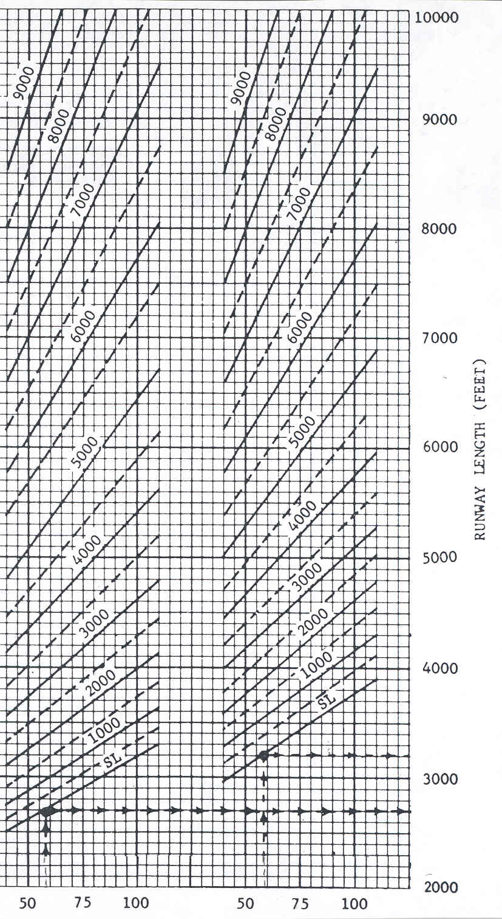

Mean Daily Maximum Temperature of the Hottest Month of Year
(Degrees F)

Figure 2-2. Small Airplanes Having 10 or More Passenger Seats
(Excludes Pilot and Co-pilot)

Representative Airplanes | Runway Length Curves
Raytheon B80 Queen Air  Raytheon E90 King Air  Raytheon B99 Airliner  Raytheon A100 King Air  (Raytheon formerly Beech Aircraft)  Britten-Norman  Mark III-I Trilander  Mitsubishi MU-2L  Swearigen Merlin III-A  Swearigen Merlin IV-A  Swearigen Metro II | Example: Temperature (mean day max hot month) 90º F (32º C)  Airport Elevation (msl) 1,000 feet (328 m)  Recommended Runway Length 4,400 feet (1,341 m)  Note: For airport elevations above 3,000 feet (915 m), use the 100 percent of fleet grouping in figure 2-1.  (Degrees F)

CHAPTER 3. RUNWAY LENGTHS fOR AIRPLANES wITHIN A MAXIMUM CERTIFICATED TAKEOFF WEIGHT oF MORE THAN 12,500 POUNDS (5,670 KG) UP TO aND INCLUDING 60,000 POUNDS (27,200 KG)

- DESIGN GUIDELINES. The design procedure for this airplane weight category requires the following information: airport elevation above mean sea level, mean daily maximum temperature of the hottest month at the airport, the critical design airplanes under evaluation with their respective useful loads. Once obtained, apply either figure 3-1 or figure 3-2 to obtain a single runway length for the entire group of airplanes under evaluation. Finally, apply any landing or takeoff length adjustments, if necessary, to the resulting runway length to obtain the recommended runway length.

- DESIGN APPROACH. The recommended runway length for this weight category of airplanes is based on performance curves (figures 3-1 and 3-2) developed from FAA-approved airplane flight manuals in accordance with the provisions of 14 Code of Federal Regulations Part 25, Airworthiness Standards: Transport Category Airplanes, and Part 91, General Operating and Flight Rules. If the airport is planned for operations that will include only turbojet-powered airplanes weighing under 60,000 pounds (27,200 kg) maximum certificated takeoff weight (MTOW) in conjunction with other small airplanes of 12,500 pounds (5,670 kg) or less, use the curves shown in either figures 3-1 or 3-2. To determine which of the two figures to apply, first use tables 3-1 and 3-2 to determine which one of the two “percentage of fleet” categories represents the critical design airplanes under evaluation. With that determination, then select either the “60 percent useful load” curves or the “90 percent useful load” curves on the basis of the haul lengths and service needs of the critical design airplanes. Note: at elevations over 5,000 feet (1,524 m) above mean sea level, the recommended runway length obtained for small airplanes from chapter 2 may be greater than those obtained by these figures. In this case, the requirements for the small airplanes govern. Finally, the curves of figures 3-1 and 3-2 apply to airport elevations up to 8,000 feet (2,439 m) above mean sea level. For higher elevations, consult the airplane manufacturer(s) for their recommendations.

- PERCENTAGE OF FLEET AND USEFUL LOAD FACTOR. The curves in figure 3-1 and 3-2 are based on a grouping of only the turbojet-powered fleet (and business jets) according to performance capability as contained in the FAA-approved airplane manuals under an assumed loading condition. Interpolation is allowed only within a single set of curves (e.g., an elevation at 2,500 feet within the “75 percent of the fleet at 60 percent useful load” set of curves) but not valid between sets of curves (e.g., an 85 percent useful load between the set of curves “75 percent of the fleet at 60 percent useful load” and “75 percent of the fleet at 90 percent useful load.”) The restriction is because each set assumed a specific, non-variable loading condition. Figures 3-1 and 3-2 contain a set of two curves based upon the percentage of the fleet and the percentage of useful load that can be accommodated by the runway lengths obtained from the curves. For example, the “75 percent fleet at 60 percent useful load” curve provides a runway length sufficient to satisfy the operational requirements of approximately 75 percent of the fleet at 60 percent useful load. This figure is to be used for those airplanes operating with no more than a 60 percent useful load factor. Both figures 3-1 and 3-2 provide examples that start with the horizontal temperature axis, then proceed vertically to the airport elevation curve, and finally proceed horizontally to the vertical axis to obtain the runway length. The final step is to apply any necessary length adjustments to the obtained length in accordance with paragraph 304 to determine the recommended runway length.

a. Percentage of Fleet.

(1) Tables 3-1 and 3-2. Table 3-1 provides the list of those airplanes that comprise the “75 percent of fleet” category and therefore can be accommodated by the runway lengths resulting from figure 3-1. Table 3-2, provides the remaining airplanes beyond that of table 3-1 that comprise the “100 percent of fleet” category and therefore can be accommodated by the resulting runway lengths from figure 3-2. The distinction between the tables is that airplanes listed in table 3-2 require at least 5,000-foot (1,524 m) runways at mean sea level and at the standard day temperature of 59° F (15° C) (see paragraph 403 and table 4-1 for an explanation of the concept.). Airplanes listed in table 3-1 require less than 5,000 feet (1,524 m) for the same conditions.

(2) Selecting Figures 3-1 or 3-2. The airport designer must determine from which list the airplanes under evaluation are found. Use figure 3-1 when the airplanes under evaluation are not listed in table 3-2. If a relatively few airplanes under evaluation are listed in table 3-2, then figure 3-2 should be used to determine the runway length. If no adjustments to this length are necessary as outlined above, then this becomes the recommended runway length.

b. Useful Load Factor.

(1) The term useful load factor of an airplane for this AC is considered to be the difference between the maximum allowable structural gross weight and the operating empty weight. A typical operating empty weight includes the airplane’s empty weight, crew, baggage, other crew supplies, removable passenger service equipment, removable emergency equipment, engine oil, and unusable fuel. In other words, the useful load then consists of passengers, cargo, and usable fuel. It is noted that although operating empty weight varies considerably with individual airplanes, the curves used in the figures were based on the average operating empty weights of numerous business jets.

(2) Figures 3-1 and 3-2 provide only two useful load percentages, namely “60 percent useful load” and “90 percent useful load.” Curves are not developed for operations at “100 percent useful load” because many of the airplanes used to develop the curves in figures 3-1 and 3-2 were operationally limited in the second segment of climb. That is, the allowable gross takeoff weight is often limited by ambient conditions of temperature and elevation to an operating weight that is less than their maximum structural gross weight. Therefore, APMs contain climb limitations when required. Because of the climb limitation, the runway length resulting from the “90 percent useful load” curves are considered by this AC to approximate the limit of beneficial returns for the runway. A specific list of business jets were used to obtain an average operating empty weight, which in turn, was used to develop the curves.

c. Privately Owned Business Jets. Business jets that are privately owned are included in their respective 75 percent and 100 percent of fleet categories.

d. Air Carrier Regional Jets. As previously mentioned, the recommended runway lengths for regional jets for air carrier service are addressed in chapter 4.

- RUNWAY LENGTH ADJUSTMENTS. The runway lengths obtained from figures 3-1 and 3-2 are based on no wind, a dry runway surface, and zero effective runway gradient. Effective runway gradient is defined as the difference between the highest and lowest elevations of the runway centerline divided by the runway length. Therefore, increase the obtained runway lengths from the figures to account for (1) takeoff operations when the effective runway gradient is other than zero and (2) landing operations of turbojet-powered airplanes under wet and slippery runway surface conditions. These increases are not cumulative since the first length adjustment applies to takeoffs and the latter to landings. After both adjustments have been independently applied, the larger resulting runway length becomes the recommended runway length. The procedures for length adjustments are as follows:

a. Effective Runway Gradient (Takeoff Only). The runway lengths obtained from figures 3-1 or 3-2 are increased at the rate of 10 feet (3 meters) for each foot (0.3 meters) of elevation difference between the high and low points of the runway centerline.
b. Wet and Slippery Runways (Applicable Only to Landing Operations of Turbojet-Powered Airplanes). By regulation, the runway length for turbojet-powered airplanes obtained from the “60 percent useful load” curves are increased by 15 percent or up to 5,500 feet (1,676 meters), whichever is less. By regulation, the runway lengths for turbojet powered airplanes obtained from the “90 percent useful load” curves are also increased by 15 percent or up to 7,000 feet (2,133 meters), whichever is less. No adjustment is necessary by regulation for turboprop-powered airplanes.
- PRECAUTION FOR AIRPORTS LOCATED AT HIGH ALTITUDES. At elevations above 5,000 feet (1,524 m) mean sea level, the recommended runway length for propeller driven airplanes of 12,500 pounds (5,670 kg) MTOW or less found in chapter 2 may be greater than those determined in this chapter for turbojet-powered airplanes. In this case, the longer recommended runway length of the small airplane weight category must be provided.

306. GENERAL AVIATION AIRPORTS. General aviation (GA) airports have witnessed an increase use of their primary runway by scheduled airline service and privately owned business jets. Over the years business jets have proved themselves to be a tremendous asset to corporations by satisfying their executive needs for flexibility in scheduling, speed, and privacy. In response to these types of needs, GA airports that receive regular usage by large airplanes over 12,500 pounds (5,670 kg) MTOW, in addition to business jets, should provide a runway length comparable to non-GA airports. That is, the extension of an existing runway can be justified at an existing GA airport that has a need to accommodate heavier airplanes on a frequent basis.

Figure 3-1. 75 Percent of Fleet at 60 or 90 Percent Useful Load

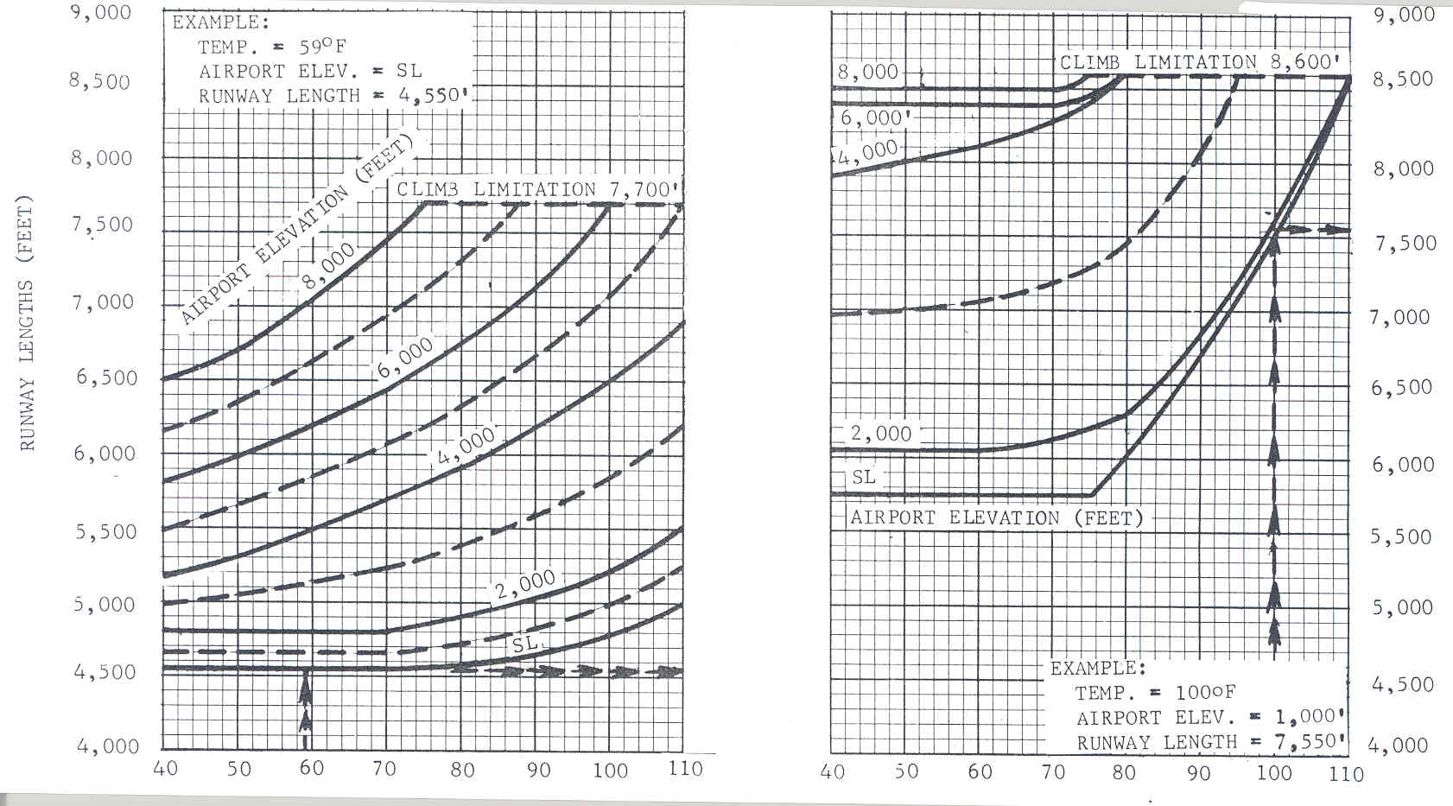
Mean Daily Maximum Temperature of Hottest Month of the Year in Degrees Fahrenheit

75 percent of feet at 60 percent useful load 75 percent of feet at 90 percent useful load

Figure 3-2. 100 Percent of Fleet at 60 or 90 Percent Useful Load

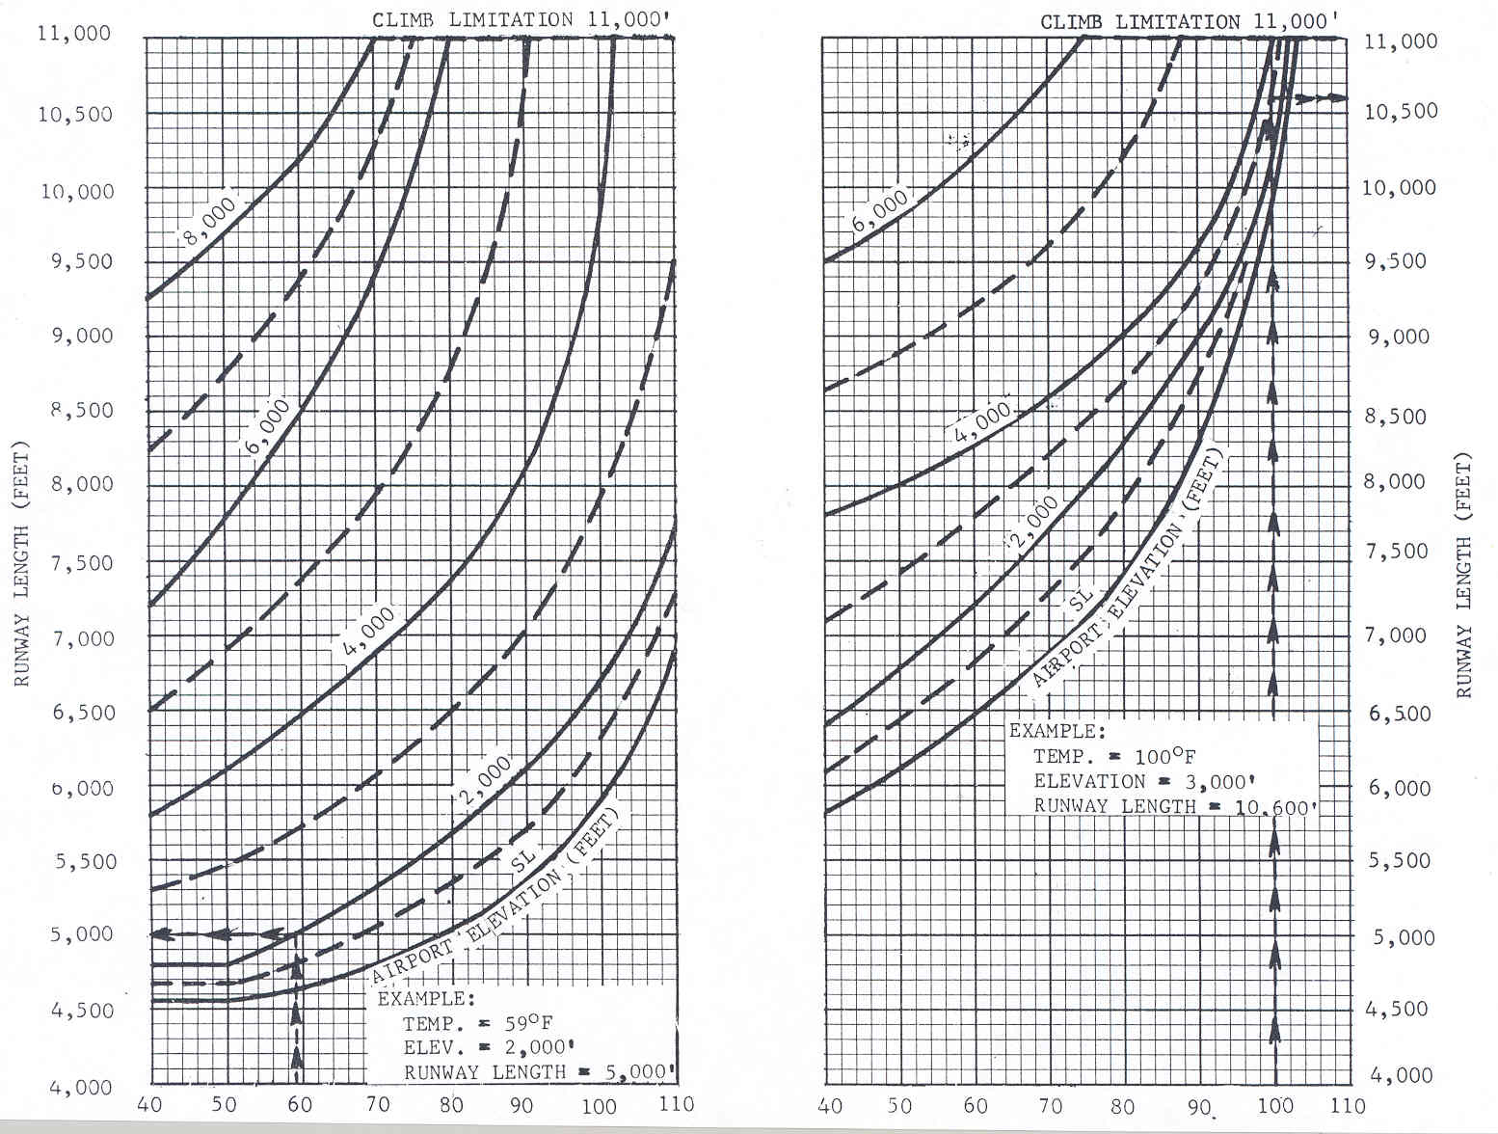
Mean Daily Maximum Temperature of Hottest Month of the Year in Degrees Fahrenheit

100 percent of feet at 60 percent useful load 100 percent of feet at 90 percent useful load

Table 3-1. Airplanes that Make Up 75 Percent of the Fleet

Manufacturer | Model |  | Manufacturer | Model
Aerospatiale | Sn-601 Corvette |  | Dassault | Falcon 10
Bae | 125-700 |  | Dassault | Falcon 20
Beech Jet | 400A |  | Dassault | Falcon 50/50 EX
Beech Jet | Premier I |  | Dassault | Falcon 900/900B
Beech Jet | 2000 Starship |  | Israel Aircraft Industries  (IAI) | Jet Commander 1121
Bombardier | Challenger 300 |  | IAI | Westwind 1123/1124
Cessna | 500 Citation/501Citation Sp |  | Learjet | 20 Series
Cessna | Citation I/II/III |  | Learjet | 31/31A/31A ER
Cessna | 525A Citation II (CJ-2) |  | Learjet | 35/35A/36/36A
Cessna | 550 Citation Bravo |  | Learjet | 40/45
Cessna | 550 Citation II |  | Mitsubishi | Mu-300 Diamond
Cessna | 551 Citation II/Special |  | Raytheon | 390 Premier
Cessna | 552 Citation |  | Raytheon Hawker | 400/400 XP
Cessna | 560 Citation Encore |  | Raytheon Hawker | 600
Cessna | 560/560 XL Citation Excel |  | Sabreliner | 40/60
Cessna | 560 Citation V Ultra |  | Sabreliner | 75A
Cessna | 650 Citation VII |  | Sabreliner | 80
Cessna | 680 Citation Sovereign |  | Sabreliner | T-39

Table 3-2. Remaining 25 Percent of Airplanes that Make Up 100 Percent of Fleet

Manufacturer | Model
Bae | Corporate 800/1000
Bombardier | 600 Challenger
Bombardier | 601/601-3A/3ER Challenger
Bombardier | 604 Challenger
Bombardier | BD-100 Continental
Cessna | S550 Citation S/II
Cessna | 650 Citation III/IV
Cessna | 750 Citation X
Dassault | Falcon 900C/900EX
Dassault | Falcon 2000/2000EX
Israel Aircraft Industries  (IAI) | Astra 1125
IAI | Galaxy 1126
Learjet | 45 XR
Learjet | 55/55B/55C
Learjet | 60
Raytheon/Hawker | Horizon
Raytheon/Hawker | 800/800 XP
Raytheon/Hawker | 1000
Sabreliner | 65/75
Note: Airplanes in tables 3-1 and 3-2 combine to comprise 100% of the fleet.

Page intentionally blank
CHAPTER 4. RUNWAY LENGTHS FOR REGIONAL JETS AND THOSE AIRPLANES WITH A MAXIMUM CERTIFICATED TAKEOFF WEIGHT OF MORE THAN 60,000 POUNDS (27,200 KG)

  - DESIGN GUIDELINES. The design procedure for this weight category requires the following information: the critical design airplanes under evaluation and their APMs, the maximum certificated takeoff weight or takeoff operating weight for short-haul routes, maximum certificated landing weight, airport elevation above mean sea level, effective runway gradient, and the mean daily maximum temperature of the hottest month at the airport. Apply the procedures in this chapter to each APM to obtain separate takeoff and landing runway length requirements. Apply any takeoff and landing length adjustments, if necessary, to the resulting lengths.

  - DESIGN APPROACH. The recommended runway length obtained for this weight category of airplanes is based on using the performance charts published by airplane manufacturers, i.e., APMs, or by contacting the airplane manufacturer and/or air carriers for the information. Regardless of the approach taken by the airport designer, the design procedure described below must be applied to the information/performance charts. Both takeoff and landing runway length requirements must be determined with applicable length-adjustments in order to determine the recommended runway length. The longest of the takeoff and landing runway length requirements for the critical design airplanes under evaluation becomes the recommended runway length.

  - Airport Planning Manual (APM). Each airplane manufacturer’s APM provides performance information on takeoff and landing runway length requirements for different airplane operating weights, airport elevations, flap settings, engine types, and other parameters. It is noted that airplane manufacturers do not present the data in a standard format. However, there is sufficient consistency in the presentation of the information that allows their application in determining the recommended runway length as described in paragraph 403.

  - United States Federal Aviation Regulations (FAR) and European Joint Aviation Regulations (JAR) or Certification Specifications (CS).

    - Recently CS have replaced the European JARs that were previously issued by the Joint Aviation Authorities of Europe. Today the European Aviation Safety Agency (EASA) issues all CS.

    - Airport designers and planners should be aware that some APM charts provide curves for both FAR and JAR (or CS) regulations. That is, a chart may contain dual curves labeled “FAR” and curves labeled “JAR.” In the case for air carrier operators under the authority of the United States, the airport designer must use the curves labeled “FAR.” In the case of foreign air carrier operators who receive approves by their respective foreign authority, such as EASA, the airport designer must use the curves authorized by the foreign authority, i.e., curves labeled “JAR,” “CS”, or “FAR.” Therefore, the recommended labeled-curves that airport designers must use are those that the authorizing aviation authority approved for the air carrier’s airplane fleet.

  - Airplane Manufacturer Website. Appendix 1 provides the website addresses of the various airplane manufacturers to assist in obtaining APMs or for further consultation.

  - PROCEDURES FOR DETERMINING RECOMMENDED RUNWAY LENGTH. Determine both takeoff and landing runway length requirements as prescribed below, select the longest resulting takeoff and landing runway lengths, then apply any length adjustments described in the following subparagraphs. The longest resulting runway length between the takeoff and landing runway lengths for the critical design airplanes under evaluation becomes the recommended runway length. Appendix 3 offers several examples that employ the design guidelines and procedures. It is noted that the charts used in this procedure are provided by the airplane manufacturers for information only and not for flight operations. The pilot must use the FAA-approved flight manuals to conduct flight operations.

        - The Temperature Parameter in APM Takeoff Charts. The parameter airport temperature is used only for takeoff length determinations by setting it equal to the “mean daily maximum temperature of the hottest month at the airport.” In turn, APMs provide takeoff runway length data in terms of airport elevation and standard day temperatures (SDT). Figure 4-1 shows how APMs correlate SDTs with airport elevations. Fortunately many airplane manufacturers provide at least two takeoff runway length requirement charts, one at SDT (59° F (15° C)) and one at SDT + some additional temperature, for example, SDT + 27° F (SDT + 15° C). The latter chart corresponds to 59° F + 27° F = 86° F (15° C + 15° C = 30° C.) Hence, the potential benefit for airport designers is quick and easy takeoff length determinations when the value of airport temperature, “mean daily maximum temperature of the hottest month at the airport,” equals or is less than the provided SDT. In order to augment this benefit, it is acceptable for airport designers to use a SDT chart if it is no more than 3° F (1.7° C) lower than the recorded value for the “mean daily maximum temperature of the hottest month at the airport”. For example, a SDT+ 27° F (STD + 15° C) chart could be used when airport temperatures are equal to or less than 89° F (3° F + 86° F) (30° C [15° C + 15° C]). If no SDT chart is available for the recorded airport temperature, consult the airplane manufacturer directly to obtain the takeoff length requirement under the same conditions outlined in this paragraph.

Table 4-1. Relationship Between Airport Elevation and Standard Day Temperature

Airport Elevation ¹ |  | Standard Day Temperature ¹ (SDT)
Feet | Meters | ° F | ° C
0  2,000  4,000  6,000  8,000 | 0  609  1,219  1,828  2,438 | 59.0  51.9  44.7  37.6  30.5 | 15.00  11.04  7.06  3.11  -0.85

Note 1: Linear interpolations between airport elevations and between SDT values are permissible.

        - Landing Length Requirements. For the airplane model with, if provided, the corresponding engine type under evaluation:

    - Locate the landing chart with the highest landing flap setting (if more than one flap setting is offer), zero wind, and zero effective runway gradient. If the chart does not indicate the wind or effective runway gradient conditions, assume they are equal to zero.

    - Enter the horizontal weight axis with the operating landing weight equal to the maximum certificated landing weight. Linear interpolation along the weight axis is allowed. Do not exceed any indicated limitations on the chart.

    - Proceed vertically to the airport elevation curve, sometimes labeled “pressure altitude.” Interpolation between curves is allowed. It is noted that some charts simultaneously show both the “dry runway” and “wet runway” curves. Use the “wet runway” curve. Wet runway conditions are required only for turbojet-powered airplanes (see paragraph 508). See step (5) below for the turbo-jet powered airplanes when the chart only provides “dry runway” curves.

    - Proceed horizontally from the wet runway curve to the length axis to read the runway length. Linear interpolation along the length axis is allowed.

    - Increase the obtained landing length for “dry runway” condition by 15 percent for those cases noted in paragraph 508. No landing length adjustment is necessary by regulation for non-zero effective runway gradients for any airplane type.

c. Takeoff Length Requirements. For the airplane model with, if provided, corresponding engine type under evaluation:

- Locate the takeoff chart with dry runway, zero wind, and zero effective runway gradient conditions for the appropriate SDT chart (within the temperature range for the airport’s mean daily maximum temperature of the hottest month at the airport). If the chart does not indicate the “zero wind” or “zero effective runway gradient” conditions, assume they are equal to zero, but this is not a conservative assumption.

- Enter the horizontal weight axis with the operating takeoff weight equal to maximum certificated takeoff weight. For Federally funded projects, the airport designer must take into account the length of haul (range) that is flown by airplanes on a substantial use basis. The length of haul range will determine the operating takeoff weight for the design airplanes under evaluation. Long-haul routes should set the operating takeoff weight equal to the MTOW while short-haul routes should apply the actual operating takeoff weight. The Payload Break point as shown in figure 4-1 in conjunction with the Payload-Range charts provided by APMs for the design airplane(s), determine whether or not to use MTOW. Figure 4-1 illustrates a generic Payload-Range chart with Range and Payload axes, the Payload Break point, and the boundary parameters. For length of haul ranges that equal to or exceed the Payload Break point, the operating takeoff weight is set equal to the MTOW. For all the other cases, set the design operating takeoff weight equal to the actual operating takeoff weight. For the latter case, AC 120-27D, Aircraft Weight and Balance Control, provides average weight values for passengers and baggage for payload calculations for short-haul routes.

Figure 4-1 Generic Payload-Range Chart

P
A
Y
L
O
A
D

P  A  Y  L  O  A  D | RANGE (increasing)
MLW maximum design landing weight
MTOW maximum design takeoff weight (some APMs label it Brake Release)
MZFW maximum design zero fuel weight (some APMs label it Maximum Design Payload)

- Proceed vertically to the airport elevation curve without exceeding any indicated limitations, such as, maximum brake energy limit, tire speed limit, etc. Interpolation between curves is allowed because the chart is used for airport design as compare to flight operations. It is also noted that some airport elevations curves show various flap settings along the curve. In such cases, continue to use the same airport elevation curve.

- Proceed horizontally from the airport elevation curve to the runway length axis to read the takeoff runway length. Linear interpolation along the runway length axis is allowed.

- Adjust the obtained takeoff runway length for non-zero effective runway gradients (see paragraph 509). In those cases the airport designer must increase the obtained length by 10 feet (3 m) per foot (0.3m) of difference in runway centerline elevations between the high and low points of the runway centerline elevations.

d. Final Recommended Runway Length. The final recommended runway length is the longest resulting length after any adjustments for all the critical design airplanes that were under evaluation.

  - EXAMPLES. Appendix 3 provides example scenarios utilizing APM performance charts.

CHAPTER 5. DESIGN RATIONALE

  - INTRODUCTION. This chapter explains the application of eight factors that affect runway lengths. Previous chapters describe how to use performance curves and tables to determine the recommended runway length. However, the airport designer has the option to determine the recommended runway length by obtaining data provided in airplane flight manuals and then equally applying the eight variable factors discussed in this chapter and all other factors mentioned in the respective chapters. Table 5-1 summarizes the eight variable factors. For Federally funded projects the eight variable and other factors mentioned need to be applied in a manner to produce the shortest runway length.

  - AIRPLANES. The design criterion is to catalog the current or forecasted critical design airplane(s) that will use the runway and require the longest runway length.

  - LANDING FLAP SETTINGS. The design criterion is to select the landing flap setting that produces the shortest runway length. Figures in chapters 2 and 3 are based on this design criterion. Chapter 4, which relies on the use of an APM, directs the airport designer to select the flap setting that generates the shortest runway length from among the certificated landing flap settings.

  - AIRPLANE OPERATING WEIGHTS. The recommended runway length is based on expected airplane operating weights during takeoff and landing operations. The expected landing weight is the lower of the maximum allowable landing weights for the three conditions specified in subparagraph 504a and the takeoff weight is the lower of the maximum allowable takeoff weights for the seven conditions specified in subparagraph 504b.

a. Maximum Allowable Landing Weight. The airplane’s maximum allowable landing weight is the lower of the following three conditions:

    - Maximum structural landing weight.

    - Climb limited landing weight.

    - Runway length-limited landing weight (insufficient available runway length).

b. Maximum Allowable Takeoff Weight. The airplane’s maximum allowable takeoff weight is the lower of the following:

- Maximum structural takeoff weight.

- Climb limited takeoff weight.

- Tire speed limited takeoff weight.

- Brake energy limited takeoff weight.

- Takeoff weight limited by maximum landing weight.

- Obstacle clearance limited takeoff weight.

- Runway length-limited takeoff weight (insufficient available runway length).

c. Operating Weights for Design. The design criterion is based on the following:

- Small Airplanes 12,500 pounds (5,670 kg) or less MTOW. Figures 2-1 and 2-2 along with the guidelines in chapter 2 provide recommended runway lengths by a single curve that incorporates both maximum allowable takeoff and landing weights.
- Large Airplanes over 12,500 pound (5,670 kg) MTOW.

      - Chapter 3. The curves of figures 3-1 and 3-2 provide runway lengths based on the percentage of fleet and percent of useful load. The curves used the lesser of the maximum allowable takeoff and landing weights as described above or the weight of the airplane with useful load.

      - Chapter 4, Using Airplane Planning Manuals (APMs).

  - For landing, use the maximum allowable landing weight excluding limitations of subparagraph 504a(3). In nearly all cases, the weight is set to the maximum structural landing weight.

  - For takeoff, use maximum allowable takeoff weight, excluding limitations of subparagraph 504b(5), (6), and (7). For Federally funded projects, the airport designer must take into account the length of haul (range) that is flown by airplanes on a substantial use. In this case, use the determined length of haul (range) and compare it to the Payload Break point of the Payload-Range chart in the APM (see paragraph 403(c) for an explanation.) For ranges greater than or equal to the Payload Break point, set the operating takeoff weight equal to MTOW excluding limitations of subparagraph 504b(5), (6), and (7). For ranges less than the Payload Break point, use the calculated operating takeoff weight for the given range, i.e., short-haul routes. In many cases, the weight is set to the MTOW, thus resulting in a runway that permits airplanes to operate at full payload service capabilities.

  - AIRPORT ELEVATION. The design criterion is to substitute airport elevation above mean sea level for pressure altitude. This substitution is acceptable since the two are approximately equal and the probability of these conditions occurring simultaneously is relatively remote. Therefore, any difference would be slight.
  - TEMPERATURE. The design criterion is to use the mean daily maximum temperature of the hottest month at the airport. This temperature is readily available and yields a realistic operational length.
        - Application. Airport designers using chapters 2 and 3 are to apply the actual temperature value to the provided figures. Airport designers using an APM are to employ either the tables from the APM when the actual temperature falls within a prescribed temperature range or, when it falls outside the prescribed temperature range, to contact the airplane manufacturer directly for the applicable runway table.
        - Availability of Temperature Data. This information can be obtained from the publication “Monthly Station Normals of Temperature, Precipitation, and Heating and Cooling Degree-Days” (Climatography of the United States No.81). This is the official source for the mean maximum temperature for the hottest month. The latest data, averaged over a period of thirty years, may be obtained from the National Climatic Data Center, Federal Building, Asheville, North Carolina 28801. Phone: (828) 271-4800; fax: (828) 271-4876; or website: http://www.ncdc.noaa.gov/oa/ncdc.html (specify the state when ordering).
  - WIND. The design criterion is based on the condition of zero wind velocity for both takeoff and landing operations for all airplane weight categories. The figures in chapters 2 and 3 are based on zero wind conditions. Users of APMs are instructed to select the zero wind curves.
  - RUNWAY SURFACE CONDITIONS. The design criterion is to address wet, slippery runway surface conditions for only landing operations and only for turbojet-powered airplanes. The design criteria follows the 14 Code of Federal Regulations requirement that dry runway landing distances for turbojet-powered airplanes must be increased 15 % when landing on wet or slippery runways. Therefore, the obtained runway lengths from this AC for turbojet-powered airplanes are further increased by 15 percent. Many airplane manufacturers’ APMs for turbojet-powered airplanes provide both dry runway and wet runway landing curves. If an APM provides only the dry runway condition, then increase the obtained dry runway length by 15 percent. The landing portion of the curves in figures 3-1 and 3-2 are based on dry runway conditions. Thus, as instructed by chapter 3, increase the landing dry lengths for turbojet-powered airplanes by 15 percent to increase the landing length, but not more than 5,500 feet (1,676 meters), whichever is less.
  - MAXIMUM DIFFERENCE OF RUNWAY CENTERLINE ELEVATION. The design criterion is to address uphill longitudinal runway profiles for takeoff operations of large airplanes. A runway whose centerline elevation varies between runway ends produces uphill and downhill conditions, which in turn, cause certain airplane weight categories to require longer operational lengths. This AC addresses the uphill condition, termed “effective runway gradient,” for takeoff operations by using the maximum difference of runway centerline elevation. For airplanes over 12,500 pounds (5,670 kg) maximum certified takeoff weight, the recommended runway length for takeoff derived from the curves of figures 3-1 and 3-2 or from the APMs must be increased by 10 feet per foot of difference in centerline elevations between the high and low points of the runway centerline elevations. Airport designers using APMs should also apply the same adjustment because APMs use zero effective runway gradients in their takeoff curves. This adjustment to the obtained runway length approximates the operational increase required to overcome the uphill effective runway gradient. For airplanes of 12,500 pounds (5,670 kg) or less MTOW, no operational requirement for an increase to the obtained runway length for takeoff is necessary to compensate for non-zero effective runway gradients. In the case for landing operations, no operational requirement for an increase to the obtained runway length for landing is necessary to compensate for non-zero effective runway gradients.
Table 5-1. Rationale Behind Recommendations for Calculating Recommended Runway Lengths
Variable Factors and Paragraph References |  | Family Groupings  Consult Advisory Circular |  |  | Airplane Performance Characteristics  Non-Turbojet/Turbojet  (Consult Airplane Manufacturer’s Airport Planning Manuals (APM)  Chapter 4)
 |  | Figures
 |  | 2-1 and 2-2 | 3-1 | 3-2
Airplane Type  (Paragraph 502) |  | Based on number of seats | Based on percent of fleet |  | Specific manual for each airplane
Flap Setting (Paragraph 503) |  | Shortest runway length |  |  | Shortest runway length
Operating Weights (Paragraph 504) | Takeoff | Maximum takeoff weight | Based on percent of useful load |  | Located in airplane general characteristics
Operating Weights (Paragraph 504) | Landing | Maximum landing weight | Based on percent of useful load |  | Located in airplane general characteristics
Airport Elevation (Paragraph 505) |  | Indicated on AC curves |  |  | Indicated on APM curves
Temperature (Paragraph 506) | Takeoff | Indicated on AC curves |  |  | Indicated on APM curve
Temperature (Paragraph 506) | Landing | Indicated on AC curves | Independent of results |  | Independent of results
Wind (Paragraph 507) | Takeoff | Zero wind |  |  | Zero wind
Wind (Paragraph 507) | Landing | Zero wind |  |  | Zero wind
Runway Surface Conditions (Paragraph 508) | Takeoff | Independent of results |  |  | Independent of results
Runway Surface Conditions (Paragraph 508) | Landing | Independent of results | Dry |  | Wet (turbo) Dry (non-turbo)
Difference in Centerline Elevation (Paragraph 509) | Takeoff | Independent of results | Zero |  | Zero
Difference in Centerline Elevation (Paragraph 509) | Landing | Independent of results |  |  | Independent of results
Runway Length for Takeoff |  | Airplane takeoff distance | Larger of airplane takeoff distance or accelerated stop distance |  | Larger of airplane takeoff distance or accelerated stop distance
Runway Length for Landing |  | Airplane takeoff distance | Airplane dry landing distance divided by 0.6 |  | If available, airplane wet landing distance divided by 0.6. Otherwise, airplane dry landing distance divided by 0.6 then multiplied by 1.15

APPENDIX 1. WEBSITES FOR Manufacturers of AIRPLANES

OVER 60,000 POUNDS (27,200 kg)

Airplane Manufacturers | Website
Airbus | www.airbusworld.com/  (Registration required)
Antonov | www.antonov.com
BAE Systems  (military aircraft) | www.baesystems.com
Boeing | www.boeing.com/airports
Bombardier | www.bombardier.com
Bristol  (British Aircraft Corporation) | www.baesystems.com
Canadair | www.canadair.com
Dassault Aviation | www.dassault-avaition.com
de Havilland  (Hawker Siddley Group, now British Aerospace) | www.dhsupport.com
Embraer | www.embraer.com
Fairchild Dornier | www.fairchilddornier.com
Fokker | www.fokker.com
General Dynamics  (Gulfstream Aerospace Corporation) | www.generaldynamics.com
Grumman | www.northgrum.com
Gulfstream  (General Dynamics Corporation) | www.gulfstream.com
Hawker Siddeley Group  (British Aerospace Corporation) | www.bombardier.com
Ilyushin | No existing web page  Mailing address:  45g Liningradsky Prospekt  125190 Moscow Phone: 7 (095) 157-3312
Kawasaki  (military aircraft) | www.khi.co.jp
Lockheed Martin  (military aircraft) | www.lmco.com
MAI | www.merlinaircraft.com
McDonnell Douglas | www.boeing.com
Saab Aircraft | www.saabaircraft.com
Short Brothers  (Bombardier) | www.bombardier.com
Tupolev | www.tupolev.ru

APPENDIX 2. Selected Federal Aviation Regulations Concerning Runway length requirements

Part | Section
Part 23: Airworthiness standards: Normal, utility, acrobatic, and commuter category airplanes | Section 45: General
Part 25: Airworthiness standards: Transport category airplanes | Section 105: Takeoff
Part 25: Airworthiness standards: Transport category airplanes | Section 109: Accelerate-stop distance
Part 25: Airworthiness standards: Transport category airplanes | Section 113: Takeoff distance and takeoff run
Part 91: General operating and flight rules | Section 605: Transport category civil airplane weight limitations
Part 121: Operating requirements: Domestic, flag, and supplemental operations | Section 173: General
Part 121: Operating requirements: Domestic, flag, and supplemental operations | Section 177: Airplanes: Reciprocating engine-powered: Takeoff limitations
Part 121: Operating requirements: Domestic, flag, and supplemental operations | Section 189: Airplanes: Turbine engine powered: Takeoff limitations
Part 121: Operating requirements: Domestic, flag, and supplemental operations | Section 195: Airplanes: Turbine engine powered: Landing limitations: Destination airports
Part 121: Operating requirements: Domestic, flag, and supplemental operations | Section 197: Airplanes: Turbine engine powered: Landing limitations: Alternate airports
Part 121: Operating requirements: Domestic, flag, and supplemental operations | Section 199: Non-transport category airplanes: Takeoff limitations
Part 121: Operating requirements: Domestic, flag, and supplemental operations | Section 203: Non-transport category airplanes: Landing limitations: Destination airport
Part 121: Operating requirements: Domestic, flag, and supplemental operations | Section 205: Non-transport category airplanes: Landing limitations: Alternate airport
Part 135: Operating requirements: Commuter and on demand operations and rules governing persons on board such aircraft | Section 367: Large transport category airplanes: Reciprocating engine powered: Takeoff limitations
Part 135: Operating requirements: Commuter and on demand operations and rules governing persons on board such aircraft | Section 375: Large transport category airplanes: Reciprocating engine powered: Landing limitations: Destination airports
Part 135: Operating requirements: Commuter and on demand operations and rules governing persons on board such aircraft | Section 377: Large transport category airplanes: Reciprocating engine powered: Landing limitations: Alternate airports
Part 135: Operating requirements: Commuter and on demand operations and rules governing persons on board such aircraft | Section 379: Large transport category airplanes: Turbine engine powered and Takeoff limitations
Part 135: Operating requirements: Commuter and on demand operations and rules governing persons on board such aircraft | Section 385: Large transport category airplanes: Turbine engine powered: Landing limitations: Destination airports
Part 135: Operating requirements: Commuter and on demand operations and rules governing persons on board such aircraft | Section 387: Large transport category airplanes: Turbine engine powered: Landing limitations: Alternate airports
Part 135: Operating requirements: Commuter and on demand operations and rules governing persons on board such aircraft | Section 393: Large non-transport category airplanes: Landing limitations: Destination airports
Part 135: Operating requirements: Commuter and on demand operations and rules governing persons on board such aircraft | Section 395: Large non-transport category airplanes: Landing limitations: Alternate airports
Part 135: Operating requirements: Commuter and on demand operations and rules governing persons on board such aircraft | Section 398: Commuter category airplanes performance operating limitations

Page intentionally blank

APPENDIX 3. EXAMPLES USING AIRPLANE PLANNING MANUALS

EXAMPLE SCENARIO #1. BOEING 737-900

1-1. INFORMATION. This example scenario, involving a Boeing 737-900, allows the airport designer to use published information in the airplane manufacturer’s airport planning manual (APM). That is, the airport’s mean daily maximum temperature for the hottest month falls within the permissible temperature range for the provided SDT + Temp chart. The airport designer will determine the separate length requirements for takeoff and landing, make necessary adjustments to those lengths, and then select the longest length as the recommended runway length. The example also assumes that the length of haul is of sufficient range so that the takeoff operating weight is set equal to the MTOW.

1-2. DATA. The calculation will use the following design conditions:

- Airplane Boeing 737-900 (CFM56-7B27 Engines)
- Mean daily maximum temperature of hottest month at the airport 84° Fahrenheit (28.9° C)
- Airport elevation 1,000 feet
- Maximum design landing weight (see table A3-1-1) 146,300 pounds
- Maximum design takeoff weight (non-Federally funded project; see table A3-1-1) 174,200 pounds
- Maximum difference in runway centerline elevations 20 feet

1-3. CALCULATIONS. The steps used in the calculations are those provided in paragraph 403, noting applicable conditions. Figures A3-1-1 and A3-1-2 are used for the calculations. It is noted that the charts are only for airport design purposes and not for flight operations.

              - Landing Length Requirement (see figure A3-1-1).

  - Step 1 – the Boeing 737-900 APM provides three landing charts for flap settings of 40-degrees, 30-degrees, and 15-degrees. The 40-degree flap setting landing chart, figure A3-1-1, is chosen since, it results in the shortest landing runway length requirement.

  - Steps 2 and 3 – Enter the horizontal weight axis at 146,300 pounds and proceed vertically and interpolate between the airport elevations “wet” curves of sea level and 2,000 feet for the 1,000-foot wet value. Wet curves are selected because the airplane is a turbo-jet powered airplane (see paragraph 508). Interpolation is allowed for both design parameters.

  - Step 4 – Proceed horizontally to the length axis to read 6,600 feet. Interpolation is allowed for this design parameter.

  - Step 5 – Do not adjust the obtained length since the “Wet Runway” curve was used. See paragraph 508 if only “dry” curves are provide.

  - The length requirement is 6,600 feet. Note: Round lengths of 30 feet and over to the next 100-foot interval. Thus, the landing length for design is 6,600 feet.

              - Takeoff Length Requirement (see figure A3-1-2).

  - Step 1 – The Boeing 737-900 APM provides a takeoff chart at the standard day + 27°F (SDT + 15° C) temperature applicable to the various flap settings. Notice that this chart can be used for airports whose mean daily maximum temperature of the hottest month at the airport is equal to or less than 85.4° F (29.7° C). Since the given temperature for this example is 84° F (28.9° C) falls within this range, select this chart. See figure A3-1-2.

  - Steps 2 and 3 – Enter the horizontal weight axis at 174,200 pounds and proceed vertically and interpolate between the airport elevation curves of sea level and 2,000 feet for the 1,000-foot value. Interpolation is allowed for both design parameters. Note: As observed in this example, a takeoff chart may contain under the “Notes” section the condition that linear interpolation between elevations is invalid. Because the application of the takeoff chart is for airport design and not for flight operations, interpolation is allowed.

  - Step 4 – Proceed horizontally to the length axis to read 8,800 feet. Interpolation is allowed for this design parameter.

  - Step 5 – Adjust for non-zero effective runway gradient (see paragraph 509).

8,800 + (20 x 10) = 8,800 + 200 = 9,000 feet

  - The takeoff length requirement is 9,000 feet. Note: Round lengths of 30 feet and over to the next 100-foot interval. Thus, the takeoff length for design is 9,000 feet.

1-4. ANSWER.

Max. Landing Design Weight | 146,300 pounds
Max. Takeoff Design Weight | 174,200 pounds
Landing Length | 6,600 feet
Takeoff Length | 9,000 feet

Select the longest length for airport design. In this case, the takeoff length of 9,000 feet is the recommended runway length.

Table A3-1-1. Boeing 737-900 General Airplane Characteristics
(Reference document number: D6-58325-3)
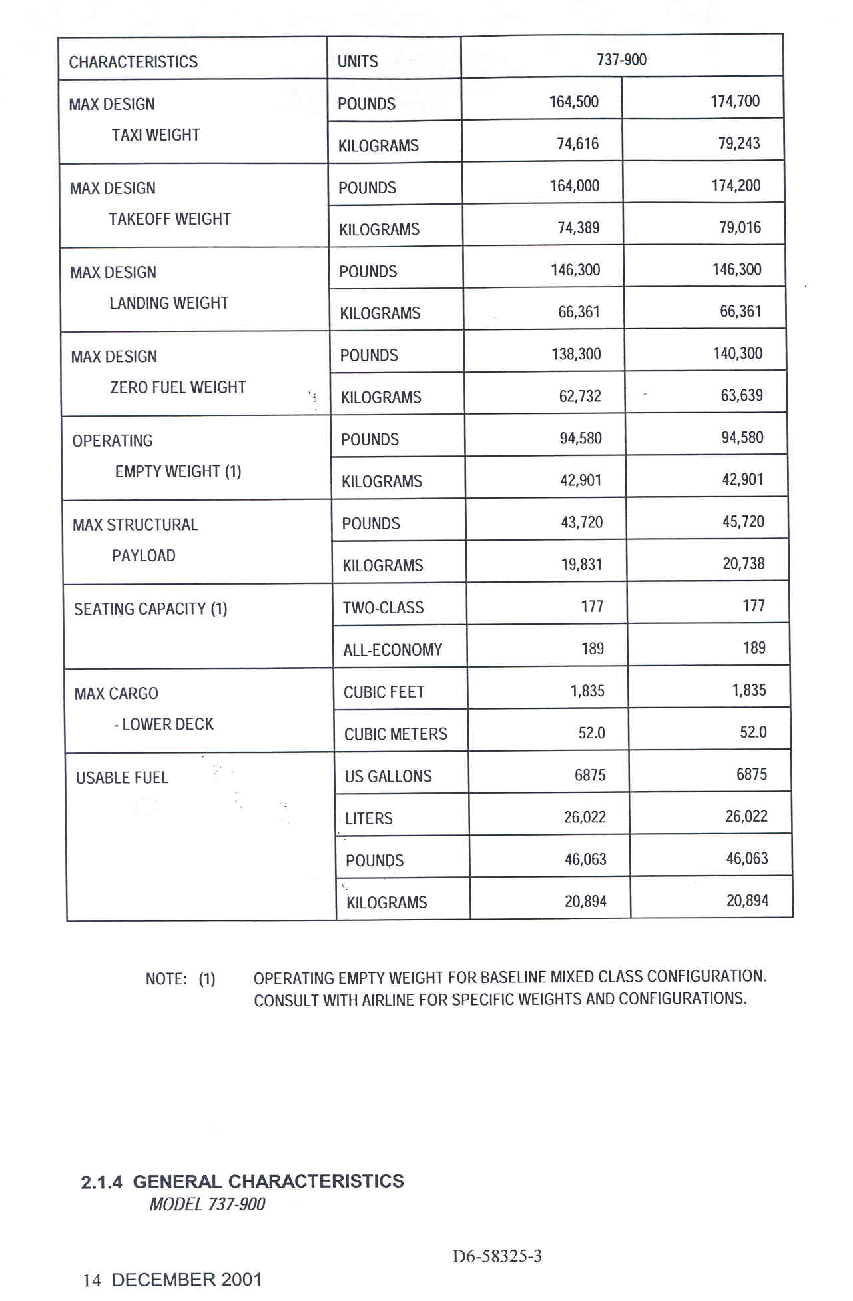

Takeoff Weight

Landing Weight

Figure A3-1-1. Landing Runway Length for Boeing 737-900 (CFM56-7B27 Engines)
(Not for Flight Operations)
(Reference document number: D6-58325-3)
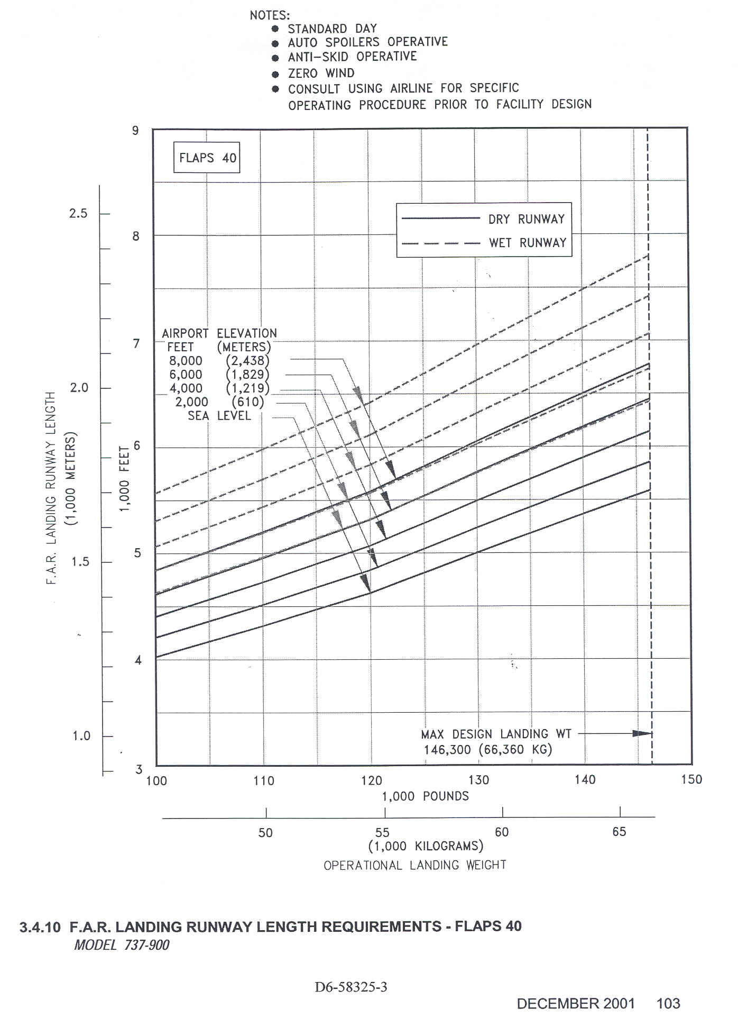
Figure A3-1-2. Takeoff Runway Length for Boeing 737-900 (CFM56-7B27 Engines)
(Not for Flight Operations)
(Reference document number: D6-58325-3)

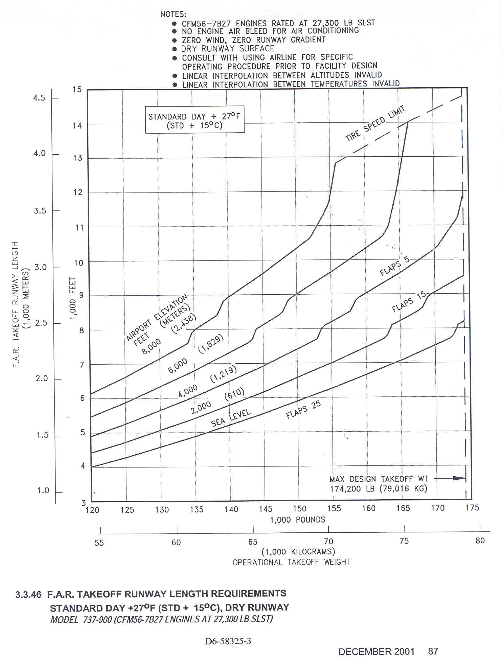
EXAMPLE SCENARIO #2. SAAB FAIRCHILD 340B

2-1. INFORMATION. This example scenario, involving a SAAB Fairchild 340B, allows the airport designer to use published information in the airplane manufacturer’s airport planning manual (APM) instead of the figures provided in chapter 3 of this AC. The airport designer will determine the separate length requirements for takeoff and landing, make necessary adjustments to those lengths, and then select the longest length as the recommended runway length. The example also assumes that the length of haul is of sufficient range so that the takeoff operating weight is set equal to the MTOW.

2-2. DATA. The calculation will use the following design conditions:

    - Airplane Saab 340B (CT7-9B Engines)
- Mean daily maximum temperature of hottest month at the airport 74° Fahrenheit (23.3° C)
- Airport elevation Sea level
- Maximum design landing weight (see table A3-2-1) 28,000 pounds
- Maximum design takeoff weight (non-Federally funded project; see table A3-2-1) 28,500 pounds
- Maximum difference in runway centerline elevation 20 feet

2-3. CALCULATIONS. The steps used in the calculations are those provided in paragraph 403, noting applicable conditions. Figures A3-2-1 and A3-2-2 are used for the calculations. It is noted that the charts are only for informational design purposes and not for flight operations.

- Landing Length Requirement (see figure A3-2-1).

  - Step 1 – the SAAB 340 APM provides two landing charts one for a flap setting of 25-degrees and one for a flap setting of 35-degrees. The 35-degree flap setting landing chart, figure A3-2-1, is chosen since it results in the shorter landing runway length requirement.

  - Steps 2 and 3 – Enter the horizontal weight axis at 28,000 pounds and proceed vertically to the airport elevation curve for sea level. Select the dash curve labeled “FAR” and not the solid curve labeled “JAR” (see subparagraph 402b).

  - Step 4 – Proceed horizontally to the length axis to read 3,450 feet.

  - Step 5 – Do not adjust the obtained length for wet landing operations for the SAAB 340B since it is not a turbojet-powered airplane. The 15-percent adjustment applies only to turbojet-powered airplanes (see paragraph 508).

  - The landing length requirement is 3,450 feet. Note: Round lengths of 30 feet and over to the next 100-foot interval. Thus, the landing length for design is 3,500 feet.

- Takeoff Length Requirement (see figure A3-2-2).

  - Step 1 – the SAAB 340 APM provides a takeoff chart at the standard day + 18°F (10° C) temperature for flap setting of 15-degrees. Notice that this chart can be used for airports whose mean daily maximum temperature of the hottest month at the airport is equal to or less than 80°F (26.7° C). Since the given temperature for this example is 74° F (23.3° C) falls within this range, select this chart. See figure A3-2-2.

  - Steps 2 and 3 – Enter the horizontal weight axis at 28,500 pounds and proceed vertically to the airport elevation curve for sea level. Select the dash-curve labeled “FAR” and not the solid-curve labeled “JAR” (see subparagraph 402b). Interpolation is allowed for both design parameters.

  - Step 4 – Proceed horizontally to the length axis, the result is 4,375 feet.

  - Step 5 – Adjust for non-zero effective runway gradient (see paragraph 509).

4,375 + (20 x 10) = 4, 375 + 200 = 4,575 feet

(5) The takeoff length requirement is 4,575 feet. Note: Round lengths of 30 feet and over to the next 100-foot interval. Thus, the takeoff length for design is 4,600 feet.

2-4. ANSWER.

Max. Landing Design Weight | 28,000 pounds
Max. Takeoff Design Weight | 28,500 pounds
Landing Length | 3,500 feet
Takeoff Length | 4,600 feet

Select the longest length for airport design. In this case, the takeoff length of 4,600 feet is the recommended runway length.

Table A3-2-1. SAAB 340 Airplane Characteristics
(Reference number SAAB 340 ACAP 000)
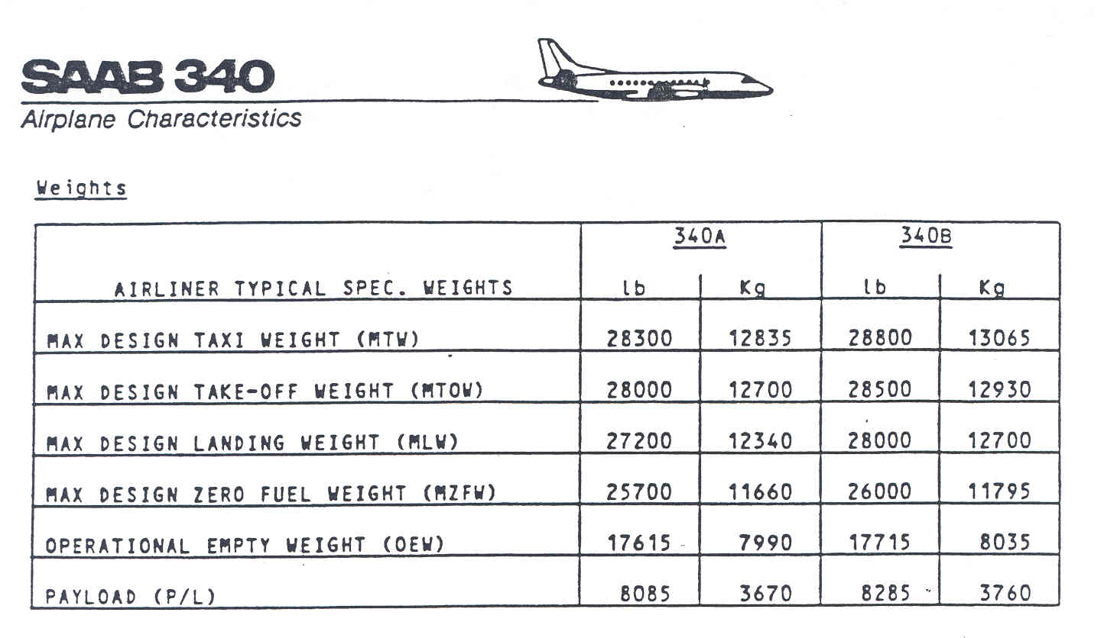
Takeoff Weight
Landing Weight

Figure A3-2-1. Landing Runway Length for SAAB 340B (CT7-9B Engines)
(Not for Flight Operations)
(Reference number SAAB 340 ACAP 000)

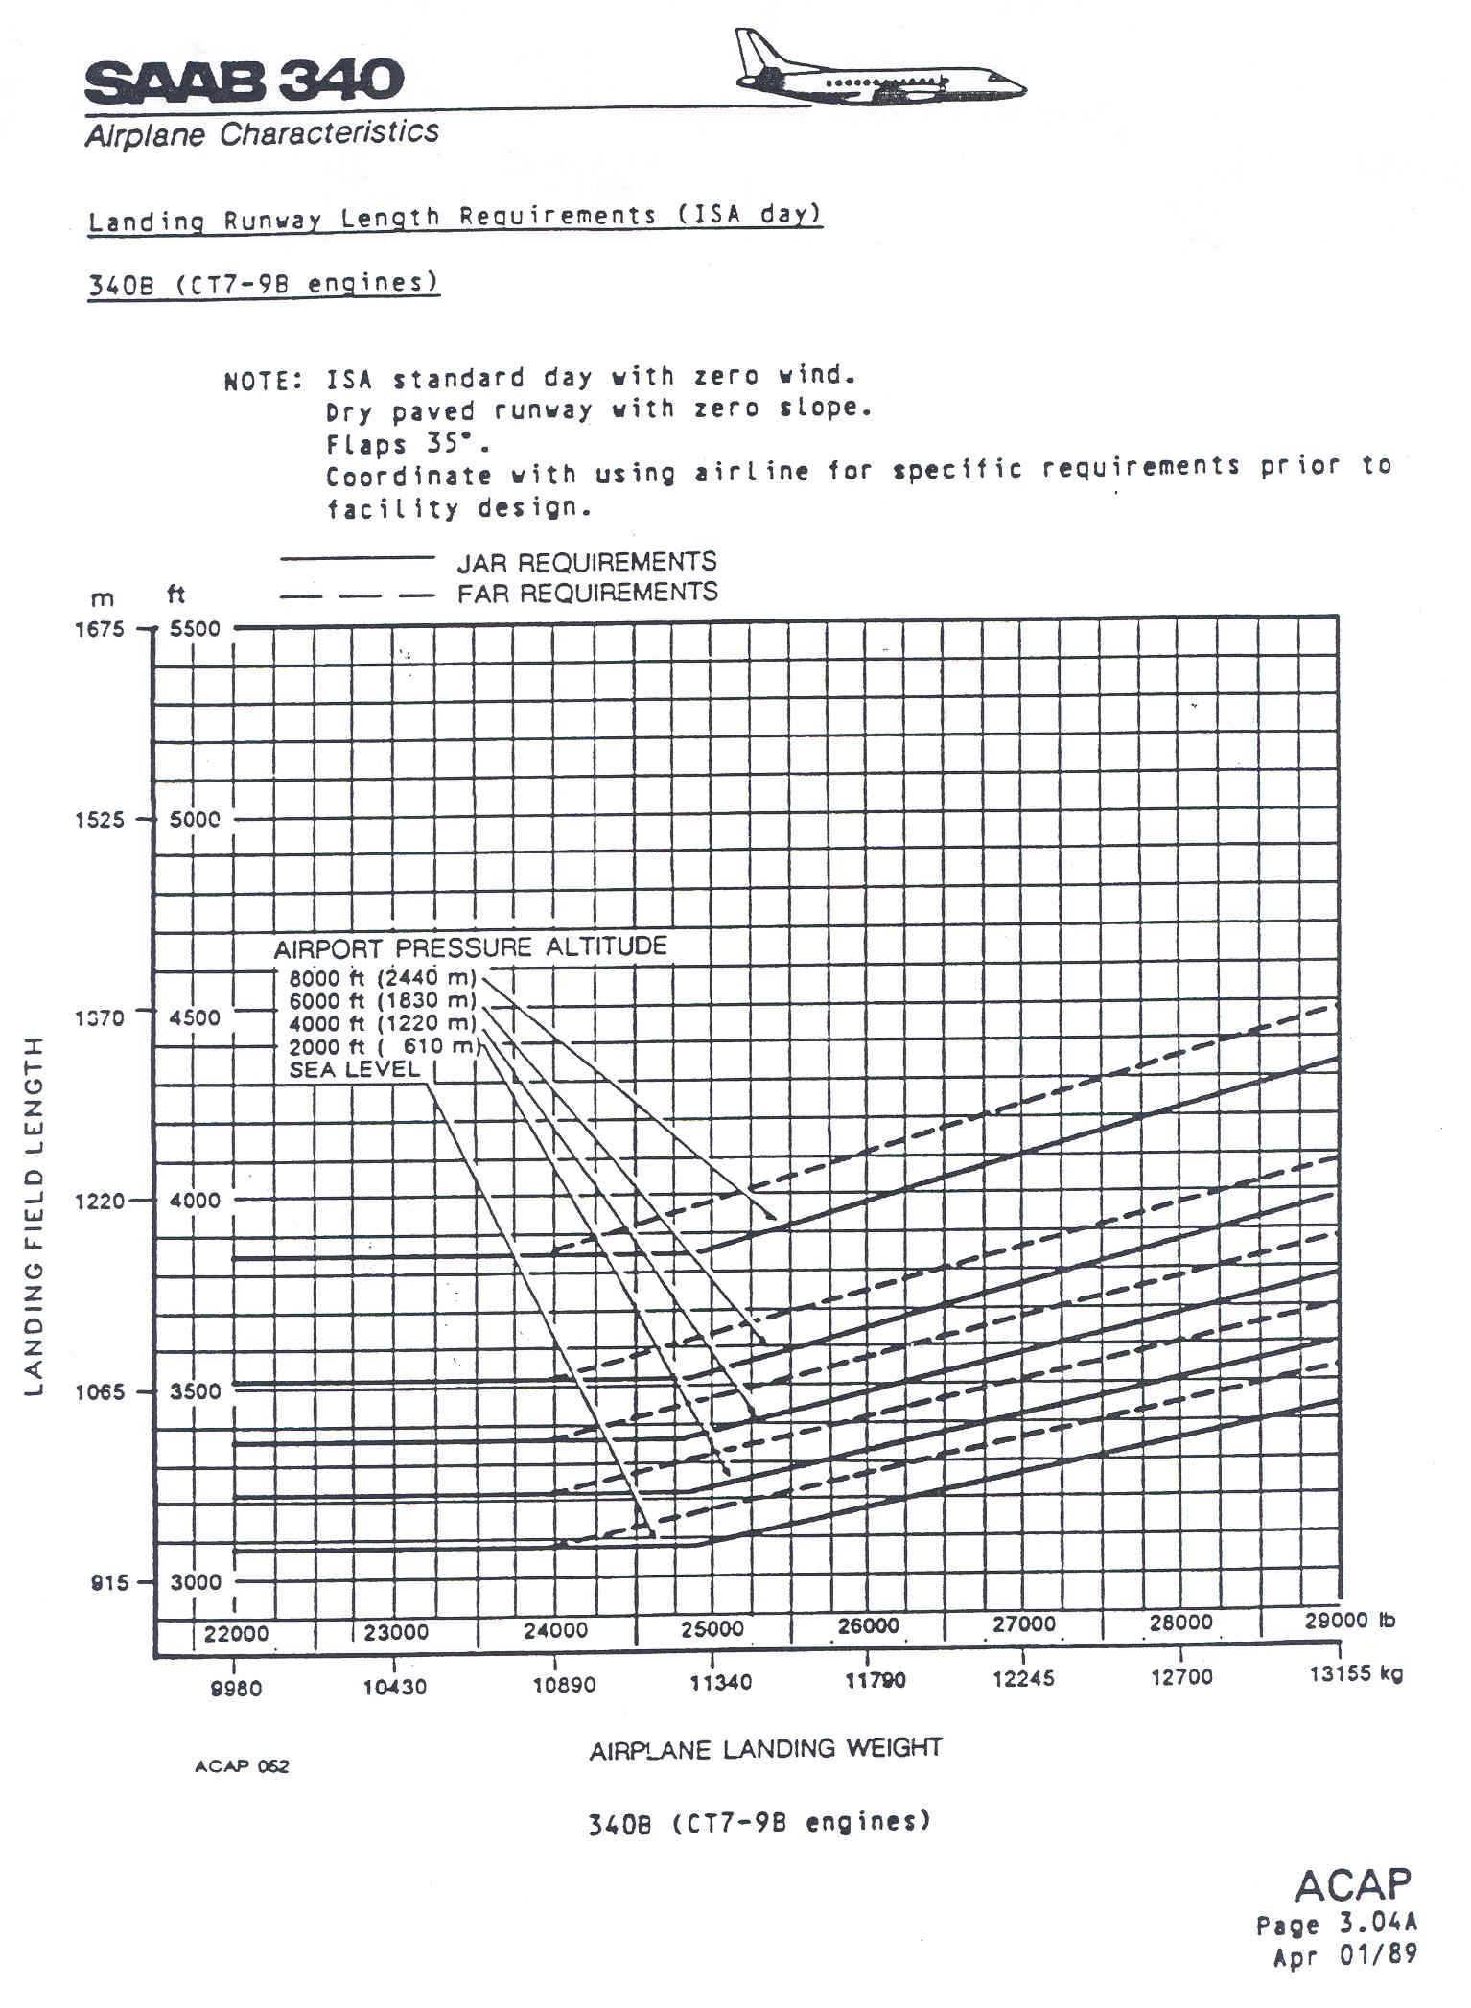

Figure A3-2-2. Takeoff Runway Length for SAAB 340B (CT7-9B Engines)
(Not for Flight Operations)
(Reference number SAAB 340 ACAP 000)

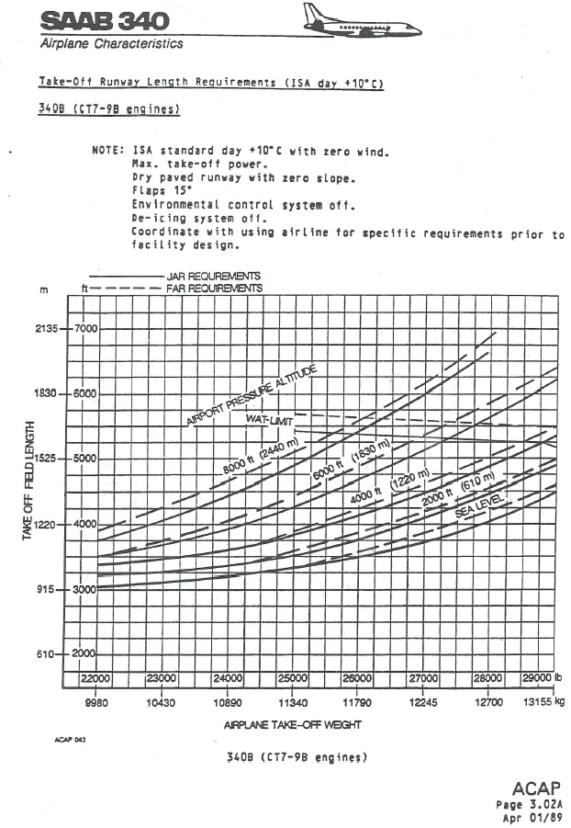

Page intentionally blank

