U.S. Department  of Transportation  Federal Aviation  Administration | Advisory  Circular

Subject: STANDARDS FOR AIRPORT MARKINGS | Date: 4/29/05  Initiated by: AAS-300 | AC No: 150/5340-1J  Change:

1. PURPOSE. This advisory circular (AC) contains the Federal Aviation Administration (FAA) standards for markings used on airport runways, taxiways, and aprons.

2. CANCELLATION. AC 150/5340-1H, Standards for Airport Markings, dated August 31, 1999, is canceled. This AC also cancels AC 150/5340-1I, although it is substantially the same document and only changes the AC version letter from I to J.

3. EXPLANATION OF CHANGES. This AC incorporates guidance on use of the enhanced taxiway centerline markings and the surface holding position signs. These enhancements were designed by the Federal Aviation Administration and MITRE CAASD to better define the location of holding position markings for air crews. These markings were tested at Theodore Francis Green Airport in Providence, Rhode Island. The markings tested included the enhanced taxiway centerline, the extension of existing holding position markings onto taxiway shoulders, the changing of the color of the dashed lines from yellow to white on the holding position markings (which is not adopted at this time) and the enhanced use of the surface painted holding position signs.

The enhanced taxiway centerline is being adopted as the standard for commercial service airports that have 1.5 million or more passenger enplanements in a calendar year. The enhanced taxiway centerline will be the only acceptable means of complying with 14 CFR Part 139 for these airports effective June 30, 2008. Similarly, the extension of the runway holding position markings onto the paved shoulder is being adopted as the only acceptable means of compliance with Part 139 for airports regularly served by aircraft in Aircraft Design Groups 5 and 6, also effective June 30, 2008. The standards for enhanced taxiway centerline and extension of the runway holding position markings are optional for all other airports.

4. METRIC UNITS. To promote an orderly transition to metric units, the text and figures include both English and metric dimensions. The metric conversions are based on operational significance and may not be exact equivalents. The conversion procedure used throughout the AC applies the relationship of 1 foot equals 0.3 meter, except for a few instances where rounding was used in order for linear dimensions to sum correctly. Until there is an official changeover to the metric system, the English dimensions should be used.

5. APPLICATION. The FAA recommends the guidelines and standards contained herein for the marking of airport runways, taxiways, and aprons. These standards are the only method of complying with the marking of runways and taxiways at airports certificated under Title 14 of the Code of Federal Regulations, Chapter I – FAA, DOT, Part 139, Certification and Operations: Land Airports Serving Certain Air Carriers (14 CFR Part 139). These standards are also mandatory for airport projects receiving Federal funds under the Airport Grant Assistance program or funds received from the Passenger Facility Charge program. These standards are to be used on all new projects that are under development and are to be implemented at all Part 139 certificated airports no later than one year from the date of this AC.

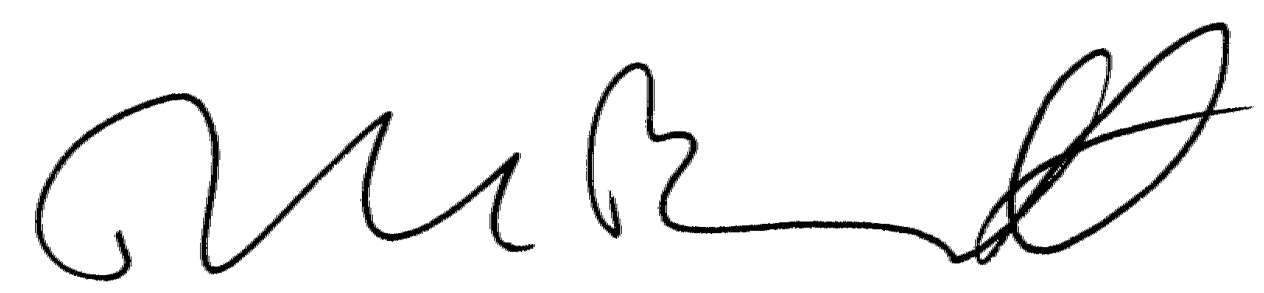
DAVID L. BENNETT
Director, Office of Airport Safety and Standards

CONTENTS
MARKINGS FOR PAVED RUNWAYS AND TAXIWAYS. 1
SECTION 1. GENERAL. 1
1. Purpose 1
2. Definitions 1
3. Marking Practices 1
4. Visibility of Markings. 1
SECTION 2. RUNWAY MARKINGS 2
5. Application. 2
6. Runway Marking Precedence 3
7. Runway Designation Marking. 3
8. Runway Centerline Marking 4
9. Runway Threshold Marking 4
10. Runway Aiming Point Marking. 5
11. Runway Touchdown Zone Marking 5
12. Runway Side Stripe Marking 6
13. Runway Threshold Bar 6
14. Demarcation Bar 6
15. Arrows and Arrowheads 7
16. Chevrons 7
17. Holding Position Markings on Runways. 7
18. Runway Shoulder Markings 8
19. Reserved 8
SECTION 3. TAXIWAY MARKINGS 8
20. Application 8
21. Taxiway Centerline Markings 8
22. Taxiway Edge Marking 10
23. Runway Holding Position Markings on Taxiways 10
24. Holding Position Markings for Instrument Landing System (ILS)/
Precision Obstacle Free Zone (POFZ) 11
25. Intermediate Holding Position Markings for Taxiway/Taxiway Intersections 12
26. Surface Painted Holding Position Signs 13
27. Surface Painted Taxiway Direction Signs 14
28. Surface Painted Taxiway Location Signs 14
29. Surface Painted Gate Identification Signs 15
30. Surface Painted Apron Entrance Point Signs 15
31. Taxiway Shoulder Markings 16
32. Geographic Position Markings 16
33. Reserved 16
34. Reserved 16
SECTION 4. OTHER MARKINGS 17
35. Application 17
36. Vehicle Roadway Markings 17
37. VOR Receiver Checkpoint Markings 17
38. Non-Movement Area Boundary Marking 18
39. Marking of Temporarily Relocated Thresholds 18
40. Marking and Lighting of Permanently Closed Runways and Taxiways 18
41. Temporarily Closed Runways and Taxiways 18
42. Converting a Runway to a Taxiway 19
43. Intermittent Use of a Taxiway as a Runway 19
44. Closed/Abandoned Airports 19
45. Heliport Marking 19
46. Vertiport Marking 19
47. Marking for Arresting Gear 19
48. Hazardous Areas 19

FIGURES

Figure 1. Precision Runway Markings 20
Figure 2. Nonprecision Runway and Visual Runway Markings 21
Figure 3. Example of Conflicting Markings on Crossing Runways 22
Figure 4. Runway Designation Numerals and Letters 23
Figure 5. Displaced Threshold Markings 24
Figure 6. Markings for Taxiway Aligned With Runway 25
Figure 7. Markings for Blast Pads and Stopways 26
Figure 8. Marking for Blast Pad or Taxiway Preceding a Displaced Threshold 27
Figure 9. Runway Shoulder Markings 28
Figure 10. Marking Details 29
Figure 11. Taxiway Markings 30
Figure 12. Taxiway Centerline Marking Methods 31
Figure 13. Surface Painted Signs 32
Figure 14. Surface Painted Gate Identification Signs 33
Figure 15. Surface Painted Apron Entrance Point Signs 34
Figure 16. Taxiway Shoulder Markings 35
Figure 17. Geographic Position Markings 36
Figure 18. Vehicle Roadway Markings 37
Figure 19. VOR Receiver Checkpoint Markings 38
Figure 20. Closed Runway and Taxiway Markings 39

APPENDIX 1. Inscriptions for Signs and Geographic Position Markings (5 Pages)
Figure A-1. Pavement Markings ABCDEFGH 40
Figure A-2. Pavement Markings IJKLMNOP 41

Figure A-3. Pavement Markings QRSTUVWX 42
Figure A-4. Pavement Markings YZ123456 43
Figure A-5. Pavement Markings 7890-,↑ 44

APPENDIX 2. EXAMPLES OF MARKINGS OUTLINED IN BLACK (2 pages)
Figure B-1. Runway Holding Position Marking 45
Figure B-2. ILS/MLS Holding Position Marking 45
Figure B-3. Continuous Taxiway Edge Line Marking 46
Figure B-4. Dashed Taxiway Edge Line Marking 46
Figure B-5. Alternate Outlining Method for Dashed Taxiway Edge Line Marking 46
Figure B-6. Taxiway Centerline Marking 46
Figure B-7. Intermediate Holding Position Markings 46
Figure B-8. Non-Movement Area Boundary Area Marking 46

APPENDIX 3. ENHANCED MARKINGS FOR RUNWAY HOLDING POSITION (12 pages)

Figure C-1. Enhanced Taxiway Centerline Markings 47
Figure C-2. Dashed Lines at Converging Taxiway Centerlines 48
Figure C-3. Enhanced Runway Holding Position Markings on Taxiways 49

Figure C-4. Surface Painted Holding Position Signs 50
Figure C-5. Surface Painted Holding Position Signs when Taxiway Centerline is not Perpendicular to Runway Holding Position Marking 51
Figure C-6. Surface Painted Holding Position Signs Co-Located with a Geographic Position Marking 52
Figure C-7. Two Taxiway Centerlines Converging at a Runway Holding Position Marking 53

Figure C-8. Intersection of Two Taxiways at Runway End 54
Figure C-9. Intersection of Three Converging Taxiway Centerlines 55
Figure C-10. Intersection of Multi-Taxiway Centerlines with Less than 150 Feet (45.7 m) Between Taxiways 56
Figure C-11. Two Taxiway Centerlines Intersecting a Runway Holding Position Marking 57
Figure C-12. Intersection of Stub Taxiway and Runway 58

TABLES
Table 1. Runway Marking Elements 3
Table 2. Threshold Stripes Required for Configuration B 5
Table 3. Pairs of Touchdown Zone Markings Required when Installed on Both Runway Ends 6
Table 4. Location of Holding Position Markings for Runway/Runway and Runway/Taxiway Intersections 8
Table 5. Perpendicular Distances for Taxiway Intersection Markings from Centerline of Crossing Taxiway 13
MARKINGS FOR PAVED RUNWAYS AND TAXIWAYS.

Section 1. General.

1. PURPOSE . This chapter provides the standards for markings used on paved areas (runways, taxiways, aprons, and roadways) on airports. Markings for large aircraft parking positions and markings for unpaved runways will be addressed at a future date in Chapters 2 and 3 respectively.

2. DEFINITIONS . The following definitions apply to terms used in this AC:

a. Displaced Threshold. A threshold that is located at a point on the runway other than the designated beginning of the runway.

b. GPS Runway. A runway having a precision or nonprecision approach procedure using GPS navigational guidance with or without vertical guidance.

c. Nonprecision Runway. A runway having an existing instrument approach procedure utilizing air navigation facilities with only horizontal guidance for which a straight-in or side-step nonprecision approach procedure has been approved.

d. Precision Runway. A runway having an existing instrument approach procedure utilizing air navigation facilities with both horizontal and vertical guidance for which a precision approach procedure has been approved.

e. Runway Threshold. The beginning of the runway that is available for landing.

f. Visual Runway. A runway having no straight-in instrument approach procedure.

3. MARKING PRACTICES . The following addresses some common practices used in airport marking.

a. Increasing the Friction Coefficient. The friction coefficient of the marking surface can be increased by spreading silica sand on the marked surface immediately after painting. Use of glass beads in the marking materials also has the side benefit of increasing the friction coefficient of the marking surface. Glass beads or silica sand are required when durable markings (epoxy based and methylacrylate based paints) are used. These paints are usually applied at 18 - 30 mils in dry thickness.

b. Striated Markings. Striated markings, which may be used in areas subject to frost heave, consist of painted stripes 4 inches (10 cm) to 8 inches (20 cm) in width separated by unpainted stripes. The width of the unpainted stripe may not exceed the width of the painted stripe. The predetermined width of the painted and unpainted stripes must be the same throughout the specific marking. A painted stripe is to begin and end the width of the markings. Since striated markings have a reduced visibility, more frequent maintenance is required to provide an acceptable marking system. Striated markings are not used on Category II and Category III precision runways.

c. Temporary Markings. In selecting a material for temporary markings, consider the difficulty of removing the marking when it is no longer needed. In this regard, some success has been realized by using water-based paint. Striated markings may also be used for temporary markings except for those used to denote a closed pavement or Category II and Category III runways.

d. Removal of Markings. Physically remove pavement markings that are no longer needed by sand blasting, chemical removal or other means, not painting over them. Painting over the old markings merely preserves the old marking, will require additional maintenance, and in certain conditions, can be misleading to pilots.

4. VISIBILITY OF MARKINGS. Markings that cannot be seen by pilots and others operating on marked surfaces are useless. The following actions are intended to increase the visibility of markings at airports. The following two techniques have been successfully used to enhance markings. Use these two techniques in conjunction with each other, unless otherwise specified in this chapter.
a. Outlining in Black.

- The contrast of a marking on concrete pavement surfaces and light colored pavements can be increased by outlining all edges of the marking with a black border that is 6 inches (15cm) or greater in width.
- Markings Requiring Black Outlining.
  - All holding position markings (as specified in Paragraphs 17, 23, 24, and 25) and non-movement area boundary markings (as specified in Paragraph 38).

  - All SMGCS taxiway centerlines (as specified in Paragraph 21 d).

  - Enhanced taxiway centerline (as specified in Paragraph 21e(2)).

  - Intermediate holding position markings (as specified in Paragraph 25 c).

  - Surface painted holding position signs (as specified in Paragraph 26 c).

  - Geographic position markings (as specified in Paragraph 32 c).

(3) Markings Recommended for Black Outlining. Outlining all other markings on such surfaces is strongly recommended, particularly for taxiway centerlines. Appendix 2 contains illustrations of the acceptable layout for various markings outlined in black.

b. Glass Beads. Glass beads are an effective means of highlighting pavement markings for operations occurring at night, during low visibility conditions, or during periods when the pavement surface may be wet. Glass beads should not be used in black paint. Due to the increase in marking conspicuity, FAA recommends that type 3 or type 4 glass beads be used on runway holding position markings.

- Markings Requiring Glass Beads. Glass beads are required for the following permanent pavement markings:
  - All runway and taxiway holding position markings.

(ii) Runway threshold marking.

(iii) Runway threshold bar.

(iv) Runway aiming point marking.

(v) Runway designation marking.

(vi) Runway touchdown zone markings.

(vii) Runway centerline marking.

(viii) Taxiway centerline marking.
(viiii) Geographical position marking.

(x) Surface painted signs.

(xi) Non-movement area boundary markings.

(2) Markings Recommended for Glass Beads. Glass beads are recommended for the following permanent pavement markings:

(i) Runway side stripes,

(ii) Taxiway edge markings,

(iii) Displaced threshold markings, and
(iv) Demarcation bar.
(3) Glass Beads Specifications. The glass beads used for the above applications should meet the specifications found in AC 150/5370-10A.

Section 2. Runway Markings.

5. APPLICATION. Table 1 identifies the marking elements for each type of runway as shown in Figures 1 and 2. The two ends of a runway having different approach categories, i.e., visual vs. nonprecision, may have different markings. The markings on a runway may be upgraded to include elements that are not required. For example, side stripes, touchdown zone markings, etc., could be installed on a visual runway. If a runway has a displaced threshold, blast pad, stopway, or wide shoulders, additional marking elements may be necessary. All elements should be of a corresponding size. For example, a 75-foot wide runway requires runway threshold markings (in configuration A) and aiming point markings that are proportional to the runway width; however, the runway centerline width should remain at the minimum width for runway category. E.g., Visual runway – 12 inches.

Table 1. Runway Marking Elements.

Marking element | Visual runway | Nonprecision runway /  GPS Nonprecision | Precision runway /  GPS Precision
Designation (par. 7) | X | X | X
Centerline (par. 8) | X | X | X
Threshold marking (par. 9) | X¹ | X | X
Aiming point (par.10) | X² | X² | X
Touchdown zone (par. 11) |  |  | X
Side stripes (par. 12) | X³ | X³ | X

¹ Only required on runways used, or intended to be used, by international commercial transport.
² On runways 4,000 feet (1200 m) or longer used by jet aircraft.
³ Used when the full pavement width may not be available as a runway.

6. RUNWAY MARKING PRECEDENCE . Where runways intersect, the markings on the runway of the higher precedence continue through the intersection, while the markings of the runway of the lower precedence are interrupted except that the runway threshold marking, designation marking, aiming point marking and touchdown zone markings are moved along the lower precedence runway to avoid the intersection area. Where aiming point markings need to be moved more than 200 feet (60 m), the threshold will have to be displaced or repositioned to retain the distance between the threshold to the aiming point marking (see Figure 3 for an example). The distance between the threshold and aiming point markings must be at least than 1,000 feet. Whenever the distance between the threshold and aiming point markings is 1,200 feet or more, an airport operator may place a note in the Airport/Facility Directory (A/FD) to inform users of the distance that exists between the threshold and the aiming point markings. A runway configuration with “closed V” intersections requires shifting the runway designation marking down the runway due to precedence of the intersecting runways. In this case start at the inside corner of the intersection and perpendicular to the runway centerline, then move 20 feet down-runway from this baseline to locate the numeral position. For an intersection of runways of the same precedence order, the preferred runway (lowest approach minimums or most often used) is considered to be of a higher precedence order. For marking purposes, the order of precedence, in descending order, is as follows:
a. Precision runway, Category III.

b. Precision runway, Category II.

c. Precision runway, Category I.

d. Nonprecision runway.

e. Visual runway.

7. RUNWAY DESIGNATION MARKING.

a. Purpose. A runway designation marking identifies a runway by its magnetic azimuth.

b. Location. Runway designation markings, as shown in Figures 1 and 2, are located on each end of a runway.

c. Color. Runway designation markings are white. It is particularly helpful to pilots if these markings are outlined in black on light colored pavements (see paragraph 4(a)(1)).

d. Characteristics. A runway designation marking consists of a number and, on parallel runways, is supplemented with a letter. A single-digit runway designation number is not preceded by a zero. On a single runway, dual parallel runways and triple parallel runways, the designation number is the whole number nearest one-tenth of the magnetic azimuth when viewed from the direction of approach. For example, where the magnetic azimuth is 183 degrees, the runway designation marking would be 18; and for a magnetic azimuth of 87 degrees, the runway designation marking would be 9. For a magnetic azimuth ending in the number “5,” such as 185 degrees, the runway designation marking can be either 18 or 19. On four or more parallel runways, one set of adjacent runways is numbered to the nearest one-tenth of the magnetic azimuth and the other set of adjacent runways is numbered to the next nearest one-tenth of the magnetic azimuth.

(1) Parallel Runways. In the case of parallel runways, each runway designation number is supplemented by a letter, in the order shown from left to right when viewed from the direction of approach, as shown in the following examples:

(i) For two parallel runways having a magnetic azimuth of 182 degrees, the runways would be designated “18L,” “18R.”

(ii) For three parallel runways having a magnetic azimuth of 87 degrees, the runways would be designated “9L,” “9C,” “9R.”

(iii) For four parallel runways having a magnetic azimuth of 324 degrees, the runways would be designated “32L,” “32R,” “33L,” “33R.”
(iv) For five parallel runways having a magnetic azimuth of 138 degrees, the runways would be designated “13L,” “13R,” “14L,” “14C,” “14R.”

(v) For six parallel runways having a magnetic azimuth of 83 degrees, the runways would be designated “8L,” “8C,” “8R,” “9L,” “9C,” “9R.”

(vi) For seven parallel runways having a magnetic azimuth of 85 degrees, the runways would be designated “8L,” “8C,” “8R,” “9L,” “9C,” “9R,” “10.”

(2) There are some cases where parallel runway designation may not be appropriate because of possible pilot confusion with the runway surface or the distance between landing thresholds. For example a turf runway or a visual runway, which is parallel to a higher precedence runway and has a distance between the landing thresholds may have a different runway designation, especially if the paved runway has a paved parallel taxiway. Another example where a parallel runway designation may not be appropriate is a situation where the parallel runways are separated by a large distance with a terminal between them.

(3) The size and spacing of the numbers and letters are reduced only when necessary due to space limitations on narrow runways, and should be no closer than 2 feet from the runway edge or side strips if present. The numbers and letters are in the form and proportion shown in Figure 4.

8. RUNWAY CENTERLINE MARKING .

a. Purpose. The runway centerline marking identifies the physical center of the runway and provides alignment guidance during takeoff and landing operations.

b. Location. A runway centerline marking is located along the centerline of the runway between the runway designation markings.

c. Color. Runway centerline markings are white.
d. Characteristics. A runway centerline marking consists of a line of uniformly spaced stripes and gaps. The stripes are 120 feet (36 m) in length, and the gaps are 80 feet (24 m) in length. Adjustments to the length of the stripes and gaps, where necessary to accommodate the runway length, are made near the runway midpoint. The minimum width of the stripes is 36 inches (90 cm) for precision runways, 18 inches (45 cm) for nonprecision runways and 12 inches (30 cm) for visual runways. Centerline widths are not to be decreased even if all other marking sizes are proportioned narrower because of runway width.

9. RUNWAY THRESHOLD MARKING.

a. Purpose. A threshold marking identifies the beginning of the runway that is available for landing.

b. Location. The runway threshold markings start 20 feet from the runway threshold. This dimension may be increased to 30 feet from the runway threshold when a threshold bar is present. However, if a threshold bar is added after the runway threshold marking is already present, it is acceptable for the threshold marking to be located 20 feet from the threshold to preclude shifting the runway markings by 10 feet.

c. Color. Threshold markings are white.
d. Characteristics. The threshold markings may have either of the characteristics in (1) or (2) below, but after January 1, 2008, only those characteristics in (2) will be acceptable.
(1) Configuration A. The runway threshold marking consists of eight longitudinal stripes of uniform dimensions spaced symmetrically about the runway centerline as shown in Figure 1. The stripes are 150 feet (45 m) long and 12 feet (3.6 m) wide and spaced 3 feet (1 m) apart, except for the center space, which is 16 feet (4.8 m). For runways less than 150 feet (45 m) in width, the length of the markings is not changed, but the width of the markings, spaces between markings and distance of markings from the runway edge are changed proportionally. For runways greater than 150 feet (45m) in width, the width of the markings and spaces between the markings may be increased proportionally or additional stripes may be added to both sides.
(2) Configuration B. For this configuration, the number of stripes required is related to the runway width as indicated in Table 2. The stripes are 150 feet (45 m) long and 5.75 feet (1.75 m) wide and spaced 5.75 feet (1.75 m) apart except the center space is 11.5 feet (3.5 m) as shown in Figure 1. The outboard edges of the outboard stripes extend laterally to within 10 feet (3 m) of the edge of a runway or to a distance of 92 feet (27 m) on either side of a runway centerline, whichever results in the smaller lateral distance.

Table 2. Threshold Stripes Required for Configuration B.

Runway width | Number of stripes
60 feet (18 m) | 4
75 feet (23 m) | 6
100 feet (30 m) | 8
150 feet (45 m) | 12
200 feet (60 m) | 16

10. RUNWAY AIMING POINT MARKING.

a. Purpose. An aiming point marking serves as a visual aiming point for landing operations.

b. Location. The preferred beginning of the aiming point marking starts 1,020 feet (306 m) from the threshold. However, a tolerance of plus or minus 200 feet (60 m) is allowed when it is necessary to move the aiming point marking to avoid a runway intersection (see paragraph 5). This adjustment may result in a change in threshold crossing heights for approaching aircraft. Runway approach aids such as Precision Approach Path Indicators (PAPI), Visual Approach Slope Indicators (VASI), and other aids may no longer have compatible threshold crossing heights when aiming point markings are changed. Adjust approach aids as necessary in conjunction with a change in aiming point markings to maintain compatible threshold crossing heights.
c. Color. Aiming point markings are white.

d. Characteristics. An aiming point marking consists of two rectangular markings, 150 feet
(45 m) in length, located symmetrically on each side of the runway centerline as shown in Figure 1. The width of each marking is 30 feet (10 m) for a runway width of 150 feet (45 m) or greater. The lateral spacing between the inner sides of the markings is 72 feet (22 m) for a runway width of 150 feet (45 m) or greater. For runway widths less than 150 feet (45 m), the width of the markings, and the lateral space between markings, is decreased in proportion to the decrease in runway width, but the lengths remain the same. Where touchdown zone markings are provided, the lateral spacing between the markings should be the same as that of the aiming point markings.

11. RUNWAY TOUCHDOWN ZONE MARKING .

a. Purpose. Touchdown zone markings identify the touchdown zone for landing operations and are coded to provide distance information.

b. Location. Touchdown zone markings consist of groups of one, two, and three rectangular bars symmetrically arranged in pairs about the runway centerline as shown in Figure 1.

c. Color. Touchdown zone markings are white.

d. Characteristics. For runways less than 150 feet (45m) wide, the markings and spaces are reduced proportionally, but the lengths remain the same. For runways having touchdown zone markings on both ends, those pairs of markings, which extend within 900 feet (270 m) of the runway midpoint are eliminated. No touchdown zone markings are eliminated where installed on only one end of the runway. Table 3 lists the touchdown zone markings required when installed on both runway ends. On shorter runways where one or more pairs of touchdown zone markings will be eliminated, it is recommended that touchdown zone markings be installed on the precision end only, so a full set will be available for precision instrument landings.

Table 3. Pairs of Touchdown Zone Markings Required When
Installed on Both Runway Ends.

Runway length | Markings on each end
7990 feet (2436 m) or greater | Full set of markings
6990 feet (2130 m) to 7989 feet (2435 m) | Less one pair of markings
5990 feet (1826 m) to 6989 feet (2129 m) | Less two pairs of markings
4990 feet (1521 m) to 5989 feet (1825m) | Less three pairs of markings

12. RUNWAY SIDE STRIPE MARKING.

a. Purpose. Runway side stripes provide a visual contrast between the runway and the surrounding terrain and delineate the width of the paved area that is intended to be used as a runway.

b. Location. Runway side stripes are part of the usable runway, are located on the runway and consist of continuous stripes located along each side. The maximum distance between the outer edges of the stripes is 200 feet (60m).

c. Color. Runway side stripe markings are white.

d. Characteristics. The stripes have a minimum width of 36 inches (90 cm) for runways 100 feet (30 m) or wider and at least 18 inches (45 cm) on other runways. The stripes extend to the end of displaced threshold areas, which are used for takeoffs or rollouts.

13. RUNWAY THRESHOLD BAR.
- Purpose. A threshold bar delineates the beginning of the runway that is available for landing when there is pavement aligned with the runway on the approach side of the threshold.
b. Location. A threshold bar is located on the landing runway at the threshold as shown in Figure 5. The threshold bar is part of the usable runway for landing.

c. Color. A threshold bar is white.

d. Characteristics. A threshold bar is 10 feet (3 m) in width and extends across the width of the runway. The runway threshold markings start 20 feet from the runway threshold.

14. DEMARCATION BAR.

a. Purpose. A demarcation bar delineates a runway with a displaced threshold from a blast pad, stopway or taxiway that precedes the runway.
b. Location. The demarcation bar is located on the blast pad, stopway or taxiway at the point of intersection with the runway. However, the demarcation bar is not part of the usable runway as shown in Figure 8.
c. Color. A demarcation bar is yellow.

d. Characteristics. A demarcation bar is 3 feet (1 m) wide and extends across the width of the blast pad, stopway or taxiway.

15. ARROWS AND ARROWHEADS .

a. Purpose. Arrows are used to identify a displaced threshold area and are useful for centerline guidance for takeoffs and/or rollouts. Arrowheads are used in conjunction with a threshold bar to further highlight the beginning of a runway where the use of chevrons is not appropriate.

b. Location. Where a runway threshold is permanently displaced, arrows and arrowheads are provided in the portion of the runway before the displaced threshold (see Figures 5 and 8). Where the pavement area preceding a runway is used as a taxiway, arrowheads are provided prior to the threshold bar (see Figure 6).

c. Color. Arrows and arrowheads used in a displaced threshold area are white. Arrowheads used on a taxiway prior to a runway threshold are yellow.

d. Characteristics. Dimensions and spacing of arrows and arrowheads are as shown in Figures 5 and 6, respectively.

16. CHEVRONS .

a. Purpose. Chevrons are used to identify pavement areas unusable for landing, takeoff, and taxiing.

b. Location. Chevrons are located on pavement areas that are aligned with and contiguous to the runway as shown in Figures 7 and 8, respectively.
c. Color. Chevrons are yellow.

d. Characteristics. Dimensions and spacing of chevrons are shown in Figure 7.
17. HOLDING POSITION MARKINGS ON RUNWAYS.

a. Purpose. These markings are installed on a runway where an aircraft is to stop when the runway is normally used as a taxiway or used for Land and Hold Short Operations (LAHSO) as identified in a letter of agreement with the Airport Traffic Control Tower (ATCT). A runway should be considered as normally used for taxiing if there is no parallel taxiway and no ATCT. Otherwise, seek input from ATCT.

b. Location. Holding position markings for runway/runway intersections are located in accordance with Table 4 for the most demanding aircraft using the runway. These markings are normally located in the lower precedence runway. Holding position markings for operations involving "land and hold short of a taxiway" are also located in accordance with Table 4. Holding position markings for operations involving "land and hold short of a predetermined point or approach/departure flightpath" are located at the predetermined hold-short point. Moving the hold-short point away from the intersection does not necessitate redefining the type of land and hold short operation if an intervening taxiway or runway is present. For example, a hold-short point will be moved away from a runway/runway intersection just enough to allow both signs to be installed, clear of an intervening taxiway. The fact that the hold-short point is now prior to a taxiway does not necessitate conversion of the operation to "land and hold short of a taxiway." The signs would retain the runway designations. If instead, ATCT and the airport operator choose to convert the operation to "land and hold short of a taxiway," the hold-short point should be moved further back to meet the setback requirements from the taxiway, as indicated in Table 4. Also, any reduction to the minimum distances permitted in Table 4 must be coordinated with the regional Flight Standards Division and Airport Division.

c. Color. Holding position markings on runways are yellow, and are outlined in black on light colored pavements.

d. Characteristics. These markings are identical to runway holding position markings on taxiways described in Paragraph 23 and shown in Figure 10. The solid lines of these markings are always on the side where the aircraft is to hold. The markings are installed perpendicular to the runway centerline and interrupt all runway markings except for the runway designation marking. In the latter case, the holding position markings and related signs shall be adjusted along the runway so they do not interrupt the designation marking. Markings should extend to the full width of the runway. Markings should not extend onto runway shoulders or onto taxiway fillets in the event of intervening taxiways.

Table 4. Location of Holding Position Markings for
Runway/Runway and Runway/Taxiway Intersections.

Aircraft approach category  and (airplane design group) | Perpendicular distance from runway centerline to intersecting taxiway/runway centerline in feet (meters)¹:  Visual / Nonprecision/  GPS Nonprecision runway | Perpendicular distance from runway centerline to intersecting taxiway/runway centerline in feet (meters)¹:  Precision /GPS precision runway ²
See Table 1, AC 150/5340-18D, | See Table 1, AC 150/5340-18D, | See Table 1, AC 150/5340-18D,
Standards for Airport Sign Systems | Standards for Airport Sign Systems | Standards for Airport Sign Systems

18. RUNWAY SHOULDER MARKINGS .

a. Purpose. Runway shoulder markings are used, when needed, as a supplement to runway side stripes to identify pavement areas contiguous to the runway sides that are not intended for use by aircraft. Runway side stripes are usually sufficient in defining the limits of usable pavement. Shoulder markings are generally needed where pilots have experienced problems identifying the runway from the shoulder thereby creating a need to delineate the shoulder as unusable pavement.

b. Location. Runway shoulder markings are located between the runway side stripes and the pavement edge as shown in Figure 9.
c. Color. Runway shoulder markings are yellow.

d. Characteristics. Runway shoulder markings consist of stripes 3 feet (1 m) in width and spaced 100 feet (30 m) apart. The stripes start at the runway midpoint, are slanted at an angle of 45 degrees to the runway centerline, and are oriented as shown in Figure 9.
19. RESERVED .

Section 3. Taxiway Markings.

20. APPLICATION . All taxiways should have centerline markings and runway holding position markings whenever they intersect a runway. Taxiway edge markings should be installed wherever there is a need to separate the taxiway from a pavement that is not intended for aircraft use or to delineate the edge of the taxiway that is not otherwise clearly visible. Instrument Landing System/Microwave Landing System (ILS/MLS) critical areas holding position markings, intermediate holding position markings where a taxiway/taxiway intersect, and taxiway shoulder markings should be installed as appropriate.

21. TAXIWAY CENTERLINE MARKINGS .
a. Purpose. Taxiway centerline markings provide a visual cue to permit taxiing along a designated path.
b. Location. On a straight section of a taxiway, taxiway centerline markings are provided along the centerline of the designated taxiway. On a taxiway curve, the markings continue from the straight portion of the taxiway at a constant distance from the outside edge of the taxiway.

(1) At taxiway intersections where fillets do not meet the standards of AC 150/5300-13, Airport Design, and judgmental oversteering is required, the centerline markings continue straight through the intersection as shown in Figure 12a. Where adequate fillets exist as determined by the most demanding aircraft, the centerline markings follow the taxiway curve, as shown in Figure 12b, to permit cockpit-over-centerline steering.

(2) At taxiway intersections with runway ends, the taxiway centerline is terminated at the runway edge except that the following applies:

(i) Where there is a displaced threshold the centerline continues into the displaced area of the runway.

(ii) The taxiway centerline continues across the runway when it is a crossing route as designated by the local Air Traffic Facility.

(3) On all other taxiways, the taxiway centerline marking curves onto the runway and extends parallel to the runway centerline marking for a distance of 200 feet (60 m) beyond the point of tangency or terminating at the threshold bar, which ever is less, and three feet from the runway centerline measured near-edge to near-edge. See Figure 11, detail A. This lead-on or lead-off line (the taxiway centerline) is interrupted for all runway markings.

(4) For taxiways crossing a runway, either straight across or offset and normally used as a taxi route, the taxiway centerline marking may continue across the runway but is normally interrupted for any runway markings. For low visibility operations, when the runway visual range is below 1200 feet (360 m), taxiway centerline markings continue across all runway markings with the exception of the runway designation marking.

c. Color. Taxiway centerline markings are yellow.

- Characteristics.

(1) Width. A width of 6 inches (15 cm) to 12 inches (30 cm) is acceptable for a taxiway centerline. However, the width selected must be uniform for the entire length of the taxiway unless:

(i) It involves a surface movement guidance and control system (SMGCS) route. When a taxiway or part of a taxiway is designated as a SMGCS route, the width of the taxiway centerline must be 12 inches (30 cm) wide and is outlined in black in light colored pavement. The centerline width of the remaining part of a taxiway that is not a part of a SMGCS route can change abruptly at the intersection with other taxiway centerline markings, e.g. from 12 inches (30 cm) to 6 inches (15 cm).

  - There is a need to emphasize a preferred routing through a confusing intersection.
- Continuity. The centerline is continuous in length except where it intersects a holding position marking (see Figure 10) or a runway designation (see paragraph 21b(4)).

e. Enhanced Taxiway Centerline Marking. The guidelines and standards contained in this section for enhanced taxiway markings will be considered the only acceptable means of compliance with Part 139 for airports with annual passenger enplanements of 1,500,000 or more, effective June 30, 2008. The guidelines and standards are optional at all other airports, and may be used at any airport as a measure to prevent runway incursions. To minimize pilot confusion, if the enhanced centerline is used at an airport it must be applied to all runway holding positions on the airport.

(1) Location. Taxiway centerlines are enhanced for 150 feet (45.7 m) prior to a runway holding position marking, except in the situations described in Paragraph e(3)(i) below. The taxiway centerline is not enhanced between the runway holding position marking and the runway. The following methods are commonly used to measure the 150-foot (45.7 m) length on a curved taxiway from the runway holding position:

(i) With a measuring wheel, measure from the intersection of the taxiway centerline at the runway holding position along the existing taxiway centerline out to 150 feet (45.7 m).

(ii) With a 150-foot (45.7 m) tape measure, swing an arc from the intersection of the taxiway centerline at the runway holding position until it intersects the taxiway centerline.

(2) Color. Enhanced taxiway centerline markings are yellow and must contain glass beads. In addition, the enhanced taxiway centerline marking must be outlined in black paint on light-colored pavements.

(3) Characteristics. An enhanced taxiway centerline marking consists of a parallel line of yellow dashes on either side of the existing taxiway centerline. The first dashes start 6 to 12 inches (15–30 cm) from the runway holding position marking, and the pattern is repeated for a distance of 150 feet (45.7 m). The yellow dashes are 9 feet (2.74 m) in length and 6 inches (15 cm) wide and have a gap of 3 feet (1 m) between them, as shown in Appendix 3, Figure C-1.

(i) If the taxiway centerline to be enhanced continues through a taxiway/taxiway intersection that is located within 150 feet (45.7 m) of a runway holding position marking, the taxiway centerline enhancement must be terminated 5 feet (1.5 m) prior to the point where the other taxiway centerline crosses the enhanced taxiway centerline (see Appendix 3, Figure C-10).

(ii) If the enhanced taxiway centerline intersects another runway holding position marking that is located within 150 feet (45.7 m) of a runway holding position marking, then the entire taxiway centerline between the two runway holding position markings must be enhanced. However, in no case should the taxiway centerline be enhanced between the runway holding position marking and the runway (see Appendix 3, Figure C-10).

(iii) Where two taxiway centerlines come together (converge) at or before the runway holding position marking, there must be no partial dashed lines less than 9-feet (2.74 m) at the point of convergence. The first inside dashed lines must be aligned with the outside dashed lines―starting and stopping with the dashed lines on the outside. (Appendix 3, Figure C-2)

(iv) If an ILS holding position marking is within 150 feet of a runway holding position marking, the enhanced taxiway centerline is interrupted the same as it is for a regular centerline (i.e. 3 feet (0.9 m) on the runway side and 6 - 12 inches (15 to 30 cm) on the holding side).

22. TAXIWAY EDGE MARKING .

a. Purpose. Taxiway edge markings are used to delineate the edge of the taxiway. They are primarily used when the usable taxiway edge does not correspond with the edge of the pavement. Two types of markings are used depending upon whether the aircraft is supposed to cross the taxiway edge. The outer edge of the stripe defines the edge of the usable pavement.

(1) Continuous Markings. Continuous taxiway edge markings are used to delineate the taxiway edge from the shoulder or some other contiguous paved surface not intended for use by aircraft (see Figures 10 and B-3). When an operational need exists, the continuous taxiway edge marking may be used to delineate the edge of the taxiway from a contiguous non-paved surface. Continuous taxiway edge markings are not to be used in situations where aircraft would be required to cross them.

(2) Dashed Markings. Dashed taxiway edge markings are used when there is an operational need to define the edge of a taxiway or taxilane on a paved surface where the pavement contiguous to the taxiway edge is intended for use by aircraft, e.g., an apron (see Figures 10 and B-4). Where the taxiway is contiguous to an apron, the markings must be installed at a distance equal to one-half the taxiway width from taxiway centerline. Dashed edge stripes are not to be used to provide wing tip clearances for parked aircraft on an apron. See taxiway/taxiway hold lines Par. 25, or non-movement area boundary markings Par. 38, as appropriate.

b. Location. Taxiway edge markings are located on the taxiway at its defined edge, and are part of the usable taxiway pavement.

c. Color. Taxiway edge markings are yellow.

d. Characteristics. Continuous taxiway edge markings consist of a continuous double yellow line, with each line being at least 6 inches (15 cm) in width, spaced 6 inches (15 cm) apart (edge to edge). These markings can also be used to designate islands that have been painted green or striated with yellow markings. Dashed taxiway edge markings consist of a broken double yellow line, with each line being at least 6 inches (15 cm) in width, spaced 6 inches (15 cm) apart (edge to edge). The lines are 15 feet (4.5 m) in length with 25-foot (7.5 m) gaps (see Figure 10). These markings are not to be used to designate islands except for some very special conditions.

23. RUNWAY HOLDING POSITION MARKINGS ON TAXIWAYS .

a. Purpose. At airports with operating airport traffic control towers, runway holding position markings identify the location on a taxiway where a pilot is to stop when he/she does not have clearance to proceed onto the runway. Holding position markings may be supplemented with Geographic Position Markings (see Paragraph 32) as part of the airport’s SMGCS Plan. At airports without operating control towers these runway holding position markings identify the location where a pilot should assure there is adequate separation with other aircraft before proceeding onto the runway.

- Location.

(1) The runway holding position markings should be located in accordance with Table 4 on all taxiways that intersect runways based upon the most critical aircraft using the runway and extend across the entire width of the taxiway. These markings are also located on taxiways crossing through the runway approach area. This protects the following surfaces and ensures that an aircraft on the taxiway will not penetrate the surface used to locate the runway threshold, inner approach obstacle free zone, and inner transitional obstacle free zone. If located closer, such that aircraft penetrate the Terminal Instrument Procedures (TERPS) surfaces, higher minimums may result. A discussion of these surfaces is contained in AC 150/5300-13. Locating holding position markings other than in accordance with the preceding criteria must be approved by the FAA. Except as specified in paragraph 17, holding position markings should not be used for any situation other than those described in this paragraph.

(2) The runway holding position markings will be extended onto the paved shoulder to within 5 feet (1.5 m) of the pavement edge or 25 feet (7.5 m) from the edge of the taxiway, whichever is less (Appendix 3, Figure C-3). At airports that have regular service by aircraft in Aircraft Design Groups 5 and 6 (such as the MD-11, A-330, A-340, A-380, B-747, B-767, and B-777), the extended holding position markings will be the only acceptable means of compliance with Part 139 effective June 30, 2008. At all other airports, the extended markings are optional

(i) Taxiway edge markings must be removed for the width of the extended holding position marking.

(ii) If the holding position marking is outlined in black, taxiway edge markings should abut the black outline on both sides (solid yellow line and dashed yellow line).

(iii) If the holding position marking is not outlined in black, taxiway edge markings should abut the holding position marking on both sides (solid yellow line and dashed yellow line).

(iv) If a light fixture or sign is located on the taxiway shoulder and aligned with the extended holding position marking, the extended holding position marking should be extended no closer than 5 feet (1.5 m) to the edge of the light or sign .
(v) If a taxiway has taxiway shoulder markings (see Paragraph 31, Taxiway Shoulder Markings) and the extended holding position marking will be located within 10 feet (3 m) of the taxiway shoulder marking, the extended holding position marking must supersede the taxiway shoulder marking, i.e., the taxiway shoulder marking must be omitted in that location.

c. Color. Holding position markings on taxiways are yellow, and will be outlined in black on light colored pavements.

d. Characteristics. Runway holding position markings consist of a set of 4 yellow lines and 3 spaces, each 12 inches (30 cm) in width, as shown in Figure 10.* The solid lines of these markings are always on the side where the aircraft is to hold. The markings are installed perpendicular to the taxiway centerline but may be canted from the perpendicular in unique situations, such as illustrated in Figure 11. In these cases, it may be necessary to install additional holding position signs, runway guard lights, etc. Holding position lines on taxiways may be angled as needed where two or more taxiways intersect at the hold line. On angled taxiways the distances given in Table 4 is measured from the runway centerline to the taxiway centerline (Figure 11). On an angled taxiway, consideration should also be given to locating the markings such that no portion of an aircraft (i.e., wing tip) placed at the holding position line will penetrate the runway safety area.

*Note: At airports that do not have an airport traffic control tower and are not certificated under 14 CFR Part 139, each of the four yellow lines and three spaces may be 6 inches (15 cm) in width.

24. HOLDING POSITION MARKINGS FOR INSTRUMENT LANDING SYSTEM (ILS)/ PRECISION OBSTACLE FREE ZONE (POFZ).

a. Purpose. The ILS critical area/POFZ holding position marking identifies the location on a taxiway or holding bay where an aircraft is to stop when it does not have clearance to enter the ILS critical area or the POFZ. This marking also can be used to identify the boundary of a microwave landing system (MLS) critical area and to identify the holding position for CAT II/III operations. Marking the boundary of these areas is necessary to protect the navigational aid signal.

b. Location. The ILS critical area/POFZ holding position marking is located on the taxiway at the perimeter of the ILS (or MLS) critical area or the POFZ and, as appropriate, at the holding position for CAT II/III operations.

(1) Where the distance between the runway holding position marking on a taxiway and the holding position marking for an ILS (or MLS) critical area is 50 feet (15 m) or less, one holding position may be established, provided it will not affect capacity. In this case, the runway holding position is moved back to the ILS/MLS holding position and only the runway holding position markings are installed.

(2) If a taxiway penetrates the POFZ, only one holding position marking should be installed to delineate the ILS critical area and the POFZ. This holding position marking should be located at the more conservative boundary of these two areas. In this instance, the ILS/POFZ holding position marking cannot be replaced with, or used in lieu of, a runway holding position marking.

(3) FAA will designate the ILS (or MLS) critical area and POFZ boundaries and, as appropriate, determine the holding position location for CAT II/III operations for the airport operator. The markings are installed perpendicular to the taxiway centerline but may be canted from the perpendicular in unique situations, such as illustrated in Figure 11.

- The runway holding position markings may be extended onto the paved shoulder to within 5 feet (1.5 m) of the pavement edge or 25 feet (7.5 m) from the edge of the taxiway, whichever is less (See paragraph 23 b (2) above.) At airports that have regular service by aircraft in Aircraft Design Groups 5 and 6 (such as the MD-11, A-330, A-340, A-380, B-747, B-767, and B-777), the extended holding position markings will be the only acceptable means of compliance with Part 139 effective June 30, 2008. At all other airports, the extended markings are optional.

c. Color. The ILS critical area/POFZ holding position markings on taxiways are yellow, and will be outlined in black on light colored pavements.

d. Characteristics. The ILS critical area/POFZ holding position marking consists of a set of two 2-foot (0.6 m) wide parallel yellow lines spaced 4 feet (1.2 m) apart, 6 inches (15 cm) from the taxiway centerline on the aircraft holding side as shown in Figure 10.* In between these two lines and perpendicular to them, there are sets of two 1-foot (0.3 m) wide parallel yellow lines 1-foot (0.3 m) apart. See Figure 10 for proper spacing dimensions.
*Note: At airports that do not have airport traffic control towers and are not certificated under 14 CFR Part 139, the airport operator has the option to reduce the dimension for the width of the parallel
yellow lines and spaces from 2 feet (.6 m) to 1 foot (.3 m) and from 4 feet (1.2 m) to 2 feet (.6 m).
25. INTERMEDIATE HOLDING POSITION MARKINGS FOR TAXIWAY/TAXIWAY INTERSECTIONS .

a. Purpose. These markings identify the location on a taxiway or apron where aircraft are supposed to stop when told to hold short of another taxiway or apron. They should be used at airports with an operating ATCT where there is an operational need to hold traffic at a taxiway/taxiway intersection, at a geographic position (see paragraph 32), or holding bay, as illustrated in Figure 11, to define the edge of the taxiway object free area to assure adequate clearance from taxiing aircraft.
b. Location. Holding position markings for taxiway/taxiway intersections are located for the most demanding aircraft using the airport in accordance with Table 5.

c. Color. Holding position markings on taxiways are yellow, and will be outlined in black on light colored pavements.

d. Characteristics. The holding position markings for taxiway/taxiway intersections consist of a 1 foot (0.3 m) wide yellow line with 3 foot (0.9 m) long dashes and spaces. The taxiway centerline is 6 – 12 inches (15 cm – 30 cm) on either side of the intermediate holding position marking, as shown in Figure 10.

Table 5. Perpendicular Distances for Taxiway
Intersection Markings from Centerline of Crossing Taxiway.

Airplane design group ¹
I | II | III | IV | V | VI
44.5 feet | 65.5 feet | 93 feet | 129.5 feet | 160 feet | 193 feet
(13.5 m) | (20 m) | (28.5 m) | (39 m) | (48.5 m) | (59 m)

¹ See AC 150/5300-13, Airport Design.

26. SURFACE PAINTED HOLDING POSITION SIGNS .

a. Purpose. Surface painted holding position signs supplement the signs located at the holding position (including ILS/POFZ holding position markings) in accordance with current AC 150/5340-18, Standards for Airport Sign Systems. This type of marking is required where the width of the holding position on the taxiway is greater than 200 feet (60 m). These markings are useful at other locations, and provide additional visual cues to alert pilots of an upcoming runway holding position, identify the location as a runway holding position, and confirm the runway designation. If a taxiway centerline is closer than 35 feet from the edge of the taxiway and the mandatory hold sign is in clear view, the surface painted holding position sign on that side of the taxiway may be eliminated.

b. Location. The surface painted holding position signs are located both to the left and to the right of the taxiway centerline. It might not be possible to install surface painted holding position signs on both sides of the taxiway centerline, particularly where taxiway centerlines converge just prior to the runway holding position marking. In these cases, the surface painted holding position signs may be omitted on one side. Additionally, surface painted hold position signs are to be at least 2 feet from the edge of the inside taxiway edge marking (or from the edge of the taxiway, if there are no taxiway edge markings). Holding position signs must not be painted on runways. Surface painted location signs may be located along with the surface painted holding position signs when adequate pavement width exists. In these cases, the surface painted signs will mimic the mandatory hold position signs. If the collocated surface painted location sign and mandatory sign serves two converging taxiways, then the surface painted location sign should be located on the left of the surface painted holding position sign. Surface painted taxiway direction signs are not to be co-located with a surface painted holding position sign.

(1) The surface painted holding position signs may be located parallel to the runway holding position marking:

(i) At a distance of 2 feet (.67m) to 4 feet (1.34m) prior to the holding position marking to allow clearance of in-pavement runway guard lights and/or stopbars (see Appendix 3, Figures C-4 and C-5), and

(ii) At a distance of 3 to 10 feet (1–3 m) from the center of the taxiway centerline. If the holding position marking and the taxiway centerline are not perpendicular to each other, then this distance should be measured from the center of the taxiway centerline to the nearest corner of the surface painted holding position sign (see Appendix 3, Figure C-5).

(2) Alternately, surface painted holding position signs may be located perpendicular to the taxiway centerline:

(i) At a distance of 3 –10 feet (1 – 3 m) from the center of the taxiway centerline

(ii) The distance measured from the runway holding position marking to the nearest corner of one of the surface painted holding position sign should be 2 – 4 feet (0.6 – 1.2 m).

(3) Surface painted holding position signs located between two taxiway centerlines should be:

(i) Parallel to the runway holding position marking.

(ii) Approximately equidistant from both taxiway centerlines at a distance of no less then 3 feet (1 m) or more than 15 feet (4.57 m) from either taxiway centerline as measured from the center of the taxiway centerlines to the nearest corner of the surface painted holding position sign.

(4) If two or more taxiway centerlines intersect the runway holding position marking or intersect each other within 15 feet (4.57 m) of the runway holding position, there might not be enough space for two or more surface painted holding position signs. These locations will require individual assessment for applying surface painted holding position signs that take into account such factors as taxi route usage rate and space.

c. Color. The surface painted holding position sign has a red background with a white inscription, and will be outlined in black on light colored pavements. The black border around the white alphanumerics required on the actual mandatory holding position sign is not necessary on the surface painted holding position signs
d. Characteristics. The inscription is to have a height of 12 feet (3.67m), however it may be reduced, as necessary to the minimum height of 9 feet (3m). If it is necessary to reduce the height below 12 feet at one location on the airport, the airport operator may want to reduce all surface painted holding position signs on the airport to the same height in order to avoid the need for multiple stencils. However, the height of the surface painted holding position signs should be uniform for each holding position. The width of the letters, numbers, and other symbols used in the inscription must be proportional to the height in order to conform in appearance to the letters, numbers, and other symbols in Appendix 1. The background is rectangular and extends a minimum of 15 inches (38 cm) laterally and vertically beyond the extremities of the inscription. The Surface Painted Holding Position Sign may be eliminated if it would extend onto another taxiway.

27. SURFACE PAINTED TAXIWAY DIRECTION SIGNS .

a. Purpose. Surface painted taxiway direction signs will be provided when it is not possible to provide taxiway direction signs at intersections in accordance with AC 150/5340-18 or, when necessary, to supplement such signs.

b. Location. Surface painted taxiway direction signs are 3 feet (1 m) from the centerline with signs indicating turns to the left being on the left side of the taxiway centerline and signs indicating turns to the right being on the right side of the centerline, as shown in Figure 13. Taxiway direction signs are not painted on runways, or between a runway holding position and a runway. For taxiways intersecting at 90 degrees a surface painted taxiway direction sign is combined with arrows to indicate directions and is located on the left side of the taxiway centerline.

(1) When a direction sign is not installed along side of the taxiway, the surface painted taxiway direction sign is located at the same distance from the intersection as the distance specified in AC 150/5340-18.

(2) When a surface painted taxiway direction sign supplements a direction sign installed along side of the taxiway, the surface painted direction sign may be located at or anywhere between the distance specified in subparagraph (1) above and the point of divergence of the painted centerlines.

c. Color. Surface painted taxiway direction signs have a yellow background with a black inscription.

d. Characteristics. The inscription is to have a height of 12 feet (3.67m), however it may be reduced, as necessary to the minimum height of 9 feet (3m). The width of the letters, numbers, and other symbols used in the inscription must be proportional to the height in order to conform in appearance to the letters, numbers, and other symbols in Appendix 1. Each taxiway designation must be accompanied by an arrow showing the general direction of turn. The background is rectangular and extends a minimum of 15 inches (38 cm) laterally and vertically beyond the extremities of the inscription. A 6-inch (15 cm) wide vertical black stripe separates each taxiway designation when more than one designation is included on either side of the centerline.

28. SURFACE PAINTED TAXIWAY LOCATION SIGNS .

a. Purpose. Surface painted taxiway location signs are used, when necessary, to supplement the signs located along side the taxiway and assist the pilot in confirming the designation of the taxiway on which the aircraft is located.
b. Location. The surface painted taxiway location signs are normally located on the right side of the taxiway centerline as shown in Figure 13. The edge of the surface painted taxiway location sign should be 3 feet (1 m) from the edge of the taxiway centerline. However, a surface painted taxiway location sign can be located on the left side of the taxiway centerline if it is located with a surface painted taxiway holding position sign on a large expanse of pavement. Location signs are not painted on runways, or between a taxiway/runway holding position and a runway.

c. Color. Surface painted taxiway location signs have a black background with a yellow inscription and yellow border around its perimeter.

d. Characteristics. The inscription is to have a height of 12 feet (3.67m), however it may be reduced, as necessary to the minimum height of 9 feet (3m). The width of the letters, numbers, and other symbols used in the inscription must be proportional to the height in order to conform in appearance to the letters, numbers, and other symbols in Appendix 1. The background is rectangular and extends a minimum of 15 inches (38 cm), including the 6 inch (15 cm) yellow border, laterally and vertically beyond the extremities of the inscription.

29. SURFACE PAINTED GATE IDENTIFICATION SIGNS .

a. Purpose. Surface painted gate identification signs are used, when necessary, to assist pilots in locating their destination gate. They are especially useful for low visibility operations.

b. Location. Surface painted gate identification signs may be installed in non-movement areas or movement areas, which are in the proximity of terminal buildings, as shown in Figure 14. They are located adjacent to taxiway centerlines on the side to which a turn will be made to travel toward the gate(s).

c. Color. Surface painted gate identification signs have a yellow background with a black inscription.

d. Characteristics. For surface painted gate identification signs containing one row of gate designations, as shown in Figure 14, the inscriptions must have a maximum height of 4 feet (1.2 m). For gate identification signs containing more than one row of gate designations, also shown in Figure 14, the inscriptions must have a minimum height of 3 feet (1 m). The width of the letters, numbers, and other symbols used in the inscription must be proportional to the height in order to conform in appearance to the letters, numbers, and other symbols in Appendix 1. The background is rectangular and extends a minimum of 15 inches (38 cm) laterally and vertically beyond the extremities of the inscriptions. There is no maximum size for a surface painted identification sign of more than one row. A range of gates should be indicated with a “dash” (i.e. gate A1 through A4 is indicated by “A1 - A4”). Non-sequential individual gates contained within the same gate identification sign should be separated by a “comma” (i.e., “B1, B3, B5”).

30. SURFACE PAINTED APRON ENTRANCE POINT SIGNS .

a. Purpose. Surface painted apron entrance point signs are used, when needed, to assist pilots in locating their position on an apron, which has a large expanse of continuous pavement along the edge of the terminal apron. They are especially useful to identify entrances and exits from the terminal apron.

b. Location. Surface painted apron entrance point signs may be installed in non-movement areas or movement areas which are in the proximity of an apron leading to the terminal buildings, as shown in Figure 15. They are located 7 feet from the taxiway centerlines on the side to which a turn will be made to travel toward the apron.

c. Color. The surface painted apron entrance point sign has a yellow background with a black inscription and black border around its perimeter as shown in Figure 15.

d. Characteristics. The surface painted apron entrance point sign consists of two 9 foot (3 m) diameter circles located 7 feet from the associated taxiway/apron entrance centerline with a line leading to another 9 foot (3 m) diameter circle on the apron. Each one of three circles is comprised of a 6-inch (15 cm) outer back ring with an 8 foot (2.7 m) diameter yellow circle in the middle. The numeric identification of the three associated markings should be the same. The inscription inside the circle should be a number only, black in color and 4 feet (1.3 m) in height. The width of the numbers used in the inscription must be proportional to the height in order to conform in appearance to the numbers in Appendix 1. When installed on asphalt or other dark-colored pavements, the white ring is substituted for the black ring.
31. TAXIWAY SHOULDER MARKINGS .
a. Purpose. Holding bays, aprons, and taxiways are sometimes provided with shoulder stabilization to prevent blast and water erosion. This stabilization may have the appearance of a full strength pavement but is not intended for use by aircraft. Usually the taxiway edge marking will define this area, but conditions may exist such as stabilized islands or taxiway curves where confusion may exist as to which side of the edge stripe is intended for use by aircraft. Where such a condition exists, taxiway shoulder markings should be used to indicate the pavement is not to be used to taxi an aircraft.

b. Location. On straight sections, the marks are placed at a maximum spacing of 100 feet (30 m). On curves, the marks are placed a maximum of 50 feet (15 m) apart between the curve tangents.
c. Color. Taxiway shoulder markings are yellow. It is also acceptable to paint the stabilized island area green in lieu of shoulder markings, and to use green on both stabilized surfaces and structural pavement.

d. Characteristics. The stabilized area is marked with 3-foot (1 m) yellow stripes perpendicular to the edge stripes as shown in Figure 16. The stripes are extended to 5 feet (1.5 m) from the edge of the stabilized area or to 25 feet (7.5 m) in length, whichever is less.

32. GEOGRAPHIC POSITION MARKINGS .

a. Purpose. Geographic position markings are installed when points are necessary to identify the location of taxiing aircraft during low visibility operations. Low visibility operations are those that occur when the runway visual range (RVR) is below 1200 feet (350 m).

b. Location. These markings are located along low visibility taxi routes designated in the airport’s SMGCS plan. They are positioned to the left of the taxiway centerline in the direction of taxiing. When the geographic position marking will be used by Air Traffic Control to designate a holding position, it will always be located in conjunction with and prior to the holding position marking as shown in Figure 17. When the geographic position marking is not used as a holding position, the installation of a holding position and clearance bar is optional. The geographic position marking shall not be located at a runway holding position for the low visibility runway but may be located at the holding positions for other runways that the designated taxi route crosses. Unless the geographic position marking is located at a runway holding position (see paragraph 23), a taxiway/taxiway holding position marking should be used (see paragraph 25). If the geographic position marking is located at a holding position along a taxi route designated for use in visibilities below 600 RVR, then a clearance bar consisting of three yellow lights must also be installed in conjunction with the geographic position marking and holding position marking. On a particular airport, the airport operator in coordination with the regional Airports Division, will determine where these markings are needed.

c. Color. A geographic position marking is a 7 foot (2.3 m) diameter pink circle surrounded by a 6 inch wide white ring contiguous to a 6 inch wide black outer ring, when installed on concrete or other light colored pavements as shown in Figure 17. When installed on asphalt or other dark-colored pavements, the white ring and the black ring are reversed, i.e., the white ring becomes the outer ring and the black ring becomes the inner ring.

d. Characteristics. Geographic position markings are designated with either a number or a number and letter. The number corresponds to the consecutive position of the marking on the route. When used the letter indicates the letter designation of the taxiway on which the marking is located. If a geographic position marking is located on a taxiway with an alphanumeric designation only the alpha portion of the designation should be used for designating the geographic position markings. For example, the fourth spot on the route is located on Taxiway A7. The alphanumeric designation for this spot would be “4A.” The geographic position marking is never designated with a letter followed by a number. The designation of the geographic position marking should be centered in the circle. The designation is black, has a height of 4 feet (1.3 m) and conforms in appearance to the numbers and letters in Appendix 1.

33. RESERVED .

34. RESERVED .

Section 4. Other Markings.

35. APPLICATION . The markings in this section are used, as appropriate, on airports.

36. VEHICLE ROADWAY MARKINGS .

a. Purpose. The standards for vehicle roadway markings contained in this paragraph are used to delineate roadways located on or crossing areas that are also intended for use by aircraft. Markings for roadways not located on aircraft maneuvering areas should conform, whenever possible, to those in the U.S. Department of Transportation’s Manual on Uniform Traffic Control Devices.
b. Location. Vehicle roadways are delineated on aircraft maneuvering areas when there is a need to define a pathway for vehicle operations. A minimum spacing of 2 feet (0.67 m) must be maintained between the roadway edge marking and the non-movement area boundary marking (see paragraph 38) vehicle roadway markings are interrupted by taxiway markings.

c. Color. Vehicle roadway markings are white.

d. Characteristics.

(1) Vehicle roadway markings consist of a solid line to delineate each edge of the roadway and a dashed line to separate lanes within the edges of the roadway. The edgelines and lane lines are both 6 inches (15cm) wide and the dashes for the lane lines are 15 feet (4.5 m) in length with a spacing of 25 feet (7.5 m) between dashes. These markings are illustrated in Figure 18.

(2) In lieu of the solid lines, zipper markings may be used to delineate the edges of the vehicle roadway wherever the airport’s SMGCS working group or the airport operator determines the roadway edges need enhanced delineation. The zipper marking consists of two dashed lines side by side with alternating dashes that are 12 inches (30 cm) wide and 4 feet (1.3 m) in length, along each edge of the roadway as shown in Figure 18. Details of the zipper marking are shown in Figure 10.

(3) Where a roadway crosses a taxiway, a solid white stripe 2 feet (.67 m) wide is provided across the driving lane at the distances specified in Table 5 to assure adequate clearance from taxiing aircraft. When the roadway is not located on an aircraft maneuvering area, a frangibly mounted retro-reflective stop or yield sign should be installed on the right hand side of the roadway in conjunction with the solid white stripe.

37. VOR RECEIVER CHECKPOINT MARKINGS .
a. Purpose. VOR receiver checkpoint markings allow a pilot to check aircraft instruments with navigational aid signals.

b. Location. VOR receiver checkpoints should be on the airport apron or taxiways (preferably the holding bay but never on a runway) at points selected for easy access by aircraft but where other airport traffic would not be unduly obstructed. VOR receiver checkpoints normally should not be established at distances less than one-half mile from the facility, nor on unpaved areas. FAA Flight Inspection personnel determine the location for checkpoints and issue information for checkpoint descriptions in flight publications.

c. Color. The checkpoint is marked with a painted circle of the size and color as shown in Figure 19. The color of the letters and numerals on the sign are black on a yellow background.

d. Characteristics. VOR receiver checkpoints are provided with painted markings and an associated sign.

(1) Markings. The VOR receiver checkpoint is a circle 10 feet in diameter with a yellow arrow aligned toward the facility and surrounded by a 6 inch wide yellow ring contiguous to a 6 inch wide white outer ring as shown in Figure 19. When installed on concrete pavements, the interior of the circle is painted black.

(2) Sign. The sign should have an overall mounting height of not less than 20 inches (50.8 cm) and not more than 30 inches (76.2 cm). It should be located as nearly as practicable on an extension of the diameter line and faced perpendicularly to the line-of-sight of the viewer in the circle. The inscription on the sign should show the facility identification, channel, radial selected (published) for the check, and the plotted distance from the antenna (when applicable). The station identification and course numerals should be at least 7 inches (17.8 cm) high and the other letters and numerals at least 3 inches (7.6 cm) high. The sign shall be installed in accordance with the height and distance standards in AC 150/5340-18C Table 2, on an extension of the radial and faced perpendicularly to the line-of-sight of the viewer in the circle. An example follows:
BGR-VORTAC
114.8 (CH 95) 153/333
DME 3.8 NM
38. NON-MOVEMENT AREA BOUNDARY MARKING .

a. Purpose. Non-movement area boundary markings are used to delineate the movement area, i.e., area under air traffic control, from the non-movement area, i.e., area not under air traffic control. This marking should be used only when the need for this delineation is specified in the letter of agreement between the airport operator and airport traffic control tower, which designates the movement area.

b. Location. A non-movement area boundary marking is located on the boundary between the movement and non-movement area. In order to provide adequate clearance for the wings of taxiing aircraft, this marking should never coincide with the edge of a taxiway.

c. Color. A non-movement area boundary marking is yellow and will be outlined in black on light colored pavements.

d. Characteristics. The non-movement area boundary marking consists of two yellow lines (one solid and one dashed) as shown in Figure 10. The solid line is located on the non-movement area side while the dashed yellow line is located on the movement area side. Each line is 6 inches (15 cm) in width with a 6 inch spacing between lines. The width of the lines and spaces may be doubled to 12 inches (30 cm). The use of this wider marking is strongly encouraged at locations having difficulty discerning the location of the movement area. The dashes are 3 feet (1 m) in length with a 3-foot (1 m) spacing between dashes. If a taxiway centerline intersects a non-movement area boundary marking, the boundary marking shall be 6 inches from the taxiway centerline on the aircraft holding side and 3 feet (0.9 m) from the taxiway centerline on the movement area side.

39. MARKING OF TEMPORARILY RELOCATED THRESHOLDS . Information on the marking, as well as lighting, of temporarily relocated thresholds is contained in AC 150/5370-2, Airport Safety During Construction, and AC 150/5340-30, Design and Installation Details for Airport Visual Aids.

40. MARKING AND LIGHTING OF PERMANENTLY CLOSED RUNWAYS AND TAXIWAYS . For runways and taxiways that have been permanently closed, the lighting circuits are disconnected. The runway threshold, runway designation and touchdown zone markings are obliterated and solid, not striated, yellow X’s are placed at each end and at 1,000-foot (300 m) intervals. If the closed runway intersects an open runway, X’s should be placed on the closed runway on both sides of the open runway. For taxiways, a yellow X is placed on the closed taxiway at each entrance. The X’s shown in Figures 20a and 20c are normally used, but the X’s shown in Figures 20b and 20d are more readily seen from aircraft on final approach and may be used.

41. TEMPORARILY CLOSED RUNWAYS AND TAXIWAYS . The following procedures are to be followed when it is necessary to temporarily close a runway or a taxiway:

a. When it is necessary to provide a visual indication that a runway is temporarily closed, X’s are placed only at each end of the runway on top of the runway designation markings or just off the runway end when required by construction activity. The X’s are yellow in color and conform to the dimensions specified in Figure 20. Since the X’s are temporary, they are usually made of some easily removable material, such as plywood or fabric rather than painted on the pavement surface. Any materials used for temporary X’s should provide a solid appearance. Since these X’s will usually be placed over white runway markings, their visibility can be enhanced by a 6 (15 cm) black border.

b. A raised-lighted X may be placed on each runway end in lieu of the markings described in paragraph 41a to indicate the runway is closed. The X is to be located within 250 feet (75 m) of the runway end. Normally the raised-lighted X would be located on the runway; however, it may be located in the safety area on the extended runway centerline.

c. Temporarily closed taxiways are usually treated as hazardous areas (see paragraph 48). However, as an alternative, a yellow X conforming to the dimensions in Figure 20 may be installed at each entrance to the taxiway.

d. If the runway or taxiway will be closed during the nighttime, the runway and taxiway lights will normally be disconnected so that they can not be illuminated unless such illumination is needed to perform maintenance operations on or adjacent to the runway, e.g., snow removal.

NOTE: The airport operator is responsible for determining the need for a visual indication that a runway or taxiway is closed and for determining the safest place to put the X. In making this determination, the airport operator should consider such things as the reason for the closure, duration of the closure, airfield configuration, and the existence and hours of operation of the airport traffic control tower.

42. CONVERTING A RUNWAY TO A TAXIWAY . The following actions are necessary to close a runway permanently and convert the pavement to a taxiway.

a. If the pavement is to be used as a taxiway, then all runway markings including the runway designation numbers are to be obliterated. The centerline is to be painted yellow. Any edge lights should be blue. For those runways that have centerline lights, it may be appropriate to leave them in operation and change the lens color to green. Aircraft should not be permitted to land on or takeoff from a taxiway.

b. X’s are used to indicate that a runway or taxiway is closed to aircraft. Consequently, it is improper to place X’s on a runway if it is intended to be used as a taxiway.

c. The holding position lines must be removed and appropriate signs installed to indicate the existence of a taxiway.

43. INTERMITTENT USE OF A TAXIWAY AS A RUNWAY . The following actions are necessary for the intermittent use of a taxiway as a runway. There are several things that must be considered to achieve the proper markings and signage. A section of pavement cannot be marked as both a taxiway and a runway at the same time - that is, it can not have a yellow centerline and white designation numbers. (NOTE: On airports subject to National Environmental Policy Act requirements, a proposal to use a taxiway as a runway should include a review of the environmental consequences of such an action.)

a. If the pavement is to be used as a runway during the day, it should be painted, at a minimum, with visual runway markings, i.e., white designation numbers and a white centerline. Further, if it used as a runway at night and is to be lighted, it should have lighting conforming to AC 150/5340-24.

b. If the pavement is to be used ONLY as a taxiway at night, blue lights conforming to AC 150/5340-24 should be used.

c. In either case, the Airport Layout Plan, as well as other appropriate documents, must be updated to indicate the presence of the runway. If the runway is to be used ONLY as a taxiway at night and blue edge lights have been installed, then the runway is to be listed as unlighted along with an appropriate annotation in the Airport/Facility Directory (A/FD) and the Airport Master Record (FAA Form 5010) indicating the runway is closed to nighttime operations and that blue lights are provided for taxiing aircraft.

d. Since the pavement is now considered a runway, any taxiway intersecting the designated runway must have appropriate holding position markings and signs placed in accordance with AC 150/5340-1 and AC 150/5340-18.
44. CLOSED/ABANDONED AIRPORTS . When all runways are closed temporarily, the runways are marked as in paragraph 41, and the airport beacon is turned off. When an airport is abandoned and all runways are closed permanently, the runways are marked as in paragraph 40, the airport beacon is disconnected, and an X is placed in the segmented circle or at a central location if no segmented circle exists.
45. HELIPORT MARKING . Information on the marking for heliports is contained in AC 150/5390-2, Heliport Design.

46. VERTIPORT MARKING . Information on the marking for vertiports is contained in AC 150/5390-3, Vertiport Design.
47. MARKING FOR ARRESTING GEAR . Information on the marking for arresting gear is contained in AC 150/5220-9, Aircraft Arresting Gear for Joint Civil/Military Airports.

48. HAZARDOUS AREAS . Marking of hazardous areas, in which no part of an aircraft may enter, are marked in accordance with AC 150/5370-2, Airport Safety During Construction.

Figure 1. Precision Runway Markings

Figure 2. Nonprecision Runway and Visual Runway Markings

Figure 3. Example of Conflicting Markings on Crossing Runways

Figure 4. Runway Designation Numerals and Letters

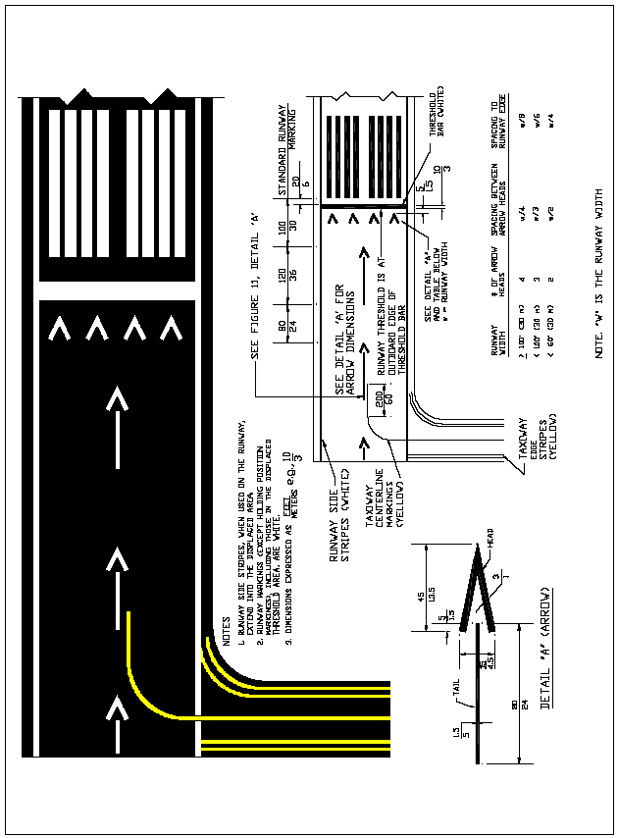

Figure 5. Displaced Threshold Markings

Figure 6. Marking for Taxiway Aligned with Runway

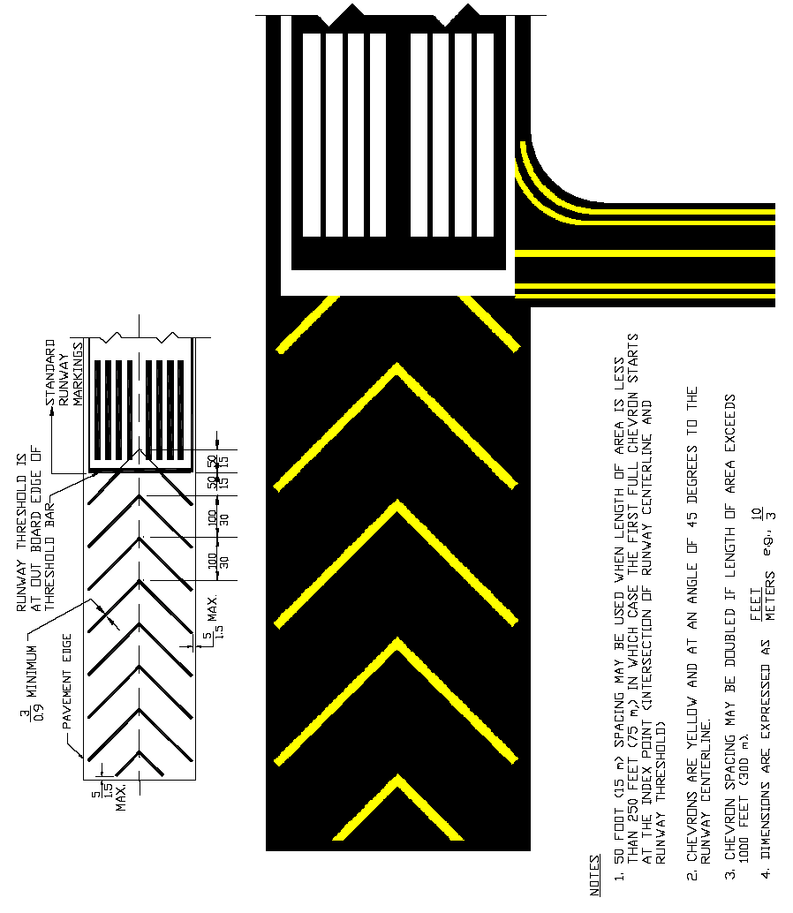

Figure 7. Markings for Blast Pads and Stopways

Figure 8. Marking for Blast Pad or Taxiway Preceding a Displaced Threshold

Figure 9. Runway Shoulder Markings

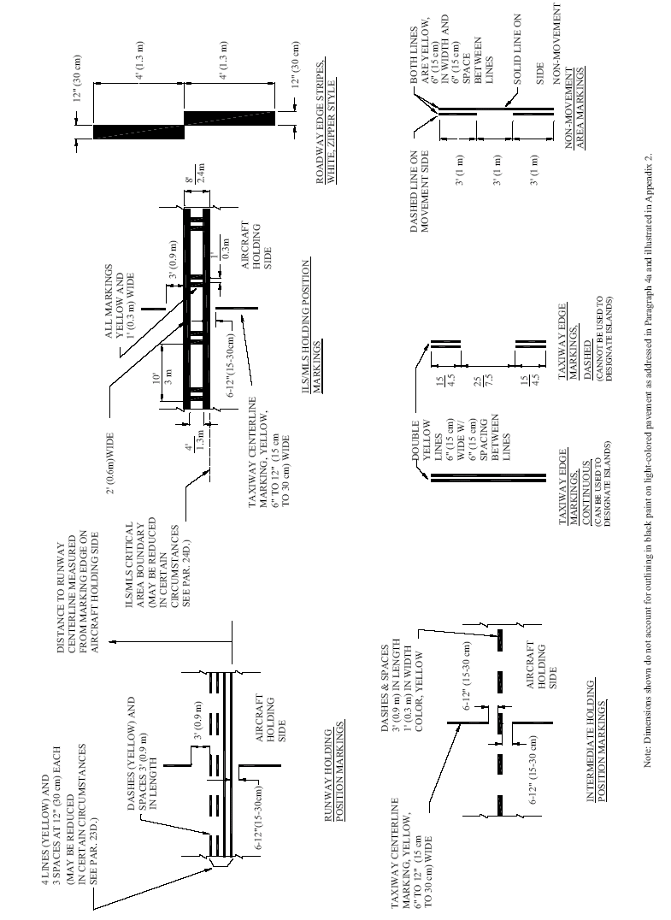

Figure 10. Marking Details

Figure 11. Taxiway Markings

Figure 12. Taxiway Centerline Marking Methods

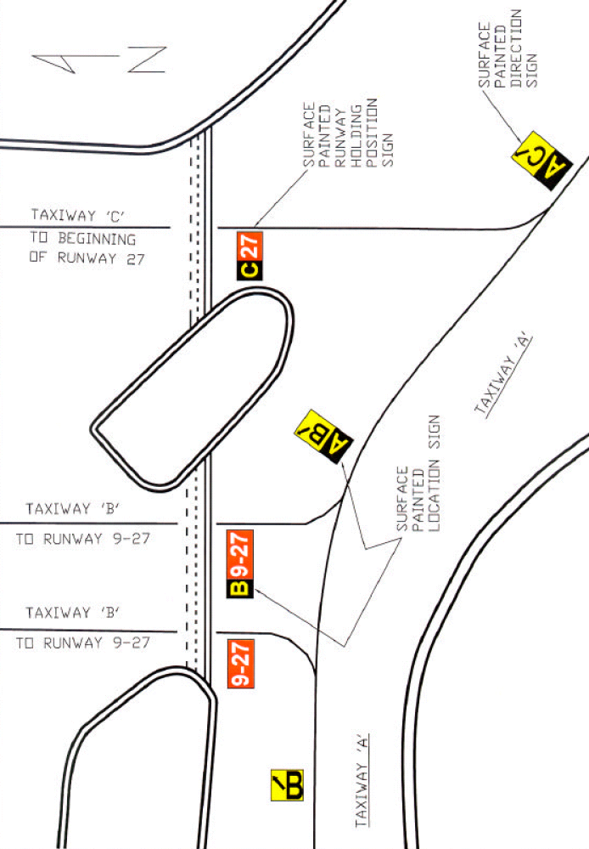

Figure 13. Surface Painted Signs

Figure 14. Surface Painted Gate Identification Signs

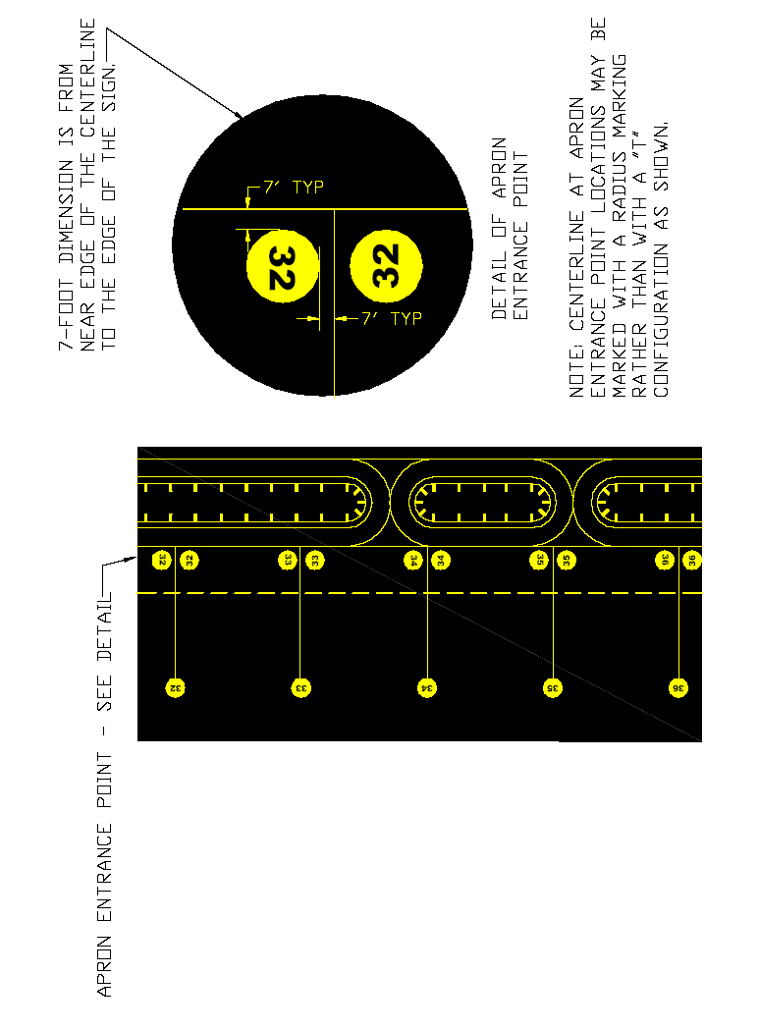

Figure 15. Surface Painted Apron Entrance Point Signs

Figure 16. Taxiway Shoulder Markings

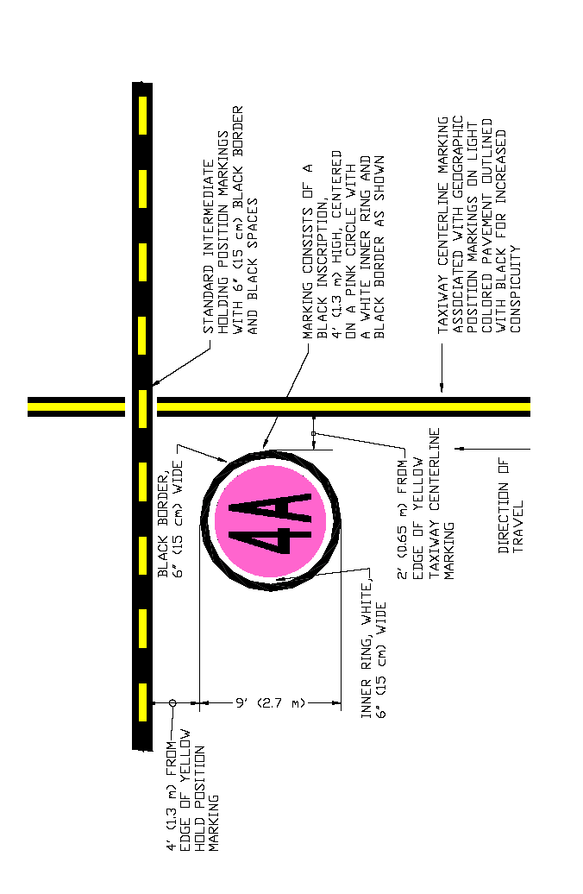

Figure 17. Geographic Position Markings

Figure 18. Vehicle Roadway Markings

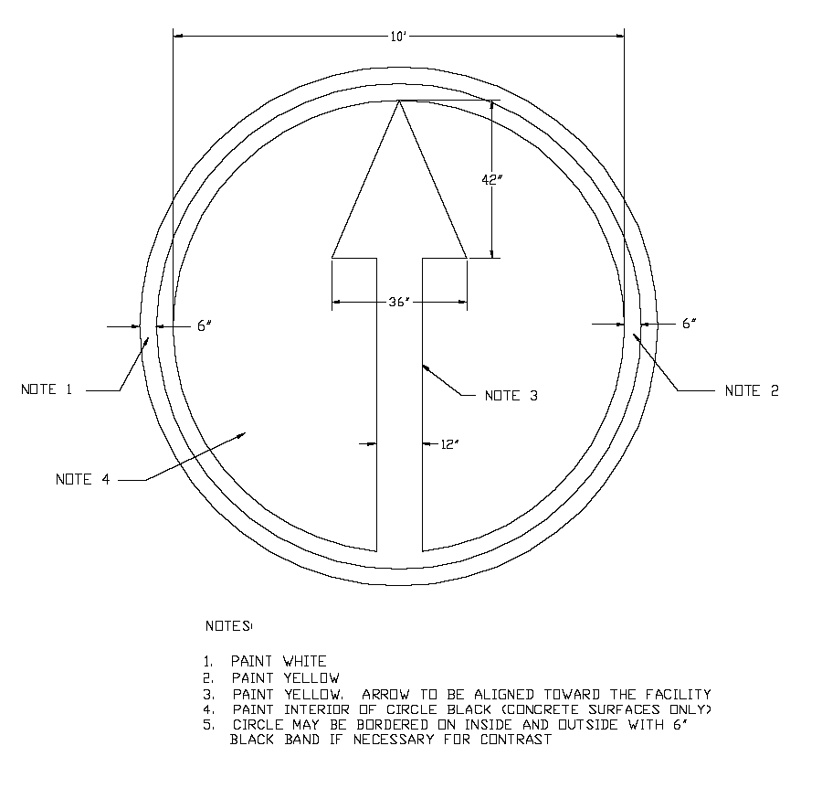

Figure 19. VOR Receiver Checkpoint Markings

Figure 20. Closed Runway and Taxiway Markings

APPENDIX 1. INSCRIPTIONS FOR SIGNS AND GEOGRAPHIC POSITION MARKINGS.

Figure A-1. Pavement Markings ABCDEFGH

Figure A-2. Pavement Markings IJKLMNOP

Figure A-3. Pavement Markings QRSTUVWX

Figure A-4. Pavement Markings YZ123456

Figure A-5. Pavement Markings 7890-,↑

APPENDIX 2. Examples of Markings Outlined in Black.

This appendix illustrates the acceptable layout for various markings outlined in black. The black paint extends at least six inches beyond the outside edge of the markings. All spaces between paint lines in markings comprised of two or more lines or dashes are painted in black as illustrated in the figures that follow. An alternate outlining pattern is provided for dashed taxiway edge line markings. These figures are not drawn to scale.

Figure B-2. ILS/MLS Holding Position Marking

Figure B-1. Runway Holding Position Marking

Figure B-3. Continuous Taxiway Edge Line Marking

Figure B-4. Dashed Taxiway Edge Line Marking

25 ft
25 ft

Figure B-5. Alternate Outlining Method for Dashed Taxiway Edge Line Marking

Figure B-6. Taxiway Centerline Marking

Figure B-7. Intermediate Holding Position Markings

Figure B-8. Non-movement Area Boundary Marking

APPENDIX 3. ENHANCED MARKINGS FOR RUNWAY HOLDING POSITION.

1. GENERAL. Enhanced taxiway markings are intended to provide additional visual cues to taxiing pilots to help them identify the location of the runway holding position. This appendix provides standards for these enhanced markings and guidance, including examples, on where to use the enhanced markings.

The figures included in this appendix are not drawn to scale.

2. APPLICABILITY. The guidelines and standards contained in this appendix for enhanced taxiway markings may be used as a runway incursion prevention initiative. They may be used in combination or separately with existing taxiway markings. However, all intersections at an airport must use the same combination of markings.

3. ENHANCED TAXIWAY CENTERLINE MARKINGS.
Error: Reference source not found
3” (7.62 cm)
Note 1: Regardless of whether the centerline is 6 inches or 12 inches (15 or 30 cm) wide, the dashed lines provided by the enhancements will always be 6 inches (15 cm) in width.

Figure C-1. Enhanced Taxiway Centerline Markings

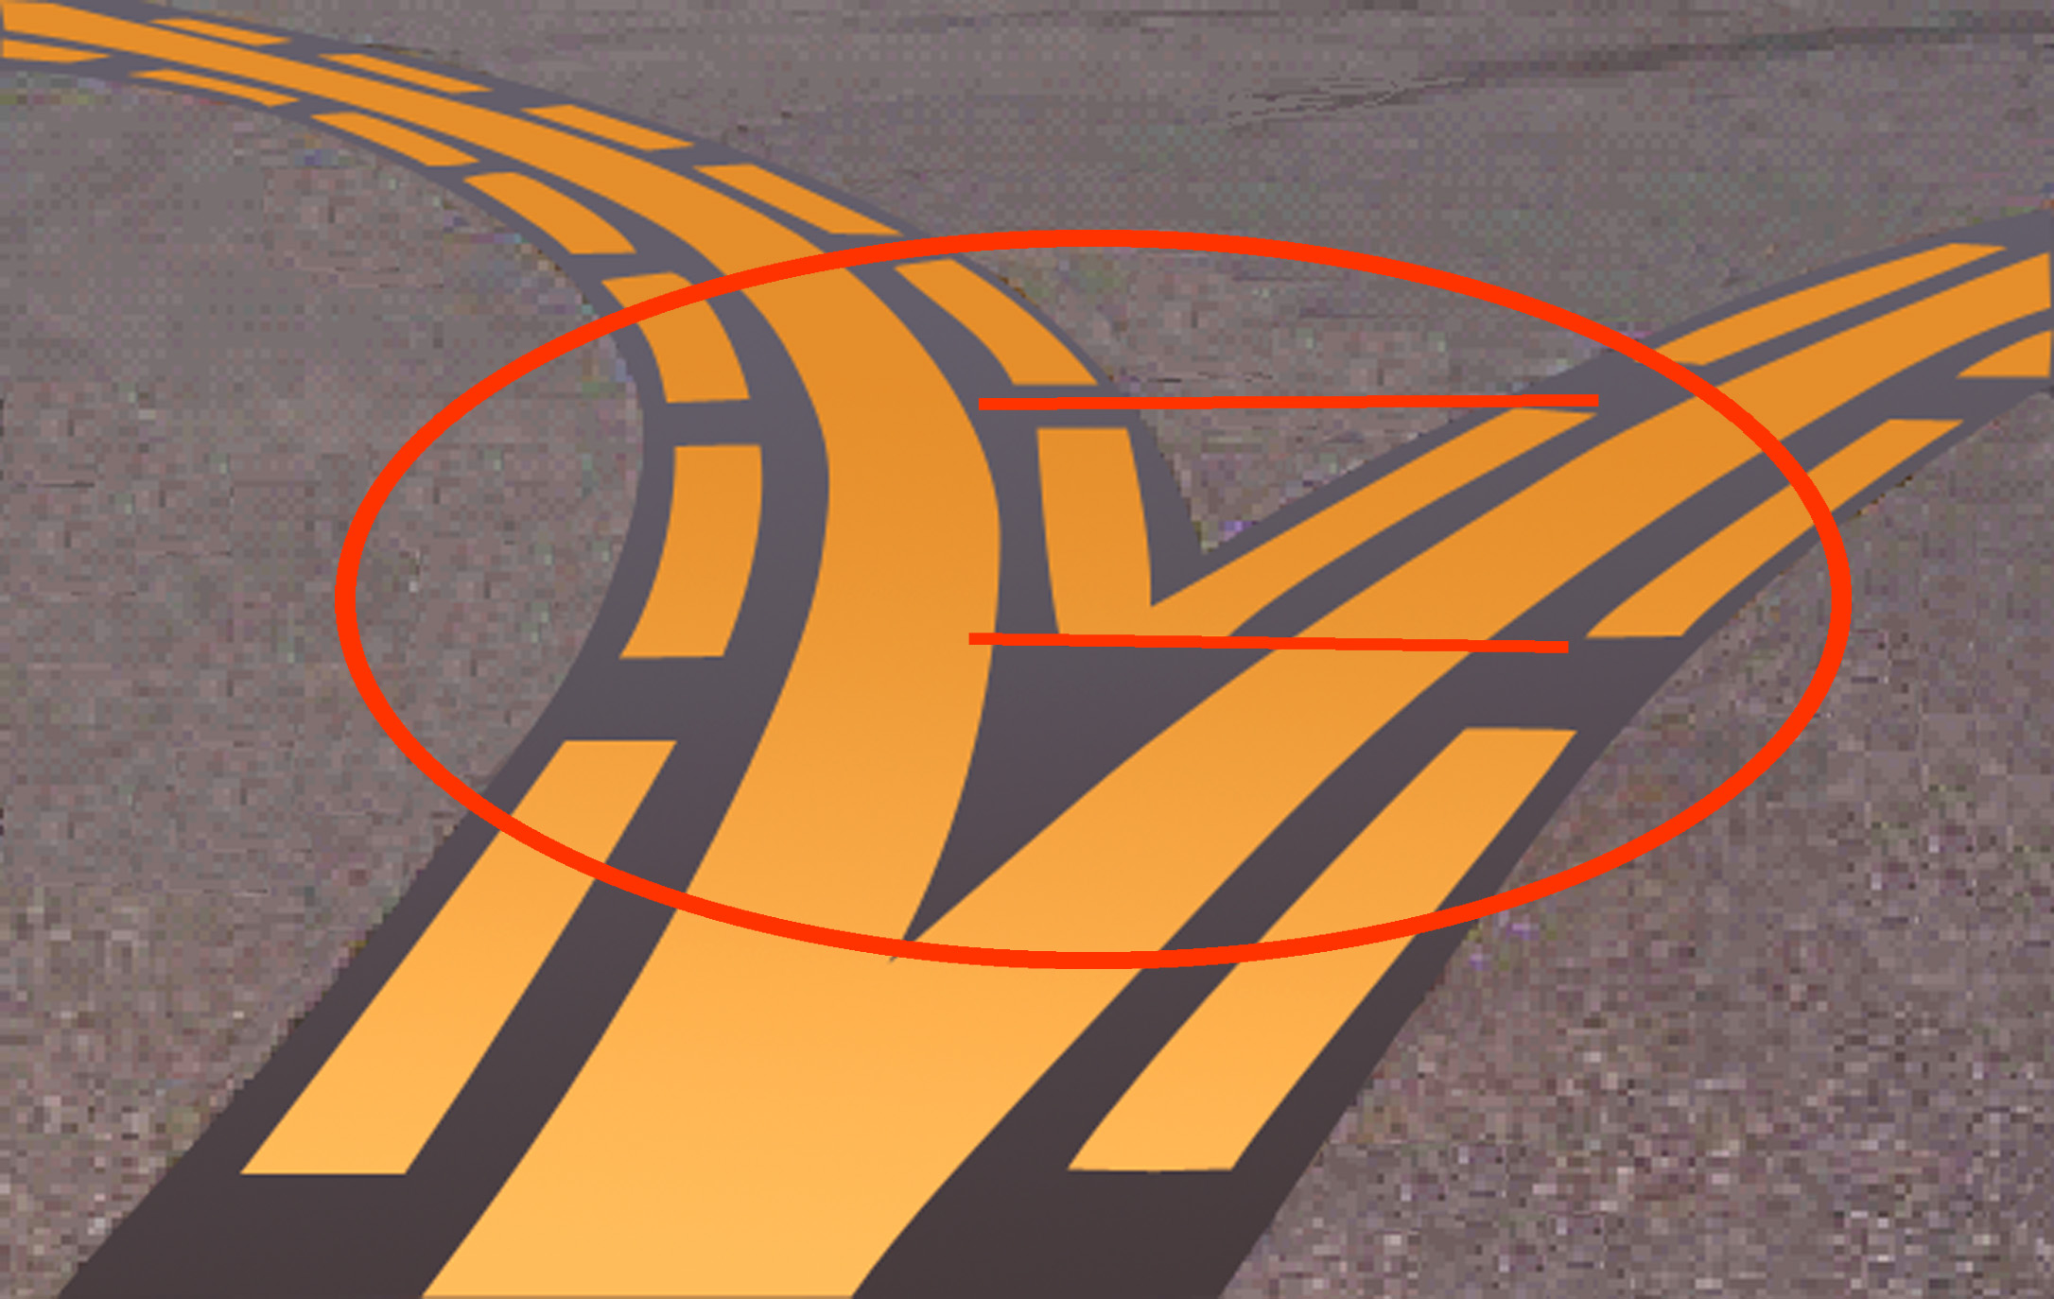Error: Reference source not found

Note: There must be no partial dashed lines less than 9-feet (2.74 m) at the point of convergence. The first inside dashed lines must be aligned with the outside dashed lines― starting and stopping with the dashed lines on the outside, as shown in the figure above.

Figure C-2. Dashed Lines at Converging Taxiway Centerlines

4. ENHANCED RUNWAY HOLDING POSITION MARKINGS.

Error: Reference source not found
Taxiway edge stripe abuts to edge
of holding position marking. [add 6 inch gap on hold side/ 3 foot gap on runway side]

Figure C-3. Enhanced Runway Holding Position Markings on Taxiways

5. SURFACE PAINTED HOLDING POSITION SIGNS.

Error: Reference source not found
16-34
16-34
2’- 4’ (0.67-1.34 m)
3’ –10’ (0.91 – 2.75 m)
15” (38 cm)
9-12’
(3 - 3.67 m)
2’- 4’ (0.67-1.34 m)
The inscription must have a height of 12’ (3.67 m);
however, it may be reduced, as necessary, to the
minimum height of 9’ (3 m).

Figure C-4. Surface Painted Holding Position Signs

2’- 4’ (0.67-1.34 m)
2’- 4’ (0.67-1.34 m)
16-34
16-34
3’ - 10’
(1-3 m)
9-12’
(3-3.67 m)

3’ - 10’
(1-3 m)

15” (38 cm)
The inscription must have a height of 12’ (3.67 m);
however, it may be reduced, as necessary to the
minimum height of 9’ (3 m).

Figure C-5. Surface Painted Holding Position Signs when Taxiway Centerline is not Perpendicular to Runway Holding Position Marking

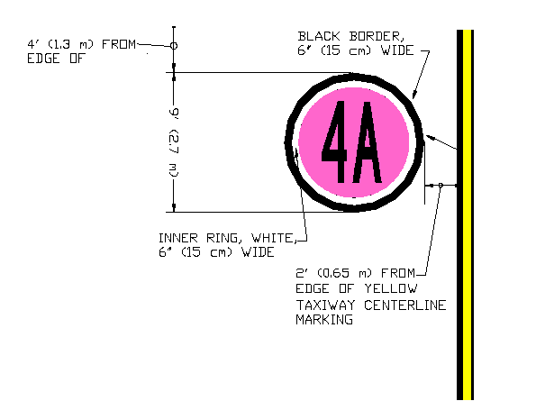
Error: Reference source not found
16-34
16-34
2’- 4’ (0.67-1.34 m)
3’ – 10’ (0.91 – 2.75 m)
15” (38 cm)
9’-12’
(3-3.67 m)
2’- 4’ (0.67-1.34 m)

Note: Because the geographic position marking cannot be located at a runway holding position for the low-visibility runway (see Paragraph 32(b)), this figure would apply only where the designated taxi route for low-visibility operations crosses a runway that is not itself the low-visibility runway.

Figure C-6. Surface Painted Holding Position Signs Co-Located with a Geographic Position Marking
6. ADDITIONAL GUIDELINES FOR APPLICATION. The following illustrations provide examples of various runway holding position locations using the enhanced markings. The figures included in this appendix are not drawn to scale.

a. Two Taxiway Centerlines Converging at a Runway Holding Position Marking. Where two taxiway centerlines converge at a runway holding position marking, the surface painted holding position signs must be installed parallel to the runway holding position marking. As shown in Figure C-7, only one sign on either side of the two taxiway centerlines is practical.

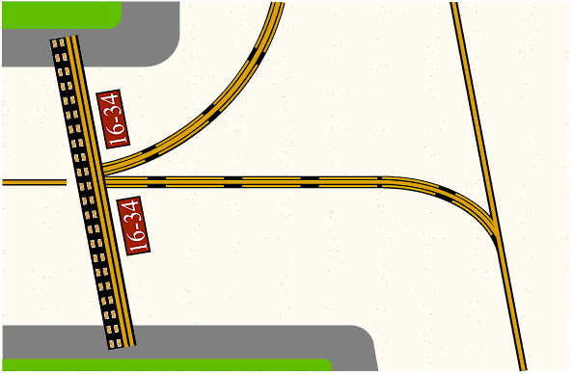
Error: Reference source not found

Figure C-7. Two Taxiway Centerlines Converging at a Runway Holding Position Marking
- Intersection of Two Taxiways at Runway End. In the case of two converging taxiway centerlines, surface painted holding position signs containing a single runway designator must be positioned parallel to the runway holding position marking, as shown in Figure C-8.

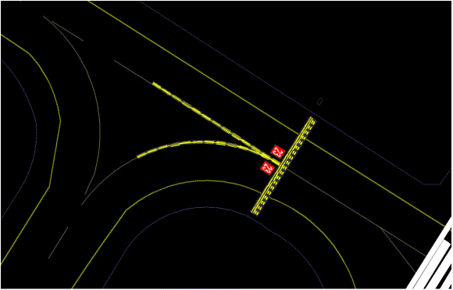
Error: Reference source not found

Figure C-8. Intersection of Two Taxiways at Runway End
c. Intersection of Three Converging Taxiway Centerlines. Figure C-9 illustrates taxiway centerline configurations when there are three converging centerlines.

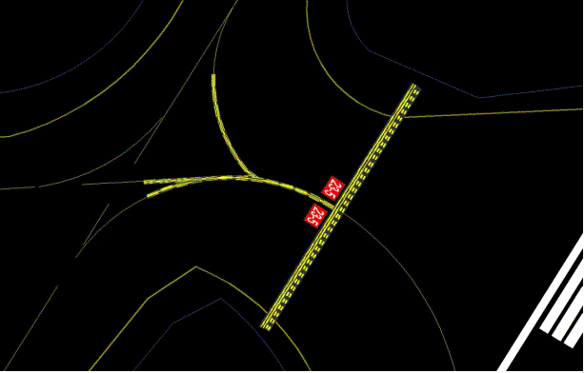

Error: Reference source not found

Figure C-9. Intersection of Three Converging Taxiway Centerlines

d. Intersection of Multi-Taxiway Centerlines with Less than 150 Feet (45.7 m) Between Taxiways. Figure C-10 illustrates different taxiway centerline configurations when there are three converging centerlines, less than 150 feet (45.7 m) between the runway holding position markings, and potential difficulty in positioning surface painted holding position signs in the available space.

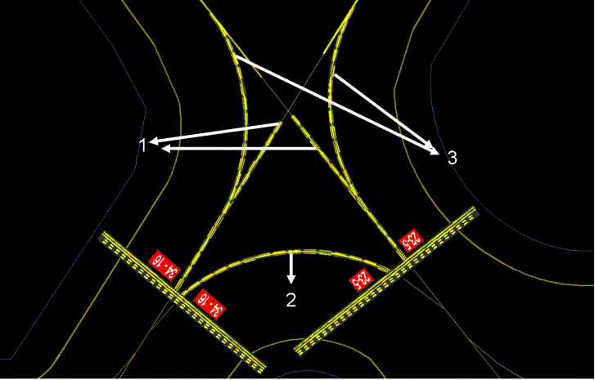

Notes for Figure C-10:
- Illustrates perpendicular taxiway centerlines less than 150 feet (45.7 m) (see Paragraph 21 e(3)(i)).
- Illustrates a curved taxiway centerline between two runway holding position markings with less than 150 feet (45.7 m) along the taxiway centerline (see Paragraph 21 e(3)(ii)).
- Illustrates two converging taxiway centerlines curving out to intersecting taxiway centerlines.

Figure C-10. Intersection of Multi-Taxiway Centerlines with Less than 150 Feet
(45.7 m) Between Taxiways
e. Two Taxiway Centerlines Intersecting a Runway Holding Position Marking. Figure C-11 illustrates an angled runway holding position marking that is intersected by two taxiway centerlines.
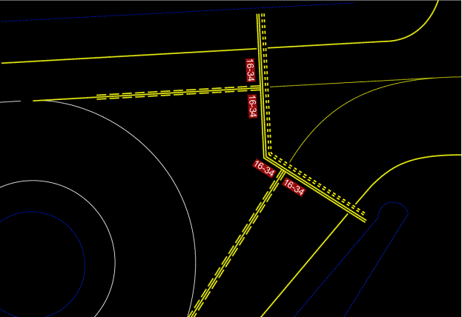

Figure C-11. Two Taxiway Centerlines Intersecting a Runway Holding Position Marking

f. Intersection of Stub Taxiway and Runway. Figure C-12 illustrates a solution for a stub taxiway that is less than 150 feet (45.7 m) long, with a 90-degree turn and angled taxiway shoulder areas.

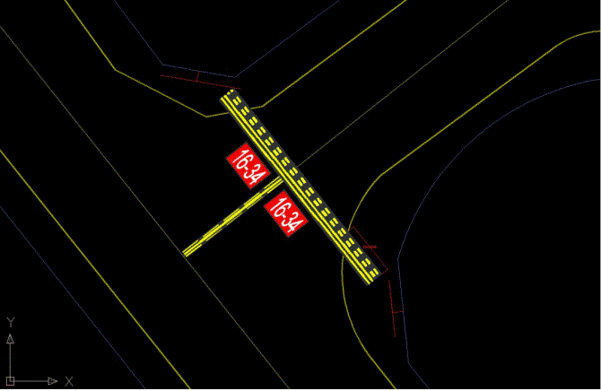

Figure C-12. Intersection of Stub Taxiway and Runway

