**Thirty-First Meeting of the**

**Informal South Pacific ATS Co-ordinating Group**

**(ISPACG/31)**

**Hawaii, USA**

**6 to 9 March 2017**

**Agenda Item 6, Other Business**

Volcanic Ash Exercise – VOLKAM Update

Presented by the United States (U.S.) Federal Aviation Administration (FAA)

**SUMMARY**

A summary of a volcanic ash exercise conducted in the far Eastern part of the Europe (EUR) Region is provided in this paper.

**1. INTRODUCTION**

1.1 Two steering groups were formed by the European Air Navigation Planning Group (EANPG) Programme Coordinating Group (COG) and North Atlantic (NAT) Implementation Management Group (IMG) to ensure continuation of regular volcanic ash exercises in the EUR and North Atlantic (NAT) Regions. The Volcanic Ash Exercises Steering Group for the far Eastern part of the EUR Region (EUR (EAST) VOLCEX/SG) planned and conducted a volcanic ash exercise called VOLKAM16 that simulated a volcano eruption of Karpinsky (Northern Kurile Islands) from 2200 Coordinated Universal Time (UTC) on 21 April 2016 to 0130 UTC on 22 April 2016.

1. **DISCUSSION**
   1. Elaborating on VOLKAM16, two volcanic ash plumes emanated from the simulated eruption of Karpinsky. One volcanic ash plume with height to flight level (FL)400, moved to the southeast – east then northeast impacting trans-east and Northern Pacific (NOPAC) routes. The other plume, with height to FL200, moved to the northeast in order to test Volcanic Ash Advisory Center (VAAC) Tokyo to VAAC Anchorage handover on the their border at 60N. The following aims and objectives were met.
   2. The objectives of the exercise (in bold) were met, with a note that improvements can be made in some areas.
      1. **Demonstrate coordination procedures between all participating parties (Air Navigation Service Providers, Air Traffic Management Centres, Aeronautical Information Services, Volcano Observatory, Volcanic Ash Advisory Centres, Meteorological Watch Offices and users)**
         1. Volcano Observatory provided Volcano Observatory Notice for Aviation (VONA) to Volcanic Ash Advisory Centre (VAAC) Tokyo, Meteorological Watch Office (MWO) Yelizovo, and Main Air Traffic Management Centre (MATMC) Moscow that triggered a Volcanic Ash Advisory from VAAC Tokyo, SIGMET from MWO Yelizovo and Notice to Airman (NOTAM) from NOTAM Office Moscow;
         2. Area Control Centre (ACC) coordination between Petropavlovsk-Kamchatsky and Fukuoka was demonstrated by utilizing the VOLKAM16 Letter of Agreement (LOA) contingency routing; ACC coordination between Anchorage and Oakland was demonstrated by transferring dozens of flights from Anchorage to Oakland; ACC coordination between Fukuoka and Oakland was demonstrated by adjusting Track 1 of Pacific Organized Track System (PACOTS) in order to avoid volcanic ash;
         3. MATMC Moscow coordination with ACCs Petropavlovsk-Kamchatsky, Khabarovsk and Magadan was demonstrated in that reroutes were reviewed and accepted into Russian Federation airspace;

* **Demonstrate tactical re-routes using available methods (use matrix from CPWG)**
  + Tactical reroutes were demonstrated between six airlines (American, Delta, United, Japan, All Nippon and Cathay Pacific) and seven ACCs serving seven flight information regions (FIRs), namely (Oakland, Anchorage, Petropavlovsk-Kamchatsky, Fukuoka, Sapporo, Magadan and Khabarovsk), noting a majority of reroutes would not require an unplanned stop for fuel. In addition, some aircraft, depending on performance and fuel availability, overflew the ash cloud that moved north with height to FL200;

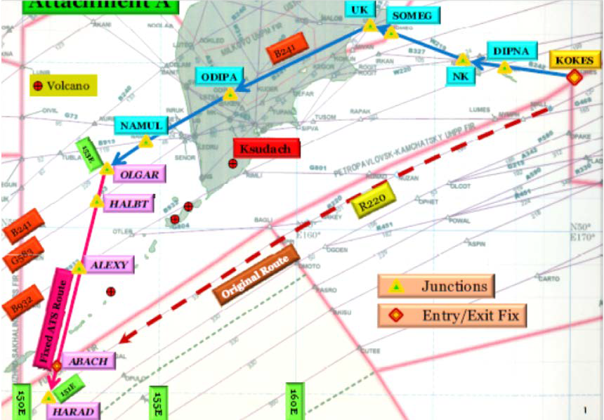

* **Demonstrate VAAC Tokyo and VAAC Anchorage handover**
  + VAAC Tokyo handover to VAAC Anchorage was demonstrated for the volcanic ash plume moving north of 60N;
* **Demonstrate transmission of special air-reports on volcanic ash in accordance to Annex 3 (aircraft->ACC->MWO->VAAC) beginning with voice communication from pilot to ACC**
  + Transmission of special air-reports were successful as observed on Satellite Distribution Service (SADIS). One special air- report was provided by voice;
* **Demonstrate information sharing via teleconferences and website (website to be confirmed)**
  + Information sharing was demonstrated via two teleconference calls. Participants provided relevant information in a succinct manner.
  1. The corresponding debrief meeting took place in Paris on 11 May 2016 in order to develop recommendations for improving the response in future real volcanic ash events, as well as for future exercises. A total of eight recommendations were formulated by the debrief meeting which were documented in the summary of discussions and posted on the ICAO Portal under group EEVOLCEXSG, subtitle VOLKAM16. Three recommendations related to routing around the volcanic ash cloud are reproduced below:
     1. **Standardize reroute requests;**
        1. Reroute requests were provided in various formats (Excel files, texts or copies of ATS plan). Providing a standard format template (FPL format recommended) in advance would assist in interpretation of reroute requests. Consider using one email for all reroute requests that all participants will have access to or which will forward all incoming messages to participants concerned;
     2. **Include coordination procedures in Exercise LOA on contingency routes;**
        1. Japan could not carry out flight information exchange between USA and Russian Federation since the coordination was conducted in advance. Providing the coordination procedures among countries as an Appendix to the Exercise LOA would assist in flight information exchange considering the forthcoming change in FIR boundaries. ATC facilities are encouraged to conclude the permanent LOA to allow use of proposed detour routes;
     3. **Include procedures to publish ad-hoc traffic management initiatives in a volcanic ash event;**
        1. Since pre-coordinated routings may not work for a given volcanic ash situation (a different volcano erupts and/or different wind scenario), all navigation elements (waypoints, airways, etc.) used should be ones that are actually loaded in the existing databases (e.g. preflight). Publish ad-hoc traffic management initiatives in a real volcanic ash event (as well as for exercises) via NOTAM. This will reduce the number of reroute requests as well as overall workload for controllers, flight crews and dispatch.
  2. For more information related to VOLKAM16, the meeting is advised to review the report of the associated debrief meeting on the ICAO Portal (group EEVOLCEXSG).
  3. The EUR (EAST) VOLCEX/SG/9 meeting was held in Petropavlovsk-Kamchatsky, Russian Federation, from 8 to 10 August 2016, which developed a first draft VOLKAM17 Exercise Directive. A simulated volcano eruption of a volcano named Koshelev, located in Kamchatka, will take place from 2200 UTC on 20 April 2017 to 0130 UTC on 21 April 2017. The simulated volcanic ash cloud to FL450 will move south-east to impact trans-east routes, NOPAC routes and possibly PACOTS. The objectives are similar to those from the previous exercise, except that the plume will warrant a VAAC handover from VAAC Tokyo to Anchorage and then from VAAC Anchorage to Washington. In addition, Magadan and Fukuoka ACCs will develop a draft letter of agreement for contingency routes around ash (canned routes) for VOLKAM17 that may include Petropavlovsk-Kamchatsky. The reason for this is that by VOLKAM17, Magadan will control en-route airspace in both sectors in the vicinity of Kamchatka. Finally, KVERT will publish aeronautical information (e.g. FIR boundaries) on the website containing the PUFF model output.

**3. ACTION BY THE MEETING**

3.1The meeting is invited to:

a) Note the information provided