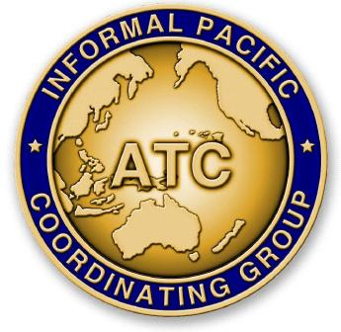
THE FORTY-NINTH MEETING OF THE
INFORMAL PACIFIC ATC COORDINATING GROUP
(IPACG/49)

Mita Kaigisho – Tokyo, Japan
December 5, 2024

Agenda Item X: Category

Title of Paper

(Presented by Organization Name)
SUMMARY

- Introduction

- Discussion

- Conclusion

  - The meeting is invited to note the information provided.

