Thirty-Seventh Meeting of the
Informal South Pacific ATS Co-ordinating Group
(ISPACG/37)

Thirtieth Meeting of the FANS Interoperability Team (FIT/30)

Papeete, Tahiti
26 April 2023

Agenda Item 8: Information Papers

Iridium Certus FAA Evaluation Planning

Presented by Iridium Satellite

SUMMARY
Iridium Certus FAA Evaluation Planning for PBCS Monitoring

- Introduction
  - Iridium has been working with our partners on the planned launch of Iridium Certus AMS(R)S capable avionics.
  - Iridium has coordinated with the FAA in the FAA PARC CWG for the Iridium Certus Evaluation. Iridium has created the Iridium Certus Evaluation Workbook that is the “living” document on the planning for the evaluation.
  - As per the FAA Evaluation, both voice and data will be monitored as per RCP240/RSP180 for data and RCP400V for voice
Note: It is understood that ICAO is working to remove RCP400V from PBCS Manual V3, however all past FAA Evaluations, including most recent Inmarsat SBB used RCP400V. Therefore it will be the same for Iridium Certus given the apparent inequity if alternative standard is to be applied.
  - As per the FAA Evaluation, the following metrics will be captured:
    - At least 1,000 ATS Voice calls
    - At least 75,000 FANS1/A data collections (include AOC messages)

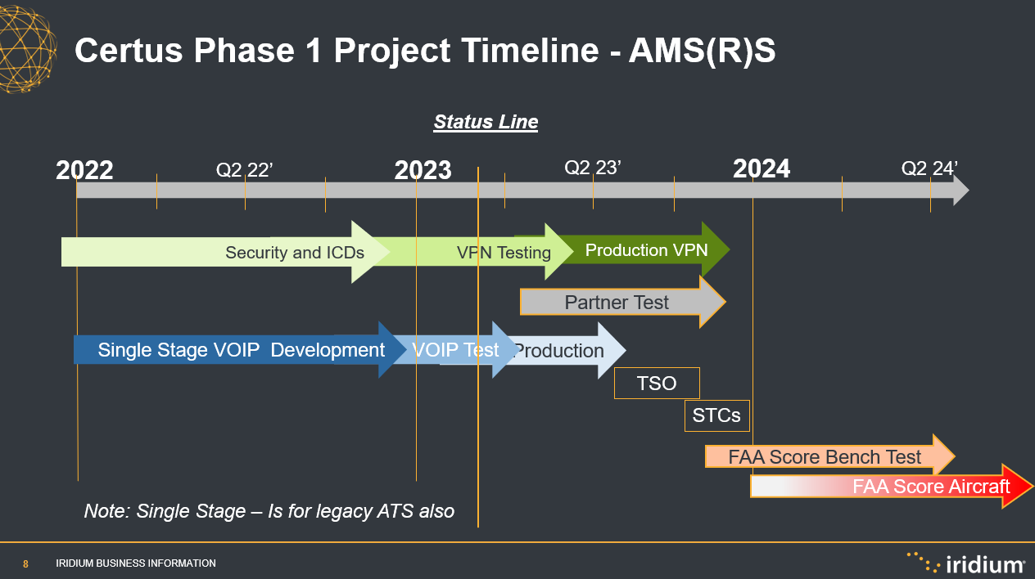
  - The current timing plan for the start of the evaluation is as per this timing chart:

  - Boeing has offered to support FAA Bench Testing using AOC data messages which will be supported in the FAA Evaluation.

  - Iridium will have aircraft operating in the North Atlantic. Formal details of the actual aircraft and flight plans will be provided through regular update to the ISPACG/FIT.

  - Iridium and our partners expect first aircraft to be operating in the early January 2024.

- Discussion

The launch of Certus requires the PBCS evaluation as per prior evaluations.
  - Iridium aircraft will be required to operate in all of the major global airspace – Atlantic, Pacific and South Pacific
  - The growth of Iridium equipped aircraft will be slow as per new technology adoption
  - There are no restrictions on aircraft that are taking part in the evaluation – normal commercial operations
  - If required, ANSPs will support programs for increased ATS voice calls such as part of departure clearance or other voice call checks. The need for this will be planned in the FAA PARC if required
  - Iridium has data monitoring and collection capabilities that will enable monitoring of RCP/RSP technical performance, PORT and CMU/FMS technical performance.
- Action by the Meeting
  - The ISPACG/FIT is invited to:
    - note the information provided;
    - endorse support of Iridium Certus Evaluation and note in actions of ISPACG/FIT
    - provide direction as deemed necessary.

/-- END --

