FANS Interoperability Team Meeting
(FIT/27)

Virtual Meeting
30 June 2020

Agenda Item 6: Any Other Papers

PBCS POST-IMPLEMENTATION MONITORING NZZO

Presented by Airways New Zealand

SUMMARY

This paper describes the monthly PBCS post-implementation monitoring and reporting carried out by Airways New Zealand. This monitoring program has been developed using the guidance in Doc 9869 PBCS Manual to meet Annex 11 requirements and ensure that the CPDLC communication and ADS-C surveillance systems operate to the required RCP24/RSP180 performance levels to maintain efficient and safe operations.

1. INTRODUCTION

  - Airways uses performance-based separations utilizing PBCS RCP240/RSP180 specifications. Doc 9869 PBCS Manual states in paragraph 4.3.1.7 a) that the ANSP should establish a local PBCS monitoring program, to ensure that the communication and surveillance capabilities in the airspace applicable to its ATS units continue to meet the RCP/RSP specification, and to coordinate monitored data, analysis, and corrective action. Further guidance for local PBCS monitoring is provided in the PBCS Manual paragraph 4.5.2 (Attachment 4).
  - To satisfy this guidance Airways monitors PBCS RCP240/RSP180 performance on a monthly basis. A monthly PBCS performance report is submitted to the responsible authority (New Zealand Civil Aviation Authority) and PBCS performance degradations are raised as problem reports to the ISPACG CRA through the CRA website.

2. DISCUSSION

2.1 Airways extracts ADS-C and CPDLC data points every month from the Airways Oceanic Control System (OCS) in formats specified in Doc 9869 PBCS Manual Annex D. These records are extracted from OCS as .csv files and are manually processed before importing to a website based PBCS analysis tool. The monthly records are also stored as excel files for subsequent analysis. The PBCS analysis website can produce combined reports of ADS-C and CPDLC performance over specified periods. These combined reports are used as input to the regional reporting of PBCS performance on the CRA website. Airways also uses these combined reports for our monthly performance analysis. Example of a raw combined report .csv file is shown in Figure 1.

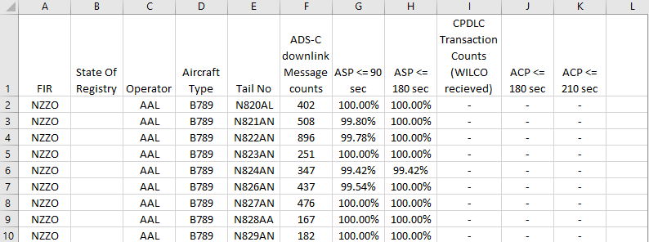

Figure 1: Example consolidated report as extracted from website

2.2 Excel reports of observed ASP and ACP are created from the raw combined report .csv data as illustrated in Figure 2. Minor processing of the raw data includes adding a color key in the performance columns, identifying PBCS qualified aircraft with a color key and removing two unnecessary columns. These excel reports now highlight any performance degradation for further analysis. We have been using a number of different combined reports to assist in analysis. These include combined reports of individual tail number performance, combined reports of aircraft operator and aircraft type for the current month, and combined reports of the previous three months consolidated data to increase the number of data points available for analysis. Two combined reports used in the June 2020 assessment are attached as Attachment 2 and Attachment 3.

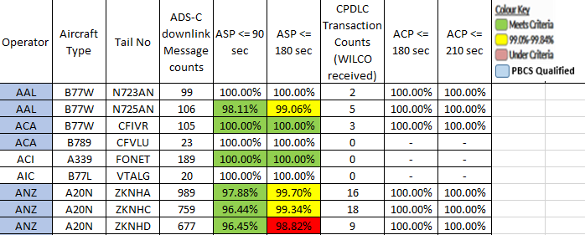

Figure 2: Example consolidated report of ASP and ACP
2.3 Individual records in the combined reports are not assessed where the number of data points is less than 100. Where records with 100 or greater data points indicate performance deterioration below ASP or ACP criteria, data is extracted from the Excel raw data files for periods where the latency exceeds requirements. Figure 3 illustrates a recent example.

Date | RGS | REP_TYPE | Latitude | Longitude | AC_time | OCS_time | Downlink_time
20200121 | XXH | P | -24.4298 | 177.5677 | 19:58:15 | 19:58:56 | 41
20200121 | XXH | W | -25.0039 | 177.3341 | 20:03:03 | 20:07:45 | 282
20200121 | XXA | P | -26.3032 | 177.0871 | 20:13:11 | 20:14:58 | 107
20200122 | XXP | P | -34.415 | 176.7161 | 02:15:31 | 02:26:46 | 675
20200122 | XXP | W | -34.1443 | 176.9305 | 02:17:47 | 02:27:53 | 606
20200122 | XXP | P | -32.5626 | 178.0324 | 02:30:27 | 02:30:43 | 16
20200122 | XXP | P | -32.0013 | 178.4125 | 02:34:54 | 02:36:28 | 94
20200122 | XXH | P | -30.6692 | 179.2931 | 02:45:23 | 02:56:06 | 643
20200122 | XXH | W | -29.9973 | 179.7264 | 02:50:42 | 02:56:31 | 349
20200122 | XXH | P | -29.0291 | -179.661 | 02:58:18 | 02:59:02 | 44
20200207 | XXH | W | -34.2851 | 177.7571 | 21:25:28 | 21:25:41 | 13
20200207 | XXH | W | -34.482 | 177.4898 | 21:27:49 | 21:27:59 | 10
20200207 | XXA | P | -35.0191 | 176.8797 | 21:33:50 | 21:37:59 | 249
20200208 | XXA | P | -36.4909 | 174.8304 | 02:11:01 | 02:11:07 | 6

Figure 3: Example of deterioration extracted from raw records
2.4 The extracted raw data records are then assessed, and an action plan developed. For the data illustrated in Figure 3 this was:

Assessment:
Data analysis shows significant latency delays when transitioning between satellite RGS 21/22 January and 7 February and at initial contract establishment on 22 January”

Action Plan:
- 16/3 Raise FANS PR to investigate (ACNZ_2020_04).
- Obtain Oakland performance for this tail on the same dates.
- Wait for Oakland feedback before action on ASP below 95% normal operating. A bad day at the office on 22/1 has skewed performance. If Oakland results OK recommend monitor only at this stage.

2.5 The performance degradations assessed each month are con solidated into a report for the CAA. The NZZO June report is attached as Attachment 1.
2.6 In addition to monitoring RCP240/RSP180 availability is monitored by maintaining a monthly record of notified CSP outages and an assessment as to operational impact as shown in Figure 4 for June 2020.

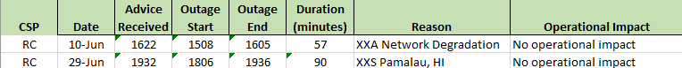

Figure 4: monitoring notified CSP outages and operational impact

2.7 Most FANS problem reports raised by NZZO come about through the monthly PBCS performance monitoring process and are always accompanied by the appropriate data points and investigation carried out by Airways to facilitate the CRA investigation.
2.8 In addition to monthly performance reports Airways provides PBCS performance data to ISPACG for the ISPACG annual report to ICAO, and to the FAA who consolidate performance reports for the CRA website. The PBCS analysis website is regularly used within Airways to review PBCS performance and update our operators on performance when requested.

3. ACTION BY THE MEETING

3.1 The meeting is invited to:

a) Note the information in this paper.

Attachment 1: NZZO June 2020 performance.docx

Attachment 2: NZZO combined_report_tail 202006

Attachment 3: NZZO combined_report operator 202004_202006

Attachment 4: PBCS Manual paragraph 4.5.2 Local PBCS monitoring programme

