FANS Interoperability Team Meeting
(FIT/27)

Virtual Meeting
30 June 2020

Agenda Item 6: Any Other Papers

LATENCY MONITOR REJECT ANALYSIS

Presented by Airways New Zealand

SUMMARY

This paper presents an analysis of Latency Monitor reject messages received from Airbus aircraft operating in NZZO during the period January 2019 to June 2020.

1. INTRODUCTION

  - Airways implemented the latency monitor on 21 June 2018 to support PBCS safety requirement #15 and mitigate the effects of late CPDLC uplink messages received at the aircraft.
  - On receipt of a CPDLC uplink message whose latency exceeds the 300 second monitored value Airbus aircraft do not present the uplink to the flight crew and send a reject message to ATC.
  - This paper provides an analysis of latency reject messages received at NZZO during the period January 2019 to June 2020.

2. DISCUSSION

2.1 With our normal pre-pandemic traffic levels NZZO was averaging 4627 set latency monitor uplinks a month. With significantly reduced traffic levels during the pandemic since March 2020 we are now averaging 1115 uplinks a month.
2.2 During the review period a total 345,049 CPDLC uplinks were initiated by NZZO, with 116,377 sent to Airbus aircraft. A total of 101 latency reject messages were received from these aircraft. This is a latency failure rate of 1 in 1152 messages or 0.09%. An analysis of the number of reject messages and the delays observed is shown in Figure 1. We were observing an average of seven rejects a month in the pre-pandemic period Jan-19 to Feb-20. However, during the reduced traffic levels experienced in the pandemic from Mar-20 through Jun-20 we have not observed any latency reject messages.
2.3 Table 1 provides a monthly breakdown of the number of reject messages and their classification. Forty-three messages (43%) are sent by HFDL. Eleven of these were sent when aircraft was operating in Oceanic airspace with no Satcom, the remaining thirty-two were sent by HFDL when the aircraft was operating Inmarsat Satcom. Twenty-five messages (25%) were sent via Inmarsat Satcom, twenty-one (21%) were sent by Iridium Satcom. Ten messages (10%) were attributed to an aircraft time source error.

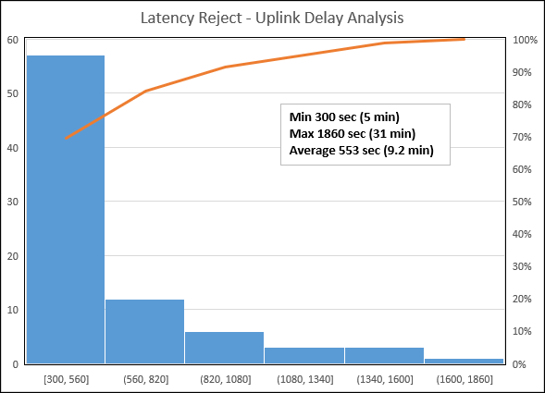

Figure 1: Uplink Delay Analysis
2.4 The number and percentage of CPDLC uplink messages sent via different RGS types in NZZO during the review period is illustrated in Figure 2. The latency reject message rate for CPDLC uplinks via HFDL is 4%, via Iridium is 0.07% and via Inmarsat 0.03%.

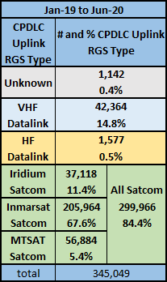

Figure 2: NZZO CPDLC uplink by RGS type

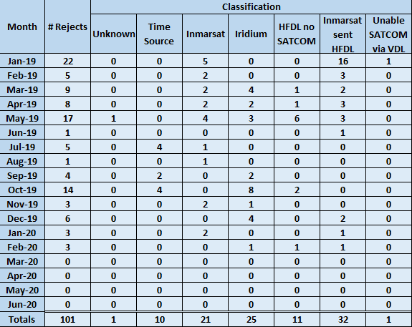

Table 1: Latency rejects by month and classification.
2.5 Airways has now started a monthly review of latency monitor rejects. A summary of all reject messages observed during the review period is attached.

3. ACTION BY THE MEETING

3.1 The meeting is invited to:

a) Review the information in this paper.

Attachment 1: Latency monitor reject summary Jan-19 to Jun-20

