Twenty-Seventh Meeting of the FANS Interoperability Team (FIT/27)

Virtual
28-29 July 2020

FANS Problem Report Briefing

Presented by the Central Reporting Agency (CRA)

SUMMARY

This paper describes recent investigation and disposition of submitted Future Air Navigation System (FANS) problem reports (PRs) that are relevant to the ISPACG FIT.

- INTRODUCTION
  - FANS stakeholders may submit PRs for investigation via the http://www.fans-cra.com/ website.
    - Airways Corporation of New Zealand (ACNZ) graciously hosts and maintains this website.
    - Stakeholders from multiple regions use this website, including the South Pacific region (ISPACG FIT), the North and Central Pacific region (IPACG FIT), the Asia region (FIT-Asia), and the North Atlantic region (NAT TIG).
  - Between preparation of the previous FANS PR briefing for the FIT/26 meeting held in March 2019 and preparation of this FANS PR briefing, FANS stakeholders submitted 272 PRs via the website, of which 31 PRs (11%) occurred in the South Pacific region. For comparison, the previous FANS PR briefing indicated that FANS stakeholders submitted 211 PRs, of which 34 PRs (16%) occurred in the South Pacific region.
  - Figure 1 illustrates the number of PRs submitted per year starting in 2006. The total number of PRs for 2020 is a linear projection based on the number of PRs submitted to date.
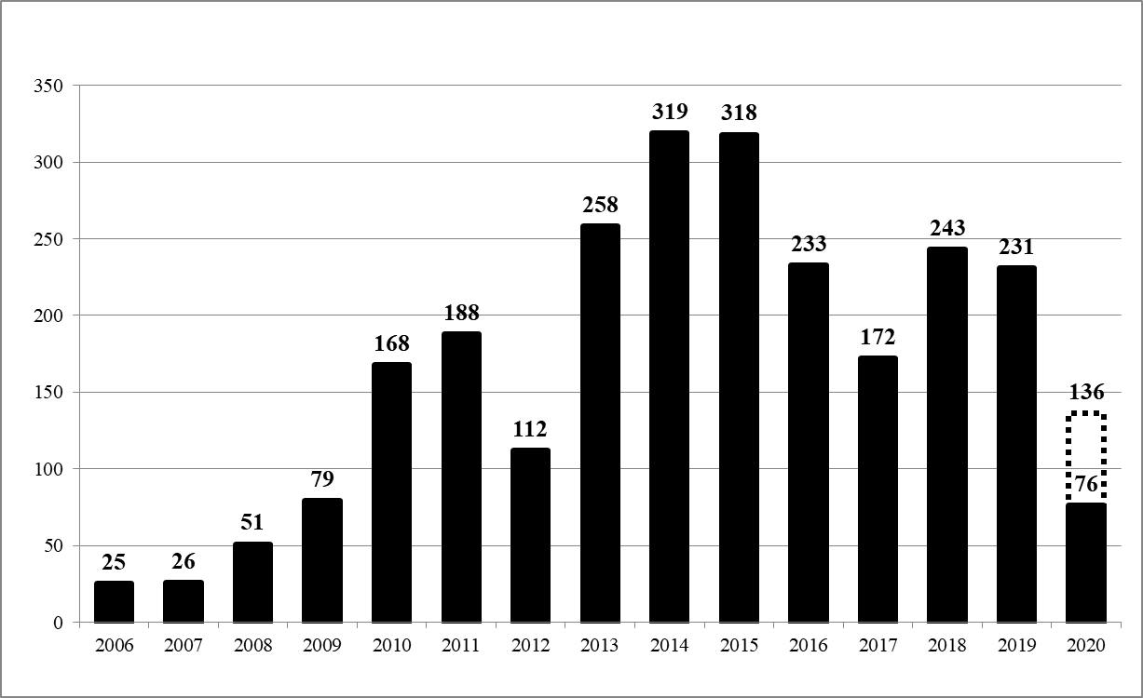Figure 1 FANS PRs Per Year
  - PR status definitions include the following:
    - Raised: The originator submitted the PR.
    - Active: The CRA processed and assigned the PR for investigation.
    - Open: The CRA completed the PR investigation but some form of corrective action is required.
    - Open – Fix Available: The appropriate stakeholder implemented corrective action and a fix is available for installation.
    - Closed: The CRA closed the PR because the appropriate stakeholder implemented corrective action.
    - Closed As Duplicate: The CRA closed the PR because the CRA is tracking the problem under another PR.
    - [Pending] Closed – Monitoring: The CRA closed the PR because no corrective action can be determined, but the CRA will monitor future PRs for any recurrences.
  - PR type definitions include the following:
    - TBA: To be assigned
    - Air: Avionics or flight crew issue
    - Air – Procedural: Flight crew issue
    - Air – Technical: Avionics issue
    - Ground: ATS unit system or air traffic controller issue
    - Ground – Procedural: Air traffic controller issue
    - Ground – Technical: ATS unit system issue
    - Network: Communication service provider or SATCOM service provider issue
    - Multiple: Multiple types of issues
    - None: Report is a non-problem
- DISCUSSION
  - The CRA has updated the status or progress of the following old PRs which are relevant to the ISPACG FIT:
    - 1198-MM, Closed / Air – Technical. This is the master PR for the problem of the Collins CMU (avionics ACARS router) potentially installed on 737, 747, 757, 767, and MD-11 airplanes to acknowledge receipt of a FANS uplink but then fail to deliver it to the FMC (avionics FANS applications), also known as CMU “ack and toss”. For the 747-8, Boeing certified core software -202 that fixes this problem. For the 737, 747-400, 757, 767, and MD-11, Collins certified core software -014 that fixes this problem.
    - 777 AIMS-2 BPV17B software, which became available in November 2019 on new airplanes delivered from Boeing and became available in December 2019 for retrofit via Service Bulletin, fixes the following PRs:
      - 1215-SN, Closed / Air – Technical. This is the master PR for 777s sending many duplicate downlinks.
      - 1533-SN, Closed / Air – Technical. This is the master PR for 777s sending early LEVEL [altitude] reports.
      - 1999-MM, Closed / Air – Technical. This is the master PR for 777s acknowledging receipt of but then intentionally discarding ACARS uplink blocks due to false-positive duplicate uplink block identifier (UBI) determination caused by an oversight (since corrected) in the ACARS air-ground protocol defined in ARINC Specification 618.
      - 2130-SH, Closed / Air – Technical. This is the master PR for 777s improperly refusing CPDLC connect requests by sending CPDLC disconnect requests with dM64 containing the designator of a previous CDA.
      - 2358-SH, Closed / Air – Technical. This is the master PR for 777s incorrectly constructing dM40 ASSIGNED ROUTE content with an undefined ATWaltitudetolerance enumeration of 3 for step climbs.
      - 2666-GM, Closed / Air – Technical. This is the master PR for 777s improperly rejecting nested uplinks by responding to them with label QX downlinks.
      - Additionally, BPV17B software complies with the RCP240 and RSP180 transaction time aircraft allocations for PBCS.
    - 2357-MM, Closed / Air – Technical. A dM40 ASSIGNED ROUTE [routeclearance] downlink from a 787 resulted in a parse error in the routeinformationadditional parameter. Boeing and Honeywell determined that this problem was caused by the navigation avionics (FMF) indicating an undefined ATWaltitudetolerance enumeration of 3 for step climbs to the communication avionics (CMF). Boeing and Honeywell fixed this problem in 787 FMF BPV4 software, which became available in September 2019.
    - 2459-MM, Closed / Air – Technical. Fukuoka and later Oakland Oceanic reported receiving an invalid ADS-C timestamp of 3,600 seconds in the basic group from a 787. This problem was due to a 787 ADS-C application software fault that caused it to incorrectly round the ADS-C timestamp to 3,600 seconds (instead of back to 0 seconds) when the current time is between 3,599.938 seconds and 3,599.999 seconds after the current hour. Boeing and Honeywell fixed this problem in 787 CMF BPv6 software, which became available in September 2019 on new airplanes delivered from Boeing and became available in December 2019 for retrofit via Service Bulletin. Of note, this software also implements the updated ACARS SATCOM retransmission timer (SAT7) value of 150 seconds that increases the likelihood of meeting the RSP180 end-to-end 99.9% (ET) requirement of 180 seconds.
    - 2586-MM, Closed / Ground – Technical. The ATS provider sent uM74 PROCEED DIRECT TO BRM with the BRM NDB incorrectly encoded as a navaid (instead of as a fixname per RTCA DO-258A / EUROCAE ED-100A), which caused the 777 avionics to select an unintended BRM navaid that was well outside of the region. The ATS provider changed the encoding for the BRM NDB and other NDBs to fixname in March 2019.
    - 2802-MM , Closed / Network. Auckland Oceanic reported (and Brisbane and Oakland Oceanic corroborated) that a 3.5-hour ACARS outage occurred with no CSP notification until several days later. The CSP subsequently reviewed its outage notification process and no further unnotified outages have occurred.
  - The CRA has investigated the following significant new PRs which occurred in the South Pacific region:
    - 2881-MM, Closed as Duplicate / Air – Technical. Airways New Zealand reported that ADS-C reports from a Boeing 787 were significantly delayed during one flight. Boeing believes that this event was a duplicate of PR 2382-MM for a known SATCOM avionics problem. Of note, the CRA closed PR 2382-MM on the basis that Inmarsat globally deployed a mitigation to that problem in February 2020.
    - 2942-MM and 2949-MM, Closed / Network. The FAA and Airways New Zealand reported increasing delays to downlinks sent via Iridium and failures of uplinks sent via Iridium during the period from 00:00 UTC to 01:00 UTC over several months. Iridium made database update processing and satellite load balancing improvements that FAA and Airways New Zealand confirmed resolved the problems.
    - 2964-MM, Active / TBA. Air New Zealand reported that an A321 flight crew received multiple delayed CPDLC uplinks. The CRA assigned this PR to Airbus to investigate. Please refer to the Airbus PR briefing for details regarding this PR.
    - 3025-MM, Closed / Network. Airways New Zealand reported that ADS-C reports from a Boeing 747-400 were significantly delayed after it switched to the Inmarsat Asia-Pacific satellite region. Inmarsat indicated that the problem occurred because of a “log-on storm” event following routine maintenance and that in April 2020 it implemented several changes to reduce the risk of another similar event due to signaling channel overload.
    - 3028-MM, Active / TBA. The FAA and Airways New Zealand reported that during a period of about 30 minutes downlinks were delayed and uplinks failed for multiple aircraft. The CRA assigned this PR to Collins (ARINC) and SITA to investigate.
    - 3057-MM, Active / TBA. Airways New Zealand reported that an Airbus A330 did not meet RSP180 at the 95% level during February 2020. The CRA assigned this PR to Airbus and Inmarsat to investigate. Please refer to the Airbus PR briefing for details regarding this PR.
    - 3060-MM, Closed / Air – Technical. Airways New Zealand reported that a Boeing 787 did not meet RSP180 at the 95% level during January and February 2020. Boeing was not able to determine the cause of this PR, but more recent performance data for the airplane in the Auckland Oceanic, Nadi, and Oakland Oceanic FIRs shows acceptable performance.
    - 3082-MM, Closed / Network. Airways New Zealand reported that a Boeing 767 did not meet RSP180 at the 95% level due to frequent HFDL use and no SATCOM use. The aircraft operator attempted to resolve the problem by changing various avionics hardware and software but performance did not improve. The aircraft operator eventually determined that a CSP registration issue prevented the airplane from using SATCOM. The aircraft operator and CSP resolved that issue and Airways New Zealand reported that the airplane has since performed well.
    - 3083-SH, Active / TBA. Airways New Zealand reported that an audit of messages which the uplink latency monitor rejected revealed several messages that did not contain a message reference number (MRN). The CRA assigned this PR to Airbus to investigate. Please refer to the Airbus PR briefing for details regarding this PR.
    - The CRA has received the following less-significant new PRs which occurred in the South Pacific region:
    - 2816-SH, Closed as Duplicate / Air – Technical. Airservices Australia reported that AFN address forwarding for an Airbus A330 failed on two occasions. The CRA assigned this PR to Airbus to investigate. Please refer to the Airbus PR briefing for details regarding this PR.
    - 2856-SH, Active / TBA. Airservices Australia reported that it established a CPDLC connection with an Airbus A330 but was unable to exchange further CPDLC messages with the airplane. The CRA assigned this PR to Airbus to investigate. Please refer to the Airbus PR briefing for details regarding this PR.
    - 2857-SH, Active / TBA. Airservices Australia reported that it lost its ADS-C connection with an Airbus A330 and that a subsequent demand contract request was not successful. The CRA assigned this PR to Airbus to investigate. Please refer to the Airbus PR briefing for details regarding this PR.
    - 2882-SH, Closed as Duplicate / Air – Technical. Airservices Australia reported that it was unable to establish a CPDLC connection as the CDA with an Airbus A330. The CRA assigned this PR to Airbus to investigate. Please refer to the Airbus PR briefing for details regarding this PR.
    - 2885-SH, Active / TBA. Airservices Australia reported that twice it temporarily lost its ADS-C connection with an Airbus A330. The CRA assigned this PR to Airbus to investigate. Please refer to the Airbus PR briefing for details regarding this PR.
    - 2893-SH, Closed / Air – Technical. Airways New Zealand reported that it received five ADS-C reports in response to a single demand contract request that it sent to an Airbus A321. The CRA assigned this PR to Airbus to investigate. Please refer to the Airbus PR briefing for details regarding this PR.
    - 2901-SH, Closed / Air – Technical. Airways New Zealand reported that it received an ADS-C acknowledgement from an Airbus A320 in response to an event contract request but then received three ADS-C negative acknowledgements and the resulting ADS-C disconnect from the airplane. The CRA assigned this PR to Airbus to investigate. Please refer to the Airbus PR briefing for details regarding this PR.
    - 2906-GM, Closed / Air –Technical. Airways New Zealand reported that ADS-C reports from a Boeing 747-400 were significantly delayed during two flights. Based on subsequent good performance, Boeing concluded that resetting or otherwise cycling power to the SATCOM avionics resolved an isolated problem.
    - 2908-SH, Active / TBA. Airways New Zealand reported that one aircraft operator’s Airbus A330 fleet does not meet the RSP180 180-second latency requirement at the 99% level. The CRA assigned this PR to Airbus to investigate. Please refer to the Airbus PR briefing for details regarding this PR.
    - 2914-GM, Closed / Air – Procedural. A Boeing 737 flight crew reported that they were unable to log on to Oakland Oceanic. Boeing discovered that the aircraft registration contained in the AFN contact message was incorrect and notified the aircraft operator accordingly.
    - 2925-GM, Active / TBA. Airservices Australia reported that it was unable to establish a CPDLC connection as the CDA with an Airbus A330, apparently due to SATCOM problems. The CRA assigned this PR to Airbus to investigate. Please refer to the Airbus PR briefing for details regarding this PR.
    - 2947-SH, Closed / Air – Technical. Air New Zealand reported that an A320 displayed “MSG RECORD UNRELIABLE” to the flight crew. The CRA assigned this PR to Airbus to investigate. Please refer to the Airbus PR briefing for details regarding this PR.
    - 2970-SH, Closed as Duplicate / Air – Technical. Air New Zealand reported that an A321 flight crew experienced CPDLC problems, including being contacted by Brisbane via VHF voice because Brisbane was not receiving CPDLC responses and failure of the CPDLC transfer of authority from Brisbane to Auckland Oceanic. The CRA assigned this PR to Airbus to investigate. Please refer to the Airbus PR briefing for details regarding this PR.
    - 2976-MM, Open / Air – Technical. A Gulfstream G650 flight crew reported that after establishing CPDLC connections with Auckland Oceanic and Brisbane they were unable to send any CPDLC downlinks. Honeywell indicated that the G650 Block 3 software update which Gulfstream plans to release in late 2020 will resolve this problem.
    - 3001-SH, Closed / Air – Technical. Airways New Zealand reported that ADS-C reports from a Boeing 777 were significantly delayed during one flight, even though the airplane previously performed well. Based on subsequent good performance (including on the following day), Boeing concluded that resetting or otherwise cycling power to the SATCOM avionics resolved an isolated problem.
    - 3023-MM, Open / Air – Technical. A Gulfstream G550 flight crew reported flight deck indications that an expected CPDLC transfer of authority from Auckland Oceanic to Brisbane failed. Honeywell indicated that the next G550 avionics certification (Cert India, which is planned to become available in early 2021) will resolve this issue.
    - 3026-MM, Open / Air – Technical. Airways New Zealand reported that a Boeing 787 reverted from SATCOM to HFDL for approximately one hour with corresponding delays to ADS-C reports. Inmarsat reported that it did not see any problems from its perspective. Boeing has not been able to determine the cause of this PR, but it is continuing to investigate it.
    - 3058-MM, Active / TBA. Airways New Zealand reported that it received an ADS-C acknowledgement from an Airbus A320 in response to an event contract request but then received three ADS-C negative acknowledgements and the resulting ADS-C disconnect from the airplane, plus another ADS-C acknowledgement. The CRA assigned this PR to Airbus and Iridium to investigate. Please refer to the Airbus PR briefing for details regarding this PR.
    - 3059-SH, Active / TBA. Air New Zealand reported that an A320 displayed “MSG RECORD UNRELIABLE” to the flight crew. The CRA assigned this PR to Airbus to investigate. Please refer to the Airbus PR briefing for details regarding this PR.
    - 3080-MM, Open / Air – Technical. Airways New Zealand reported that ADS-C performance by a Boeing 787 degraded during May 2020. Boeing has not been able to determine the cause of this PR, but it is continuing to investigate it.
    - 3081-MH, Open / Air – Technical. Airways New Zealand reported that ADS-C performance by a Boeing 777 degraded during May 2020, evidently due to SATCOM transition issues. Boeing has not been able to determine the cause of this PR, but it is continuing to investigate it.
    - 3085-CJ, Active / TBA. Airservices Australia reported unreliable CPDLC and ADS-C connections with a Boeing 747-8. Boeing is investigating this PR.
    - 3087-RP, Active / TBA. Airservices Australia reported unreliable CPDLC and ADS-C connections with a Boeing 767. Boeing is investigating this PR.
    - 3088-MM, Active / TBA. A Falcon 7X flight crew reported that they could not establish a CPDLC connection with Melbourne even though an ADS-C connection was established. Honeywell is investigating this PR.
- ACTION BY THE MEETING
  - The CRA invites the ISPACG FIT to:
    - note the content of this paper; and
    - promote expeditious resolution of Active and Open PRs.

