FANS Interoperability Team Meeting
(FIT/26)

Queenstown, NEW ZEALAND
18 – 22 March 2019

Agenda Item 5: Working Papers

Airbus PR Briefing

Presented by Airbus

SUMMARY

This paper provides the analysis of the new FANS PRs allocated to Airbus through the DLMA since FIT/25.

1. INTRODUCTION

  - In 2018, a total of 62 new PRs have been allocated to Airbus, for analysis, by the DLMA. The following breakdown was observed:

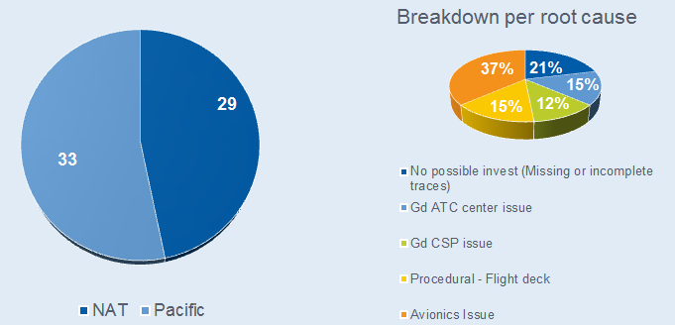

  - It is worth noting that since the start of PBCS operations in some FIRs, some Airlines have started filing PRs on their own (sometimes for cockpit technical issues that are not necessarily “reportable” at ATC level but still relevant for OEMs to investigate).

2. DISCUSSION

  - Out of the 12 PRs of the Pacific region where Avionics issues were identified, the following breakdown was observed:

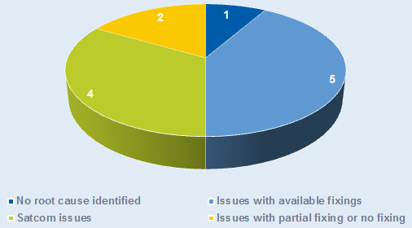

  - PRs highlighted to the group.
The following PRs are discussed in a dedicated Attachment to this Working Paper due to their potentially higher interest to the group: 2635, 2697, 2703/2704/2708, 2743 & 2747.

  - PRs to be closed due to missing or incomplete traces/logs.
The following PRs are proposed to be closed since traces were either not provided by the affected operators, or were provided with incomplete data, thus making investigations impossible: 2574, 2575, 2592, 2608, 2609, 2671 & 2716.

  - PR 2523: A333 - Delayed reports - VHF/SATCOM transition / SATCOM Spotbeam
Significant delays of datalink exchanges were observed during media transition (VHF/SATCOM) combined with a SATCOM Data Unit incorrectly set for the I4 constellation instead of I3.
Settings have now been corrected.
PR to be closed.

  - PR 2554: A332 – Connection failure
CPDLC and ADS-C connections failures were reported by WAAF following an unanswered “Confirm Speed” message. Analysis showed a manual disconnection was exercised by the crew, followed by an unexplained reset of the system. Neither the logs retrieved from this rather old standard (CLR4), nor the laboratory tests performed, allowed to reproduce the failure or understand its root cause.
PR proposed to be monitored.

  - PR 2607 & PR2672: A359 – CPDLC Error Message
VOMM center reported the reception of a DM62 “Error Message” following the uplink of two concatenated UM20 + UM175 messages “Climb To & Maintain FL410” + “Report Reaching FL410”. On recent Airbus A/C, and in agreement with GOLD recommendations, the UM175 is no longer supported and triggers a DM62 automatic answer.
Recommendation is for VOMM center to stop using the UM175.
PRs to be closed.

  - PR 2610: A388 – Contact Advisory Error Message
A failed AFN contact sequence was detected during a transfer sequence from VOMF to WMFC.
An A380 avionics issue leads CR1 not to be accepted as long as the AFN log on sequence is not completed (i.e. log on response not received from ground).
A fix will be considered for a future A380 FANS standard.

  - PR 2636: A359 – Connection fail
CPDLC connection issues reported by RPHI during the transfer of an A350 to WAAF.
Analysis has not evidenced any avionics misbehavior. Nominal CPDLC and ADS-C operations with RPHI were noted, but it occurred that no AFN contact sequence was initiated by RPHI to initiate the transfer to WAAF. Once, upon ground request, CPDLC and ADS-C connections with RPHI were properly terminated by the crew, CPDLC and ADS-C connections were then manually and nominally restored with WAAF.
Airbus suggests this PR be transferred to RPHI.

  - PR 2670: A388 – ADS-C Emergency
An unexpected activation of the Emergency mode for an ADS-C contract was reported on an A380.
When contacted, the crew confirmed that all operations were normal through voice and CPDLC.
Air/ground traces do not highlight any on-board avionics malfunction. It is thus suspected an unintentional pilot activation of the Emergency mode, which was then manually set off.
However, logs analysis shows one inconsistent ground behaviour from VOMF (Chennai) which declared VCCC as NDA via UM160 but initiated a transfer to VCCF (Colombo) via an AFN. The transfer failed as for the aircraft, the NDA was VCCC.
PR to be closed after a notification of this side issue is sent to VOMF.

  - PR 2673: A359 – ADS-C Emergency
An unexpected ADS-C Emergency message from an A350 was received on ground by VOMF, whereas the crew confirmed nominal operations.
Analysis of the logs does not highlight any on-board misbehavior, and an unintentional pilot activation is thus suspected. Following a controllers request to reset the ADS-C, nominal operations were restored.
PR to be closed.

  - PR 2700: A359 – Display of corrupted CPDLC message
After the UM77 “AT TN PROCEED DIRECT TO ADKUL” was sent by YBBB to an A350, the crew reported that another message ‘DIRECT TO ADKUL’ had been received. According to the crew, this message however was not retained in the on-board message log.
The analysis of air/ground logs shows that the sole UM77 was sent and positively answered by the crew (WILCO). This UM77 corresponds to a deferred clearance to be executed when the aircraft reaches the TN navaid.
After the crew positively answered this clearance, the A/C avionics monitored the distance to TN and, 30s before reaching TN, displayed the message again, as a reminder of the clearance. This reminder message is assumed to have been wrongly understood as a new clearance from YBBB.
PR to be closed.

Step 1: UM77 received | 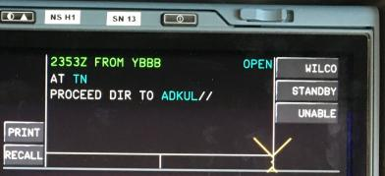
Step 2: Crew presses WILCO, FMS starts the monitoring | 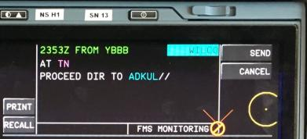
Step 3: 30 sec before TN is reached, the deferred clearance reminder is displayed | 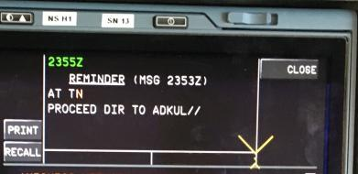

  - PR 2702: A333 – Loss of ADS-C
YBBB reported a loss of ADS-C capability during flight while CPDLC remained operational.
The affected A/C is still fitted with a CLR3 FANS A avionics version (which did not get a PBCS SoC in the Airbus AFM). This software version was prone to automatic resets, and one such occurrence was evidenced in the traces of this flight. As detailed in the PR 2284: following an automatic reset of this software version, ADS-C capability is lost and can only be recovered via a crew manual reset (this action is recommended in the Airbus FCOM in case ADS-C losses are reported by ATC).
The ADS-C inhibited state following an automatic reset, as well as the underlying reset issue have both been fixed in the already available FANS A+ software versions.
PR to be closed.

  - PR 2705: A333 – Loss of ADS-C
YBBB reported a loss of ADS-C capability during flight while CPDLC remained operational.
Two issues were evidenced during the analysis of this PR:
- Long (intermittent) SATCOM link losses, which could not be further analyzed due to the lack of SATCOM Data Unit internal traces.
- However, all ADS-C traffic was observed to have been correctly received and acknowledged at CSP level (sometimes with delay due to the above SATCOM issues). Therefore this PR suggests an issue in the ground routing of some ADS-C reports between the CSP (SITA) and YBBB.
PR proposed to be monitored for the SATCOM link part, and analysis of ground routing issue to be performed by YBBB and SITA.

  - PR 2706: A333 – Loss of ADS-C
YBBB reported a loss of ADS-C capability during flight while CPDLC remained operational.
Once again, in this PR, traces showed that each ADS-C contract was correctly acknowledged and taken into account by the A/C. The traces exhibit gaps in the recorded contract numbers, suggesting once again an issue in the ground handling of some ADS-C traffic at CSP level.
PR to be transferred to SITA.

  - PR 2707: A333 – Loss of ADS-C
YBBB reported a loss of ADS-C capability during flight while CPDLC remained operational.
After a successful transfer from NZZO to YBBB, both ADS-C connections were observed to have been kept operational in the traces. Later on, new ADS-C contracts were sent by YBBB and accepted by the A/C, however some time later ADS-C with YBBB was manually terminated by the crew. Afterwards, CSP traces do not record any further ADS-C contract request sent to the A/C by YBBB.
PR proposed to be closed as no avionics misbehavior could be identified.

  - PR 2709: A332 – Loss of ADS-C
YBBB reported a loss of ADS-C capability during flight while CPDLC remained operational.
As for PR 2706, traces showed that each of the 11 ADS-C contracts sent by the ground was correctly acknowledged and taken into account by the A/C (all corresponding reports recorded in the CSP traces). Once again, no avionics misbehavior could be identified and the possibility of an issue in the ground handling of some ADS-C traffic at CSP level should thus be investigated.
PR to be transferred to SITA.

  - PR 2710: A332 – Latency monitor triggered after CPDLC U/L sent via HFDL
NZZO reported two occurrences of a rejection of an UM68 by the A/C following a failed Uplink Latency Check.
Traces showed that during that flight, the SATCOM link was reported as available by the A/C (via ACARS media advisory D/L) but the uplinks were unexpectedly routed via HFDL, after a significant ground delay, by the CSP. This explained why both U/L were (correctly) rejected by the A/C system, as they were received more than 5 minutes after the U/L timestamping by the ATC ground system, per Latency Check function definition.
PR to be transferred to ARINC for further investigations on the U/L routing.

  - PR 2717: A333 – No Connection Confirm received
KZAK reported multiple occurrences of a lack of CC1 reception following successful CR1 emission (MAS/S received) on multiple airframes of a given operator.
Only partial traces could be recovered, but their analysis evidenced that the A/C correctly downlinked CC1 responses, which were acknowledged by the CSP.
PR to be transferred to SITA for further investigations on the CC1 routing.

  - PR 2733 & PR 2784: A333 – Degraded SATCOM performance
NZZO reported significant SATCOM performance degradation (along with large increase in HFDL use) from a given airframe.
Traces confirmed that most of the large delays encountered correspond to cases of SATCOM losses while no other media is available. The reported increase in HFDL use is indeed the direct consequence of the abnormal SATCOM losses experienced. Investigations with the operator and SSP are still in progress, and a SATCOM Data Unit configuration is currently suspected leading to undue log-on/log-off between two GES.
PR proposed to be monitored.

3. ACTION BY THE MEETING

3.1 The meeting is invited to:

a) Note the information and provide guidance and comments as appropriate.

