Thirty Third Meeting of the
Informal South Pacific ATS Co-ordinating Group
(ISPACG/33)

Queenstown, NEW ZEALAND
18 – 22 March 2019

Agenda Item 5: Working Papers

FIT Meeting Report

Presented by Central Reporting Agency

SUMMARY

This working paper summarizes significant items discussed during FIT 26. Attachment A includes PBCS monitoring data in the required format. All working papers and presentations are available in the ISPACG website.

1. INTRODUCTION

1.1 The FANS1/A Interoperability Team (FIT) was established in 1997 and was integrated into the ISPACG in 1999 to oversee the monitoring of FANS1/A data link and to ensure that performance and interoperability requirements are met.

2. DISCUSSION

Problem reporting

We continue to see an increase in operators signing up to the CRA website.

PRs for 2018 reporting period were consistent with the previous year. 211 PRs were filed via
the website, of which 34 PRs (16%) occurred in the South Pacific region. For comparison,
the previous FANS PR briefing indicated that FANS stakeholders submitted 208 PRs, of
which 32 PRs (15%) occurred in the South Pacific

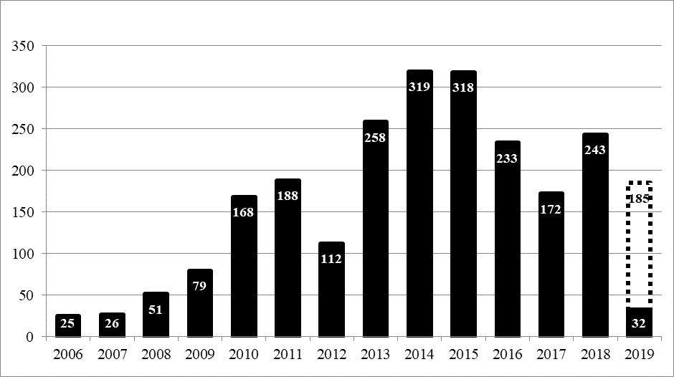

Performance Monitoring

Required PBCS performance monitoring charts are provided in attachment A. In general we
continue to see overall improved performance. The process is working as desired with
examples of particular fleet types and or individual aircraft indicating performance issues.
Those operators are contacted and work with the CRA and OEMs to resolve issues showing
which have resulted in performance improvements.

It was noted that the data showed a noticeable improvement in Iridium performance toward
the end of 2018 continuing into 2019. Most operators using Iridium are now meeting
performance requirements. Data also showed very good performance from SBB although
the sample size is still small. HF datalink continues to show reduced performance below
RCP 400 requirements. Operators using HF DL are encouraged to configure their systems
to only use HF DL for company messages only. Data collection will continue and it is
conceivable that operators that file PBCS will be required to disable HF DL for use with ATS
messages.

Availability

Monitoring data continues to show system availability significantly below target levels. In
addition unplanned outage notifications continue to fall below target levels as well. It was noted that similar issues have been identified in other regions.

RCP240/RSP180 specifications call for an availability of 0.999. This equates to a maximum of 48 unplanned outages with a maximum accumulated outage of 520 minutes. In addition unplanned outage notifications shall be provided within 5 minutes.

As an example in 2018 a global assessment based on reported outages to NZZO shows there were 29 unplanned outages. The accumulated outage was 6395 minutes and notification delay average was 103 minutes (the best was 10 minutes). A review of the global outages and assessing if an operational impact was felt in NZZO shows 8 unplanned outages had operational impact. Other ANSPs with higher traffic loading may find operational impact from outages that did not affect NZZO. The accumulated outage time where there was operational impact in NZZO was 2096 minutes (approximately 35 hours in the year).

In the first three months of 2019 monitoring data has shown 6 outages totaling 411 minutes affecting NZZO operations:

Inmarsat I4 –37 minutes
Network –15 minutes
MTSAT –19 minutes
Inmarsat I4 –138 minutes
Network –166 minutes
Iridium –36 minutes

Work is needed to improve assessment of availability from an operational perspective. NAT TIG and ICAO OPDLWG PBCS group are also working on this issue.

Confirming ACTIVE Center

It was noted that individual ANSP would transition from using the CPDLC Position Report to the free-text method when able and this would not be done at a common coordinated date. While the transition will be relatively simple and involve minimum resource and cost for some states for others this is not the case. It is recommended individual ANSP decide a transition plan and report back to FIT/27.

The meeting recommended that ICAO OPDLWG investigate and provide guidance on a standardized text. The meeting recommends use of the free-text message being used by the FAA.

“THIS IS AN AUTOMATED MESSAGE TO CONFIRM CPDLC CONNECTION TO
KZAK. REPORT SPEED CHANGES TO ATC”

3. ACTION BY THE MEETING

3.1 The meeting is invited to:

- Note and discuss the contents of this paper and accompanying attachment.

-- END --

