FANS Interoperability Team Meeting
(FIT/25)

Nadi, Fiji
9 – 12 April 2018

Agenda Item 5 - Working Papers

ISPACG and Regional PBCS monitoring

Presented by Airways New Zealand

SUMMARY

With the introduction of PBCS regional groups such as ISPACG are required to report on observed PBCS performance and issues to their ICAO regional forum. This further underlines the need for standard templates for use by ISPACG ATSP when reporting on performance to the ISPACG FIT and by ISPACG when reporting to ICAO. This paper proposes a number of templates for this purpose based on templates already in use in the NAT region, and provides an update on other PBCS related reports that have been provided to ICAO by ISPACG FIT in late 2017.

1. INTRODUCTION

  - Each ANSP has their own PBCS monitoring program to analyze and report on operational data (Actual Communications Performance (ACP), Actual Surveillance Performance (ASP), and availability).
  - Standard templates have been developed in the North Atlantic region to formalize reporting by ANSP to their regional groups. Airways see a need for similar templates in the Asia-Pacific region.

2. DISCUSSION

2.1 In this paper Airways propose a number of templates that will standardize reporting. Airways intention is to also propose these templates at the FIT-Asia 8 meeting scheduled to assist in developing an Asia-Pacific regional template.
2.2 As noted in Doc 9869 PBCS Manual the scope of local and regional monitoring programmes includes analyses on an operator basis, taking i nto account individual aircraft, aircraft types/systems and various infrastructure and technological dependencies, all of which are factors in evaluating communication or surveillance performance.
2.3 Some reporting templates already exist for the regional reporting of operator and aircraft performance for use by aircraft operators. The NAT and some Asia-Pacific ANSP are reporting performance data at six monthly intervals on the FANS1/A CRA website at http://www.fans-cra.com. This performance data is available to registered users of the FANS-CRA website. ISPACG ANSP not currently reporting on performance via this website are invited to join this initiative.
2.4 We propose moving towards a six monthly reporting interval to align with NAT region and the CRA website performance data. The following paragraphs illustrate the proposed templates.

ANSP templates for reporting to ISPACG FIT

2.5 Template 1: RSP180 report by media type and by RGS/GES.

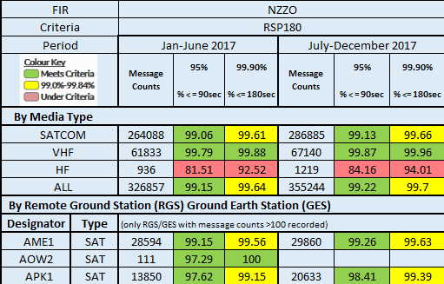

2.6 Template 2: RSP180 report by Aircraft Operator/Type.

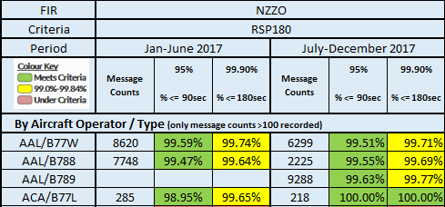

2.7 Template 3: RCP240 report by media type and by RGS/GES.

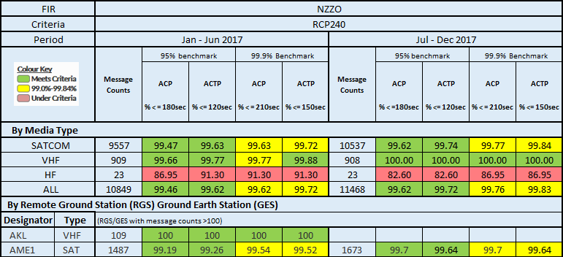

2.8 Template 4: RCP240 report by Aircraft Operator/Type.

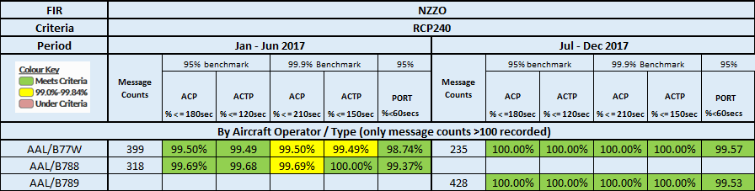

ISPACG templates for reporting to ICAO

2.9 RSP180 – ISPACG Regional Aggregates by FIR.

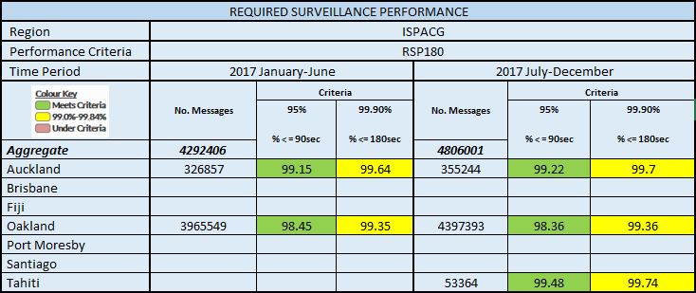

2.10 RCP240 – ISPACG Regional Aggregates by FIR.

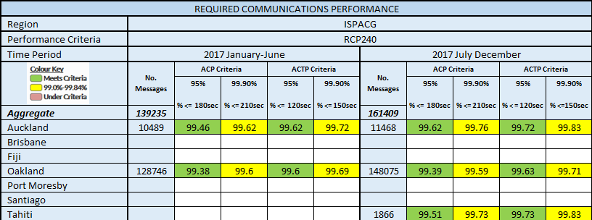

2.11 RSP180 – ISPACG report by media type and RGS/GES – exceptions only – not meeting RSP180.

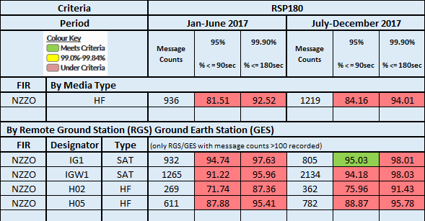

2.12 RSP180 – ISPACG report by aircraft operator/type – exceptions only – not meeting RSP180.

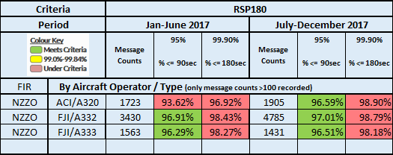

2.13 RCP240 – ISPACG report by media type and RGS/GES – exceptions only – not meeting RCP240.

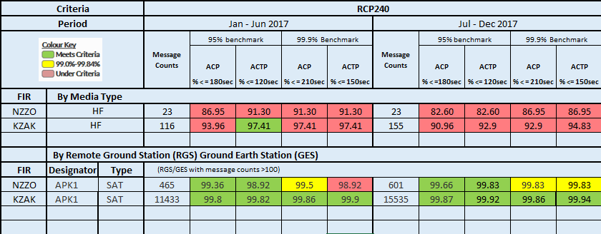

2.14 RCP240 – ISPACG report by aircraft operator/type – exceptions only – not meeting RCP240.

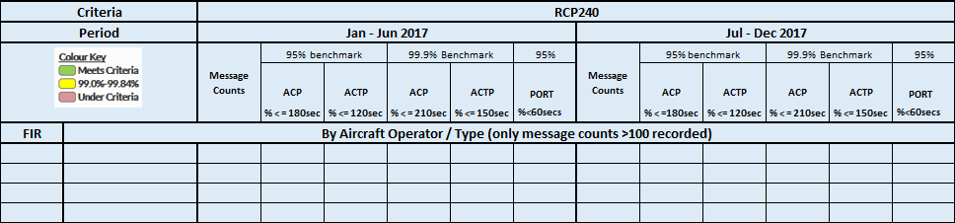

Availability Reporting

2.15 FAA have provided a table which shows the recorded availability for each individual satellite path by path identifier. As can be seen 2017 was not a stellar year for availability. The safety criteria for RCP240 is based on meeting an availability of 0.999, with a maximum of 48 unplanned outages a year greater than 10 minutes with no more than 520 accumulated minutes of outage. The efficiency criteria for RCP240 is based on meeting an availability of 0.9999, with a maximum of 4 unplanned outages a year greater than 10 minutes with no more than 52 accumulated minutes of outage.
2.16 However, an assessment of availability by path identifier alone does not provide an indication of the operational impact which requires local assessment. In the Asia-Pacific region we are well served with Inmarsat SATCOM with aircraft able to switch between I3, I4, and MTSAT. We often see failures reported by the CSP which have no operational impact in NZZO, simply because aircraft switch to an operational constellation. This redundancy will soon be reduced with the withdrawal of the Inmarsat I3 from service. The predicted lifespan of MTSAT is unknown to us but is finite. We think it reasonable to assume that with reducing redundancy then the operational impact will become significantly greater.
2.17 We propose that ISPACG adopt the FAA table format for reporting availability by satellite path.
2.18 Airways feel that further discussion on assessing and reporting on the operational impact of individual path outages. A possibility for our ISPACG report is to provide a short summary by FIR on the operational impact of the outages? 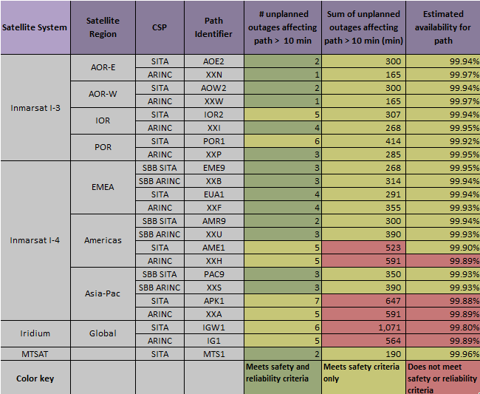

APANPIRG Conclusion APANPIRG/28/13

2.18 In 2017 APANPIRG passed Conclusion APANPIRG/28/13:Asia/Pacific Region Data Link Performance Monitoring. This conclusion requests that ISPACG/FANS Interoperability/Implementation Team (FIT) provide the Regional Airspace Safety Monitoring Advisory Group (RASMAG) a list of those states that have:
1) made arrangements for the reporting and analysis of data link problems to a competent CRA as identified by RASMAG; and
2) reported data link problems to the CRA; and
3) provided data link problem analysis reports to a recognized FIT; and
4) provided data-link performance analysis reports to a recognized FIT.
2.19 The ISPACG FIT Chair was to requested to report out on this conclusion to the FIT-Asia/7 meeting held in December 2017 by ICAO Regional Office. Airways coordinated and presented this information to FIT-Asia/7 by way of an IP. Please refer to Attachment 1 of this paper.

Additional reporting with the templates

2.20 The NAT region incorporate in their reports a brief written summary with each template giving an overview of the performance displayed and highlighting any deficiencies seen in relation to meeting the performance specifications. We propose that ISPACG FIT also include this written summary in their reporting.

Moving forward

2.20 If the meeting agrees, Airways will co-ordinate the preparation of a draft report for the 2017 year. While unlikely to be completed during this meeting it could be completed by 1 May 2018.
2.20 To simplify matters, future reports relating to Conclusion APANPIRG/28/13 will be incorporated with the proposed PBCS monitoring report.

3. ACTION BY THE MEETING

3.1 The meeting is invited to:

a) Agree the need for standardized templates for use in PBCS performance reporting and availability reporting, and agree initial templates to be used as provided in this paper.

b) Agree to move to a six monthly reporting interval to align with the NAT region and FANS-CRA website reports.

c) Agree that the ISPACG FIT reports should take a similar form to that used in the NAT with a brief written summary included with each template.

d) Agree to drafting of a report for the 2017 year.

Attachment 1: FIT-Asia/7 IP

International Civil Aviation Organization
The Seventh Meeting of the Future Air Navigation Systems Interoperability Team-Asia (FIT-Asia/7)
Bangkok, Thailand, 11 – 13 December 2017

Agenda Item 2: Global and Regional PBCS Developments

ISPACG status in relation to Conclusion APANPIRG/28/13

(Prepared by Airways New Zealand)

SUMMARY
This paper presents status of the ISPACG states in relation to conclusion APANPIRG/28/13: Asia/Pacific Region Data Link Performance Monitoring

- INTRODUCTION
  - Conclusion APANPIRG/28/13:Asia/Pacific Region Data Link Performance Monitoring requests that ISPACG/FANS Interoperability/Implementation Team (FIT) provide the Regional Airspace Safety Monitoring Advisory Group (RASMAG) a list of those states that have: 1) made arrangements for the reporting and analysis of data link problems to a competent CRA as identified by RASMAG; and 2) reported data link problems to the CRA; and 3) provided data link problem analysis reports to a recognized FIT; and 4) provided data-link performance analysis reports to a recognized FIT.
- DISCUSSION

Providing data link problem analysis reports to ISPACG FIT.
  - The Boeing CRA currently report an analysis of all problem reports (PR) at each ISPACG FIT meeting. The last summary was provided at ISPACG FIT/25 in March 2017. All ISPACG stakeholders may access a de-identified summary of all PR from the CRA website at http://www.fans-cra.com
  - ISPACG ATSP may access the details on all PR from the CRA website.

Made arrangements for the reporting and analysis of data link problems to a competent CRA.
  - All ISPACG ATSP have arranged access to the CRA website http://www.fans-cra.com used for problem reporting by the ISPACG states.

Reported data link problems to the CRA
  - The following table lists those ISPACG ATSP who have raised PR in the period 2015-2017 and the number raised each year.
ATSP | 2017 | 2016 | 2015
Airways NZ | 10 | 8 | 7
Air Services Australia | 11 | 21 | 39
FAA Oakland | 6 | 16 | 12

Provided data link performance analysis reports to a recognized FIT
  - The following table lists those ISPACG ATSP who have provided data link performance analysis reports in the period 2015-2017.
ATSP | 2017 | 2016 | 2015
Airways NZ | YES | YES | YES
Air Services Australia | NO | YES | YES
FAA Oakland | YES | YES | YES
SEAC PF | YES | NO | NO

  - Air Services Australia have advised they are upgrading their monitoring capability and that they will have their upgraded monitoring capability available by March 2018.
  - Airports Fiji have advised they now have a monitoring capability and will be providing performance reports from March 2018.
- ACTION BY THE MEETING
  - The meeting is invited to:
              - note the information contained in this paper; and
              - discuss any relevant matters as appropriate.
………………………….

