Thirty-second Meeting of the
Informal South Pacific ATS Co-ordinating Group
(ISPACG/32)

Nadi, Fiji
9 to 11 April 2018

Agenda Item IP-02

[IP Airbus FMS management of Duplicate Fixes and Non-Directional Beacons when loading Route Clearances]

Presented by [Airbus]

SUMMARY

Following questions received from some ANSPs, this paper aims at providing an overview of the management of “duplicate fixes” and Non-Directional Beacon navaids by Airbus FMS when loading Route Clearances received by CPDLC.

1. INTRODUCTION

  - Due to naming conventions and the limitations applicable to the number of characters defining a fixed waypoint (5 characters) or navaid (2 to 3 characters), it is common to find the same ident (e.g. “ABA” or “SHARK”) being used to designate different WPTs or navaids published within various regions of the World.
  - Flight Management Systems are loaded with a Navigation DataBase (NDB) which contains a subset of the complete navigation data published worldwide, whose content and coverage depends on each operator’s needs. These databases are formatted according to rules set forth by the ARINC424 and their content is split into separate sections called “records” (e.g. Airports, Runways, Waypoints, Navaids…).
  - It is therefore common to find within the NDB of a given A/C “duplicate” WPTs or navaids where the same ident (2, 3 or 5 characters) designates multiple (different) fixes that are then differentiated by their Latitude & Longitude.
  - Route clearances uplinked by the ATC may contain such “duplicate” fixes and thus need to be processed by the FMS in order to determine which fix was intended to be used by the controller.
  - The management of Non-Directional Beacon navaids has historically been made complex by the fact that these navaids could be coded either in the “Waypoints” or in the “NDB navaids” (separate from the “Navaids”) records of Navigation DataBases.

2. DISCUSSION

Management of duplicate fixes
2.1 We must first make a distinction between 2 different elements that can be contained in Route Clearances: the [Position] variable used only for UM79 & UM83 and the Routeinformation parameter of the [Routeclearance] variable used for UM79, UM80 & UM83.
    - The [Position] variable is defined only as a choice of Fixname, Navaid, Airport, LatitudeLongitude, PlaceBearingDistance.
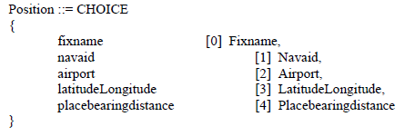
    - The Routeinformation parameter of the [Routeclearance] variable which, when designating a published identifier (e.g. WPT or navaid), is defined by a [Fixname] and an optional [LatitudeLongitude] parameter.
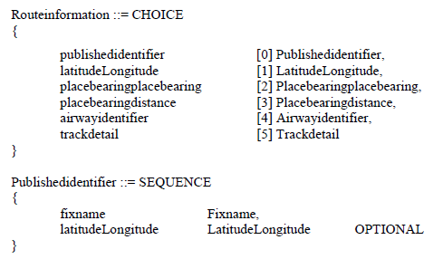
  - Therefore, when dealing with the [Position] variable of am UM79 or UM83, and in case the Fixname or Navaid uplinked is duplicated within the NDB (since no Lat/Long can be provided) Airbus FMS will only be able to load the clearance if the ident (2, 3 or 5 characters) of the uplinked [Position] variable exists in the FMS Active F-PLN.
    - If [Position] exists in the Active FMS F-PLN, it will be used to “solve the duplicate”.
    - Else the clearance will not be loadable by the FMS and the crew will have a LOAD FAILED status.
  - When dealing with the Routeinformation parameter of the [Routeclearance] variable, the logics are different. The FMS will NOT use the Active F-PLN to solve a duplication situation as there is no guarantee that the new Route Clearance sent by the Controller has anything to do with the initial route present in the FMS. If a published identifier contained within a Route Clearance has duplicates within the NDB, the following logics apply:
    - If the optional Latitude/Longitude are provided, then the FMS uses them to solve the duplicate and select the adequate WPT or navaid.
    - Else (the optional Latitude/Longitude are NOT provided), then:
      - If the published identifier is preceded or followed (in the ATC route clearance) by an Airway (and this fix belongs to this Airway), the FMS will use this information to solve the duplicate and select the WPT or navaid with the provided ident that is located on the Airway.
      - Else, the FMS is unable to solve the duplicate, this single element (published identifier) is discarded and the crew will be provided with a LOAD PARTIAL information on DCDU with additional information provided in the MCDU explaining that the rejected ident is a “DUPLICATE IN NDB”.
  - The following table summarizes the above logics.
Management of duplicate fixes when loading Route Clearances in Airbus FMS
[Position]  (UM79 or UM83) | [Position] exists in the FMS Active F-PLN | Use the F-PLN occurrence to solve the duplicate | LOAD OK
[Position]  (UM79 or UM83) | [Position] does not exist in the FMS Active F-PLN | Unable to solve the duplicate | LOAD FAILED
[Routeclearance]  (UM79, UM80 or UM83) | Published Identifier sent with optional Lat/Long | Use the Lat/Long to solve the duplicate | LOAD OK
[Routeclearance]  (UM79, UM80 or UM83) | Published Identifier sent without Lat/Long but belongs to a preceding or following Airway in the clearance | Use the Airway match to solve the duplicate | LOAD OK
[Routeclearance]  (UM79, UM80 or UM83) | Published Identifier sent without Lat/Long and is not preceded or followed by an Airway in the clearance | Unable to solve the duplicate | LOAD PARTIAL  (rejection of unsolved duplicates)
  - Although it makes the route clearance slightly “heavier”, it is highly recommended to systematically include the optional Latitude/Longitude parameter associated to a published identifier as it will allow the FMS to always have the capacity to resolve a potential duplicate. This philosophy was adopted by the FAA for the domestic DataComm program for example.

Management of Non-Directional Beacon navaids
  - As noted above, when a named fix is sent as part of the [Routeclearance] variable, it is simply sent as a [Publishedidentifier] and its type (Waypoint or Navaid) is not specified, thus the FMS will always look into all the NDB records (Waypoints, Non-directional beacon navaids, Navaids) for each named fix and in this case Non-directional beacon navaids do not cause any issue.
  - However, when a named fix is sent as the [Position] variable of an uplink, then its exact type must be precised: Fixname or Navaid. At this stage, there is a clear contradiction between §4.6.7.8.2 of DO238-A/ED100-A (FANS 1/A) and §3.3.7.6.4.9 of DO280-B/ED110-B (ATN B1) where the first calls for Non-directional beacons to be encoded as “Waypoints” whereas the second specifies that they should be uplinked as “Navaids”.
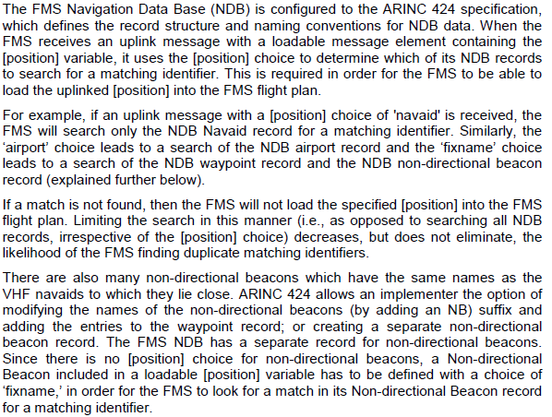
Figure 1: DO258-A/ED100-A §4.6.7.8.2
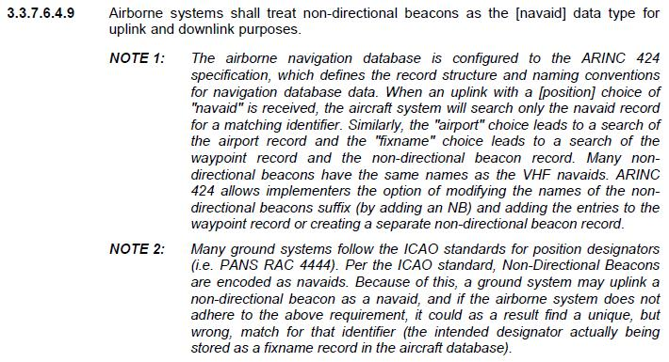
Figure 2: DO280-B/ED110-B §3.3.7.6.4.9
  - On Airbus A/C, the behaviour of the FMS is as follows:
    - For A320/A330/A340 equipped with Thales/GE FMS (about 50% of the fleet) the FMS will look into:
      - Both “Non-directional beacon navaids” and “Navaids” records of the NDB when a [Position] variable of type “Navaid” is received.
      - Both “Non-directional beacon navaids” and “Waypoints” records of the NDB when a [Position] variable of type “Fixname” is received.
      - This ensures that the system will always be able to find the Non-directional beacon navaid identifier regardless of how it is uplinked (fixname or navaid).
    - For A320/A330/A340 equipped with Honeywell FMS (about 50% of the fleet) and for A380/A350, the FMS will look into:
      - Both “Non-directional beacon navaids” and “Navaids” records of the NDB when a [Position] variable of type “Navaid” is received.
      - Only the “Waypoints” records of the NDB when a [Position] variable of type “Fixname” is received.
      - For these A/C, if a Non-directional beacon navaid is uplinked as a “Fixname”, the FMS will discard this point from the route clearance in the resulting F-PLN, a LOAD PARTIAL information will be displayed to the crew on the DCDU, and on the MCDU a page detailing that the ident of the received Non-directional beacon navaid was “not found in the Database” can be accessed.
    - Therefore, sending a Non-directional beacon ident as a “Navaid” type for a [Position] variable is the only way to ensure correct message loading into all Airbus FMS.

3. ACTION BY THE MEETING

3.1 The meeting is invited to:

    - note the information provided.

