FANS Interoperability Team Meeting
(FIT/25)

Nadi, Fiji
9 – 12 April 2018

Agenda Item IP-03

PBCS Monitoring in Fukuoka FIR

Presented by Civil Aviation Bureau of JAPAN

SUMMARY
This paper provides observed performance for the data link operation in Fukuoka FIR. This analysis includes performance of the CPDLC and ADS-C systems. The performance is measured against the criteria specified in PBCS Manual.

1. INTRODUCTION

1.1 This paper provides the observed performance for the data link operation in Fukuoka flight information region (FIR). The performance data extracted from the Controller Pilot Data Link Communication (CPDLC) and Automatic Dependent Surveillance-Contract (ADS-C) systems are measured against the appropriate Required Communication Performance (RCP) and Required Surveillance Performance (RSP) specifications detailed in the International Civil Aviation Organization (ICAO) Document 9869 Performance-based Communication and Surveillance (PBCS) Manual.

1.2 This paper presents a summary of the data link performance by media type, by stationidentifier, and by operator observed for the recent a-half-year period from July 2017 to December 2017 in Fukuoka FIR. The purpose is to demonstrate that safety objectives in the respective airspace, which rely on the surveillance and communication infrastructure, can be satisfied by the aircraft and ground system.

2. DISCUSSION

2.1 The PBCS Manual provides the guidance material for the analysis to assess the data link performance against the appropriate RSP and RCP requirements. In the guidance material, the data observation points in FANS 1/A aircraft communications addressing and reporting system (ACARS) transaction and the calculation process for actual communication performance (ACP), actual communication technical performance (ACTP), pilot operational response time (PORT) and actual surveillance performance (ASP) are described. The outputs from those processes are necessary in order to complete the post-implementation monitoring analysis.
    - Table 1 presents a summary of the observed performance by media type for the ADS-C downlink messages and computable CPDLC transactions within the Fukuoka FIR, during the aggregate period from July 2017 to December 2017.
    - Table 1 shows that the 95% criteria for RSP180 ASP and RCP240 ACTP, ACP and PORT were satisfied in the calculation where all the media types including SAT and VHF were combined. In addition, the performance at the levels specified by the 99.9% criteria is 99.0% or better for all performance measures.
Table 1 Observed Data Link Performance by Media Type

  - Observed Data Link Performance by Station Identifier
    - Table 2 provides a complete combination of the station/gateway identifier, the associated location and the service providers which have been observed in the combined data from the Data Link Center System (DLCS) at Kobe Aeronautical Satellite Center.
Table 2 Station/Gateway Identifier
Satellite | GES Location | Region | SITA | ARINC
Inmarsat I-3 | Perth, Australia | IOR | IOR2 | XXI
Inmarsat I-3 | Perth, Australia | POR | POR1 | XXP
Inmarsat I-4 | Paumalu, Hawaii | Asia-Pac | APK1 | XXA
Inmarsat I-4 | Paumalu, Hawaii | Asia-Pac (SBB) | PAC9 | XXS
Iridium | Phoenix, Arizona | Global | IGW1 | IG1
MTSAT | Kobe and Hitachiota | Japan | MTS1 | -
    - Figure 1 shows the ASP by station/gateway identifier for all satellite operations observed for a-half-year period from July 2017 to December 2017 in Fukuoka FIR.

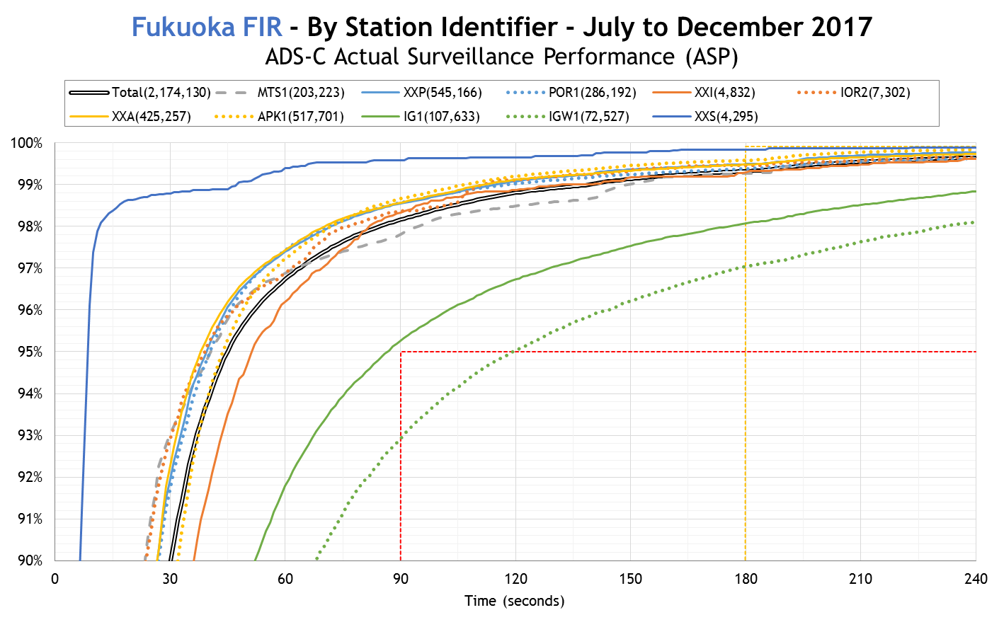
Figure 1 ADS-C (RSP180) – Data Link Performance by Station Identifier
    - Figure 1 shows that all the paths met the criteria for the 95% of RSP180 ASP in Fukuoka FIR, except for the path corresponding to the Iridium satellite service associated with SITA.
  - Observed Data Link Performance by Operator
    - During a-half-year period from July 2017 to December 2017, 75 operators were observed with at least 100 ADS-C downlink reports and 38 operators were observed with at least 100 CPDLC transactions. Table 3 provides a summary of the number of operators met the criteria for the PBCS Manual performance measures.
Table 3 Summary of Observed Data Link Performance by Operator

3. ACTION BY THE MEETING

3.1 The meeting is invited to:

a) Note the information in the paper and the accompanying power point presentation; and

b) Review and comment on the observed performance.

END

