FANS Interoperability Team Meeting
(FIT/25)

Nadi, Fiji
9 – 12 April 2018

Agenda Item 6 - Information Papers

CPDLC and ADS-C Data Link Performance Monitoring for the Brisbane FIR and Melbourne FIR

Presented by Airservices Australia

SUMMARY

This paper presents Controller Pilot Data Link Communication (CPDLC) and Automatic Dependent Surveillance – Contract (ADS-C) from the Brisbane FIR and Melbourne FIR as specified in the Global Operational Data Link Document (GOLD). Data was for the entire 2017 calendar year.

1. INTRODUCTION

1.1 This paper provides observed performance from the operational data link system in the Brisbane FIR and Melbourne FIR. The purpose of this paper is to present the most recent observed performance for the period 1 January 2017 to 31 December 2017 according to the GOLD Appendix D specifications. Plots are included in the Appendix at the end of the paper.

1.2 The performance data observed from the Controller Pilot Data Link Communications (CPDLC) and Automatic Dependent Surveillance - Contract (ADS-C) systems are measured against the appropriate Required Communication Performance (RCP) and Required Surveillance Performance (RSP) specification to demonstrate that safety objectives which rely on the communications infrastructure can be met by the aircraft and ground systems.

1.3 This paper presents the data link performance by media type and by operator with a break down by monthly performance

2. DISCUSSION

2.1 Performance Monitoring for the Brisbane FIR: ADS-C Performance

2.1.1 The RSP180 requirement is for 95% of downlinks to be received within 90 seconds and for 99.9% of downlinks to be received within 180 seconds. For 2017, 98.96% were received within 90 seconds and 99.68% were received within 180 seconds.

2.1.2 Of the 31 aircraft types monitored (with more than 100 downlinks), all except B752 (253 downlinks) and GLF4 (970 downlinks) meet the 95% RSP180 criteria. Three meet the 99.9% RSP180 criteria while a further 22 are 99.0% or better for the 99.9% RSP180 criteria.

2.1.3 The 95% RSP180 criteria was met for all satellite paths except for IGW1 (Iridium). The 99.9% criteria is 99.0% or better for all paths except for IG1, IGW1 (both Iridium) and XXI (Inmarsat). This is consistent with results for 2016.

2.1.4 151 out of 152 operator/aircraft type pairs with at least 100 ADS-C messages meet the 95% RSP180 criteria while 143 pairs are 99.0% or better for the 99.9% RSP180 criteria.

2.2 Performance Monitoring for the Brisbane FIR: CPDLC Performance

2.2.1 The RCP240 requirement is for 95% of CPDLC transactions to be completed within 180 seconds and for 99.9% of transactions to be completed within 210 seconds. For 2017, 99.22% of transactions were completed within 180 seconds and 99.36% of transactions were completed within 210 seconds.

2.2.2 All 20 aircraft types monitored meet the 95% RCP240 criteria. Only one type meets the 99.9% RCP240 criteria while a further 13 are 99.0% or better for the 99.9% RCP240 criteria.

2.2.3 The 95% RCP240 criteria is met for all satellite paths except for IG1 (Iridium). The 99.9% criteria is 99.0% or better for all paths except for IG1, IGW1 (both Iridium) and APK1 (Inmarsat). The results for Iridium satellites are consistent with results from 2016.

2.2.4 81 out of 82 operator/aircraft pairs with at least 100 transactions during the period meet the 95% RCP240 criteria while 64 pairs are 99.0% or better for the 99.9% RCP240 ACP criteria.

2.3 Performance Monitoring for the Melbourne FIR: ADS-C Performance

2.3.1 For 2017, 99.01% of downlinks were received within 90 seconds and 99.65% were received within 180 seconds.

2.3.2 Of the 30 aircraft types monitored (with more than 100 downlinks), all except B762 (113 downlinks) and GLF4 (367 downlinks) meet the 95% RCP240 criteria. Three meet the 99.9% RCP240 criteria while a further 20 are 99.0% or better for the 99.9% RCP240 criteria.

2.3.3 The 95% RSP180 criteria was met for all satellite paths except for IG1, IGW1 (both Iridium), XXF and XXN (both Inmarsat). The 99.9% criteria is 99.0% or better for all paths except for IG1, IGW1 and XXF. There is a drop in performance for IG1, IGW1 and XXF in comparison to results from 2016.

2.3.3 127 out of 129 operator/aircraft type pairs with at least 100 ADS-C messages meet the 95% RSP180 criteria while 120 pairs are 99.0% or better for the 99.9% RSP180 criteria.

2.4 Performance Monitoring for the Melbourne FIR: CPDLC Performance

2.4.1 For 2017, 99.51% of transactions were completed within 180 seconds and 99.67% of transactions were completed within 210 seconds.

2.4.2 All 16 aircraft types monitored meet the 95% RCP240 criteria. Three types meets the 99.9% RCP240 criteria while a further 10 are 99.0% or better for the 99.9% RCP240 criteria. Three types (B77L, B77W and GLEX) are lower than 99.0% for 99.9% RCP240 criteria.

2.4.3 The 95% RCP240 criteria is met for all satellite paths and the 99.9% criteria is 99.0% or better for all paths except for EUA1 (Inmarsat), IG1 and IGW1 (both Iridium). There is a drop in performance for these three paths in comparison to results from 2016.

2.4.4 All 48 operator/aircraft pairs with at least 100 transactions during the period meet the 95% RCP240 criteria while 42 pairs are 99.0% or better for the 99.9% RCP240 criteria.

3. ACTION BY THE MEETING

3.1 The meeting is invited to:

a) Note the content.

Appendix A: Performance Data for Brisbane FIR

ADS-C: Latency by month for Brisbane FIR
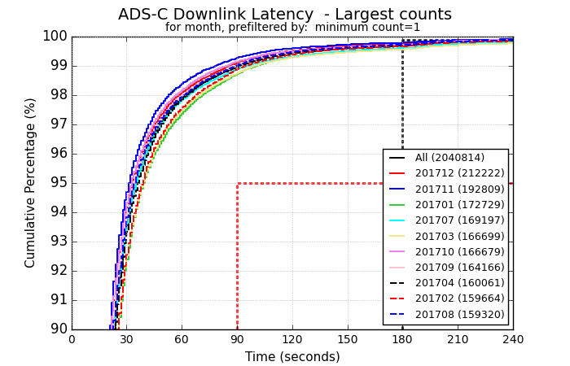
ADS-C: Latency by media for Brisbane FIR
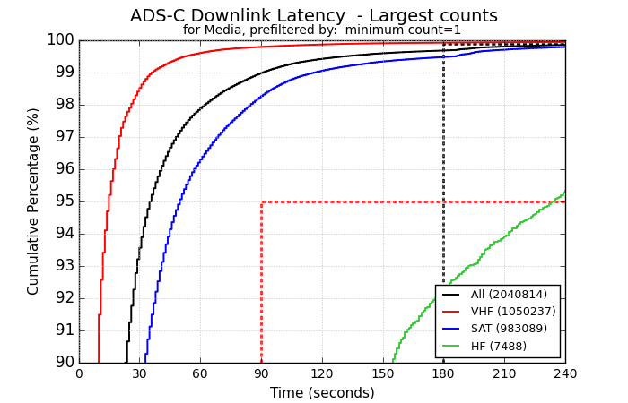
ADS-C: Latency for GES for Brisbane FIR
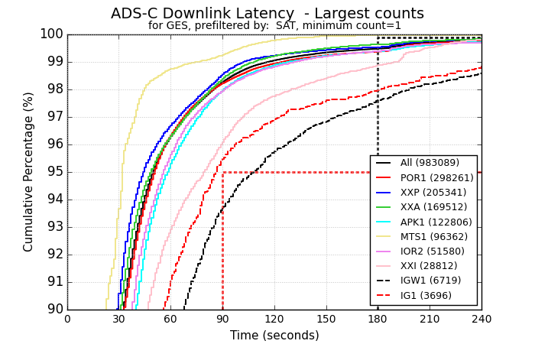
ADS-C: Latency for operators (Top 20 by downlinks) for Brisbane FIR
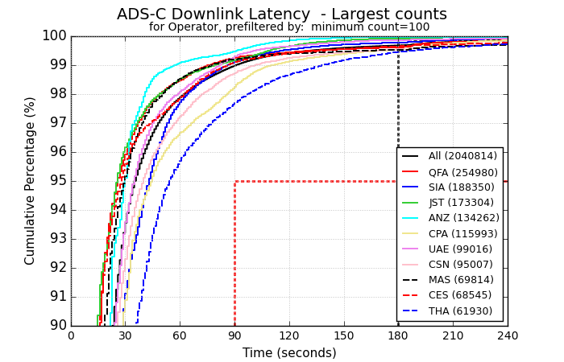

ADS-C: Latency for aircraft types (Top 20 by downlinks) for Brisbane FIR
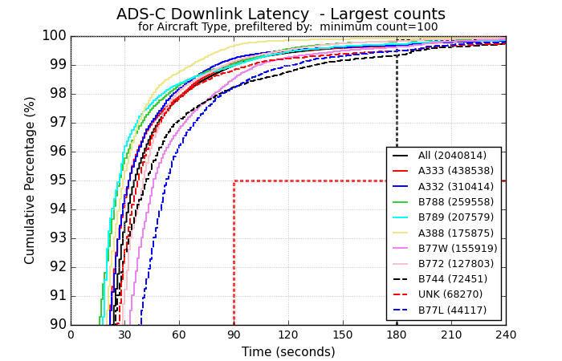

CPDLC: ACP by month for Brisbane FIR
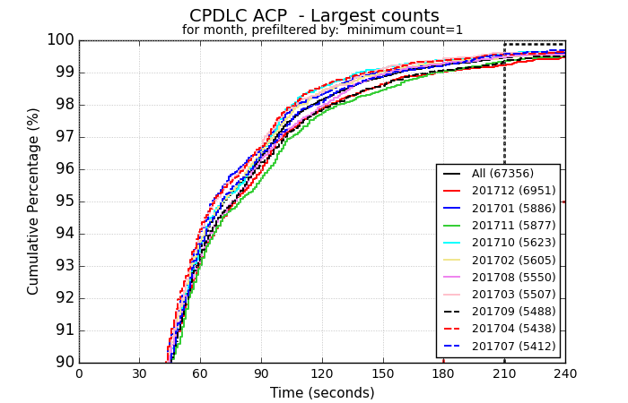
CPDLC: ACP by media for Brisbane FIR
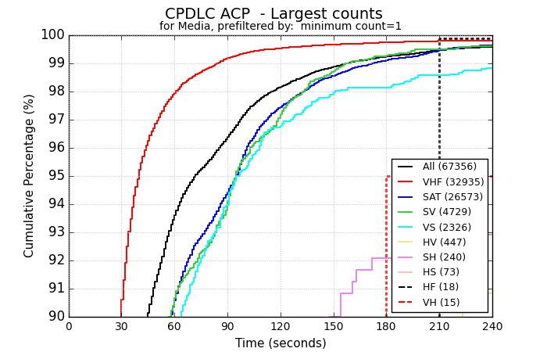

CPDLC: ACP for GES for Brisbane FIR
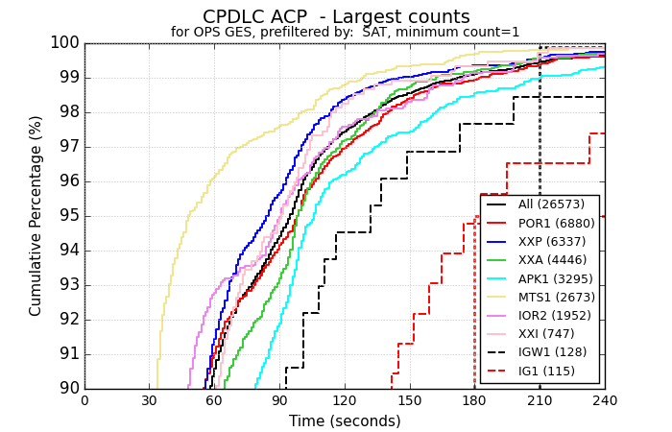

CPDLC: ACP for operators (Top 20 by transactions) for Brisbane FIR
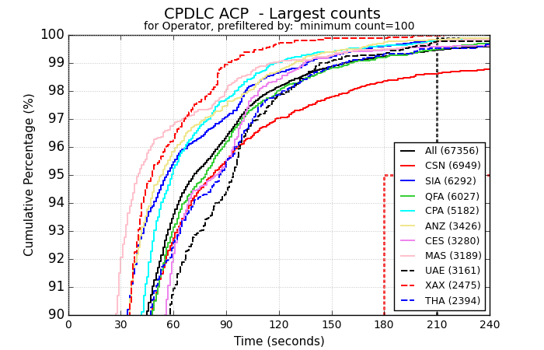

CPDLC: ACP for worst 10 operators at 180 seconds for Brisbane FIR
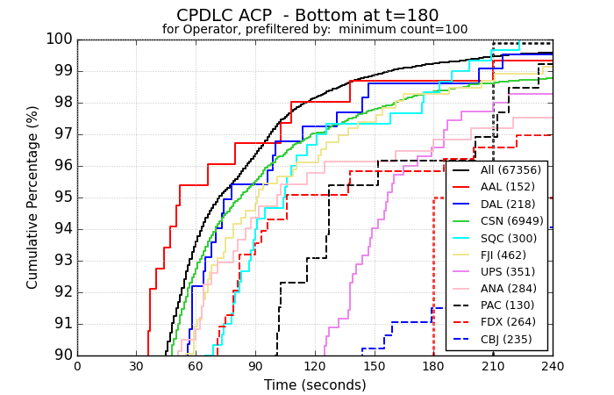

CPDLC: ACP for aircraft types (Top 20 by transactions) for Brisbane FIR
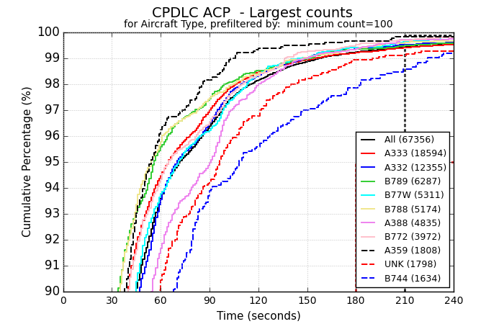

Appendix B: Performance Data for Melbourne FIR

ADS-C: Latency by month for Melbourne FIR
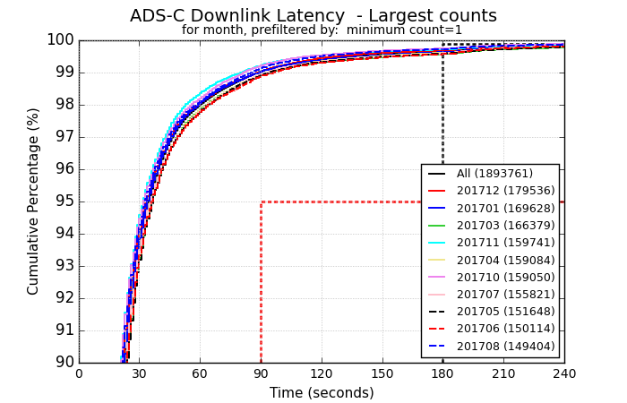
ADS-C: Latency by media for Melbourne FIR
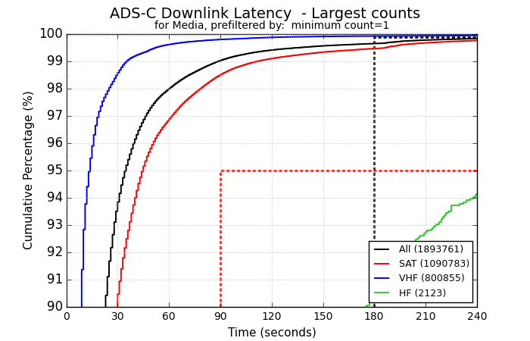
ADS-C: Latency for GES for Melbourne FIR
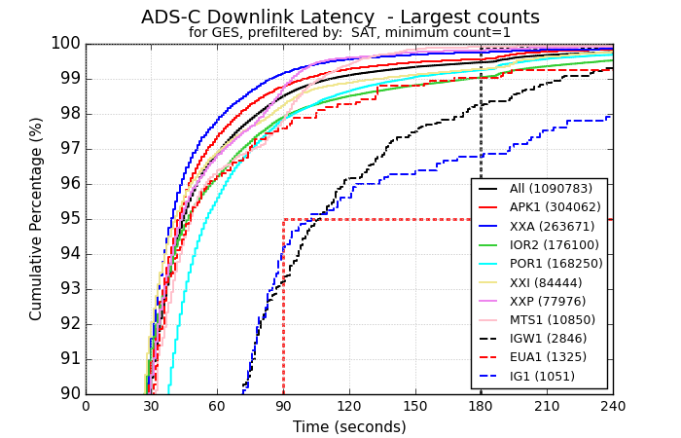

ADS-C: Latency for operators (Top 20 by downlinks) for Melbourne FIR
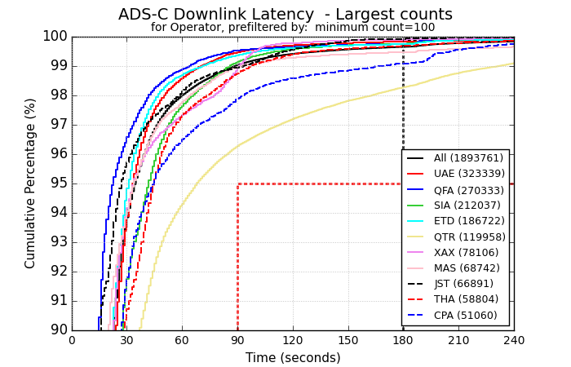

ADS-C: Latency for aircraft types (Top 20 by downlinks) for Melbourne FIR
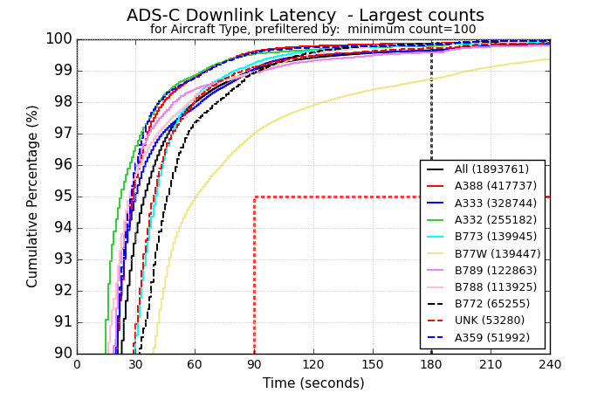

CPDLC: ACP by month for Melbourne FIR
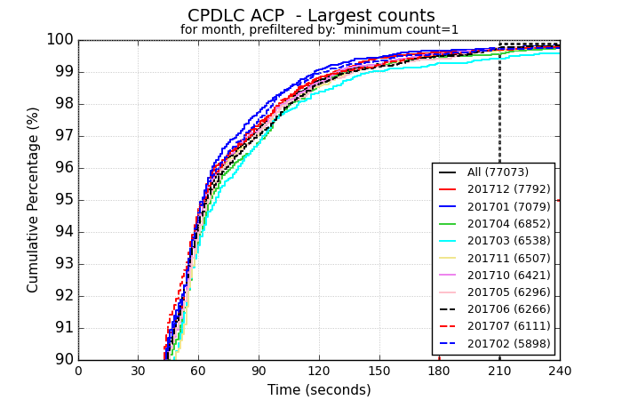

CPDLC: ACP by media for Melbourne FIR
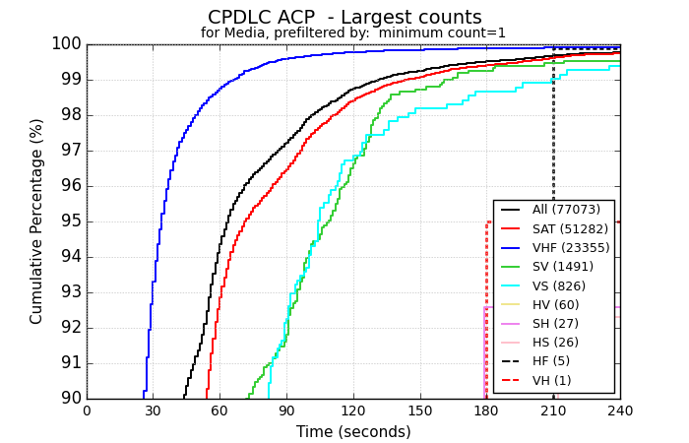

CPDLC: ACP for GES for Melbourne FIR
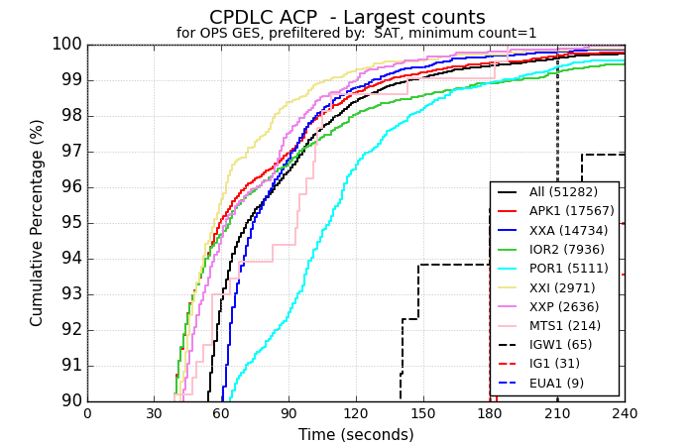

CPDLC: ACP for operators (Top 20 by transactions) for Melbourne FIR
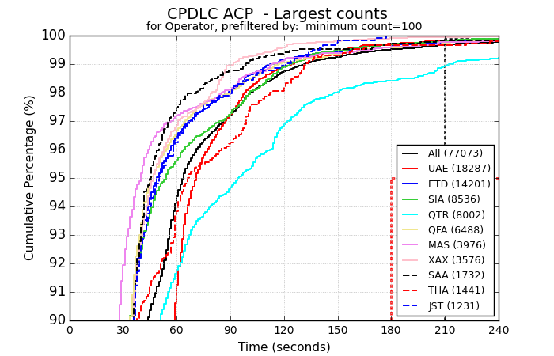

CPDLC: ACP for worst 10 operators at 180 seconds for Melbourne FIR
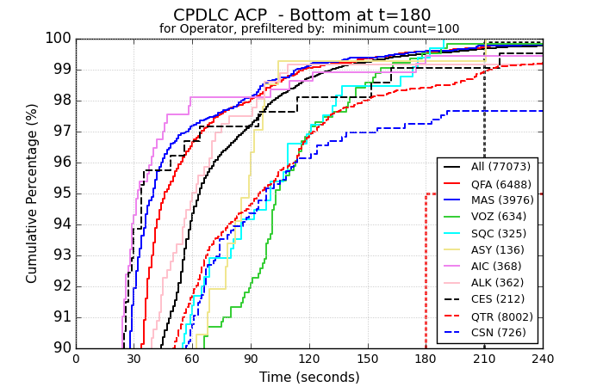

CPDLC: ACP for aircraft types (Top 20 by transactions) for Melbourne FIR
