Attachment 1 - Speed Changes


NORTH ATLANTIC AIR TRAFFIC MANAGEMENT GROUP

FORTY THIRD MEETING

(Prestwick, United Kingdom, 10 to 14 March, 2014)

Agenda Item 3: Update procedures and requirements

d) Variable altitude and speed
NAT ATMG/43 – WP10
19/02/2014

Analyses of the Speed Distribution of Aircraft that have an Assigned Mach Speed

(Presented by Iceland)

SUMMARY
This working paper analyses the speed distribution of aircraft that have been assigned a fixed Mach speed in the Reykjavik CTA. Speed information is obtained via ADS-C periodic reports and compared to the assigned Mach speed as issued in the NAT Oceanic clearance. The working paper partly addresses NAT ATMG Action Item 41-03.

Introduction

  - This working paper analyses the speed distribution of aircraft that have been assigned a fixed Mach speed in the Reykjavik Control Area (CTA). Speed information is obtained via Automatic Dependent Surveillance Contract (ADS-C) periodic reports and compared to the assigned Mach speed as issued in the North Atlantic region (NAT) Oceanic clearance.

  - The working paper partly addresses NAT ATMG Action Item 41-03:

NAT ANSPs investigate how the reference speed for fix-time calculation would be determined if an aircraft was not assigned a fixed Mach speed.

Discussion

Background

  - All turbojet aircraft in the NAT are assigned a fixed Mach speed in the Oceanic clearance that is issued to aircraft before entry into the NAT area. This practice is governed by the following provision in the NAT section of the Regional Supplementary Procedures (SUPPs, Doc 7030):

6.1.1.7 The ATC-approved true Mach number shall be included in each clearance given to subsonic turbo-jet aircraft operating within Bodø Oceanic, Gander Oceanic, New York Oceanic, Reykjavik, Santa Maria Oceanic and Shanwick Oceanic control areas.
(17 pages)

  - The four-dimensional aircraft profile, including the cleared Mach speed, is stored in the Reykjavik Flight Data Processing System (FDPS) and saved to enable post-flight analyses. All Future Air Navigation Systems (FANS) equipped aircraft that log on to the Reykjavik FDPS are assigned an 18-minute periodic ADS-C contract (in addition to other types of ADS-C contracts). The periodic contract includes the Air Reference Group, which includes the Mach speed. The periodic ADS-C reports therefore include the Mach speed of the aircraft.
  - Aircraft manufacturers have stated that the reported Mach speed in ADS-C reports is instantaneous speed and not the target speed of the aircraft. It has been stated that because the reported Mach speed is instantaneous it could not be relied on for separation and fix-time calculations since it will show fluctuations from the target speed and may show significant fluctuations in some cases such as when the aircraft encounters turbulence (target speed = the speed that the aircraft is striving to maintain).
  - Because all turbojet aircraft are assigned a fixed Mach speed in the Reykjavik CTA the cleared Mach speed can also be assumed to be the target speed of the aircraft. This situation therefore provides a unique opportunity to answer the following two questions:
    - When aircraft are assigned a fixed Mach speed, how much can the speed be expected to vary from the cleared Mach speed?
    - How reliably does the ADS-C reported Mach speed represent the target speed of the aircraft?
Analyses
  - Data set before filtering:
- 15,128 flights.
- 124,209 periodic ADS-C reports. Of those 95,.330 were within the Reykjavik CTA
- Average number of periodic ADS-C reports per flight is 8.2.
- The average Mach number reported is M0.823.
  - The data set was filtered as follows:
- Spans the period 19 June 2013 – 31 August 2013.
- The flight profile data was correlated with the ADS-C periodic reports. 46 flights could not be correlated.
- Only over-flights were used, flights that departed and/or arrived within the Reykjavik CTA were excluded.
- Only flights that had the same cleared Mach speed throughout the flight in the Reykjavik CTA were retained, 520 aircraft that were issued a Mach speed change were excluded and those may be analysed further at a later date if needed.
- Only flights that maintained F285 or higher throughout the flight in the Reykjavik CTA were retained, aircraft that had any part of the flight profile below F285 were excluded.
- Only ADS-C reports within the Reykjavik CTA were examined, all ADS-C reports where the reported position was outside the Reykjavik CTA were excluded.
- Only aircraft that had 3 or more periodic ADS-C reports were retained. 2894 aircraft with 2 or fewer periodic ADS-C reports (19%) were excluded. The reason for this filtering is to try to find those aircraft that are not maintaining their cleared Mach speed (see table in Appendix A).

  - Data set after filtering:
- 12,234 flights.
- 92,284 periodic ADS-C reports.
- Average number of periodic ADS-C reports per flight used for this analysis is 7.5.
- The average Mach number reported is M0.822.

  - The number of ADS-C periodic reports from each flight after filtering is shown in Figure 1 below:

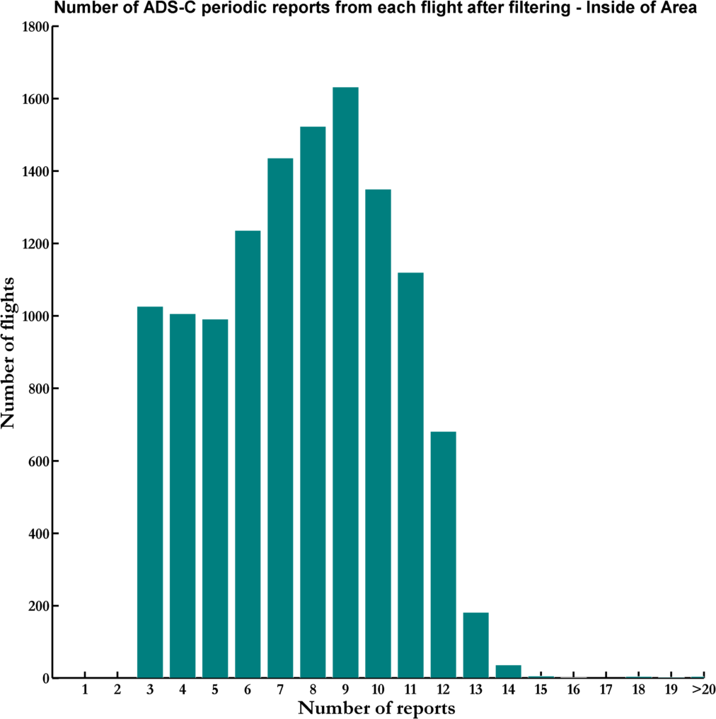

Figure 1

  - The distribution of the cleared Mach speed is shown in Figure 2 below:

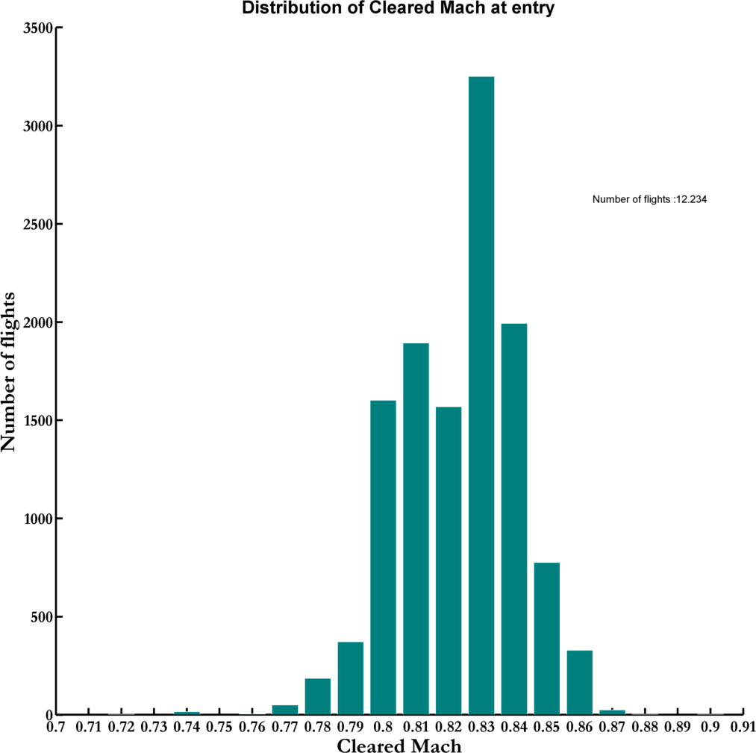

Figure 2

  - In the data set that is used for the analysis there were no values detected outside the M0.70 – M0.91 interval.

  - Figure 3 below shows a histogram of reported Mach speed in ADS-C reports:

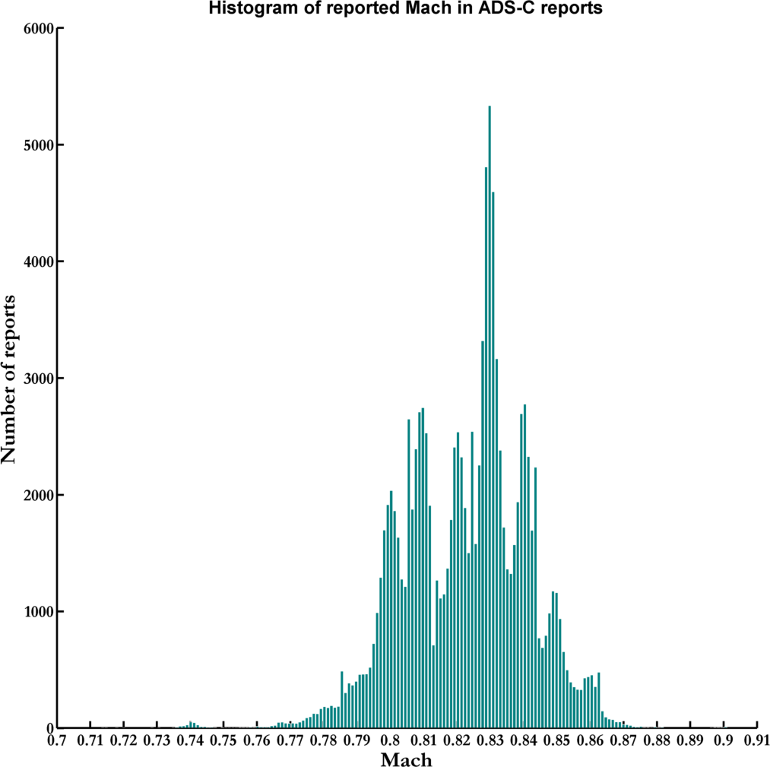

Figure 3

Results

  - Figure 4 and Figure 5 below show the results concerning reported Mach in all ADS-C reports as a difference from the cleared Mach speed:

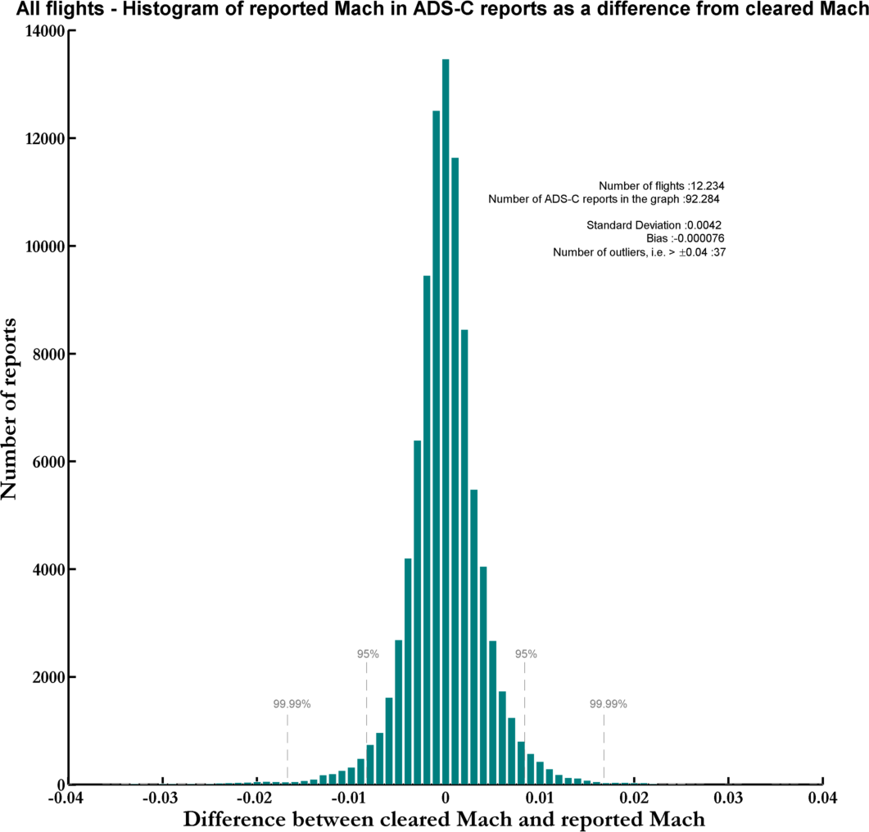

Figure 4

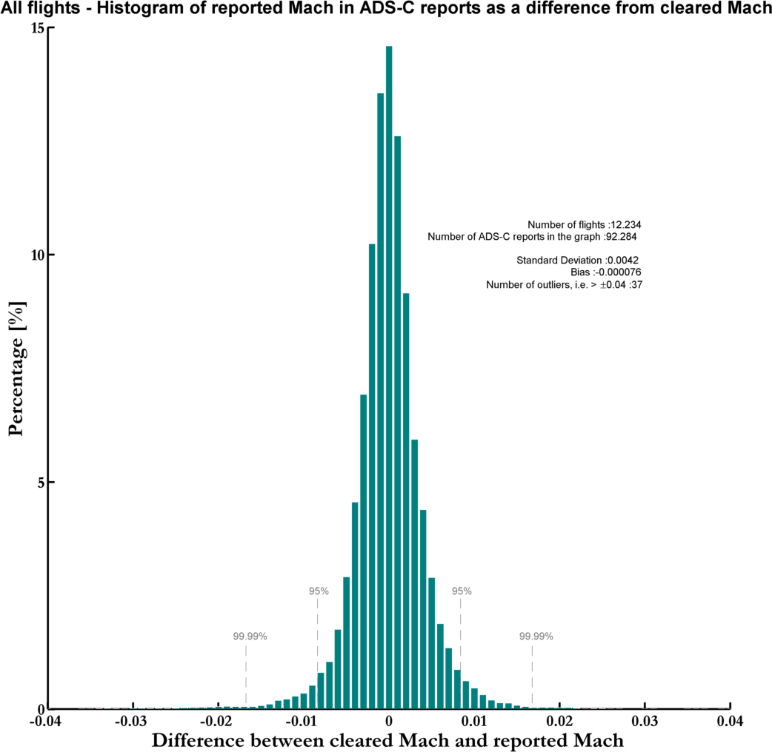

Figure 5

  - There are 37 outliers that are not contained within +/- M0.04 from the cleared Mach speed. They are scrutinized in the table in Attachment A:

  - Figure 6, Figure 7, and Figure 8 below show the results concerning reported Mach in ADS- C reports as a difference from the cleared Mach speed for a few aircraft types. No noticeable difference can be seen between the different aircraft types.

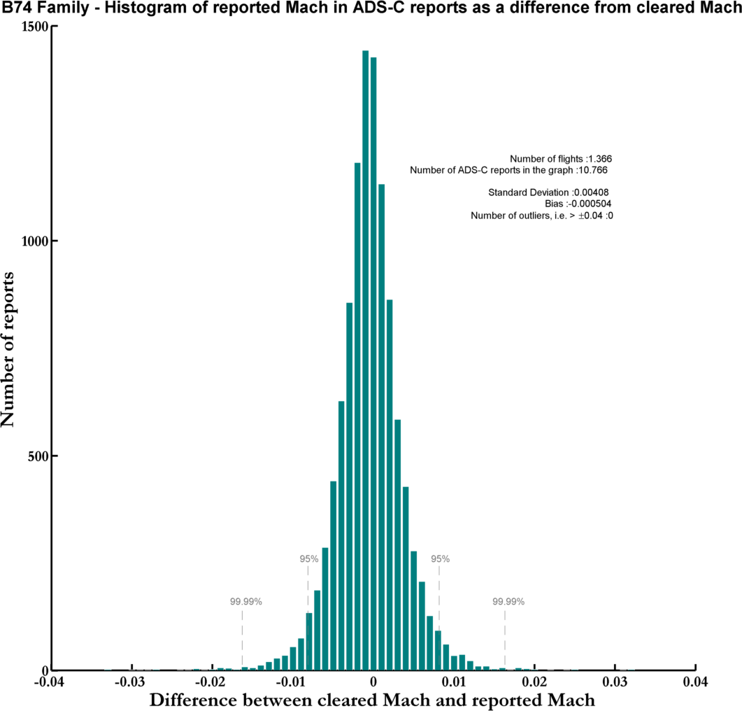

Figure 6

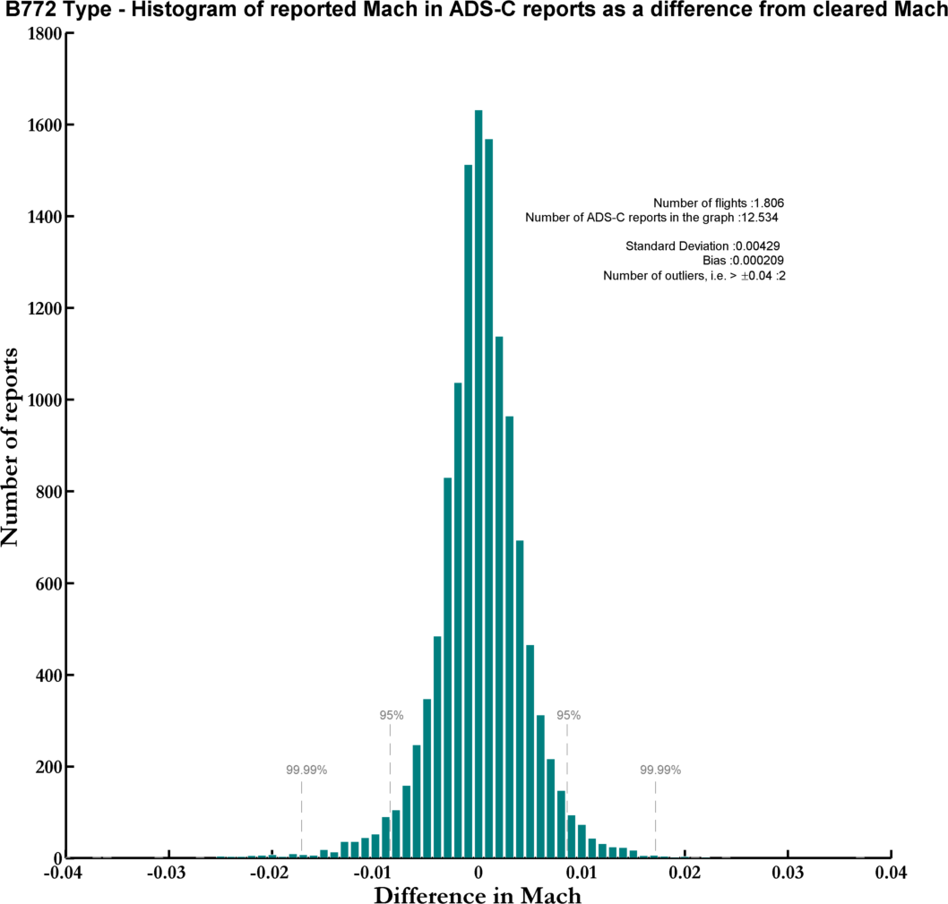

Figure 7

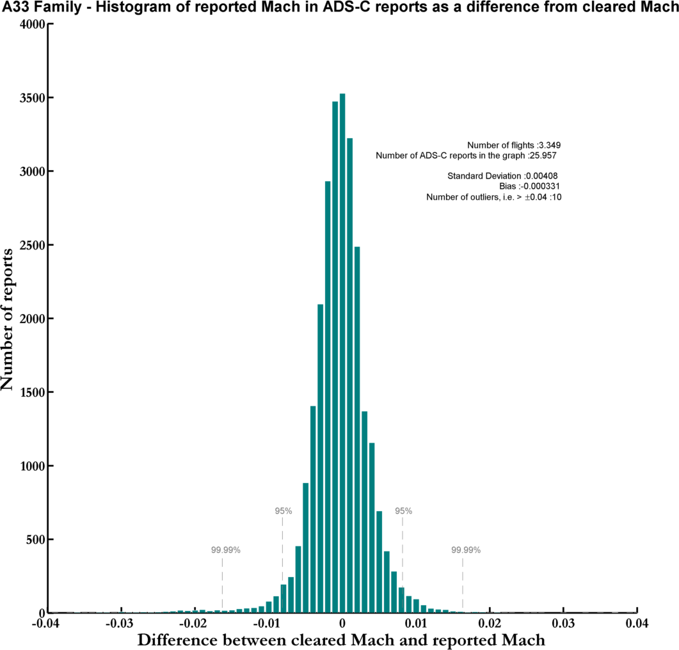

Figure 8

  - Figure 9, Figure 10, and Figure 11 below show the results concerning reported Mach in ADS-C reports as a difference from the cleared Mach speed for three airlines. The only noticeable difference is that for airline 2 the distribution is greater which results in increased standard deviation and that the 95% and 99.99% confidence intervals are at higher values.

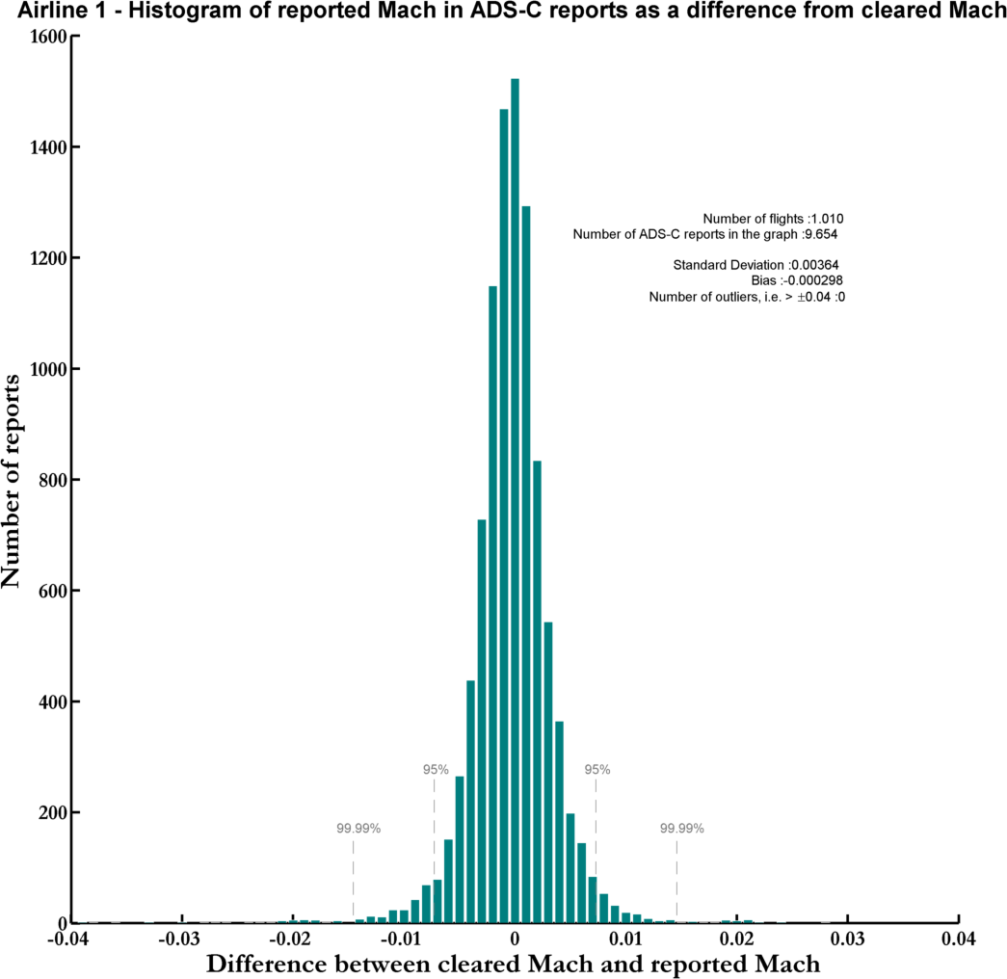

Figure 9

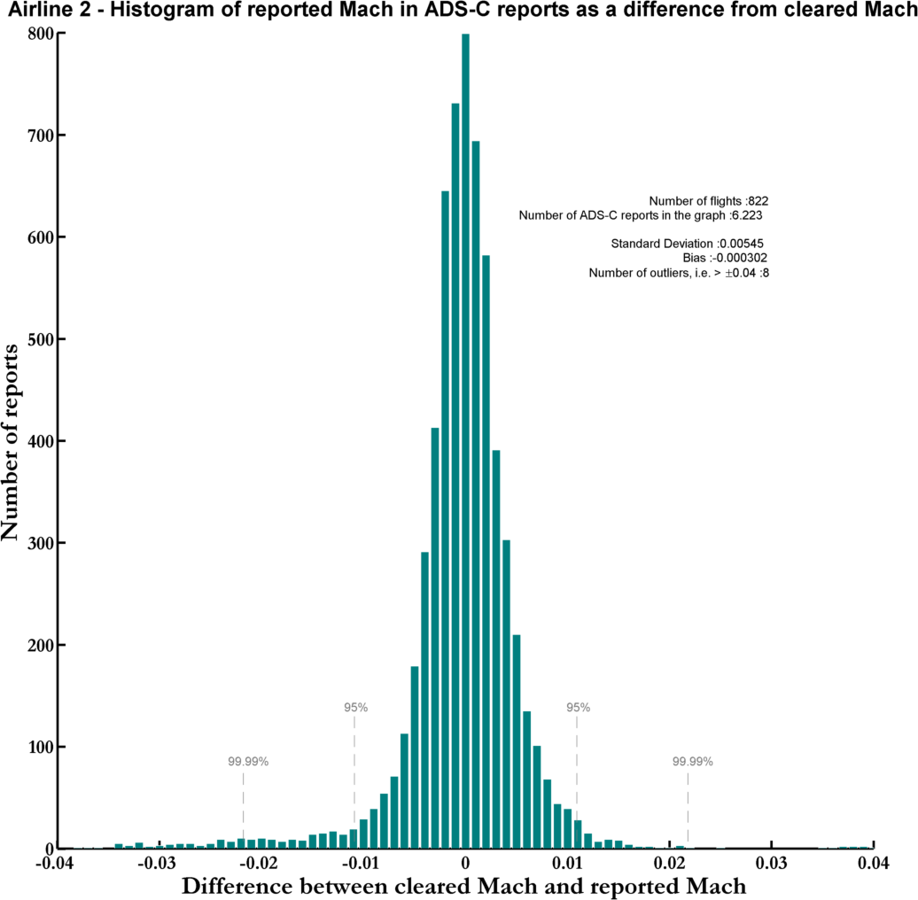

Figure 10

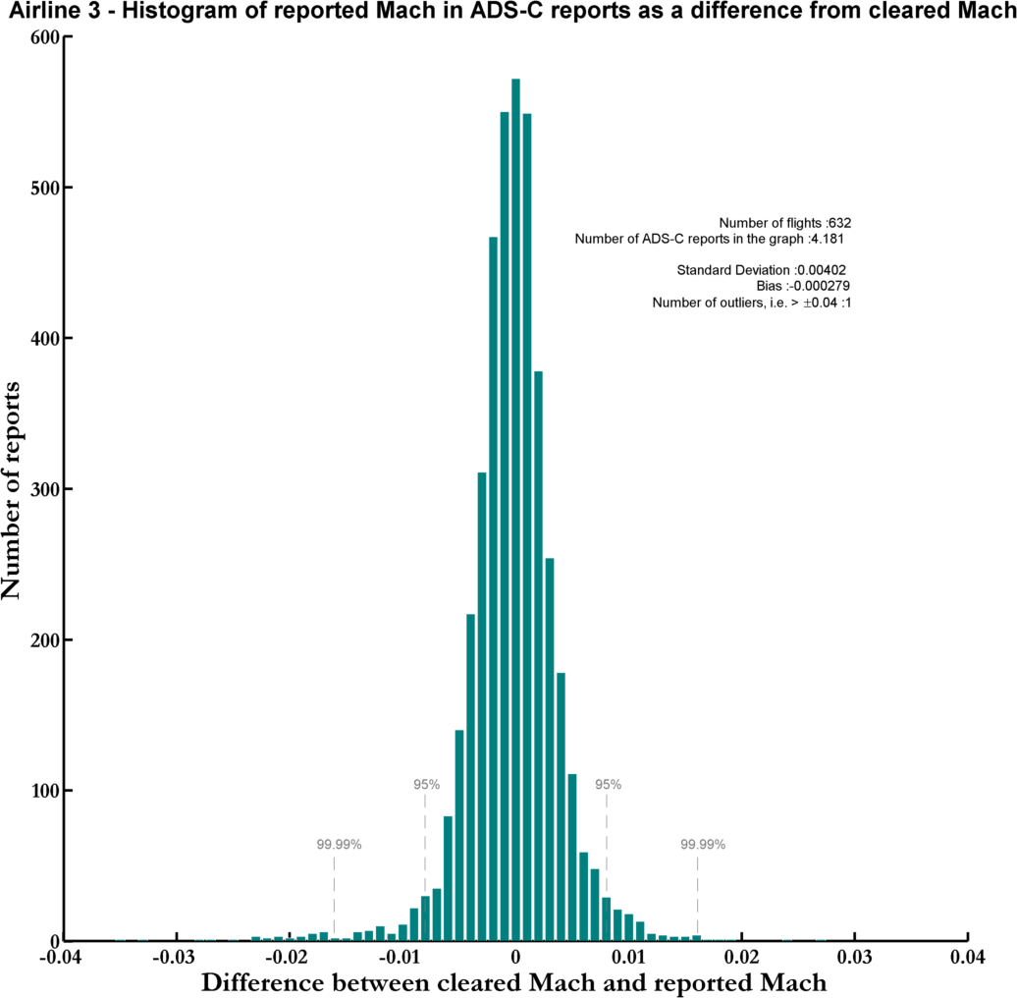

Figure 11

Variance calculations

  - Some limited variance calculations have been done in an effort to determine which flights are not flying their cleared Mach speed. The variance calculation has been done for every flight with 3 or more ADS-C periodic reports. The variance of the reports is calculated from the cleared Mach or in other terms from a given mean value. If the variance is over a defined threshold (0.0003) then the flight is classified as not flying cleared Mach. First results show that the configurable limit should be linked to the number of reports received and then the calculations would return better estimations. Further work could be done in this area if that is deemed to be beneficial. The results of the variance calculations can be seen in Attachment A.

Conclusions

  - Figures 4 and 5 indicate the following:

    - The speed distribution of aircraft with assigned Mach speed is more than 99.99% within +/- M0.02 (approximately 13 knots) from the assigned Mach speed.

    - Since the cleared Mach speed also represents the target aircraft speed in this research it can also be concluded that an Air Navigation Service Provider can be 99.99% confident that a Mach speed received in an ADS-C report from an aircraft is within +/- M0.02 of the aircraft target speed regardless of whether the aircraft was cleared on a fixed Mach number or not.

  - As a reference the following table can be used to visualize the effect of +/- M0.02 on fix- time calculations:

Route (F340) | M080 | M082 | M084 | Δt
45N030W | 00:00:00 | 00:00:00 | 00:00:00 | (424 NM)
45N040W | 00:54:55 | 00:53:35 | 00:52:18 | -00:01:20/+00:01:17
61N030W | 00:00:00 | 00:00:00 | 00:00:00 | (291 NM)
61N040W | 00:37:38 | 00:36:43 | 00:35:51 | -00:00:55/+00:00:52
75N030W | 00:00:00 | 00:00:00 | 00:00:00 | (171 NM)
75N040W | 00:20:05 | 00:19:36 | 00:19:08 | -00:00:29/+00:00:28

  - The above table only takes ADS-C waypoint reports into account. The 20 minute leg between 75N030W and 75N040W would however be indicative of a 20 minutes periodic ADS-C contract anywhere in the NAT. The time estimate error over the 20 minute reporting interval would only be around 30 seconds. (This is discounting the effect of wind and temperature which would be the same regardless of whether Mach speed was assigned or not).

  - This indicates that if Mach speed is derived from ADS-C reports, then time based longitudinal separation can be applied without assigned Mach speed provided that speed control (Mach assignment or time restriction) is applied when estimated separation is within 1-2 minutes of the separation minima.

Action by the Meeting

c) decide on any further action.
3.1 The NAT ATMG is invited to:
a) note and discuss the information provided in this working paper;
b) discuss the effect on application of longitudinal separation; and

