Thirty-First Meeting of the
Informal South Pacific ATS Co-ordinating Group
(ISPACG/31)

Hawaii, USA
6 to 9 March 2017

Agenda Item 6 - Other business

Principles of boundary coordination

Presented by Airservices Australia

SUMMARY

This WP presents issues identified with boundary coordination (or “information transfers”) with adjoining ATSUs.

1. INTRODUCTION

  - The purpose of coordination from one ATSU to another is to provide information about a flight to facilitate the provision of an air traffic service. Generally, coordination will be for a flight that directly enters an ATSU’s airspace, but on occasion “boundary coordination” or an “information transfer” may be required for a flight that is operating in proximity to, but not crossing the common FIR boundary.

  - Recent changes to the LOA with NFFF has revealed unexpected functionality in processing boundary coordination by surrounding ATSUs.

2. DISCUSSION

2.1 3000S16300E is the intersection of the YBBB, NFFF and NZZO FIRs. Until recently, for flights operating eastbound on A346 via TEKEP, YBBB had an exemption, whereby coordination to NFFF was not required, even though this route is within procedural tolerances (50NM) of NFFF.

2.2 Following recent changes to our LOA with NFFF, this exemption for boundary coordination was removed. So now, for a flight operating eastbound on A346 via TEKEP, coordination is required from YBBB to NZZO <OK> as well as boundary coordination from YBBB to NFFF.

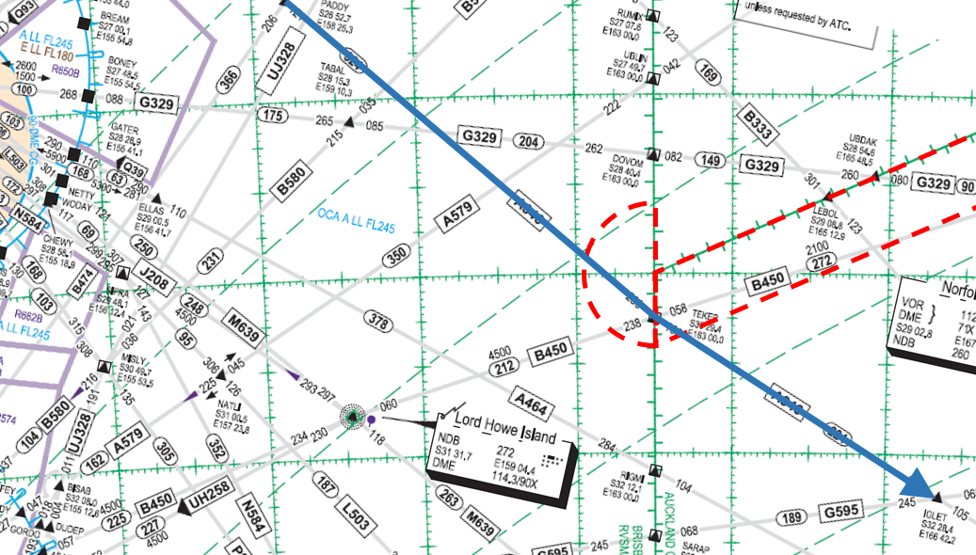
YBBB
NFFF
NZZO
30S163E

2.3 What was discovered after this LOA change took place was that NZZO, as a function of their automation, also sends a coordination message to NFFF (because the aircraft enters the Area Of Interest (AOI) that they have adapted for NFFF).

2.4 Because NFFF only supports one coordination message, any subsequent coordination message is rejected. So in the example above, whoever conducts the coordination second ends up with an open coordination dialogue (i.e. no ACP response from NFFF is received).

2.5 Liaison with NZZO reveals that they have made software changes to support 2 separate coordination messages from different ATSUs. These software changes were made as a result of similar “double coordination” problems in other areas of their airspace. I understand that Oakland may have made similar software changes.

2.6 While AIDC guidance material concerning boundary coordination is not clear on thi smatter, in the example above, I do not consider it the responsibility of NZZO to provide boundary coordination to NFFF

3. ACTION BY THE MEETING

3.1 The meeting is invited to:

a) Discuss the issues raised by this WP

b) Consideration developing updates to AIDC guidance material in affected documents

