Thirty-First Meeting of the
Informal South Pacific ATS Co-ordinating Group
(ISPACG/31)

Hawaii, USA
6 to 9 March 2017

Agenda Item 6, Other Business

PILOT REPORTS - PIREP

Presented by Air New Zealand

Summary

For many years, pilots have had an obligation to report significant weather to ATC and traditionally this was done using H.F. voice. With modern communications systems there is now a reluctance to use H.F, and there are also much better methods for distributing reports to interested parties.

- INTRODUCTION
  - Anecdotal evidence suggests more turbulence encounters in recent years than in the past and these, unfortunately, have resulted in injury to both passengers and crew and damage to aircraft. In addition, some modern turbo-fan engines have proven to be susceptible to ice crystal icing, so this is a phenomenon that now has more prominence than it might have had historically.

1.2 We believe we must do all that we can to avoid these encounters at the planning stage, but if turbulence or other weather phenomena are encountered, this must be reported to both other potentially affected aircraft, and the forecasting agency.

- DISCUSSION
  - Modern Airbus and Boeing aircraft, and probably other types, include optional weather reporting within the CPDLC Position Report. We only send these reports at FIR boundaries in Asia/Pacific, and not at all in North Atlantic and surrounding airspace. In addition, most ANSPs process these reports automatically and do not display the content to the controller, making this method of reporting weather unsatisfactory.

  - Japan (Fukuoka) has a formal reporting process using CPDLC free text but this (or a similar) electronic procedure is not documented in other regions. We note some States use a manual PIREP form and this generally needs encoding and decoding.

Sample U.S. PIREP

KOKC UA/OV KOKC090064/TM 1522/FL080/TP C172/SK SCT090-TOPUNKN/WX FV05SM HZ/TA M04/WV 24540KT/TB LGT/RM IN CLR

2.3 In 2016, Air New Zealand engaged with MetService New Zealand as they were keen to receive more PIREPS to improve weather forecast modelling. We developed an ACARS communications page which allows pilots to easily report weather of significance to MetService, ATC and our own Flight Dispatch flight watch desk in plain language. We have trialled the initial release with Airways New Zealand, and as a result changed the FIR filtering method.

The PIREP can be distributed by either email or AFTN, and recipients can elect which reports to receive. As an example, MetService request reports of nil turbulence in areas where SIGMETS have been issued, which should assist in more accurate SIGMET forecasting.

Air New Zealand customised PIREP page

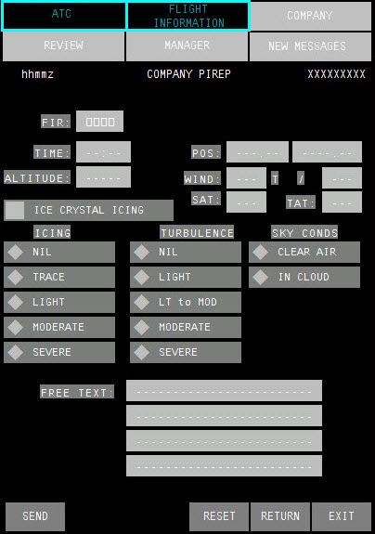

The pilot only needs to enter FIR name and then select the appropriate weather entries adding free text if required. All current state information is automatically populated.

Sample PIREP

-------------------- ANZ PIREP --------------------
B772 ANZ23 CYVR/NZAA OKB 18-JAN-17 15:02:41
Report time: 1502
Report POS: S28.12 W179.71
ALT: 37999
SAT: -51
TAT: -20
WIND: 171T/45Kt System generated
Ice Crystal Icing: No
Icing: Nil
Turbulence: Light to moderate
Sky Condition: Clear air
COMMENTS:
SIGMET 12 ONLY LT TURB Pilot entry

2.4 As Airways New Zealand has elected to receive reports of only moderate turbulence or greater, this report was distributed to MetService and Air NZ Flight Watch only.

2.5 Air New Zealand offers these reports initially to all Pacific ANSPs on a ‘trial’ basis. Reports are filtered by FIR, and recipients can elect to receive reports that suit their needs by either AFTN or email. We understand ANSPs have existing agreements with national forecasting agencies relating to PIREP distribution so leave it to local procedures how these reports are disseminated outside the ANSP. The reports could be machine translated by the recipient into various formats to suit.

2.6 Until the process is fully established and tested, crews are required to report PIREPS by traditional means, but we expect this will be dis-established in FIRs that ‘opt in’ to this procedure.

Contact mark.shepherd@airnz.co.nz to discuss further or arrange a trial.
3. ACTION BY THE MEETING

3.1 The meeting is invited to:
a) Consider this process and, if suitable for local procedures, request a trial or discuss with the national forecasting agency.

