Thirty-First Meeting of the
Informal South Pacific ATS Co-ordinating Group
(ISPACG/31)

Honolulu, Hawaii, United States of America
6 to 9 March 2017

Agenda Item 2, Update from States

South Pacific AFS Network Replacement Proposal

Presented by the United States (U.S.) Federal Aviation Administration (FAA)

SUMMARY

The objective of the South Pacific AFS Network Replacement (SPANR) is to offer a safe, secure, robust and cost effective telecommunications transport service to all Members, and to offer the possibility to all Candidates to contract that service in a timely manner.

It will facilitate voice and data communications between Members by allowing all participants on the network the opportunity to establish communications with each other. Telecommunication costs will be minimized as countries will only need a small number of connections to a far-reaching network, rather than individual connections to each neighboring state.

The current process to upgrade or add a new circuit is estimated to take about two years from planning to implementation. With a new common network in place, this process could be reduced to months or even weeks.

1. INTRODUCTION

  - The objective of the South Pacific AFS Network Replacement (SPANR) is to offer a safe, secure, robust and cost effective telecommunications transport service to all Members, and to offer the possibility to all Candidates to contract that service in a timely manner.
  - It will facilitate voice and data communications between Members by allowing all participants on the network the opportunity to establish communications with each other. Telecommunication costs will be minimized as countries will only need a small number of connections to a far reaching network, rather than individual connections to each neighboring state.
  - Each user of the network will take responsibility for its own IT security. However, the network will support this security by being a closed private network, without access to the public Internet. Each Member can (and should) establish IT security protections so that they comply with their organization’s security policies. At their discretion, some Members may also establish bi-lateral IP Security (IPSEC) VPN tunnels over the SPANR to provide an additional layer of protection.
  - Finally, the network should support the telecommunication standards which the Region intends to use. Accordingly, it should carry both IP versions 4 and 6.
  - The network will be used to support the delivery of Air Traffic Management (ATM) services. It must be fit for purpose so that each Air Navigation Service Provider (ANSP) can provide the highest levels of safety.
  - The South Pacific Network Forum comprises States with boundaries to the South Pacific Oceanic FIR regions that currently implement telecommunications between them for the purpose of South Pacific oceanic air traffic management including: Fiji, Papua New Guinea, Australia, New Zealand, and the United States.

2. DISCUSSION

  - Description of the traffic being exchanged between States
The scope of the SPANR is to provide a cross-border telecommunications network for Members in the South Pacific region. This network will allow each Member to easily communicate with any other Members in the region.

- Information to be carried by the SPANR Network
• Ground-ground voice ATM communications, referred to as voice communications
• Ground-ground ATS surveillance data, referred to as surveillance data
• Ground-ground AFS (AFTN/AMHS) data
• Ground-ground AIDC data
• Ground-ground AIM data
• Ground-ground ATFM data
• Ground-ground SWIM data
• Miscellaneous data: other data not pertaining to the categories above, or carried for TEST purpose only
• Any other category as agreed later

- Issues to be considered
Issues to be considered include, but are not limited to, the following:
• Technical requirements
• Cost, including arrangement for division/allocation of cost
• Methods of billing and payment
• Process for contract award
• Responsibility for network administration
• Need for single point of contact to deal with service provider
• Handling of network service issues
• Performance specifications
• Network security issues
• Network redundancy issues
• Capacity for growth and expansion
• Required lead time for implementation
• Business Continuity / Disaster Recovery issues relating to the network
• Performance management, measurement, monitoring, reporting and control

  - Current Configuration

- Map showing all current point-point connections
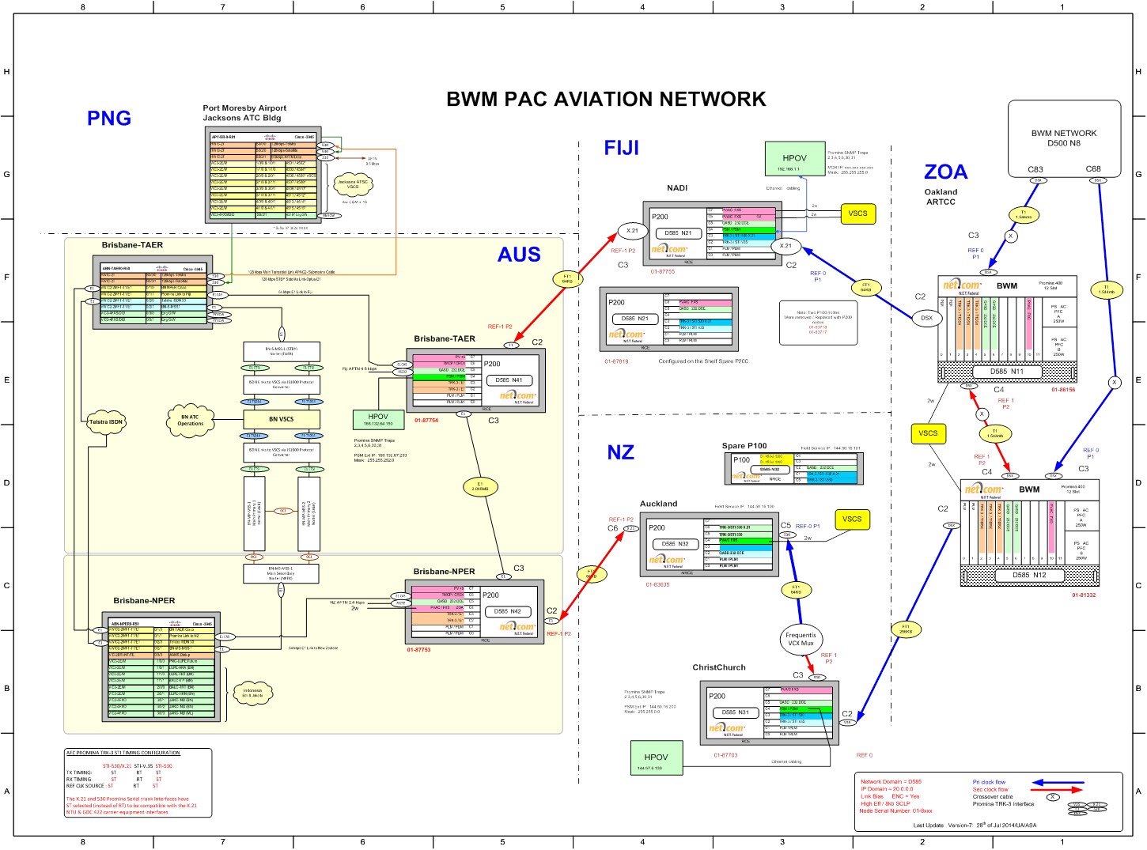

- Current issues
As pointed out by the ICAO survey on ground-ground communications performed early 2014, the existing point-to-point network configuration exhibits a number of limitations, including (but not limited to):
- cost limitations: high costs per connection;
- a marked obsolescence threat due to aging technologies and protocols (IPL, X25 etc.);
- a need for telecommunication backup or diversity, although the current reliability is assessed as rather satisfactory;
- problems experienced with change management;
  - Separate requisition process for each new connection, generally a time-consuming and cumbersome process;
  - Limited flexibility for increase in bandwidth;
  - Limited flexibility for expansion to other end-points;
  - Need to deal with half circuit vs. full circuit arrangements, depending upon policies of ANSPs involved;
- A design that is not optimized for current needs nor readily adaptable to new needs;
  - Potential duplication of network services as bandwidth for other types of data are generally obtained separately;
  - the inability to switch to new protocols like VoIP or SWIM with an efficient network design; and
- Inconsistent practices as to performance requirements and monitoring

- Proposed Plan/Configuration

- Technical Requirements
Table V-1 End-to-end Network Requirements for Voice
Availability | .999
Latency | 100ms one way
Jitter | <40ms
Dropped Packets | <1%
VoIP Codec | G.711

Table V-2 End-to-end Network Requirements for Data
Availability | .999
Latency | 500ms one way
Dropped Packets | <1%

Table V-3 Current and Future Bandwidth Requirements
Connection | Current | Projected | Notes
Brisbane-Auckland | 64 K
Brisbane-Nadi | 64 K
Brisbane Total | 128 K | 2048 K
Melbourne Total | n/a | 2048 K | Redundant link for Brisbane
Nadi-Brisbane | 64 K
Nadi-Brisbane | 64 K
Nadi-Oakland | 64 K
Nadi Total | 192 K | 256 K
Oakland-Nadi | 64 K
Oakland-Christchurch | 256 K
Oakland Total | 320 K | 256 K
Salt Lake City Total | n/a | 256 K | Redundant link for Oakland
Atlanta | n/a | 256 K | Redundant link for Salt Lake City
Christchurch-Oakland | 256 K
Auckland-Brisbane | 64 K
New Zealand Data Total | 320 K | 256K

3. ACTION BY THE MEETING

3.1 The meeting is invited to:

a) Review the SPANR proposal

b) Coordinate with SPANR members to upgrade or request new service as needed

