Thirty-First Meeting of the
Informal South Pacific ATS Co-ordinating Group
(ISPACG/31)

Hawaii, USA
6 to 9 March 2017

Agenda Item 6, Other Business

Rocket Launches

Presented by Airways NZ

SUMMARY

This information paper details the operational procedures in place for the commercial launch of rockets from the east coast of New Zealand north Island.
Rocket labs electron rocket is 16 meters high, 1.2 meters in diameter and designed to carry a payload of 150kg to a 500km sun-synchronous orbit.

1. INTRODUCTION

  - Rocket Lab (RL) plan to launch their first Electron rocket into orbit between 5th Jan and 21st June, from their launch complex on the Mahia Peninsula, which situated on the eastern most part of the north island.
  - Several temporary SUA’s have been created, four of which (NZD492, NZD025, NZD026 and NZD027) which impact on Oceanic operations.

2. DISCUSSION

2.1 Launch advice is 15 days prior to the intended launch with confirmation required 48 hours prior to launch.

2.2 In order to meet the requirements of their Space launch licence, Rocket Labs has a number of additional requirements to ensure that the NOTAMed danger areas are clear of traffic.

2.3 Oceanic will receive a call from the Launch Coordinator/Duty Manager at the following times;

Launch Time (T)
T – 2hrs | Notification that the launch countdown has begun and check the SUA is entered into OCS.
T – 1hr | Notification that confirmation that NZD492, NZD025, NZD026 and NZD027 are “Clear of Known Traffic” will be sorted in the next 15-20mins.
T – 45-30mins | Confirmation that NZD492, NZD025, NZD026 and NZD027 are “Clear of Known Traffic”.

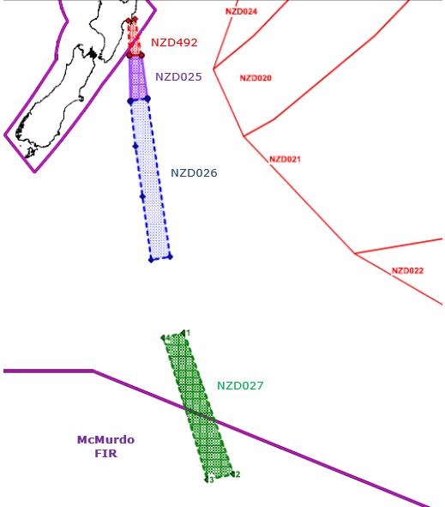
2.4 Intention to launch to orbit sun-synchronous altitudes in circular or elliptical orbits at inclinations between 45 and 98 degrees.

2.5 Software modification was required to allow flights to operate up to the boundary of the danger area establish for space debris as opposed to other activities.

2.6 Rocket proposed timeline https://www.rocketlabusa.com/book-my-launch/

3. ACTION BY THE MEETING

3.1 The meeting is invited to:

a) Note Airways readiness to support commercial rocket launches within New Zealand domestic and international flight information regions.

