Thirty-First Meeting of the
Informal South Pacific ATS Co-ordinating Group
(ISPACG/31)

Hawaii, USA
6 to 9 March 2017

Agenda Item 6 – Other business

AIDC performance between YBBB and WAAF

Presented by Airservices Australia

SUMMARY

This IP presents AIDC performance and reliability observed since the commencement of the current AIDC trial with Makassar (WAAF).

1. INTRODUCTION

1.1 AIDC messaging had previously been trialed between YBBB and WAAF a number of years ago (ISPACG/25 IP10 refers). After a period of trialing the decision was made to discontinue the exchange of ABIs due to poor performance (numerous “time out” warnings), and concerns regarding the route information in ABI messages received by YBBB.

1.2 In more recent times, the data adaptation for the airspace south of Indonesia (i.e. waypoints and routes) held by Makassar has been updated and as a result of discussions at AUSINDO/34, the exchange of ABIs was re-implemented in early February 2017.

2. DISCUSSION

2.1 Apart from a few early teething problems, the exchange and processing of ABI messages has been reasonable successful.

2.2 AIDC performance, while considerably more variable than with other ATSUs, has been generally acceptable. “Outages” that had previously been observed were not evident within the data sample reviewed.

Note. There was one period where an AIDC outage did occur, but this was during a programmed data upgrade by YBBB.

2.3 Unfortunately, while most ABI messages received from WAAF contain correct route information, a number of erroneous ABIs have been identified. The example below shows the original FPL for HVN773, and the corresponding ABI received. Note the deletion of all route data following “VINAX” in the ABI, without an ICAO truncation indicator (“T”).

(FPL-HVN773-IS-B789/H-SADGHIJ5RUWXY/LB1D1-VVTS1430 -N0514F310 LANHI1F LANHI DCT ELSAS/M085F310 M768 DAGAG/M086F330 M768 ASISU/M085F350 M768 MAMOK/N0508F350 M768 SHEPP/M086F350 M768 DONYA/M085F370 M768 DN/N0499F370 J251 TN T74 VINAX G326 TAVEV R340 MIMIB/N0493F390 R340 AGETA UH201 SCO H12 BOREE DCT-YSSY0737 YMML-PBN/A1B1C1D1L1O1S1S2 DOF/170305 REG/VNA863........)

(ABI-HVN773/A5632-VVTS-ELBIS/1816F350-YSSY-8/IS-9/B789/H-10/SADGHIJ5RUWXY/LB1D1-15/N0514F310 LANHI1F LANHI DCT ELSAS/M085F310 DAGAG/M086F330 M768 ASISU/M085F350 M768 MAMOK/N0508F350 M768 LADOP 0344S12336E ELBIS M768 SHEPP/M086F350 M768 DONYA/M085F370 M768 DN/N0499F370 J251 TN T74 VINAX -18/PBN/A1B1C1D1L1O1S1S2 DOF/170305 REG/VNA863......)

2.4 The ATM system in Makassar does actually support the route information that was deleted, which indicates that the problem is possibly an operator (of the ATM system) rather than a specific software problem.

2.5 Despite these occasional errors, the trial is continuing.

2.6 The graph below shows the one way travel times of AIDC messages sent by YBBB to WAAF. The travel time was calculated by comparing the time in the AIDC message with the transmission time of the corresponding LAM.

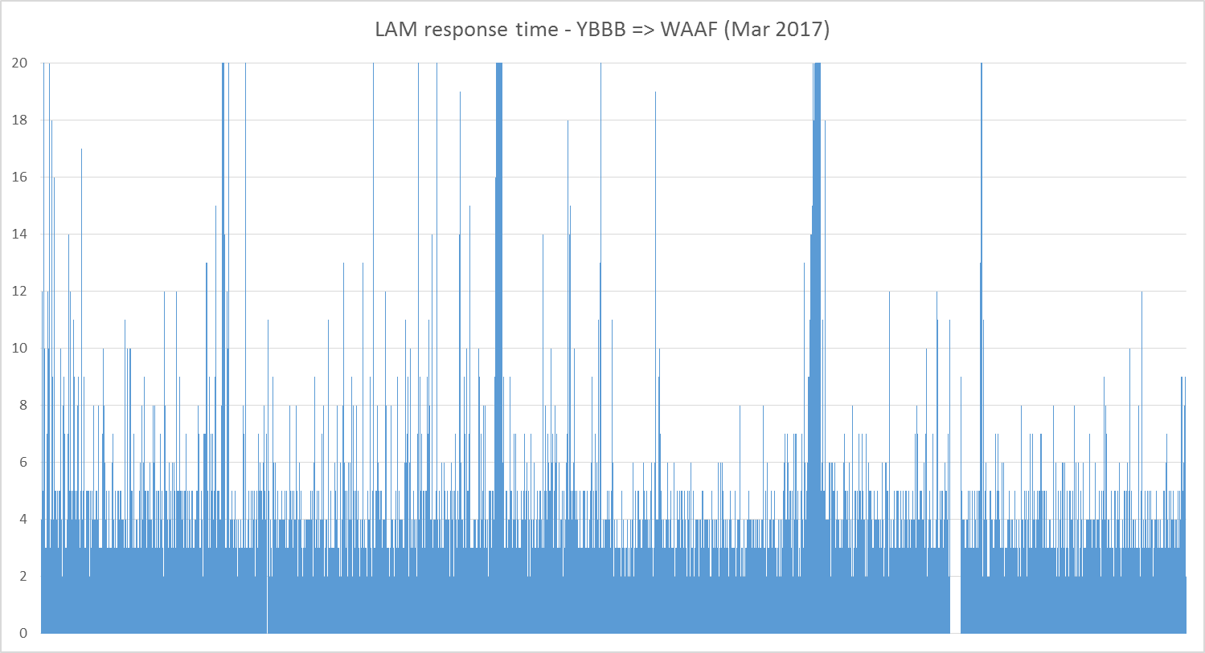

3. ACTION BY THE MEETING

3.1 The meeting is invited to note the information in this paper.

