FANS Interoperability Team Meeting
(FIT/24)

Hawaii, USA
6 to 7 March 2016

Agenda Item 8: Working Papers -FIT

HF Data link performance

Presented by Airways New Zealand

SUMMARY

This paper provides an update on the performance of HF Data link (HFDL) as observed in the Auckland Oceanic FIR. Observations again confirm that HFDL is unsuitable for operational use in an RSP180 environment when SATCOM is not available.

1. INTRODUCTION

  - In NZZO we have a growing number of fleets using HF Data Link (HFDL) in NZZO airspace. All these fleets use HFDL as a backup to SATCOM in what has become commonly known as the “Next on Busy” mode of operation.

2. DISCUSSION

2.1 In 2016 Airways observed 3126 ADS-C data points from HFDL and the media is in use by 18 aircraft fleets. Our main users by aircraft type are: A332; A333; A388; B748; B772; B77W; B788, and B789.

2.2 As noted in previous working papers on this subject the use of HFDL in the “Next on Busy” mode does cause some performance degradation but this is not considered significant in RSP180 operations. The typical degradation of pure SATCOM performance by using HFDL in “next on busy” mode is illustrated in Figure 1 below for the QANTAS A388 fleet. The graph shows pure SATCOM performance compared with that from an aggregate of SATCOM and HFDL (which is the normal operations mode “next on busy”) and also shows the performance of pure HFDL.

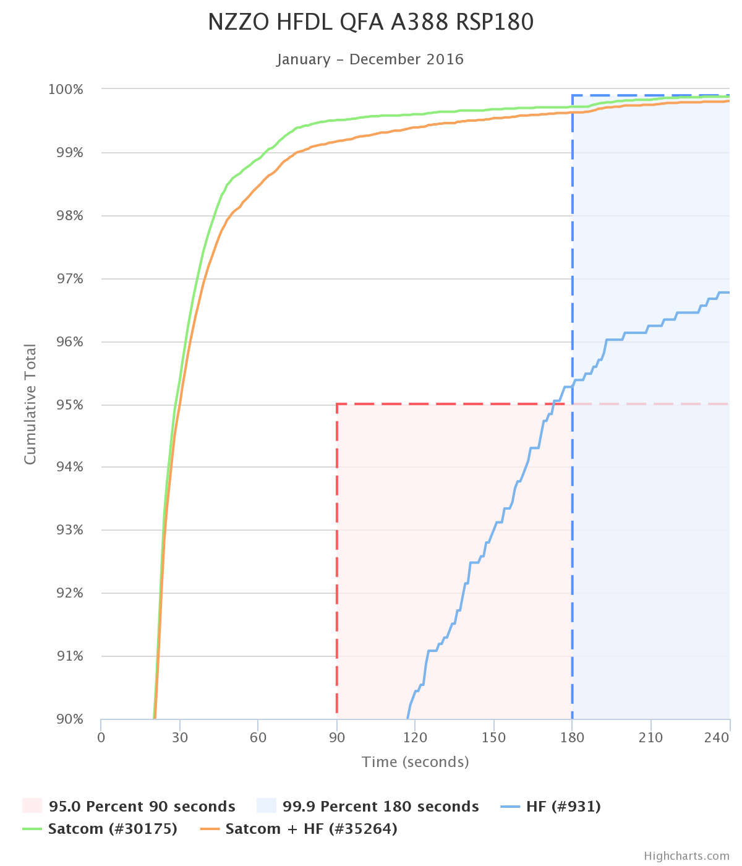
Figure 1: RSP180 QFA A388 – SATCOM, SATCOM+HFDL, HFDL

2.3 If operating in pure HFDL mode without SATCOM fleets are expected to meet RSP400. In 2016, from observations of HFDL performance when operating in “next on busy” mode with SATCOM only two of the fleets achieve RSP400, two meet 95% and two are well below. This is illustrated in Figure 2.
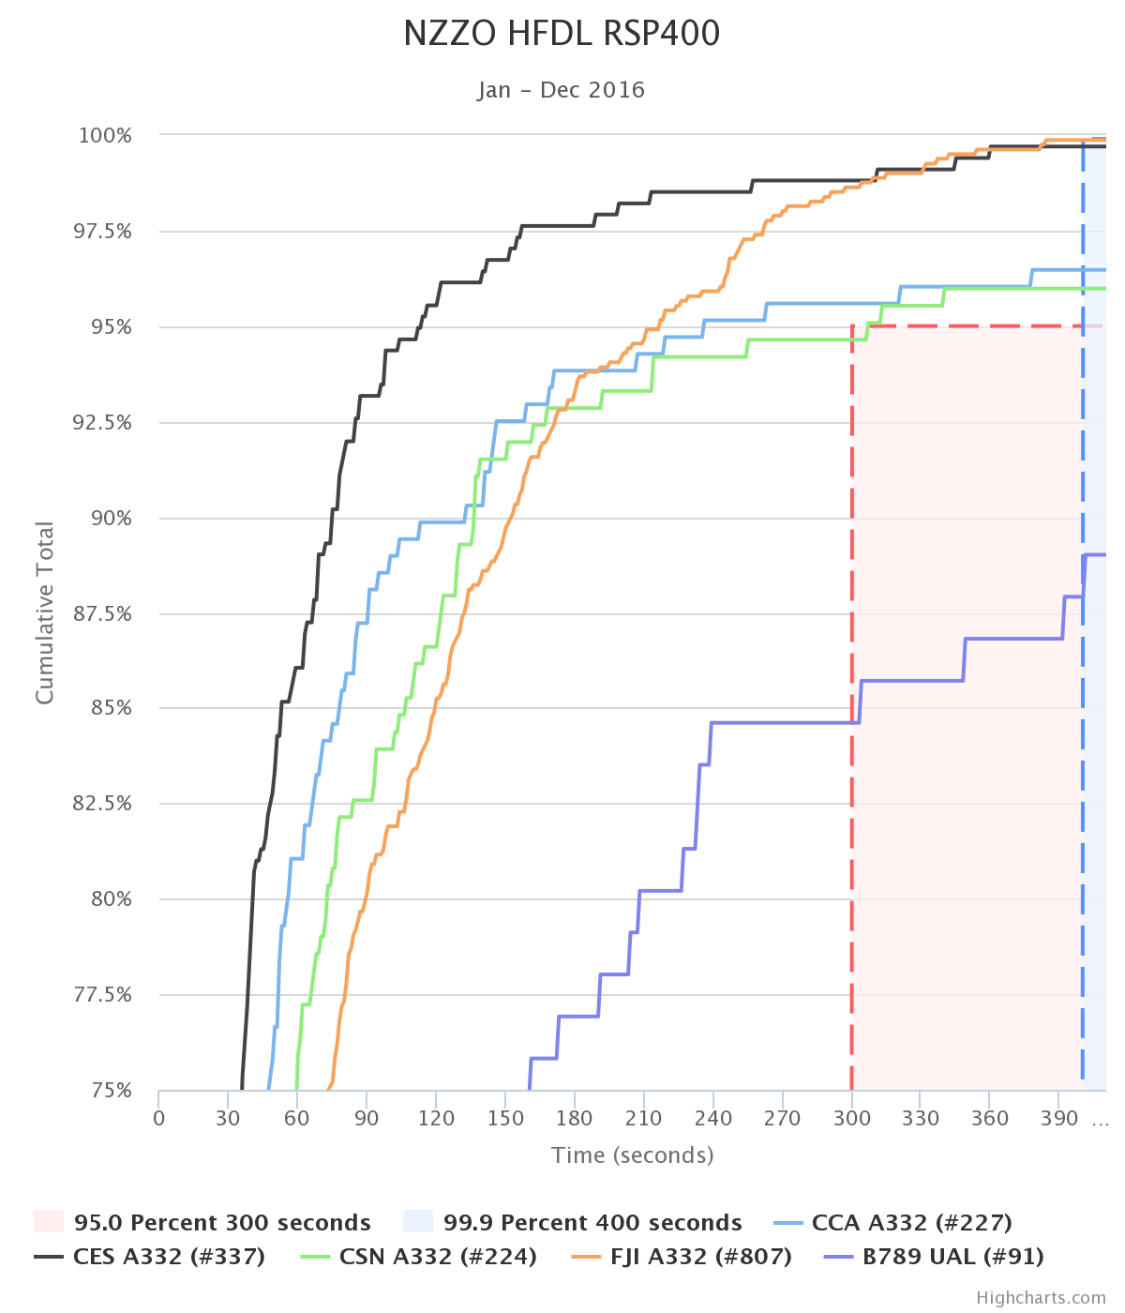
Figure 2: HFDL RSP400 analysis NZZO 2016

2.4 Our experience during SATCOM failures is that the performance of HFDL will degrade well below RSP400 when used in stand-alone mode. This was well illustrated in 2016 where we saw a number of flights operating using HFDL without SATCOM. The performance seen from the 79 data points gathered is well below RSP180 and RSP400 and illustrated in Figure 3. Crews should immediately notify any SATCOM failure as the aircraft no longer meets RSP180, and aircraft that are dispatched without SATCOM should not file RSP180, RSP400 or RCP240.

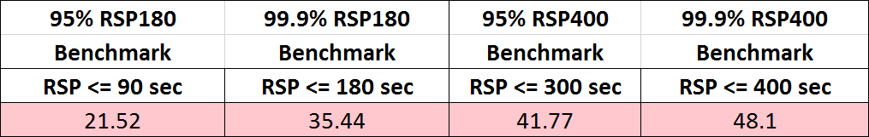

Figure 2: HFDL RSP180 and RSP400 analysis no Satcom NZZO 2016

2.5 With pending implementation of PBCS we need to enhance the guidance material for both flight crew and AOC on actions required if operating HFDL with no SATCOM. States should also consider AIP amendments to specifically cover this situation.

3. ACTION BY THE MEETING

3.1 The meeting is invited to:

a) Note the performance of HFDL ADS-C latency in NZZO in 2016,

b) provide feedback on the analysis provided, and

c) agree need for guidance material and AIP amendments to cover operations with HFDL without SATCOM.

