FANS Interoperability Team Meeting
(FIT/24)

Hawaii, USA
6 to 7 March 2016

Agenda Item 3, PBCS implementation

PBCS approval framework review

Presented by IATA

SUMMARY

In ICAO DOC9869 PBCS manual (draft), we see both ANSP and Operator requirements for approvals are still insufficient and found critical points in this framework. For the successful implementation of PBCS globally, we need to review and develop approval framework and process further.

1. INTRODUCTION

  - The PBCS manual (DOC 9869) provides the PBCS approval framework for ANSPs and Aircraft Operators, this manual includes several approaches for approval that are not seen in other operational approval schemes.
  - One key point of this framework is the relation between CSP and ANSP/ Operator as shown below. (ICAO DOC9869)
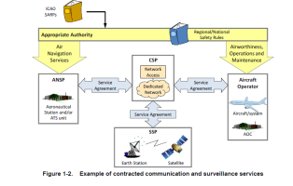

  - The CSP is the key element of PBCS performance, but both ANSPs and Operators rely on commercial contracts with CSPs for performance.
  - We do not normally rely on commercial contract SLA itself in Operational approval framework, we normally rely on certification or requirements for quality and performance.
  - Commercial contracts with service level agreements, to the degree required to support airline operational approvals under PBCS, are not normally seen in current contracts.
  - The PBCS manual shows the Network segments (D1 – D2 and D5 – D6 in the PBCS figure below) under ANSP-CSP and Operator-CSP contracts. These overlapping means of compliance make individual responsibilities unclear.
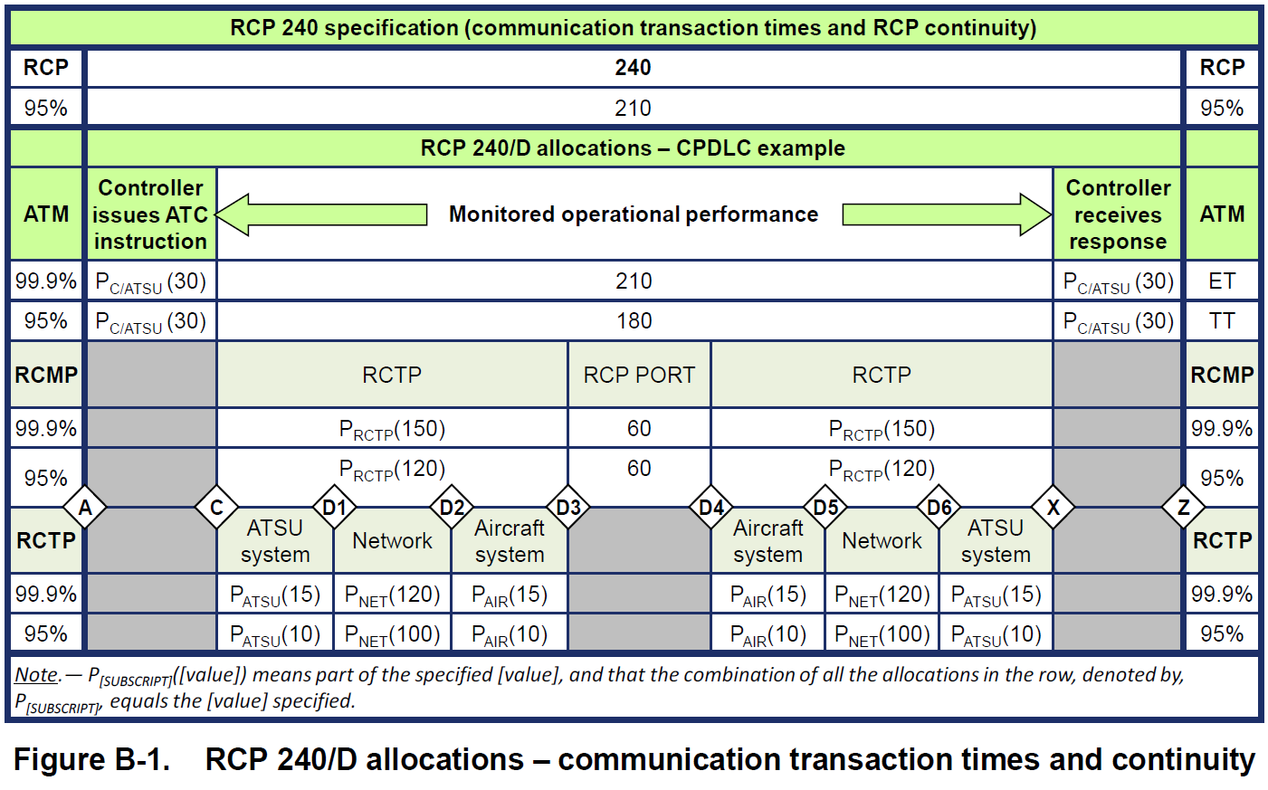
  - The actual management and oversight of CSP performance will be challenging due to the numbers of actors in the service provision side (CSPs, Satellite service providers, 3rd party network providers, etc.) in addition to the numbers of actors on the customer side (multiple airlines and ANSPs).
  - How operators will be able to effectively monitor and manage CSP compliance with performance requirements is unclear.
  - Several other requirements, such as continuous airworthiness, user modified software etc. may also need to be clarified .
  - How CSPs will notify ANSPs and aircraft operators of partial network failures is unclear, as is how ANSPs and airlines will manage such situations in a consistent manner.

2. DISCUSSION

2.1 Relying on multiple CSP service level contracts may not be the most effective and cost-efficient means of delivering the required performance guarantees. Alternative means of compliance should be considered.
2.2 There are portions of the PBCS manual that are difficult to interpret in a consistent and globally harmonized manner. Without global understanding of the aircraft operator certification requirements, we are open to inconsistent levels of performance and gaps in state certification of operators. Improved guidance material needs to be produced and understood by all affected parties before implementations are ready to proceed.
2.3 Due to the factors stated above, it is felt that many states are not adequately prepared to certify their operators. This will lead to a downturn in service if current implementation timelines are followed.
2.4 Any implementation of PBCS needs to fully assess the benefits to be delivered and the costs of doing so. ADS-C / CPDLC based separation has been delivered successfully across the globe for many years without the need to certify operators and CSPs.

3. ACTION BY THE MEETING

3.1 The meeting is invited to:

- Consider and discuss the contents of this paper.
- Provide advice regarding the need for improved guidance material
- Consider revising the target implementation date of PBCS in the South Pacific to allow for full education of states that will need to certify their operators, as currently envisaged, or another means of meeting the performance compliance requirements is determined.

