FANS Interoperability Team Meeting
(FIT/24)

Hawaii, USA
6 to 7 March 2016

Agenda Item 8 – FIT Working Papers

The Leap Second Day

Presented by Airservices Australia

SUMMARY

The recent Leap Second Day caused the loss of GPS and ADS-B functionality within Australian airspace. This WP is to provide information to other ATSUs and to seek information from Airbus concerning anomalies observed

1. INTRODUCTION

1.1 A Leap Second Day is a day on which the Coordinated Universal Time (UTC) is resynchronized with the solar time by advancing the UTC time by 1 second at midnight. These occur periodically and as a result, there is an associated GPS clock update.

1.2 During the day following the Leap Second Day, the clock of the GPS constellation satellites are synchronised with the updated UTC. It is understood that the synchronization of the full GPS constellation can take up to 24 hours. The last Leap Second Day occurred on the 31st of December 2016.

1.3 In early December 2016, correspondence from one of our airline operators flagged a potential GPS and ADS-B problem with some aircraft (A320s) in their fleet during the period of the GPS satellite resynchronisation. This advice supported observations following the previous leap second event (June 2015), during which several ADS-B anomalies were observed. At the time, these anomalies were not directly associated with the leap second event.

1.4 Correspondence with Airbus provided some useful information describing the problem:

“During the GPS constellation Clock Synchronization, the THALES MMR TLS 755 incorrectly manages the cohabitation of synchronized satellites and not yet synchronized satellites. As a consequence, the Honeywell ADIRU block I or II or III reject the corresponding GPS signal.
The GPS loss may happen on the day following the Leap Second Day from 06:00:00 UTC and can last until 23:59:59 UTC.

The GPS rejection is maintained until a full ADIRU alignment is done on the ground. However, this does not prevent any new occurrence of GPS loss while in the period mentioned above”

1.5 Airbus provided further information in a FOT (Flight Operations Transmission), numbered FOT 999.0118/16.

2. DISCUSSION

2.1 On January 1, 2017, during the period of re-synchronisation of the GPS satellites, Airservices Australia recorded 10 occurrences associated with the loss of GPS and/or ADS-B. The majority of these failures involved A320 aircraft from the operator that had previously contacted Airservices, and so these particular failures were not completely unexpected. Of some interest, however, was the fact that flight crews were able to re-set the GPS in flight – this appeared to be contrary to the advice in the FOT that it is necessary for a “full ADIRU alignment” to be completed “on the ground”.

2.2 It was also noted that a loss of ADS-B for an A350 occurred at 00:24, which is significantly earlier than the 06:00 to 24:00 time frame that was provided by Airbus. This ADS-B loss was further unexpected by the fact that we were not expecting any problems with the A350 as it was not one of the aircraft types described in the FOT that would be affected by this problem.

2.4 A preliminary review of data by several affected aircraft is depicted graphically below:

A320

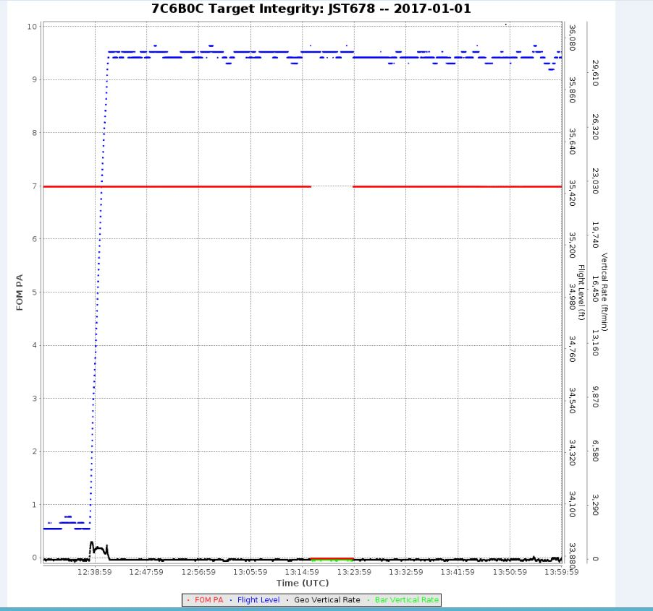

A332

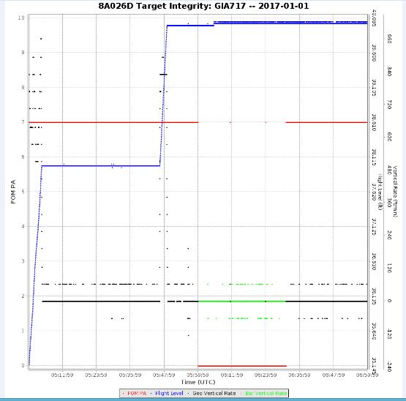

A350

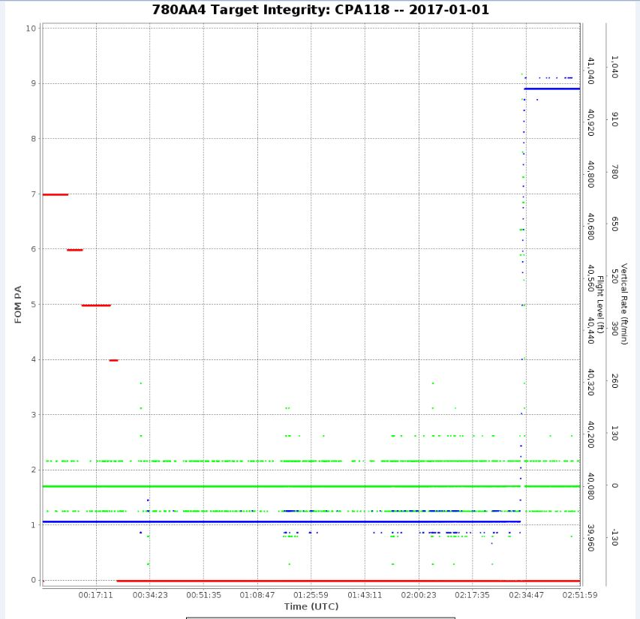

3. ACTION BY THE MEETING

3.1 The meeting is invited to:

a) Note the information in this Working paper;

b) For Airbus, responses are requested to the following questions:

- Is a correction under development to address this problem?
- What is the basis for the start time of potential problems being 0600 (i.e. rather than 0000)
- Should the A350 have been affected by this leap second event, or was the occurrence observed an unrelated coincidence? Is there a reason that the A350 FOM/PA gradually degraded, compared to the other aircraft types?

