FANS Interoperability Team Meeting
(FIT/24)

Hawaii, USA
6 to 7 March 2016

Agenda Item 4: Information Papers – PBCS Implementation

Modifying the NZZO FIR Oceanic Control System (OCS) for PBCS

Presented by Airways New Zealand

SUMMARY

This paper provides an overview of the changes to the Oceanic Control System (OCS) that were implemented on 10 November 2016 to support the implementation of PBCS.

1. INTRODUCTION

  - Software modifications to support the implementation of PBCS have been completed and were introduced into the operational platforms on 10 November 2016.

The software modifications fall into four main areas: (1) the verification of the required PBCS status before allowing the application of performance based separations; (2) providing additional background information to the controller on individual aircraft FANS1/A performance and status; (3) providing the controller a means to degrade PBCS on selected aircraft; and (4) implementing a software key that will permit performance based separation changes to be turned on at the agreed time of regional implementation.

2. DISCUSSION

Application of performance based separations
2.1 Airways controls oceanic airspace within the NZZO FIR which is designated as RVSM and RNP10 airspace. The OCS ATM system uses a conflict probe that defaults to a 15 minute longitudinal standard and a 50NM lateral standard. When the probe detects conflict between an aircraft pair at the default separation standard it will display the actual separation and the controller can then select a reduced separation standard for use by the probe if that will resolve the conflict. To apply the performance based 50NM longitudinal standard or the performance based 30NM longitudinal/lateral standard the controller selects a “D” or “3” flag on the electronic strip. The software changes implemented when activated will check for RCP240 and RSP180 status in the filed flight plan before displaying the “D” or “3” flag on the strip. The conflict probe algorithms for the application of 30NM lateral and 30NM and 50NM distance based longitudinal separation will be modified to check aircraft meets RCP240 and RSP180 requirements in the filed flight plan. In Figure 1 below UAL917 has filed Item 10 P2 = RCP240, and Item 18 SUR/RSP180 and has met other requirements for application of the performance based separation standards – “D” and “3” flags are displayed. AAL83 has not filed as meeting RCP240 or RSP180 - “D” and “3” flags are not displayed.

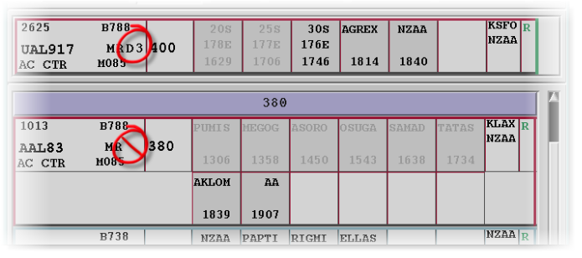
Figure 1: Electronic Strip Separation Flags

FANS1/A System Monitor
  - The implementation of PBCS requirements in the flight plan provides the controller with some assurance that the aircraft is qualified for the application of performance based separation, and monitoring of the observed performance provides further assurance. However, the qualification and monitoring is based on historical data and the controller has had no visibility on current aircraft performance. We have had a number of occasions over the years when this visibility would have been useful.
  - This lack of visibility creates uncertainty during partial system outages such as the loss of a specific satellite or remote ground station (RGS) and when individual aircraft are having communication issues. An example of a communication issue is where individual flights operate without SATCOM and some of these have used HFDL which does not meet either RCP240 or RSP180.
  - Airways has given controllers the ability to view current FANS1/A status and performance by implementing a “FANS1/A System Monitor” window which provides additional FANS1/A status information and observed downlink performance on selected aircraft. The new window enables the controller to view observed message latency and the communications pathways that are in use including: the type of media (VHF, SATCOM, or HFDL) used on this flight; the satellite RGS that have been used on this flight; the communications service provider (CSP) used; the current RCP240/RSP180 status for the flight; and the observed latency of the last 20 downlinks received. Figure 2 illustrates the window which is manually accessed from the current AFN window which provides connection status and connection/contract management.

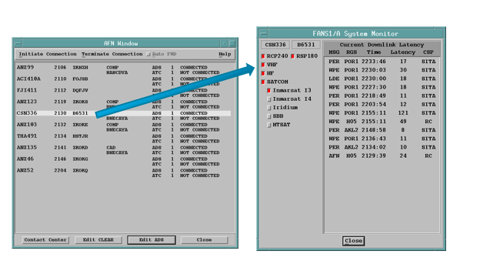
Figure 2: FANS1/A System Monitor
Degrading PBCS status in-flight

  - A “degraded-PBCS” button will be added to the electronic strip Options menu. This will allow the controller to stop the application of the performance based separation standards in flight if they are advised by the flight crew or if they suspect that RCP and RSP is degraded below what is required. Although flight plan modification is available to achieve the same aim this functionality will provide the same interface as exists for degraded-RVSM and degraded-RNP.
Activating PBCS performance based separation conflict prediction
  - A Variable System Parameter (VSP) has been created and will be used to activate the conflict prediction code changes for RCP240 and RSP180. This VSP is used while the system is operational to activate/deactivate the conflict prediction code changes that have been made. The “FANS1/A System Monitor” window is not affected by the VSP and has been available for controller use from 10 November 2016.

3. ACTION BY THE MEETING

3.1 The meeting is invited to:

a) note the information in this paper.

