Thirtieth Meeting of the
Informal South Pacific ATS Co-ordinating Group
(ISPACG/30)

Surfers Paradise, Australia
14 to 17 March 2016

Agenda Item [6.1, 6.2]

RNP2/RNP4 Lateral Separation

Presented by Airways New Zealand

SUMMARY

This paper discusses the potential for operational use of impending change to ICAO Doc 4444 RNP4 lateral separation in the November 2016 update to PANS-ATM Doc4444.

1. INTRODUCTION

1.1 The amendment to PANS-ATM (Doc 4444) applicable on 10 November 2016 contains modifications to the current lateral separation minima. The changes are detailed in 5.4.1.2 Lateral Separation Criteria and Minima as detailed in the appendix at end of paper.

2. DISCUSSION

2.1 The amendment modifies the current 30NM lateral separation to 23NM. The amendment also specifically calls out the requirement for the aircraft communication and surveillance systems to meet RCP240 and RSP180.
2.2 Within NZZO airspace we see benefits from the reduction to 23NM. While some benefits will accrue on the long-haul flights on the SOPAC-NAM route the majority of the separation issues on these flights are longitudinal in nature.
2.3 The 23NM separation will be beneficial in the Tasman particularity as more FANS1/A equipped aircraft operate within this area. With the increasing use of UPR routes on the Tasman, a large number of aircraft are flying in closer proximity than if flying the fixed route structure. This has often meant that some aircraft are unable to get their optimal level allocation. The reduction of the lateral separation combined with the increase in ADS-C equipped aircraft in the Tasman will see benefits in optimal level allocation in the Tasman
2.4 We also see a benefits in implementing the RNP2/GNSS separations introduced in November 2014. This separation establishes a 20nm lateral separation for an aircraft climbing/descending through the level of another on non-intersecting tracks.
A 15nm separation is established for aircraft on intersecting tracks.
2.5 When ISPACG implemented the 30/30 separation standard a joint safety case was developed and an implementation timeline agreed for cross FIR application. Airways see benefits from using the same approach for the new separation standards.

3. ACTION BY THE MEETING

3.1 The meeting is invited to:

- Note the provided information
- Advise intentions as to whether they will be implementing this reduced separation to allow its use across boundaries.

c) Discuss developing a coordinated approach to a regional safety case for both RNP4 23nm lateral separation and RNP2/GNSS lateral separations.

Appendix

5.4.1.2.1.6 Lateral separation of aircraft on parallel or non-intersecting tracks or ATS routes. Within designated airspace or on designated routes, lateral separation between aircraft operating on parallel or non-intersecting tracks or ATS routes shall be established in accordance with the following:
b) for a minimum spacing between tracks of 55.542.6 km (3023 NM) a navigational performance of RNP 4 or RNP 2 shall be prescribed. The communication system shall satisfy required communication performance 240 (RCP 240) and the surveillance system shall satisfy required surveillance performance 180 (RSP 180). Conformance monitoring shall be ensured by establishing an ADS-C event contract with a lateral deviation change event with a maximum of 5 NM threshold and a waypoint change event;
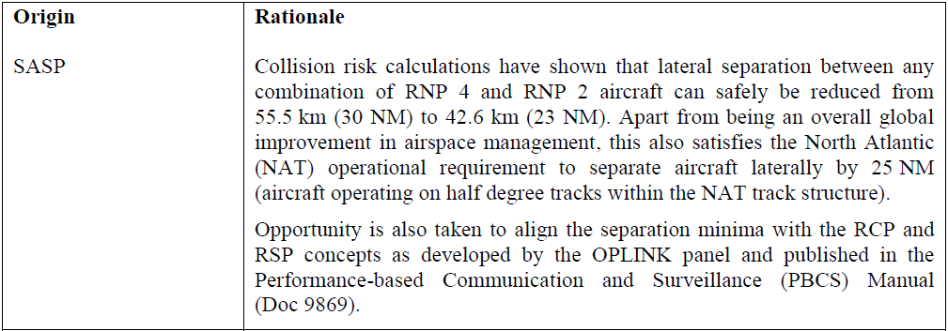
5.4.1.2.1.7 Lateral separation of aircraft on intersecting tracks or ATS routes. Lateral separation between aircraft operating on intersecting tracks or ATS routes shall be established in accordance with the following.
a) an aircraft converging with the track of another aircraft is laterally separated until it reaches a A-4 lateral separation point that is located a specified distance measured perpendicularly from the track of the other aircraft (see Figure 5-6); and
b) an aircraft diverging from the track of another aircraft is laterally separated after passing a lateral separation point that is located a specified distance measured perpendicularly from the track of the other aircraft (see Figure 5-6).
This type of separation may be used for tracks that intersect at any angles using the values for lateral separation points specified below:
