Thirtieth Meeting of the
Informal South Pacific ATS Co-ordinating Group
(ISPACG/30)

Surfers Paradise, Australia
14 to 17 March 2016

Agenda Item [5.4]

GOLD PERFORMANCE ANALYSIS

Presented by SEAC PF

SUMMARY

FRENCH POLYNESIA – DATALINK COMMUNICATION PERFORMANCE -
CHARTS MONITORING

- INTRODUCTION

Refer to the item 32A of open actions, this document presents the monitoring of datalink communication performance for ADS-C and CPDLC. In attachment you find the PowerPoint presentation.

2. DISCUSSION

ADS-C performance

  - Performance - overall media

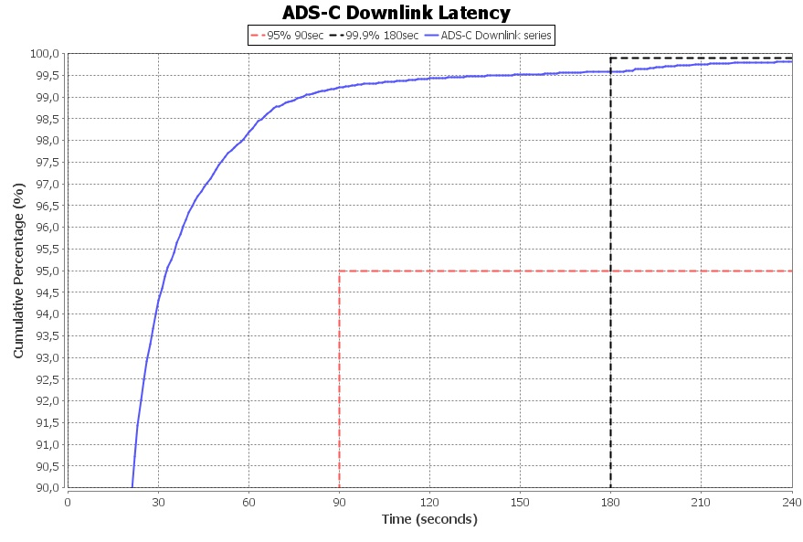
This performance of ADS-C downlink latency is acceptable with a high rate of cumulative percentage after 90s and a quite good rate after 180s (explanation: HF communication is not significative but downgrades the global performance).

  - Performance - VHF and Sat

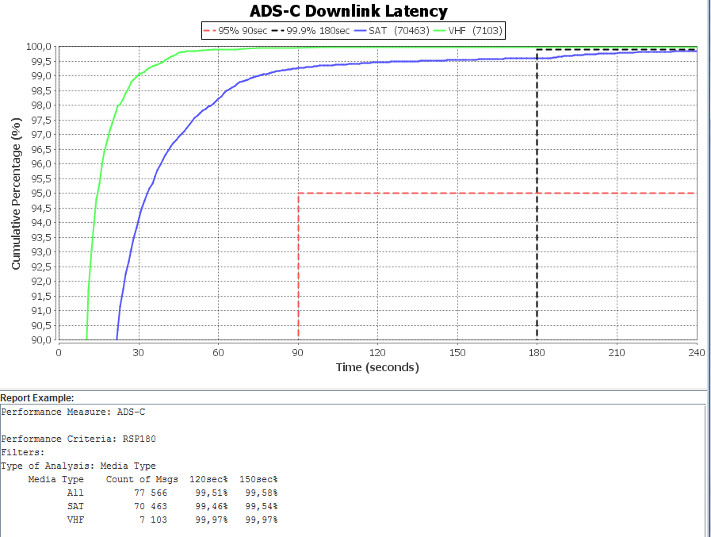

The VHF communication performance is very good with a very good high rate of cumulative percentage after 60s. For VSAT , we have an acceptable rate after 90s.
VSAT represents about 90% of data analysis. For the both, after 180s the rate is excellent (about 100%).

CPDLC Performance

- Performance - overall media

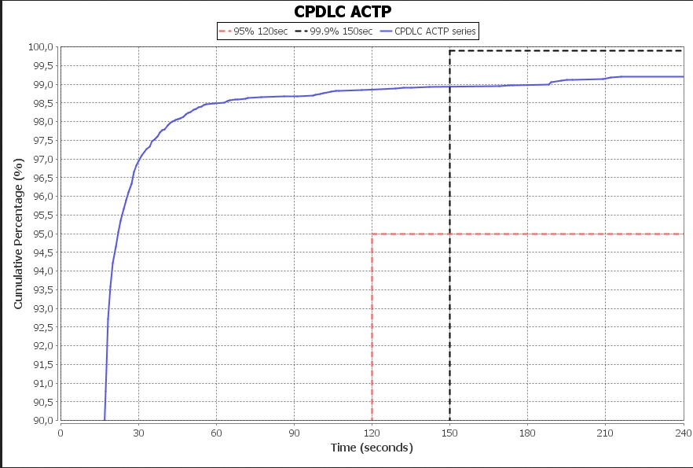

Before the 120s, the rate is very good (> 98%). But after the 150s, you can notice the rate isn’t better than 120s. After analysis, the problem is due to a bad rate of communication type (VSAT + VHF, VHF+VSAT, HF, HF+VSAT, VSAT+HF).

- Performance – VSAT and VHF
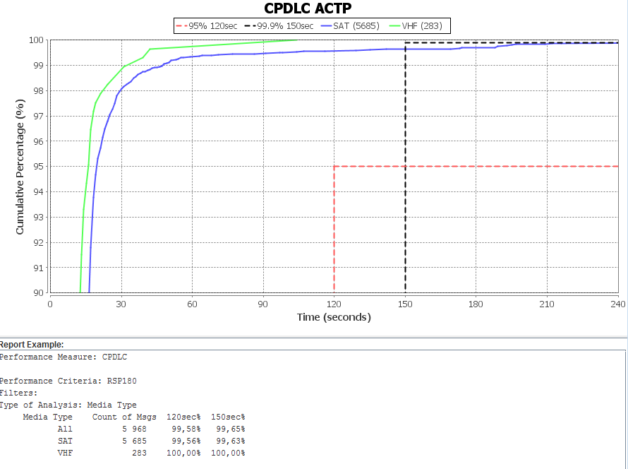

This graph shows you the excellent rate of CPDLC datalink with VSAT (more than 90% of data) and VHF. We can conclude that our performance is acceptable in according to GOLD document.

3. ACTION BY THE MEETING

The meeting is invited to note the participation of French Polynesia to monitor PBCS performance.

