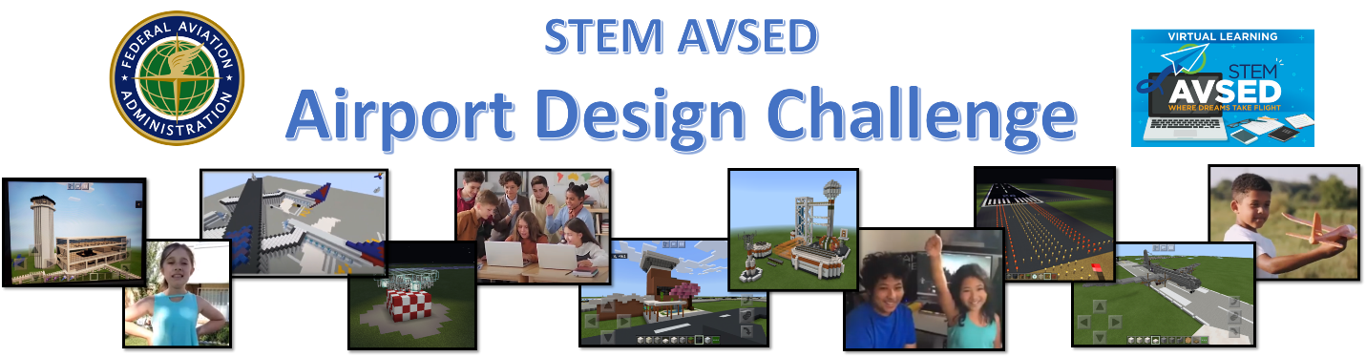In order to educate and inspire students (K-12) to better understand airports and their leading role in the National Airspace System, the FAA successfully hosted a third run of the acclaimed Airport Design Challenge competition, which utilizes Microsoft’s Minecraft to assist in developing a model airport with all of the required airside elements. Individually or in small teams, participants received instruction from FAA staff who specialize in specific areas of the airport each week. With that information, students researched a local airport of their choosing and then recreated that airport in the virtual world of Minecraft!

This Comprehensive Closeout Report seeks to evaluate individual focus areas of the Airport Design Challenge. The program has been divided into a series of focus areas and then each was evaluated to establish Lessons Learned, Mitigation, and Change Recommendations. Each focus area was also evaluated according to a numeric scale which represents the level of success or failure that element of the program experienced, wherein a 1 indicates total failure and 10 signifies absolute success. A graphical representation of these scores is shown:

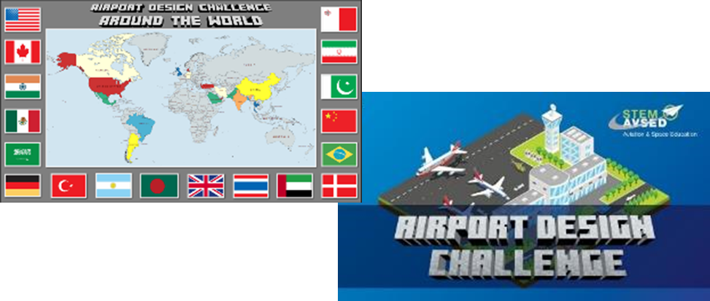

***Launch / Rollout***

***Outcome Score: 8***

**Lessons Learned (Pros & *Cons*)**

* **Targeted Marketing** – Began development on a targeted list of organizations and Points of Contact (POC) for underrepresented groups from across the country (>30,000 contacts so far)
* **Direct AOC Support** – AOC provided crucial support through press releases, Social Media campaigns, and live awards productions
* **Educator Role** - created educator role to accommodate teacher requests to view students work. Substantially more teachers signed up than anticipated (see Educator Role tab for more details)
* ***Internal FAA Marketing***- FAA employees continue to learn about the program, but often too late to register kids or promote it

**Mitigation and Change Recommendations**

* Continue to develop targeted marketing list to promote future iterations and other opportunities from the FAA (Consider specific targets applicable to each state)
* Consider partnerships with existing organizations that already engage targeted communities (look into TRIO)
* Improve internal marketing of the program to FAA employees
  + Use governance structure (SC & EB) to draft info for distro
* Enhance relationships with industry groups (AOPA, AAAE, etc.) and employee affinity groups (NBCFAE, TWO, etc.)
* Include availability of the educator role in initial marketing (early on!)
* Consider using the winning teams in marketing future iterations (interviews, promos, etc.)
* Collaborate with AVS to connect with kids from their events / same idea with Adopt A School

***Registration***

***Outcome Score: 6***

**Lessons Learned (Pros & Cons)**

* **Parental Consent** - Combining the COPPA and media release forms into a single action and making them a requirement to access course information was a substantial improvement
* **Registration Availability** – Record number of students enrolled with substantially less setbacks/frustrations than previous iterations
* **Registration Portal** - DRS saw catastrophic failure due to volume of students and lack of internal support
* **Student Team Organization** - Organizing students into teams within Blackboard was very cumbersome/frustrating for the students

**Mitigation and Change Recommendations**

* With DRS no longer supported, we must find a new registration tool that will allow students access to Blackboard
* Work with Marick to create a simplified process to organize students into teams and by category
* Consider breaking students up into three grade categories rather than two as opposed to diversifying curriculum

***Instruction***

***Outcome Score: 9***

**Lessons Learned (Pros & Cons)**

* Level of Challenge – Educators and students appeared to enjoy the content from each module. Less than 1% of enrolled students/educators expressed concerns regarding the difficulty level of module assignments.
* Career Influence Content – We added videos to each module, specifically to educate and inspire students regarding careers that are in demand today.

**Mitigation and Change Recommendations**

* Consider providing diversified learning plans for different grade ranges of students. Provide additional external resources to assist younger students in learning/retaining knowledge
* Investigate industry multimedia resources that would encourage diversity and equity in our instructional content

***Retention***

***Outcome Score: 7***

**Lessons Learned (Pros & Cons)**

* **Educator Role** - Adding the educator role appears to have substantially increased retention rates
* **Frequent Interaction** - Weekly announcements and mentor interaction were well received and likely encouraged our improved retention rate

**Mitigation and Change Recommendations**

* Encourage educators and youth organizations to enroll as groups (start early)
* Create benchmarks in the curriculum to encourage further progress (access to special tips videos shot with Minecraft experts, judges, and previous winners)
* Consider adding promos through the game as incentives

***Multimedia***

***Outcome Score: 10***

**Lessons Learned (Pros & Cons)**

* **New Content** - Added intro video from ARP-1 and a “tips from the judges” video that students seemed to enjoy
* **Variety –** While the videos we have are well done and well received, there may be room for additional video content in the actual teaching.

**Mitigation and Change Recommendations**

* Investigate industry multimedia resources that would encourage diversity and equity in our instructional content
* Consider developing more in depth instructional videos to compliment/replace written curriculum material

***FAA Mentoring***

***Outcome Score: 8***

**Lessons Learned (Pros & Cons)**

* **Mentor Team** - Mentor pool was drastically reduced. A smaller, better trained group of Subject Matter Experts gave real time help and encouragement to students
* **Communication** - Using discussion forums in Blackboard allowed mentors to communicate safely and efficiently with students and to provide redundant coverage within the team
* **Mentoring Categories** - Some categories that we provided were underutilized by the students (ex. FAA Info, Industry Info)

**Mitigation and Change Recommendations**

* Consider consolidating mentor forums for students into 3 focused efforts (Airport Help, Minecraft Help, and Other)
* Create a new support forum specifically for educators
  + Provide “help” videos for new educators, from teachers who participated
* Name discussion boards in a way that entice kids to be involved…lead kids into pathways towards aerospace career

***Educator Role***

***Outcome Score: 4***

**Lessons Learned (Pros & Cons)**

* **Viability** - New role created to allow teachers to view student work; initially launched as a limited beta test for a few select teachers, the role proved to be very popular with 84 teachers and adult sponsors participating
* **Program Impact** - Retention rates within the Educator role were significantly higher than normal
* **Educator Functions within Blackboard** – The Educator role was limited in its ability to provide all that the teachers wanted (easy access to grades, viewing students completed work, etc.)
  + **Educator Registration** - Registration was not intuitive and the process required the teacher to enroll as a student and then be manually converted by ADC staff.
  + **Educator Classroom Group Enrollment**- Teachers were given specific instruction about how to group their students. However, many were unable to follow those instructions, resulting in dozens of duplicate groups in the system.

**Mitigation and Change Recommendations**

* Conduct a thorough review of how the role should be utilized and adjust role permissions to reflect those functions
* Develop a clear process for organizing students by classroom/team
* Publish (on website) clear capabilities and limitations to notify teachers of the role
* Create a section of the program in Blackboard specifically for teachers; provide “teach the teacher” resources to help with classroom implementation
* Include availability of the educator role in initial marketing

***Final Entries***

***Outcome Score: 10***

**Lessons Learned (Pros & Cons)**

* **Quality Control** - Overall quality of final video entries was impressive
* **Accommodations** - We made a decision to accept any airport model (3D, paper, clay, etc.) by student/teacher request.
  + Students were notified that the rubric would not be altered (so their scores could be impacted) but that the projects would be accepted and judged just as those made in Minecraft.
* **Organization** - Due to the confusion with duplicate groups, we added a form for students to complete prior to turning their final project

**Mitigation and Change Recommendations**

* Final project form did not yield accurate results of the students in each group or the work they were turning in. The concept seems to work, but it needs to be refined (this may not be an issue if the original registration/team organization is better developed).
* Highlight students who participate in the program but build alternative airport models using paper, clay, and other materials available.

***Judging***

***Outcome Score: 7***

**Lessons Learned (Pros & Cons)**

* **Preparation** - Judges were required to register as ORs and attend a judges orientation
* **Timeline** – Judges appeared to have ample time to complete their assigned reviews.
* **Judging Team** – We recruited over 150 judges from various regions/LOBs to serve as judges. However, we did not build an effective support structure to help them with questions or concerns. As a result, there were some quality issues with the judging that required our intervention

**Mitigation and Change Recommendations**

* Reduce the number of judges to a smaller number (<45) of more reliable staff in order to provide better quality results for the students
* Incorporate broad recruiting for “AVSED Judges”/volunteers
* Manage expectations during application (notify all that they may be on reserve)
* Work through appropriate channels when judges need to be dismissed
* Determine ratio of judges needed per team entries

***Awards and Recognitions***

***Outcome Score: 9***

**Lessons Learned (Pros & Cons)**

* **Quality** - New medals and lanyards turned out very well. They are modern and high quality.
* **Awards Ceremonies** - Awards ceremonies were well received and viewed on more than 7,000 screens (unfortunately, there is no way to verify the number of viewers per screen). VIPs added a lot of value to the program
* **Forecasted Amount** - Swag had to be ordered well in advance due to turn around and design times as a result, we purchased more items than were needed at the end of the program
* **Distribution** - Shipping of medals and certificates was delayed due to conflicting business requirements

**Mitigation and Change Recommendations**

* Order swag at the conclusion of the program when we have a more accurate idea of required amounts
* Create a team dedicated to printing and distro of awards prior to the awards ceremonies
* Create a “team trophy” to present to sponsoring schools/orgs
* Create a framed print of the students (green screen their Minecraft airport behind them?) to present to the airport manager for displaying in the terminal
* Remove year from lanyards

***Resources***

***Outcome Score: 7***

**Lessons Learned (Pros & Cons)**

* **Primary Program Staff** - Volunteer leads were assigned to specific focus areas of the program to diversify workloads
* **Mentor Volunteers** - The number of mentors was reduced from >120 to 12, substantially reducing our staffing requirement for mentoring
* **Registration Portal** - We can no longer use DRS as a registration portal
* **Parental Consent** - Demand for an electronic parental consent signature continues to be high
* **Judge Volunteers** - The number of judges was increased substantially but a reduction to prior numbers is recommended

**Mitigation and Change Recommendations**

* Finalize quote and appropriation of Genius software to replace DRS (See Appendix 1)
* Incorporate Kids Web Services (Free) into Genius to provide digital verifiable parent consent
* Maintain volunteer lead structure for key areas of the program
* Adjust the number of judges to a smaller, core group large enough to manage the submissions, but small enough to maintain quality

***Promotional Outreach***

***Outcome Score: 10***

**Lessons Learned (Pros & Cons)**

* **Stakeholder Outreach** - Finalist information was shared with airport management, media resources, and local/state elected officials in their respective communities
* **Media** - Many teams were highlighted in newspapers, websites, and new broadcasts
* Student Recognition - Elected and airport officials took the opportunity to recognize students work through certificates, gifts, and additional outreach
* **Future Opportunities** - Minecraft Education Edition contacted us about providing outreach assistance

**Mitigation and Change Recommendations**

* Consider expanding stakeholder and media outreach to areas with higher student populations early in the program.
* Increase awareness of educator role through state education channels, teacher unions, etc.
  + Establish a teacher info packet for distro
* Collaborate with Minecraft to target under represented populations with existing Minecraft licenses that are not being fully utilized
* Engage RA offices for congressional outreach

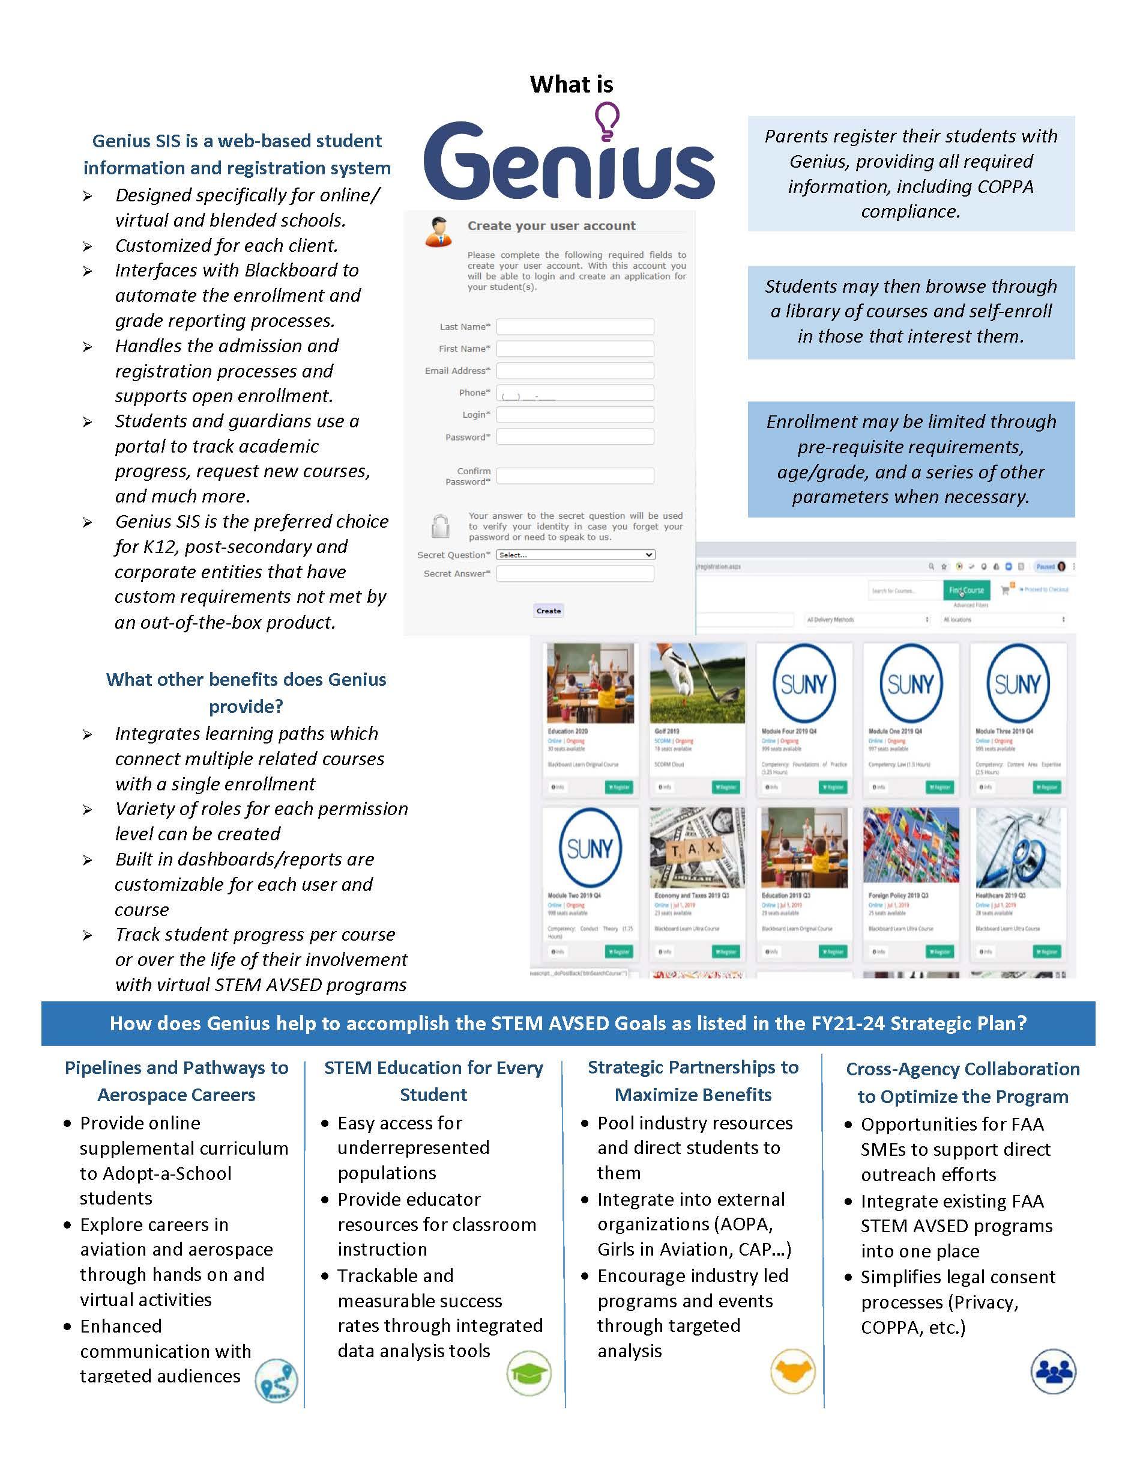**Appendix 1**

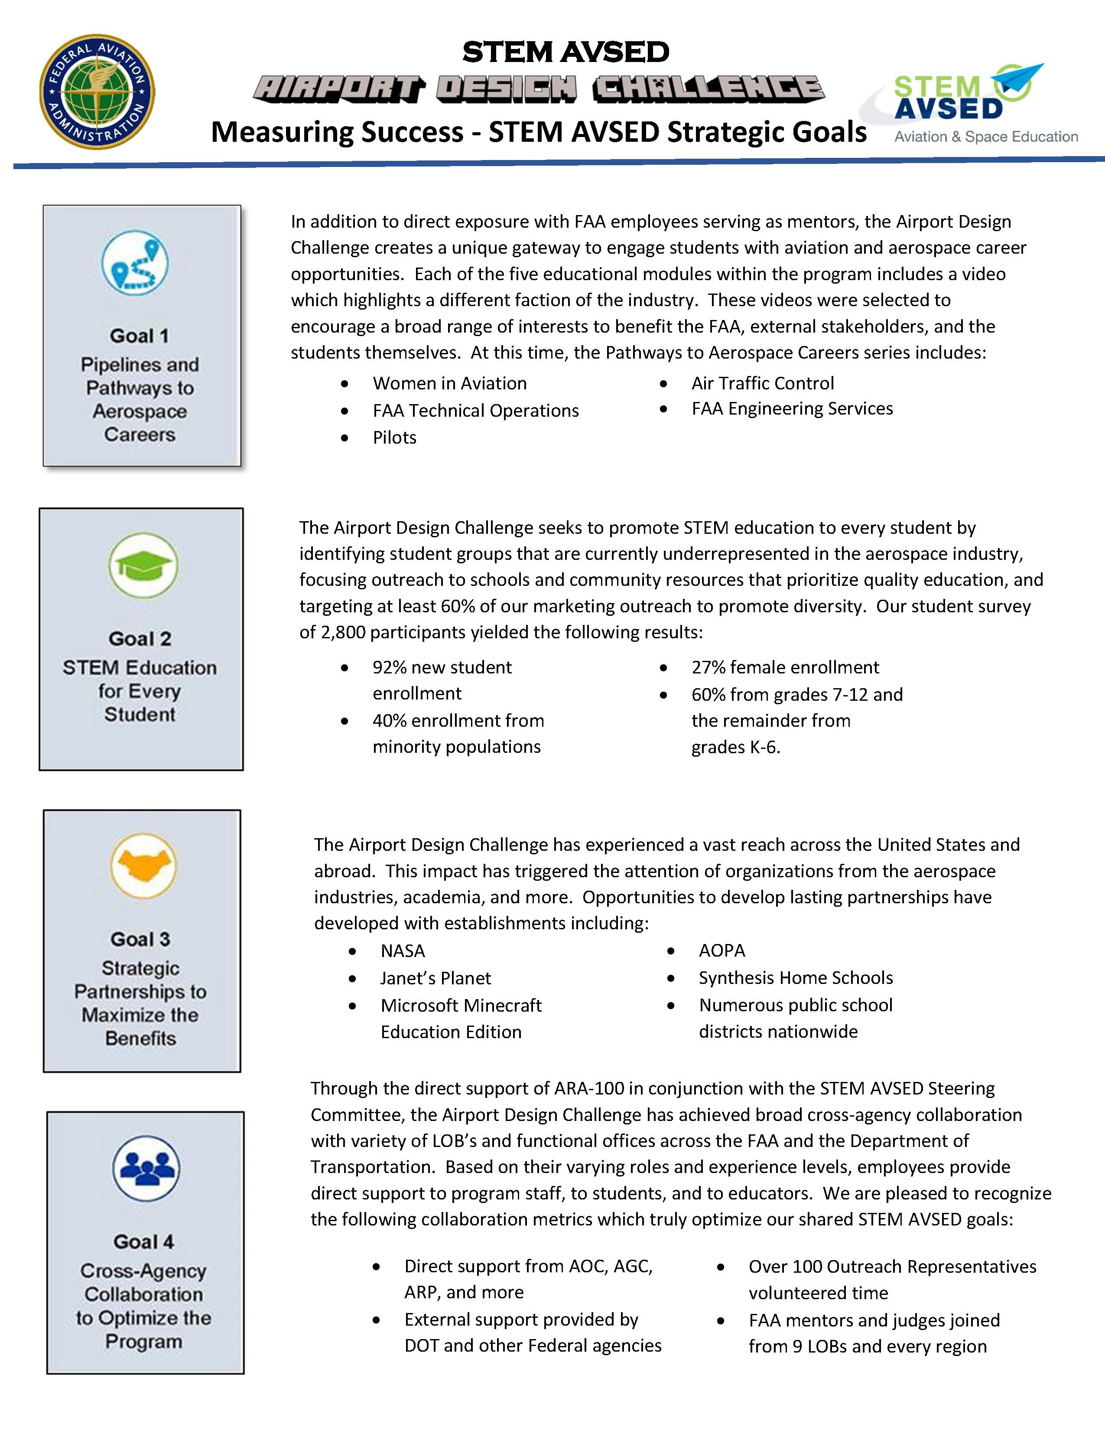**Appendix 2**