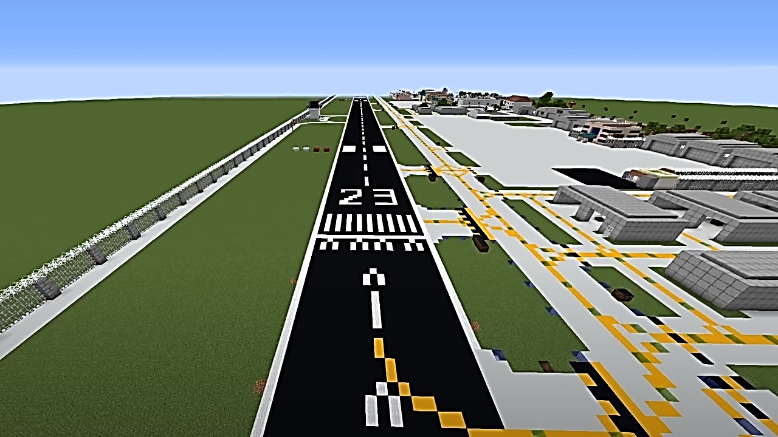
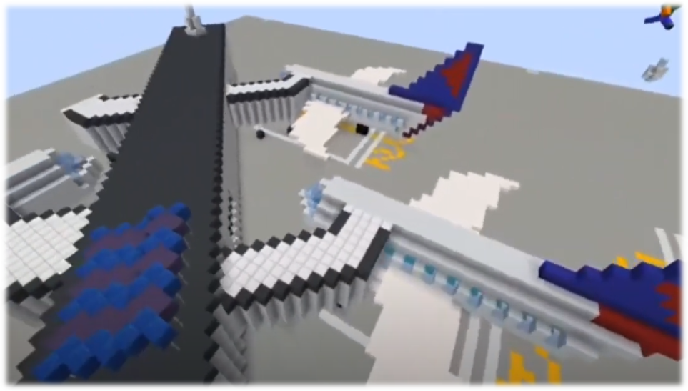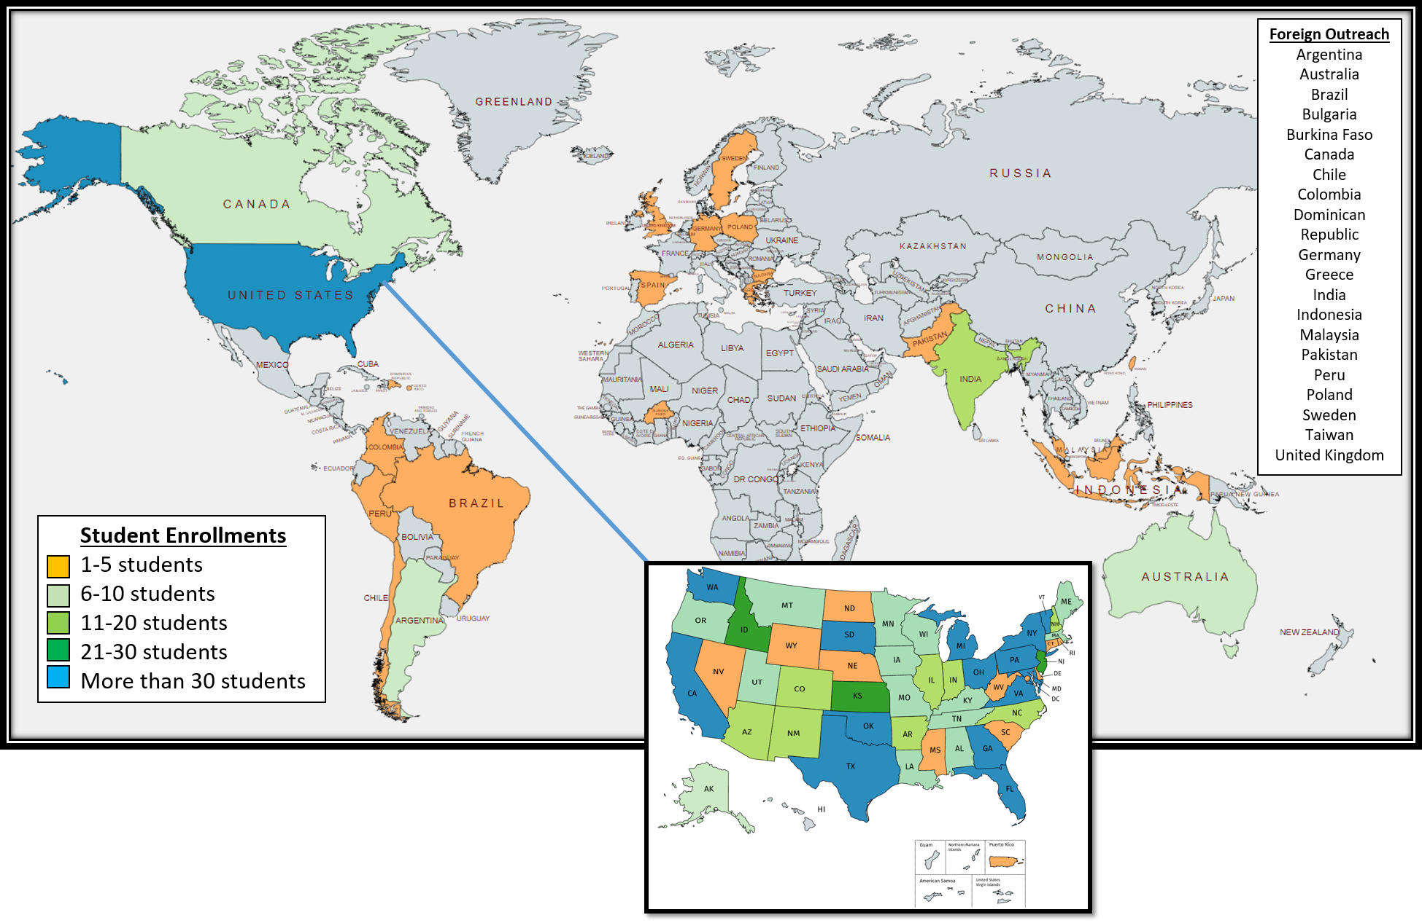` 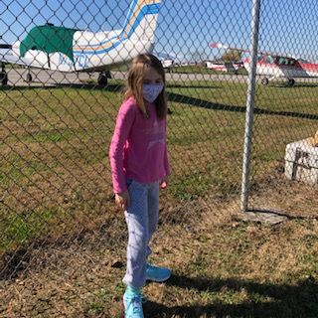
Kindergarten – 6th Grade
170 Teams
349 Student Participants
19.4% completion rate

Other Facts
12,000 Awards Ceremony views with 68,000 internet impressions
5,000 + hours spent on creating airports

Program Summary
1280 Students Enrolled
354 Teams
49 states & 21 foreign countries
127 FAA Mentors, 46 Judges

The Airport Design Challenge was initially created to provide students with Aviation and Space Education during the COVID-19 pandemic. After a successful pilot, a second iteration of the program grew into an international contest stretching across six continents and 22 countries.
7 – 12th Grade
184 Teams
394 Students
27.2% completion rate

Students received virtual instruction in airport paved surfaces, security, approaches, lighting, markings, facilities, and future growth. Led by their own initiative and guided by an FAA Mentor, each team worked to learn about and reproduce an airport from their local area using the Minecraft gaming software.
Two awards ceremonies recognized the contest winners, which involved airport managers, teachers, and administrators. The combined reach of both events was approximately 12,000 views and 68,000 internet impressions.




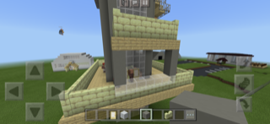
“To encourage learning, confidence, creativity, focus and discipline for kids during this really difficult time is so appreciated!
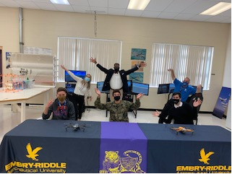

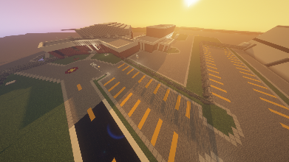
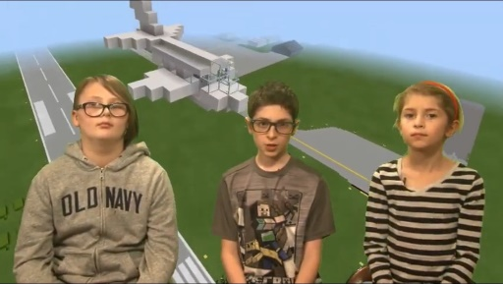

“We had a blast. Thanks for letting us compete in such an organized challenge.”

“"It was an honor to be in the competition. I'm really excited about aviation now.
“We look forward to the next FAA challenge!”

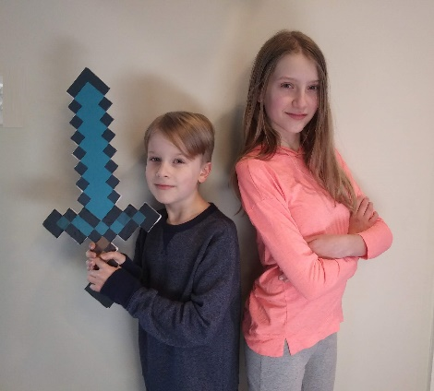

“The kids feel like real celebrities, they are so proud!”

In order to educate and inspire students (K-12) to better understand airports and their leading role in the National Airspace System, the FAA successfully hosted a second run of the acclaimed Airport Design Challenge competition, which utilizes Microsoft’s Minecraft to assist in developing a model airport with all of the required airside elements. Individually or in small teams, participants received instruction from FAA staff who specialize in specific areas of the airport each week. With that information, students researched a local airport of their choosing and then recreated that airport in the virtual world of Minecraft!
- SharePoint to Blackboard conversion –
  - Registration, educational resources, grading, and tracking each student was merged from a simple system using SharePoint and email to a fully integrated Blackboard LMS.
- Marketing & Communication Plan –
  - Grassroots efforts were made by phone and email to publicize the program prior to launch, allowing us to reach a greater focused group of students
  - Social media was used substantially more to advertise enrollment, share student work during the program, and to promote the finalists’ work.
- Enhanced Leadership Team –
  - The addition of an interagency relations liaison allowed greater balance in managing the many elements of the program during production and especially during the operational time frame
  - Additional leadership resources were provided part-time to oversee the efforts of FAA mentors, allowing the primary leads to focus on agency level requirements and the educational needs of the students
- Scheduling & Retention –
  - Many factors affected retention, but according to parent feedback, starting the program while school was in session made it difficult for students to balance academic work and the time required to develop their airport. This impact may have been heightened as students began the program in a virtual school environment due to COVID-19 restrictions and then moved back to traditional classrooms midway through the challenge.

Figure 1 - Areas of consideration have been evaluated and assigned a score, which represents the respective success or failure of that element in the overall program. A score of 1 indicates a complete failure where a score of 10 signifies absolute success
This Comprehensive Closeout Report seeks to evaluate individual focus areas of the Airport Design Challenge. Each area was initially evaluated according to the lessons learned during the program pilot, then based on what was planned, what changes were required through the course of the program, and what successes or lessons learned apply as a result. When lessons learned dictated the need, a mitigation strategy was also identified to aid in improving future sessions of the program. With each section heading, an outcome score is annotated which represents the level of success or failure that element of the program experienced, wherein a 1 indicates total failure and 10 signifies absolute success. A graphical representation of these scores is shown as a scorecard in the concluding program evaluation section of this report and includes a comparison to the scores determined at the conclusion of the Airport Design Challenge pilot.

Program Development
Outcome Score: 9

Lessons Learned  from Pilot | Changes Made  for this Iteration | Direct  Outcomes
- Efficiency in development came through a generally small, core team with autonomy to be creative and higher level management support provided as needed  - Frequent communication within the development team allowed for quick corrections on issues and updates.  - Coordination with functional LOBs provided large-scale program support and the ability to overcome obstacles | - An additional full time staff position was made available on detail. This role provided critical support in communication, organization, and structure for the students and FAA mentors.  - Two other part time staff positions were added to provide FAA mentor support.  - Higher level coordination was needed with numerous staff offices including legal, privacy, AFN, AOC, and Blackboard. | - Program transitioned from SharePoint/Excel data to the Blackboard learning management system with minimum disruption.  - Numerous updates to videos and learning materials were created to provide a more effective learning experience for the students and mentors  - Legal and privacy issue templates were established for future virtual AVSED activities

Lessons Learned from this iteration –
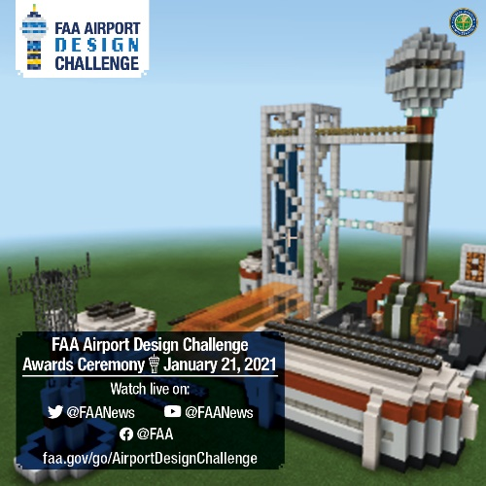
- Management support both within the development team and at higher levels was key to the success of the program.
- In order to address the rapid changes in program development, it was critical to keep the core team small and provide them creative autonomy during the development process.
- Moving ADC to an electronic LMS resulted in greater efficiency and accountability for the program
- Due to the fact children under 13 would be participating in the Airport Design Challenge, the FAA created a new Children’s Online Privacy Protection Act (COPPA) form.

Mitigation/Change Recommendations –
- Work with AGC to create templates for future web-based AVSED events (COPPA, Media Release waivers, etc).
- Develop a stand-alone version of ADC that can be used by teachers as part of their regular curriculum.

Launch/Rollout
Outcome Score: 9

Lessons Learned  from Pilot | Changes Made  for this Iteration | Direct  Outcomes
- Use emails and social networks to announce enrollment period  - Include home school coalitions and aviation groups in enrollment announcements  - Provide a longer sign up period for students  - Transition to an online LMS in order to speed up team registration processing  - Numerous teams from outside the US could potentially participate in the challenge | - Extended the enrollment period from one week to four weeks  - Worked with AOC to set up regular social network announcements across multiple platforms  - Creation of a GovDelivery list which allows interested parties to self-enroll for email announcements about upcoming programs  - Concentrated, personal contact made to aviation programs, teacher organizations, state level STEM representatives, etc.  - All participants were required to sign up for ADC using the Designee Registration System (DRS) which then allowed access to Blackboard | - AOC sponsored social media ad campaign was a huge success with over 9,000 link clicks and 688,000 impressions over a two month period.  - 1,280 students enrolled in ADC  - Registration processing was automated and information collected was stored on the FAA network.

Lessons Learned from this iteration –
- The combination of emails and social network ads provided access to a very large student audience.
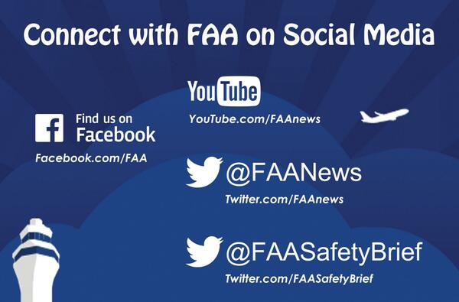
- Although time consuming, personal outreach to interested parties yielded substantial results in diversifying students geographically and otherwise. Expanding the GovDelivery list by offering enrollment widely may yield similar results with less direct interaction required.
- The electronic registration process via DRS significantly reduced the number of administrative hours required to sign up new students.
- Accessing administrative information on DRS is time consuming and requires manual filtering for specific categories such as country of origin.
- Although DRS saved the ADC team time during the registration process, it did not provide students easy access to Blackboard and required multiple mouse clicks (8+) before it allowed entry to Blackboard.
*NOTE - Generally eLMS has only been used by FAA employees to assign and monitor training. Modifications are available to allow the public to access eLMS, which can then bridge civilian users to Blackboard.

Mitigation/Change Recommendation(s) -
- Provide student access to Blackboard via eLMS* or Blackboard’s Genius program.
- Promote GovDelivery list to potential stakeholders, organizations, parents, etc.
Legal Considerations
Outcome Score: 8

Lessons Learned  from Pilot | Changes Made  for this Iteration | Direct  Outcomes
- The FAA did not have a COPPA process in place that would directly accommodate the requirements of virtual STEM outreach  - The ADC team needs to work closely with AGC to ensure no FAA rules or regulations are violated.  - Media release forms are required for the use of any photos of the students and parents. | - A COPPA form was created for ADC to ensure all students under 13 have their parents’ permission to participate.  - To ensure there were no privacy violation issues, all students regardless of age were required to have a signed COPPA and media waiver on file.  - AFN IT Security Office wrote a Privacy Act Statement (PAS) that allowed ADC participants to use DRS and Blackboard  - In order to meet PRA requirements, the name of the survey provided to the students had to be changed to a customer service review. | - AGC developed a COPPA form and all associated program requirements in a condensed timeframe  - All parents were required to sign COPPA and media release forms before the students were allowed to access any weekly lessons.  - The ADC COPPA form is being used as a template for other groups that plan to interact with students under 13 years old.  - There was a significant number of users (23%) who did not complete the required forms and were not allowed to participate in the weekly lessons.

Lessons Learned from this iteration –
- Requiring all legal forms to be signed prior to participating in the challenge helped avoid any COPPA or media release issues but it also prevented a large portion of the users who initially enrolled from being a part of the event.
- There were no complaints from any of the students regarding the requirement that all participants, regardless of age, had to sign COPPA and media release forms.
- The Designee Registration System (DRS) is a program used by non-FAA employees to access the FAA network for educational programs. It has been in place for several years but it was not designed to handle an event the size and scope of ADC. A new and more robust access point for non-FAA employee AVSED users should be pursued.
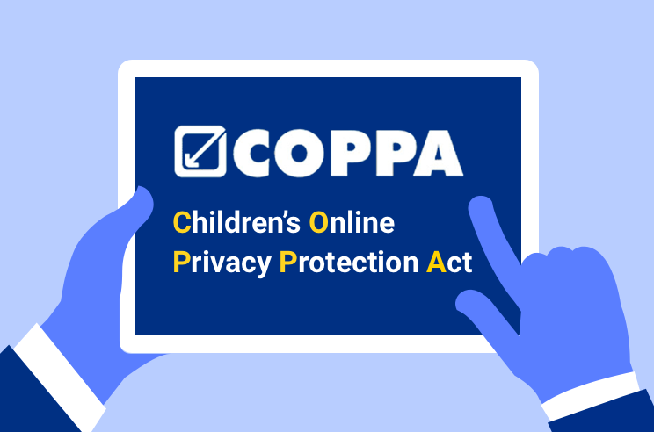
Mitigation/Change Recommendation(s) -
- Work on a method or process to connect with parents who did not complete the COPPA and media release forms
- Work on a way to make this a required step to be granted access to Blackboard
- Work closely with AGC on all future AVSED virtual events to ensure compliance with FAA rules and regulations.

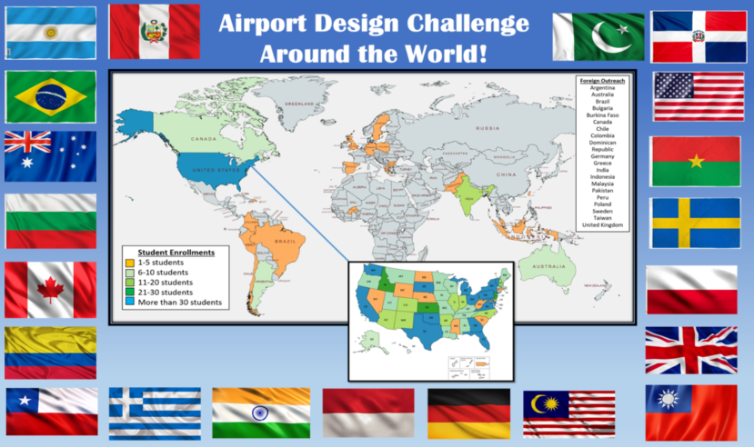
International Relations
Outcome Score: 10

Lessons Learned  from Pilot | Changes Made  for this Iteration | Direct  Outcomes
- Make sure lessons are taught at a high enough level to apply to any airport in the world | - 70 students from 21 foreign countries and 6 continents signed up for the challenge  - Videos and other learning materials were added to the curriculum | - 7 foreign students on 3 teams completed the challenge  - There were no complaints about using FAA standards to evaluate foreign airports  - A video salute to all foreign students was shown at both awards ceremonies

Lessons Learned from this iteration –
- The level of learning seemed appropriate for the international users and no complaints were received regarding the complexity of the lessons taught.
- There is significant interest from the international community in participating in ADC.
- Language packs are available through Blackboard at no additional cost.

Mitigation/Change Recommendation(s) –
- Create a more accurate contact list for foreign students in order to assist with retention
- Activate language packs in Blackboard to translate all written material into the student’s native language.

Registration
Outcome Score: 7

Lessons Learned  from Pilot | Changes Made  for this Iteration | Direct  Outcomes
- Registration process should be simplified, web-based, and consistent for all users  - Media release waivers should be included in registration packet  - Publish a firm registration window; perhaps allow a one week grace before closing registration for new applicants. | - Registration was conducted via the Designee Registration System (DRS) which allowed for everything but the parental signatures to be conducted online  - Detailed registration instructions were created for the users  - A second phase of registration was conducted with Blackboard in order to collect COPPA and media consent forms  - The registration period was extended from one week to four weeks | - Registration was more consistent, but there was confusion about the various steps: Student registration, COPPA/Media Release form submission, team registration  - There was a significant number of users (23%) who did not complete the required forms and were not allowed to participate in the weekly lessons.  - Registering students individually rather than in teams also added substantial work to program staff and to students when forming teams within Blackboard.  - Data entered into DRS was saved in an online database and used to provide access to the Blackboard LMS.

Lessons Learned from this iteration –
- Moving to an electronic sign up page allowed for consistency in how the forms were completed.
- Registration must be further simplified with all requirements captured in one place and an easy process established for parents to follow.
- The efficiency of the registration process would be significantly improved if there was a method to allow electronic signatures on the forms.
- Students must be enrolled individually in order to accommodate COPPA but forming teams after initial registration was difficult and time consuming.
- Students are able to enter assignments individually if not placed in a team, but grade book is later impacted by any changes.
- The DRS system was able to handle the number of registrations for this iteration of the Airport Design Challenge but would likely be unable to handle a larger or more complex AVSED program in the future.

Mitigation/Change Recommendation(s) -
- Simplify parent permission requirements by providing electronic signature capability within Blackboard.
- Consider using a portal where parents can pre-register accounts for their students and digitally sign consent forms as pre-requisites to program enrollments.
- Develop a new path to access Blackboard by non-FAA employees
- Provide a one week orientation period for students to become acquainted with Blackboard, discuss expectations, organize their teams, turn in consent forms, and be prepared prior to start of instruction period.
Instruction
Outcome Score: 9

Lessons Learned  from Pilot | Changes Made  for this Iteration | Direct  Outcomes
- Provide a Discussion Board platform where students can share ideas with other teams.  - Provide clearer guidance of expectations for each grading category; define specific differences between creativity and innovation.  - Provide a virtual learning management system where students may upload their weekly work  - Recommend a series of YouTube tutorial videos to help teach necessary skills in Minecraft as they apply to the challenge. | - All learning activities and instruction videos were moved to Blackboard.  - Discussion boards were set up in Blackboard to make announcements and to allow students and mentors to collaborate.  - All student work was uploaded on Blackboard and graded electronically by the ADC team.  - Weekly aviation career highlights were added to each module in order to introduce students to the vast opportunities available to them | - The time needed to grade and record the students work was reduced by an estimated 40%  - Numerous interactions within teams and between the students and mentors occurred on the Blackboard discussion boards

Lessons Learned from this iteration –
- Moving all learning activities to Blackboard allowed the ADC team to provide better responses to the students’ needs.
- Trends in learning and in student completion rates were immediately available in Blackboard
- Weekly lesson guides and knowledge checks were well received, but confusion about team registration, missing teammates and whether assignments needed to be submitted individually or per team, caused delays for Week 1 and 2.
- Several students had issues submitting their weekly knowledge checks on Blackboard. Since drafts are not saved, they had to restart.
- DRS is not the most efficient or expedient way to access Blackboard. An alternate method to access Blackboard for non-FAA employees should be developed.
- Many teams did not utilize the discussion boards even though they were frequently referenced by the ADC team.

Mitigation/Change Recommendation(s) –
- Develop alternate method to access Blackboard, possibly via eLMS or the Blackboard Genius program
- Consider creating a requirement for the students to meet with all mentors on the discussion board in Blackboard
- Assignments should be identified as group or individual assignments in the grade center prior to launch
- Provide a self-directed course that teachers may use to direct the program in classrooms independently
- Create a short test-run of the program on Blackboard, to test functions and adjust requirements/functionalities.
- Provide instructions/recommendations to students on how to save copies of work prior to submitting.

Retention
Outcome Score: 7

Lessons Learned  from Pilot | Changes Made  for this Iteration | Direct  Outcomes
- Frequent communication from multiple sources, including weekly updates from staff and mentors across multiple platforms, helped retain students and keep them involved.  - Incorporate a commercially available learning management systems that includes a mobile app to provide communication directly to the students in accordance with the COPPA Act.  - If possible, incorporate program closeout surveys in to the learning management system. | - Weekly communications updates were sent to all students and mentors conducted meetings with everyone who asked for assistance.  - Blackboard LMS allowed for better and more direct communications with the students.  - A customer service survey was provided to all students | - Overall improvement in detail and quality of submitted airports  - The number of students who submitted an application to participate in the challenge increased from 60% from 800 to 1280  - The number of teams that completed the challenge increased by 76% from the previous contest.  - 77% of the students turned in the required COPPA and media release documents and were allowed to participate in the contest.  - An increase in mentor participation did not result in increased retention

Lessons Learned from this iteration –
- Although the actual number of finalists increased 60% from the inaugural challenge, the retention percentage decreased from 38% to 16%. Feedback from the parents points at two main factors in the decrease: 1) difficulty in registering, enrolling, and completing mandatory COPPA/media forms, and 2) balance of time and workload during the school year.
- It is unclear whether there is an ideal timeframe to run the program. Scheduling in the summer could reduce academic conflicts but it will also negatively impact our ability to enroll students by classroom.

Mitigation/Change Recommendation(s) –
- Work with the Privacy office to create a true customer survey that can be administered during the contest. Estimated time for creating a new survey is 9-12 months.
- Continue tracking retention patterns to determine best time for challenges.

Multimedia
Outcome Score: 10

Lessons Learned  from Pilot | Changes Made  for this Iteration | Direct  Outcomes
- The weekly video updates were extremely popular with the teams and were critical to the educational process. The videos also captured the attention of the teams and helped them stay focused on their project throughout the challenge.  - Licenses are required for any music we do not have express permission to use.  - It was extremely helpful to have a local resource to handle all multimedia issues including the creating of weekly educational videos and program announcements. | - ARA assigned a strategic communications specialist to assist with all web page related issues.  - AOC assigned a social media expert to assist with all social media announcements and advertisements.  - New videos were created to supplement the existing set of learning resources. These new videos incorporated diversity in our instructors and provided deeper understanding of main subjects for students. | - Web page changes were handled quickly and efficiently  - Multiple social media campaigns helped spread the word about ADC around the world prior to and during the program.  - New videos highlighted diverse employment opportunities within the FAA and throughout the industry  - Instructional videos were also developed to help students learn processes such as video production, use and navigation of YouTube, etc.

Lessons Learned from this iteration –
- The addition of assigned web and social media resources dramatically improved the effectiveness of the advertising campaigns

Mitigation/Change Recommendation(s) –
- Develop additional instruction to help strengthen the educational value of each module.

- Utilize social media and internal tools within a learning management system to make program announcements, send reminders, etc.

FAA Mentoring
Outcome Score: 8

Lessons Learned  from Pilot | Changes Made  for this Iteration | Direct  Outcomes
- Mentors had a difficult time making contact with their teams  - Mentors appreciated weekly check-in meetings hosted by the program staff  - Provide an automated text message system where mentors and program staff can make secure announcements via text.  - Develop an application process for the mentors to ensure they are committed to being an active part of the project.  - Assign several alternate mentors to cover leave, changes in schedules, etc.  - Copy mentor with any correspondence to/from teams. | - New application form required mentors to acknowledge time requirements and that they are committed to being an active part of the project.  - Two part time resources assigned to oversee the mentor program.  - Mentors were provided access to each of their team’s chat rooms and were encouraged to interact with each of their teams.  - MS Teams channel was implemented to provide real-time support to mentors.  - All correspondence from program staff to students was shared with their assigned mentor | - Mentor team grew from 65 to 127 and there was a substantially greater representation from other regions  - Weekly meetings were well attended and supported.  - 85% of mentors said that their role took only 1-2 hours per week; many would have preferred to have a greater role  - No more than 3 teams were assigned per mentor

Lessons Learned from this iteration –
- All mentors are not created equal. Some mentors did a great deal of work while others were more passive.
- It appears that for most students, there is little need or interest in having a dedicated mentor. For others, the mentor played key roles in supporting, educating, and assisting the students.

Mitigation/Change Recommendation(s) -
- If the current structure for FAA mentors is maintained:
  - Assign mentors as teams are developed in Blackboard; add the mentor to the BB group and designate them as a mentor for the students to recognize.
  - Establish minimum communication guidelines on a weekly basis, perhaps via Zoom.
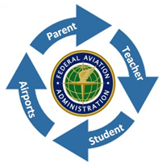
  - Develop a check-in system to ensure that mentors are actively participating.
- An alternative approach to mentoring would be:
  - Create a core group of mentors (perhaps 8-12)
  - Provide services through a “helpdesk” model , working to maintain discussion boards, receive email requests as needed, etc.
  - This platform takes less labor hours and potentially provides a more meaningful experience for the mentors while maintaining the appearance of having a dedicated mentor for each team of students

Final Entries
Outcome Score: 10

Lessons Learned  from Pilot | Changes Made  for this Iteration | Direct  Outcomes
- Require that students post their final submissions to YouTube and then share a link.  - Direct students to specifically address innovative changes they made to their airport | - All final entry YouTube links were uploaded to Blackboard  - Emphasis was made on the 5 minute time expectation of the final video, as well as the necessary content to be included  - Instructional videos were also developed to help students learn processes such as video production, use and navigation of YouTube, etc. | - Tracking of final entries was handled more effectively and efficiently  - Vast improvement in the quality of videos turned in. Students utilized technology resources which surpasses our expectations  - Posting the links on Blackboard provided easy access for judges to review the students’ work

Lessons Learned from this iteration –
- Requiring all final entries to be posted on YouTube provided a stable platform for the judges to review the students’ work.
- The changeover to YouTube also simplified the turn in process for the students and allowed the ADC team easy access for use in social media ads, video production, etc.

Mitigation/Change Recommendation(s) –
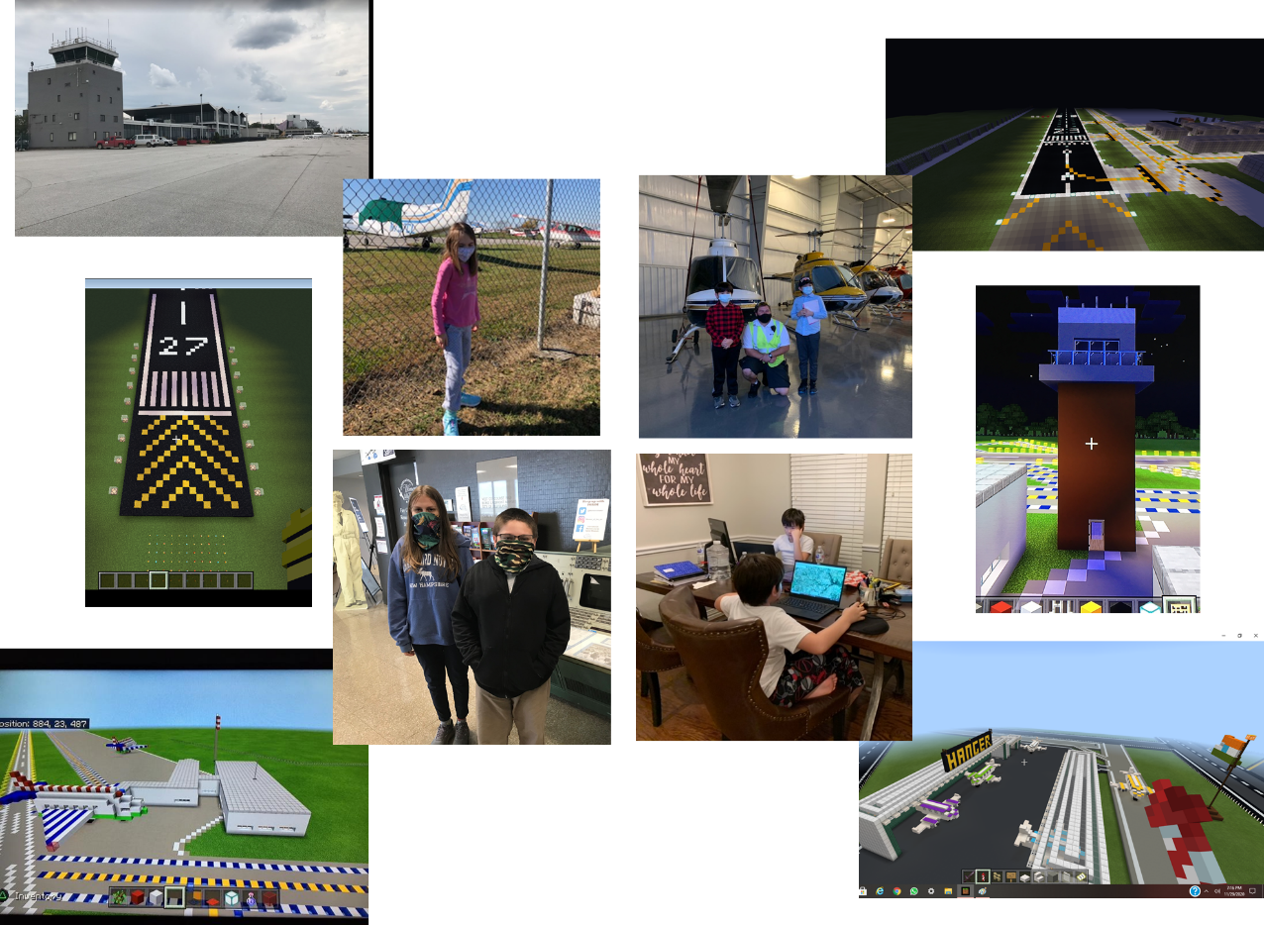
- No changes are recommended at this time

Judging
Outcome Score: 9

Lessons Learned  from Pilot | Changes Made  for this Iteration | Direct  Outcomes
- Having three judges with a variety of backgrounds was critical to providing a holistic view of each team’s work  - Post all video entries on a private YouTube channel to mitigate slow internet connection speeds.  - Provide clear guidance about 1) the instruction that was given to students, 2) the expectations of each judging category, and 3) the importance of providing meaningful comments to encourage learning. | - All final entries were posted on users’ private YouTube channels.  - Judging was conducting entirely in Blackboard using the designated grader role  - Designated graders were able to be assigned specific entries and only see/score those entries. The sum of the three scores was then averaged and reconciled in the gradebook. | - There were almost no issues accessing the final videos.  - Judges’ scores/comments were immediately available as soon as their evaluation was completed and the combined scores were automatically tabulated.

Lessons Learned from this iteration –
- Relocating all judging scoresheets to Blackboard saved numerous hours in administrative work and increased the accuracy of the tabulations.
- Conducting the judging during the winter holiday season created several issues with judges not completing scoring packets according to established deadlines.

Mitigation/Change Recommendation(s) –
- Set up multiple contact points for judges if judging is conducted during the holiday season.
- Prepare a backup plan in the event a judge cannot perform their duties.
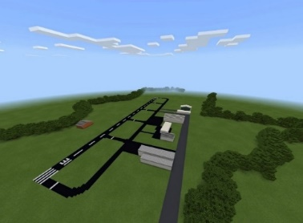
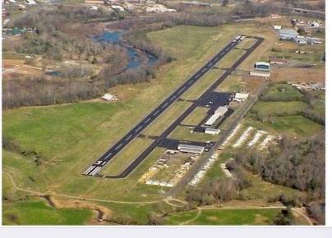


Awards & Recognitions
Outcome Score: 10

Lessons Learned  from Pilot | Changes Made  for this Iteration | Direct  Outcomes
- Inviting guest speakers from the airports and school was very meaningful for the winning teams  - It is critical to hold technical rehearsals prior to the event and to allow the presenters to practice turning their video and audio on and off in Zoom  - It is recommended that both social media and email are used for announcements of the awards ceremony | - Technical rehearsals were held prior to both ceremonies.  - Numerous emails and social media notifications were sent to the public prior to the awards ceremonies.  - Educators and airport managers in support of the winning teams were invited to speak at the awards ceremonies. | - Both awards ceremonies went very well and there were very few technical issues.  - The awards ceremonies had a combined total of approximately 12,000 views and 68,000 internet impressions.  - VIP Speaker, NASA Astronaut, Hoot Gibson volunteered his time to speak live at each event.

Lessons Learned from this iteration –
- Having two hosts for the awards ceremonies helped maintain positive energy throughout the events.
- Scheduling the VIP speaker at the end of the ceremonies was very effective in keeping everyone’s attention throughout the ceremonies.
- The “Indiana Jones” video showing all the countries that participated in the challenge helped the attendees better understand the global reach of the program.

Mitigation/Change Recommendation(s) -
- Complete production of finalist medals prior to awards ceremony
- Mail awards and certificates to students immediately following the announcements of the winners
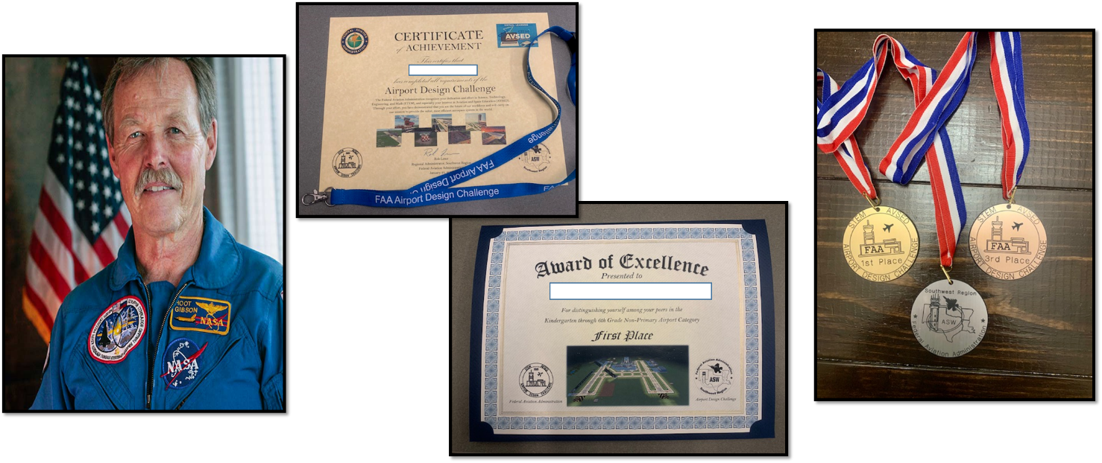
- Make sure to set up the program schedule so that the awards ceremony is not more than a few weeks after the end of the contest; the long duration through judging and then the holidays likely affected the momentum of the program and the attendance at the awards ceremony.

Resources (Hardware, Software, Personnel)
Outcome Score: 8

Lessons Learned  from Pilot | Changes Made  for this Iteration | Direct  Outcomes
- Move program to an LMS  - Utilize Outreach Representatives as FAA mentors  - Assign employees to oversee FAA Mentor team  - Utilize experts from other fields on an “as needed” basis | - Moved ADC from SharePoint/Excel format to Blackboard LMS  - Created a team to oversee the FAA Mentors  - Assigned full time detail employee to assist with ADC administrative and liaison duties  - Utilized web design expert to update and monitor web pages  - Coordinated social media advertisement campaigns with social media expert  - Obtained CNC engraving machine | - Efficiency of ADC increased exponentially which allowed for the development of higher quality products and services  - FAA Mentors were assigned to every team  - Information on ADC was effectively communicated across multiple platforms including email, web pages, and social media networks.  - Developed all finalist medals using engraving machine

Lessons Learned from this iteration –
- The only method for non-FAA employees to access Blackboard is through the Designee Registration System (DRS). Unfortunately, this system requires multiple clicks (8+) before the student is allowed entry in Blackboard. In addition, there are a limited number of people who can access DRS at any time which could limit the growth of future virtual AVSED activities.
- Organizing students into teams once they were enrolled was a cumbersome, time-consuming process.

Mitigation/Change Recommendation(s) –
- Set up access to Blackboard via eLMS or Blackboard Genius. These new systems require fewer clicks and will remove user limitations created by the DRS system.
- Work with Blackboard experts to find alternative ways to organize teams/groups that will make the process easier on students and program staff.

Program Evaluation
Each area of consideration above has been evaluated and assigned a score, which represents the respective success or failure of that element in the overall program. A score of 1 indicates a complete failure where a score of 10 signifies absolute success. The summary of scores for each area of consideration is shown in orange. A similar assessment was performed at the conclusion of the Airport Design Challenge pilot; those scores are shown in blue for comparison.

Summary of Findings

The Airport Design Challenge has proven to be a landmark approach to FAA STEM-AVSED outreach activities. This program was originally conceived to fulfill the educational requirements of a seemingly small, locally based body of students in the Southwest Region. Virally, however, the idea took on a life of its own and spread from state to state and then across international boundaries. Every day we would talk to people about what we were doing and immediately, they would want to be involved. Employees wanted to help, teachers and students wanted to play. A series of “hot wash” discussions within our internal team and with our support staff, partnered with direct feedback from students, parents, and teachers led to the conclusions enclosed in this report.

As the program scorecard displays, improvement from the pilot to the most recent launch was consistent across most areas of consideration. Substantial improvements were made to our advertising and launch campaigns, international outreach, and the way we coordinated final entries from the students. The introduction of Blackboard to the program significantly increased our ability to organize student work and communication, however, it also introduced new struggles to overcome. Factors with no growth were not neglected or forgotten, in fact, many of those saw the most substantial changes. Due to the extent of the modifications in areas such as registration and retention, an entirely new set of lessons learned have evolved. These are the greatest opportunities for us to show improvement in future iterations of the program. Since its inception, the Airport Design Challenge has quickly evolved, reaching across lines of business throughout the FAA, gaining momentum with industry partners, educators, and student organizations, and sustaining a persona of energetic momentum. The viral sensation by which it gained roots continues to help it grow as a model for large-scale virtual outreach in the years to come.
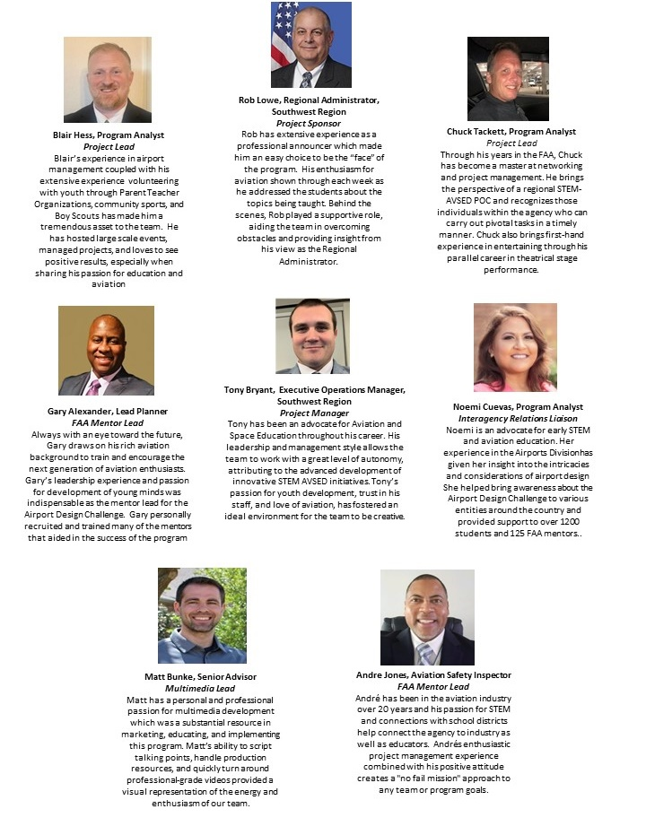
Meet The Team!

Appendix A
Internal Resource List
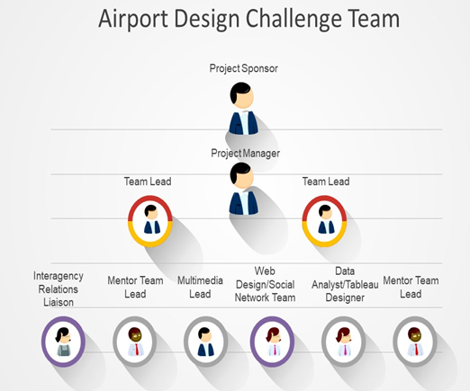

Sponsor- (Rob Lowe) The Sponsor is an advocate for the project at all levels of the organization and removes organizational obstacles. They are able to communicate well with all the key stakeholders and they should have some accountability for the project’s success.

Project Manager- (Tony Bryant) The Project Manager (PM) helps identify problems and issues that create roadblocks for the team and develops strategies to overcome them. They also oversee day to day operations and monitor and evaluate the performance of the project. They set milestones and ensure everyone on the team contributes to its success.

Team Leaders- (Blair Hess and Chuck Tackett) The Team Leaders set actions for the team members to accomplish in order to reach established project goals. They also guide the creative and educational direction of the project and develop new methods to engage students in the virtual world.

Interagency Relations Liaison- (Noemi Cuevas) The Interagency Relations Liaison is responsible for working across lines of business within the FAA to ensure timely communications and collaboration within the staff offices and headquarters personnel. Additionally, they work with a variety of educational and aviation based organizations to promote the project and answer any questions that may arise.

Multimedia Lead- (Matt Bunke) The Multimedia Lead is responsible for creating a wide variety of outreach and educational products in a high pressure environment with short deadlines. Duties include writing scripts, filming on airport locations, and adding music and pictures to videos. Other responsibilities include creating video announcements of upcoming project events and working with Web Design and Social Network team to promote upcoming ADC events.

Other Resources- The following roles were shared by the Airport Design Challenge team or were carried out on a part time basis by other FAA employees and contractors. As the project is scaled up for a larger audience, it is critical these roles are filled with dedicated resources and are not considered shared duties within the team.

- FAA Mentor Leads- (Gary Alexander and Andre Jones) The FAA Mentor Leads are responsible for the training and development of the FAA Mentor team.
  - Provide initial mentor orientation
  - Conduct weekly check-in meetings with mentor team
  - Answer questions and provide administrative and technical support to the mentor team

- Web Design/Social Network Team- (Derran Eaddy and Darcy Gagnon) The Web Design/Social Network Team provides guidance and expertise in creating web based and social network advertisements and announcements.
  - Web page coordination- Work with AOC to design the web page. Update the web page with current videos, pictures, and announcements.
  - Social network coordination- Design social network advertisement campaign. Ensure ADC information is sent across multiple social network platforms and provide data on effectiveness of outreach.

- Data Analyst/Tableau Designer - (Scott Carman) The Data Analyst/Tableau Designer works with the Airport Design Challenge team to ensure all relevant data is accurately logged and tracked.
  - Create charts and other visual aids within Tableau that allow a variety of users (students, FAA Mentors, administrators/management) to efficiently access the information they require.
  - Provide analysis of data to assist with high level briefings.
  - Identify trends in student age, demographics, program retention, and other select data.

Appendix B
External Resource List
The below mentioned groups worked with the ADC team to develop processes and procedures for the Fall 2020 Airport Design Challenge. In order to capture the outstanding achievements of each group, we have provided a list of their contributing functions, recommendations for working with each group in the future, and any concerns the ADC team identified during the development process.

AGC-400 – Legal
Concerns
- Legal is responsible for many programs, AVSED is not always their top priority; when requesting assistance, we found that providing impact statements and justification impacted the level of support we received
- COPPA – we can establish an expectation but cannot guarantee that all students will comply ethically to that standard
Functions
- COPPA – authored COPPA form and worked with privacy, PRA, etc. to establish processes pertaining to it
- Assisted in identifying programmatic needs for working with the public (non-FAA employees)
- Made recommendations of staff offices to coordinate efforts as needs were identified

Recommendations
- AGC-400 should be the first POC for any new programs. They are able to warn of any major obstacles and make recommendations to overcome them (POCs & Processes).
- COPPA laws mandate parental involvement for minors under age 13; we recommend all minors under 18.

AIS-230 – Privacy
Concerns
- The primary responsibility for writing system documents falls to the LOB that manages the system
- Privacy staff review those documents for completion an processing
- PAS approval may require contributions from multiple LOBs, each with their own review process
Recommendations
- Privacy specialists are assigned to specific systems so when you are utilizing multiples systems, you will not always be able to work with the same POC
- Allow ample time for privacy process reviews (this could take up to 90 days or more)
Functions
- Manages concerns regarding PII, COPPA, records management, etc.
- Provides written Privacy Act Statements, PTAs, ISAs, SORN, etc. exclusively for every individual system utilized

AFN (IT Security) – Paperwork Reduction Act
Concerns
- PRA applies to the amount of “paperwork” requested of the public from the government; it does not directly relate to reducing paperwork
- PRA reviews can take 9 months or more and involve all levels of government including DOT, OST, and OMB
Recommendations
- Under very limited circumstances, a generic customer service survey may allow for expedited processing (this can still take 4-6 weeks)
- Work with pre-approved templates when submitting surveys for review
Functions
- Ensure compliance with all PRA rules and regulations
- Reviews and makes recommendations for all surveys and formal correspondence with non-government officials

AOC – Office of Communications
Concerns
- AOC is responsible for many programs, AVSED is not always their top priority; when requesting assistance, we found that providing impact statements and justification impacted the level of support we received
- AOC has many SMEs assigned to specific tasks which sometimes makes coordination slow and difficult
Functions
- Provides support in web page design, social media posts, press releases (internal and external), graphic design, GovDelivery, web broadcasts, etc.
- AOC was integrated in the promotional marketing, information distribution, and awards ceremony production
Recommendations
- Identify needs and notify AOC as soon as possible
- Coordinate with communications liaison to identify recommended channels/ methods of communication

National Science Foundation Federal ListServe
Concerns
- What you send to the ListServe mailbox is exactly what will be published to everyone on the ListServe; no one will review your post.
Functions
- An interconnected email ListServe between all Federal agencies specifically related to sharing STEM opportunities
- Hosted by the NSF, but available to anyone with a .gov or .mil email address
Recommendations
- To join, you just send a (blank) email to FEDSTEMED-subscribe-request@listserv.gsa.gov.
- Once joined, send emails to FEDSTEMED@listserv.gsa.gov

Outreach and Marketing Communications
Recommendations
- Industries targeted:
  - Airports
  - Airlines
  - STEM Organizations
  - Home School Organizations
  - Teacher/ Educator/ Administrator groups
- Means of Communication:
  - Social Media
  - Email
  - Direct phone calls
Concerns
- It is difficult (impossible?) to measure the effectiveness of this outreach.
- This grass roots method of marketing is time consuming and requires resources but allows a personal contact and relationship to be created that ultimately demonstrated itself in the number of registrations received
Functions
- Internally, we worked as a team to develop relationships with potential stakeholders in a variety of industries related to the Airport Design Challenge.
- Interested parties were eager to participate and share program information with their members

Appendix C
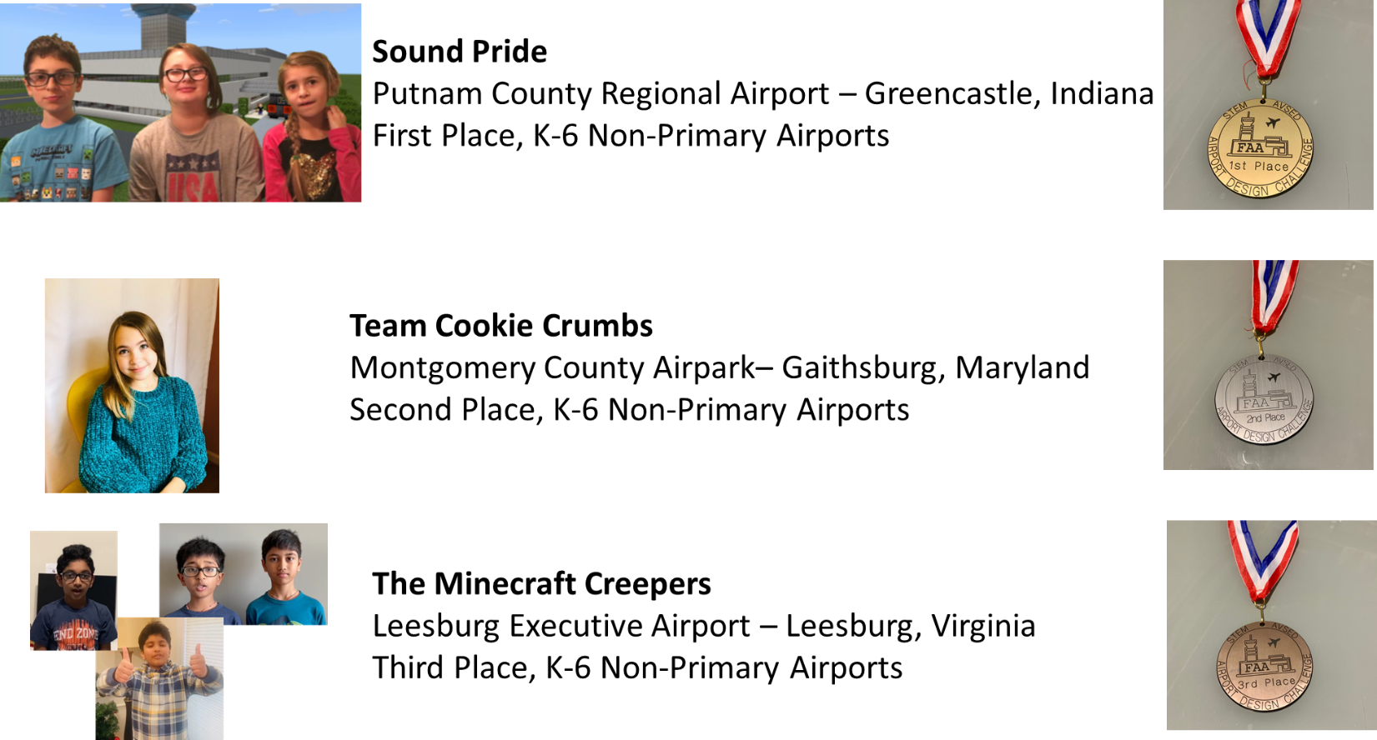
Finalist Showcase
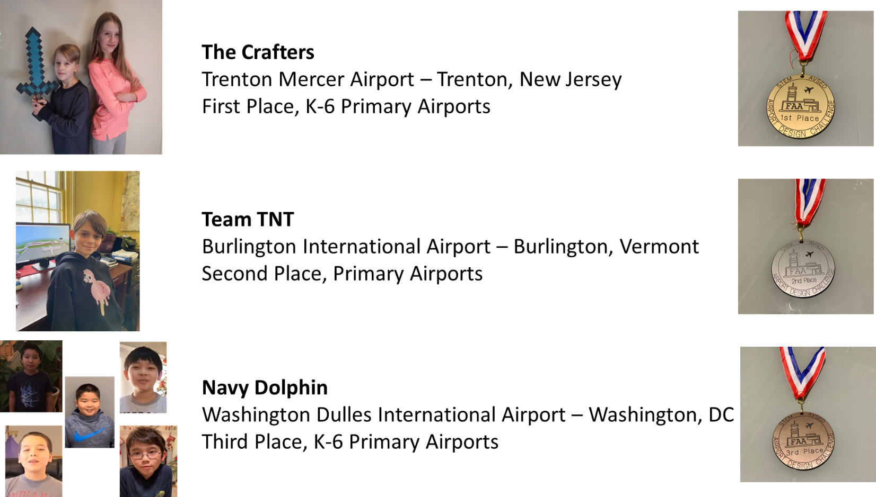

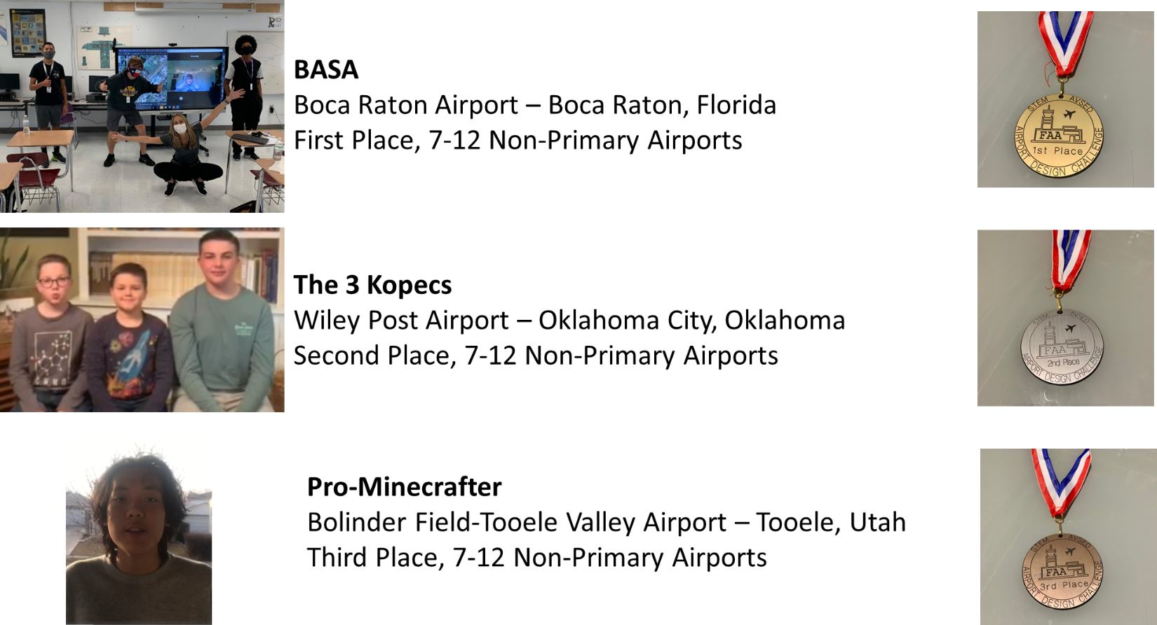

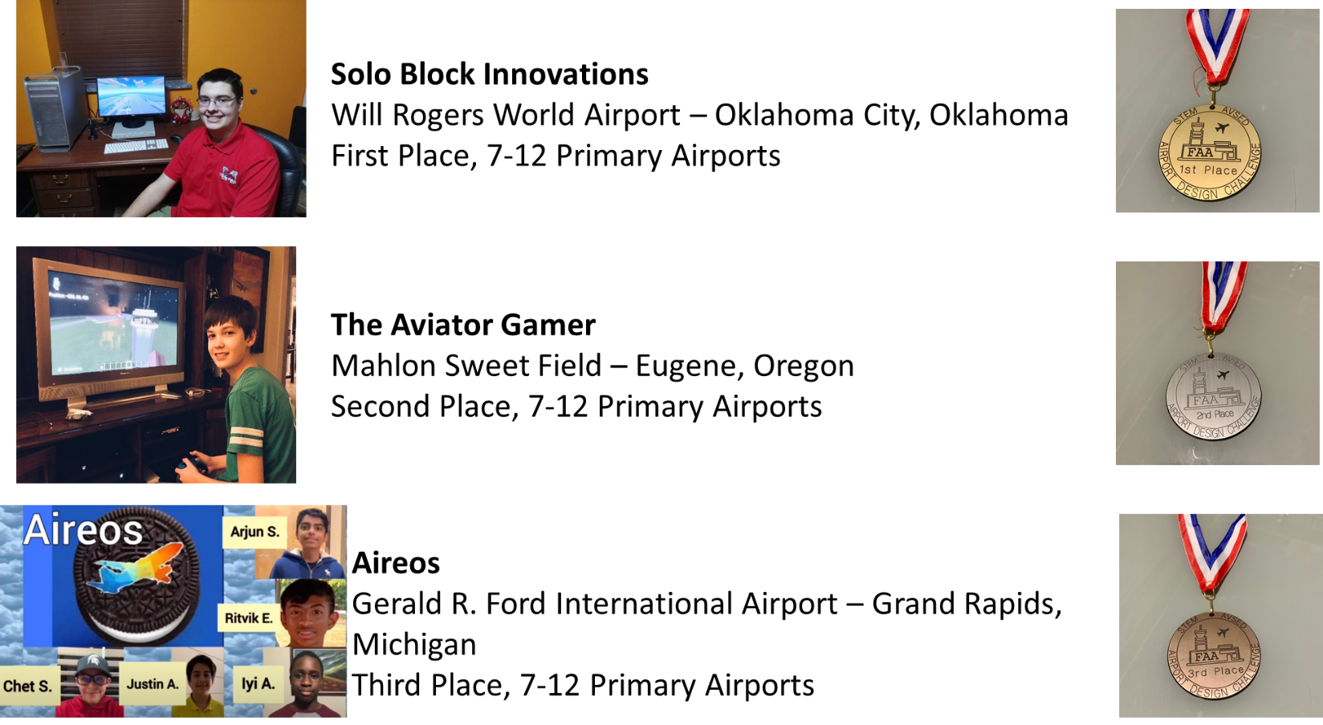
Appendix D
Acronyms

ADC Airport Design Challenge
AFN Office of Finance and Management
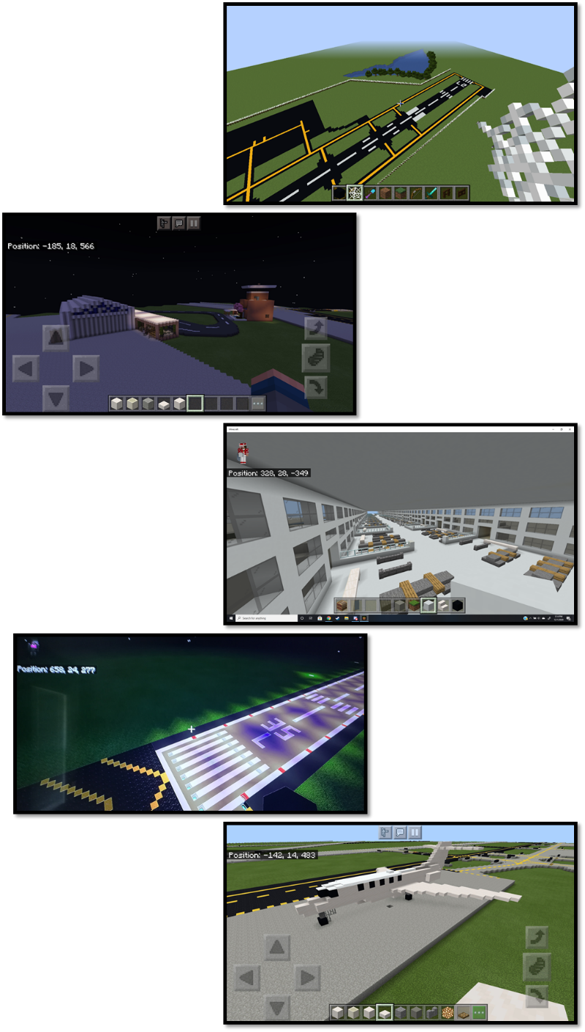
AGC Office of the Chief Counsel
AOC Office of Communications
ARA Office of National Engagement and Regional Administration
BB Blackboard LMS
CNC Computer Numerical Control
COPPA Children’s Online Privacy Protection Act
DOT Department of Transportation
DRS Designee Registration System
FAA Federal Aviation Administration
ISA Interconnection Security Agreement
IT Information Technology
LMS Learning Management System
LOB Line of Business
MS Microsoft
NSF National Science Foundation
OMB Office of Management and Budget
OST Office of the Secretary of Transportation
PAS Privacy Act Statement
POC Point of Contact
PRA Paperwork Reduction Act
PTA Privacy Threshold Analysis
SORN System of Records Notice
SME Subject Matter Experts
STEM Science, Technology, Engineering, and Math

