FAA Logo


Cockpit Display of Traffic Information (CDTI) Assisted Separation on Departure (CAS-D) Operational Description

Version 3.0

November 2023

Federal Aviation Administration

NextGen Project

Table of Contents

1 Introduction 1-3

1.1 Background 1-3

1.2 Document Overview 1-5

2 CAS-D Operational Overview 2-6

2.1 Assumptions 2-7

2.2 Operational Environment 2-8

2.3 Supporting Infrastructure 2-8

2.4 Benefits 2-9

3 Roles and Responsibilities 3-10

4 Procedure Description 4-11

4.1 Lead Aircraft Identification Designation, and Verification (Phase 1) 4-11

4.2 Instructions to Conduct CAS-D (Phase 2) 4-13

4.3 Maintaining CAS-D during Departure (Phase 3) 4-14

4.4 Cancellation (Phase 4) 4-16

4.5 Abnormal Modes 4-18

5 Sample Scenario 5-19

List of Figures

Figure 1‑1. Overview of a CAS-D Operation 1-4

Figure 4‑1. Lead Aircraft Identification and Verification (Phase 1) 4-13

Figure 4‑2. Instruction to Conduct CAS-D (Phase 2) 4-14

Figure 4‑3. Maintaining CAS-D during the Departure (Phase 3) 4-16

Figure 4‑4. Cancellation (Phase 4) 4-17

Figure 5‑1 CAS-D Initiation 5-19

Figure 5‑2 CAS-D Operation and Cancellation 5-20

**List of Tables**

Table 3‑1. Controller and Flight Crew Responsibilities during CAS-D 3-10

Table B‑1. TTF Identification Phase (Controller Initiative) B-24

Table B‑2. Instruction for Maintaining CAS from the TTF Phase B-28

Table B‑3 Maintaining CAS on the Departure Phase B-29

Table B‑4 Cancelation of CAS B-29

# Introduction

This document defines the Operational Description for the Cockpit Display of Traffic (CDTI) Assisted Separation on Departure (CAS-D). The purpose of this document is to describe the operational flow and considerations when executing a CAS-D operation and identify the controller and pilot’s tasks, roles, and responsibilities during these operations.

## Background

Air traffic controllers use Pilot-Applied Visual Separation on departure to minimize the time interval between successive departure aircraft during supporting weather conditions. When weather conditions drop below certain levels[1], they can no longer use Pilot-Applied Visual Separation. CAS-D allows airports to take advantage of Automatic Dependent Surveillance – Broadcast (ADS-B) and the CDTI Assisted Visual Separation (CAVS) application (RTCA DO-317C, 2020). CAS-D is an ADS-B In operation that falls under the CDTI Assisted Separation (CAS) operations suite of “visual” procedures. CAS operations relieve the controller of the requirement to apply radar separation during weather conditions that do not normally support pilot-applied or tower-applied visual separation. CAS-D is used only on departures, when a controller initiates the operation, and when the receiving pilot accepts the CAS-D clearance. Visual Operations within the NAS are currently dependent on a flight crew maintaining constant visual surveillance from a lead aircraft. The use of visual separation operations results in increased departure rates at the airports making use of the operation. The objective of CAS-D is to extend the higher departure rates allowed by current day pilot-applied visual separation operations into lower minimums and reduced visibilities. CAS-D is expected to recapture some of the departure throughput lost when visual separation operations are suspended. CAS-D operations do not change any requirements for procedures. The controller still clears all aircraft, including the CAS aircraft, for takeoff. Refer to Figure 1‑1 below that provides an overview of a CAS-D operation. For additional information, see (Bone, 2022) used as reference for this document.

Image of Overview of a CAS-D Operation


Figure 1‑1. Overview of a CAS-D Operation

The initial deployment of ADS-B In applications is expected to include CAS operations for both approaches and departures, and Interval Management (IM) (Perez, 2023). The initial ADS-B In applications may require automation enhancements across the Standard Terminal Automation Replacement System (STARS), En Route Automation Modernization (ERAM), Terminal Flight Data Manager (TFDM), Traffic Flow Management System (TFMS)/Flow Management Data and Services (FMDS), TBFM, and Flight Data Input/Output (FDIO). These automation enhancements will enable air traffic controllers to identify aircraft that are able to execute a CAS or IM operation. Planned enhancements to STARS will also allow the controller to denote in automation when an ADS-B In operation is active.

## 

## Document Overview

The remainder of the document is organized as follows:

* **Section 2** describes the assumptions, the operational environment, the supporting infrastructure, benefits, and the proposed concept for CAS-D operations.
* **Section 3** defines the roles and responsibilities of the air traffic controllers and pilots.
* **Section 4** provides a general procedure description and the possible abnormal modes.
* **Section 5** provides a sample scenario for a CAS-D operation.

# CAS-D Operational Overview

CAS-D builds on the existing CAVS operation, as described in Advisory Circular (AC) 90-114B *Automatic Dependent Surveillance Broadcast Operations* and the same flight deck tools are used for both CAS-D and CAVS. CAVS allows flight crews to use information on the CDTI as a substitute for continuous visual observation of the lead aircraft during Visual Meteorological Conditions (VMC). The key differences from current pilot-applied visual separation operations are (1) the controller uses aircraft identification when identifying the lead aircraft, (2) the trail aircraft flight crew uses the CDTI for a CAS operation, and (3) the trail aircraft flight crew can conduct a CAS operation while the aircraft is airborne in Instrument Meteorological Conditions (IMC) or reduced ceiling / visibility conditions. CAS-D operations are conceptually similarly to those defined for CAS on approach (Perez, 2023) to same runway. While the trail aircraft is permitted to be airborne in IMC for CAS, the airport of departure must be VMC (ceilings at or greater than 1,000 ft AGL and visibility at or greater than 3 nm). CAS operations can only be conducted when the lead and trail aircraft are departing from the same runway.

The CAS-D operation is initiated by the Tower controller, who provides the Aircraft ID[2] for the lead aircraft. The flight crew designates the lead Aircraft ID using the avionics’ CAVS application and uses the information on the CDTI as a substitute for visually acquiring and maintaining contact with the lead aircraft out-the-window (OTW) after designation has successfully occurred. Once the lead aircraft is successfully designated within the avionics’ CAVS application, the flight crew acknowledges the designation of the lead aircraft by communicating this to the controller. At the appropriate time, the local controller instructs the CAS aircraft to enter the runway, instructs the CAS aircraft to follow the lead aircraft, and clears the CAS aircraft for takeoff.

After takeoff, the flight crew uses the CDTI to conduct CAS-D. The operation continues similarly to a pilot-applied visual separation operation, except that the flight crew can maintain contact with the lead aircraft using the CAVS avionics, including during Instrument Meteorological Conditions (IMC). CAS-D does not change any runway separation requirements for successive departures or requirements for departures from other parallel/converging runways. CAS-D allows the flight crew to use the CDTI alone to maintain constant visual surveillance with the lead aircraft when OTW visual contact is not possible or is lost.

## Assumptions

This operational description makes the following assumptions:

* The CAS aircraft is equipped with an avionics system meeting the requirements defined in TSO-C195c (Federal Aviation Administration, 2020) or later to support the CAVS application; *and*
* the flight crew of the CAS aircraft is trained for the CAS-D operation; *and*
* the operator has been approved by their regulator to conduct CAS-D operations; *and*
* air traffic controllers are trained on CAS-D procedures prior to use; *and*
* CAS-D is applicable between the CAS aircraft and a single lead aircraft departing the same runway (i.e. controller responsibilities for all other aircraft are unchanged); *and*
* current FAA Requirements for pilot-applied visual separation operations other than OTW view of the lead also apply in CAS-D operations (e.g., a CAS aircraft is not authorized to follow a Super category aircraft); *and*
* CAS-D can be initiated when the departure airport has a reported ceiling of 1000’ or greater and visibility of 3 SM or greater; *and*
* the aircraft conducting a CAS-D operation may enter IMC conditions during flight once airborne and above 1000 feet AGL on a Departure; *and*
* ground automation provides an indication to the controller for which aircraft are CAS-D qualified and the ability to denote an active ADS-B In CAS-D operation; *and*
* the lead aircraft is equipped with functioning ADS-B out; *and*
* CAS-D is used in Tower and Terminal Airspace to support aircraft performing departure operations; *and*
* CAS-D can be applied in airspace of any traffic density; *and*
* the roles and responsibilities of the controller related to visual separation instructions are unchanged; *and*
* tower, departure, and downstream controllers will be aware when CAS-D operations are being performed and for which pair of aircraft are performing CAS-D operations.

## Operational Environment

The CAS-D operations described in this document will be performed in U.S. tower and terminal airspace with suitably equipped aircraft and with sufficient weather-related opportunities for these operations to be beneficial. Air traffic controllers will have a CAS-D capability indicator on their working position displays and are trained to perform CAS-D operations.

Tower and departure controllers will be aware when CAS-D operations are being performed and for which pair of aircraft are performing CAS-D operations. This may be accomplished by providing a capability indicator and an indicator of which aircraft are performing an active CAS-D operation to tower and departure controllers. The lead aircraft should be known implicitly in a CAS-D operation.

## Supporting Infrastructure

Implementation of the CAS-D operations will require changes to STARS, ERAM, TFDM, and FDIO. This document does not provide details on these implementations, but changes will be needed in ground ATC automation to occur to properly support CAS-D operations.

TFDM will need the following additional information and functionality to support the controller in CAS-D Operations:

* Identify CAS-D capable aircraft for controllers.

STARS will need the following additional information and functionality to support the controller in CAS-D operations as described in this document:

* Identify CAS-D capable aircraft.
* Ability to denote an active CAS-D operation.
* Identify an active CAS-D operation.

## Benefits

The benefits of CAS-D are for air traffic controllers and flight crews to safely perform pilot-applied visual separation operations more efficiently, on a more regular basis, and in new conditions by:

* Allowing air traffic controllers to decrease time between departures, by relieving them of the responsibility of initially having standard radar separation (3 nm), once the participating aircraft are airborne.
* Supporting flight crews in maintaining constant visual surveillance from the lead aircraft via the CDTI when weather conditions may not be conducive for visual operations.

# Roles and Responsibilities

Responsibilities for participating air traffic controllers and flight crews are based on those specified in CDTI Assisted Separation (CAS) on Departure from Same Runway Operational Description (Bone, 2022) are summarized in Table 3‑1. Controller and Flight Crew Responsibilities during CAS-D

Table 3‑1. Controller and Flight Crew Responsibilities during CAS-D

|  |  |
| --- | --- |
| Air Traffic Controller Responsibilities | Flight Crew Responsibilities |
| * Ensures the facility is executing CAS-D Operations; *and* * determines the CAS aircraft via CAS-D capability indication on an ATC display; *and* * uses the Aircraft ID of the lead aircraft to identify Traffic-to-Follow to the CAS aircraft; *and* * issues takeoff clearance to the CAS aircraft in alignment with FAA rules on visual departures; *and* * issues the CAS-D instruction in prior to the takeoff clearance; *and* * makes appropriate inputs to ATC automation to indicate which aircraft are involved in a CAS-D operation; *and* * monitors the distance between a CAS and lead aircraft for any significant issues; *and* * provides separation for the CAS aircraft, lead aircraft, and surrounding traffic throughout the CAS-D operation; *and* * cancels the CAS-D operation if the CAS-D operation is no longer applicable or the flight crew of the CAS aircraft communicates that CAS-D can no longer be maintained. | * Verifies that the CDTI information matches the Aircraft ID provided by the controller; *and* * designates the lead aircraft for the CAS-D Operation; *and* * communicates acceptance of CAS-D operation to the air traffic controller; *and* * uses the information from the CDTI to maintain pilot-applied separation from the lead aircraft; *and* * communicate unable to the controller if unable to initiate or continue CAS-D operation.; *and* * cancel the CAS-D operation if cancelled by the controller |

The tower controller is still responsible for runway separation and issuing takeoff clearances for all the aircraft pairs, including the CAS-D pair. Departure controllers will be made aware when CAS-D operations are being performed and which pair of aircraft are performing CAS-D operations.

# Procedure Description

CAS-D is comprised of four phases: Lead Aircraft Identification, Designation, and Verification; Instructions to Conduct CAS-D; Maintaining CAS-D during Departure; and Cancellation.

Descriptions and diagrams of the four phases are provided in this section. The associated tables are shown in Appendix B.

The following convention is used to indicate who or what is responsible for the task:

* GND-Pro = A task performed specifically by the ground equipment.
* GND-ATCo = A task performed specifically by the controller.
* GND = A task performed either by ground equipment, by controller, or by a combination of both.
* AC-Av = A task performed specifically by the CAS aircraft avionics.
* AC-FC = A task performed specifically by the flight crew of the CAS aircraft.
* AC = A task performed either by the CAS aircraft avionics, by the flight crew of the CAS aircraft, or by a combination of both.
* TTF = refers to the lead aircraft (Traffic-To-Follow).

## Lead Aircraft Identification Designation, and Verification (Phase 1)

Figure 4‑1 outlines the steps for the controller and flight crew to identify, designate and verify the lead aircraft. The CAS-D procedure is initiated by the controller who has assessed the following:

* The weather condition requirements for CAS-D have been met; *and*
* determines the potential CAS aircraft is CAS qualified as noted on an ATC automation display; *and*
* a lead aircraft is designated for departure immediately ahead of the CAS aircraft.

Once the “Designate” instruction[3] is issued by the controller, the flight crew of the CAS aircraft will:

* Designate the lead aircraft for the CAS-D application on the CDTI using the Aircraft ID provided by the controller; *and*
* verify the CDTI information matches the Flight ID[4].

The operation begins with the tower controller identifying the need for a CAS-D operation. Once the CAS-D operational need is established, the controller identifies the TTF and the CAS aircraft. The controller shares the TTF information with the CAS flight crew. The CAS flight crew reads back the CAS information and proceeds to designate the traffic on the CAVS application on their CDTI. At this point, the flight crew may realize they are unable to continue the operation or at any further point in the operation. If the flight crew is unable, they will communicate “Unable” to the controller. There are different reasons why a flight crew may be unable to initiate a CAS operation including but not limited to;

* If there is no traffic displayed that corresponds to the lead aircraft; *or*
* the traffic corresponding to the lead aircraft is not qualified to support the CAVS application; *or*
* the flight crew is operationally unable.

Once a tower controller receives an “Unable” response from a pilot, the controller will revert to standard procedures without the use of CAS-D for that aircraft. If the flight crew is able to designate the aircraft, they will report the aircraft as designated to the tower controller.

***Note****: At any point in the traffic identification process, the flight crew can verify the Flight ID of the lead aircraft with the controller if there are any questions about the lead aircraft location or identity.*

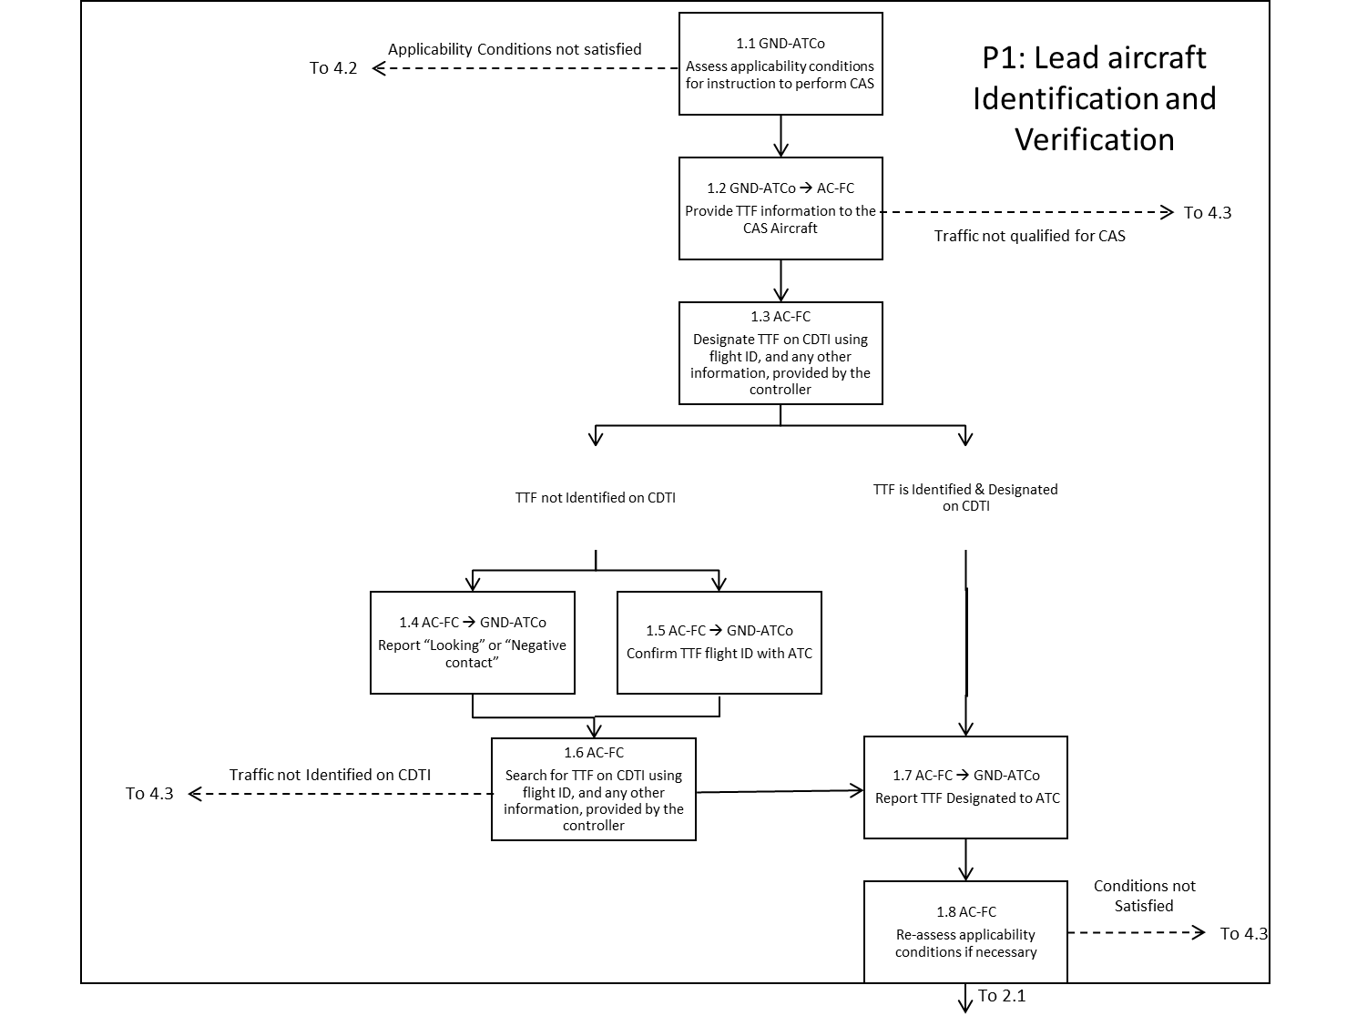

Figure 4‑1. Lead Aircraft Identification, Designation and Verification (Phase 1)

## Instructions to Conduct CAS-D (Phase 2)

For this phase of CAS-D, the local controller issues a CAS-D instruction and a takeoff clearance. The flight crew confirms the details of the CAS-D Operation and takeoff clearance with the controller. If for any reason the details of the CAS-D Operation cannot be confirmed in the CDTI, they will notify the controller. The local controller will make appropriate entries in ATC automation to indicate the CAS and lead aircraft are on an active CAS-D operation. Figure 4‑2 does not explicitly capture this step.

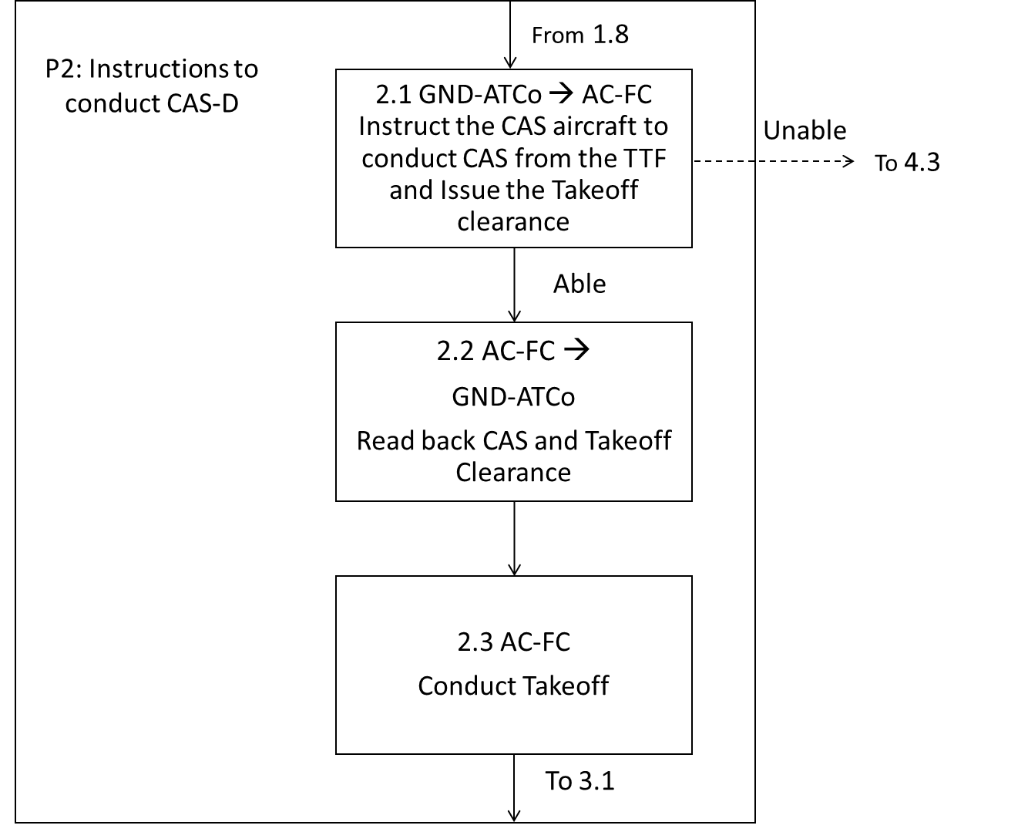

Figure 4‑2. Instruction to Conduct CAS-D (Phase 2)

## Maintaining CAS-D during Departure (Phase 3)

After takeoff, the flight crew uses the information provided by the CDTI on the lead aircraft in substitution for the OTW information to manage their spacing via CAS-D. The CDTI provides the ground speed information (i.e., the aircraft ground speeds and the differential ground speed) and a display of the horizontal range to the lead aircraft. Using the range and differential ground speed information on the CDTI, flight crews will be able to detect speed reductions of the lead aircraft and maintain the pilot-applied separation more accurately and quickly.

The flight crew of the CAS-D aircraft may use speed adjustments as needed to manage the distance between their aircraft and the lead aircraft. The flight crew of the CAS-D aircraft may not use turns or lateral maneuvering to manage their distance from the lead aircraft, without controller coordination. If pilots feel the need for a lateral maneuver during departure to increase their altitude difference from the lead aircraft, the pilot shall coordinate with a controller.

* If visual OTW contact is achieved at any point, the flight crew may use this information for situational awareness but should not rely on OTW contact to conduct CAS-D operations.

Three alerting functions are provided by CAVS functionality (RTCA DO-317C, 2020):

* An operational advisory “Traffic Range” alert is generated when the horizontal range to the lead aircraft falls below a pilot determined value (or may be a default value in the avionics). When an advisory “Traffic Range” alert is generated, the flight crew can determine if any subsequent response is required.

*Note: Subsequent flight crew responses could include adjusting speed to continue the departure or contact controller for non-visual separation/non-CAS-D instructions.*

* A technical performance “Traffic Minimum Range Caution Alert” is generated when the horizontal range to the designated traffic becomes less than 1.4 NM[5]. The objective is to alert the flight crew that the ADS-B Out data quality is no longer sufficient to use the CDTI to manage distance from the lead aircraft. When a “Traffic Minimum Range Caution Alert” is triggered, the flight crew must either have OTW visual contact with the lead aircraft or contact a controller.
* Other system failure alerts that would not allow the flight crew to continue the CAS-D operation. If these occur, the flight crew must contact a controller. If the flight crew has OTW visual contact with the lead aircraft, advise the controller.

After takeoff, the flight crew:

* Flies the departure procedure; *and*
* assesses the information (i.e., distance and relative speed) on the lead aircraft provided by the CDTI; *and*
* responds to any alerts as appropriate; *and*
* adjusts the speed of the aircraft (if required) to maintain sufficient distance from the lead aircraft, unless issued a speed assignment by the air traffic controller or relevant departure procedure.[6]

The procedure in case of abnormal modes (e.g., triggering of a “Traffic Minimum Range Caution Alert” without OTW visual contact) is identical to the current visual separation on departure with pilot-applied visual separation procedure (respectively, loss of visual contact and/or too close from the lead aircraft).

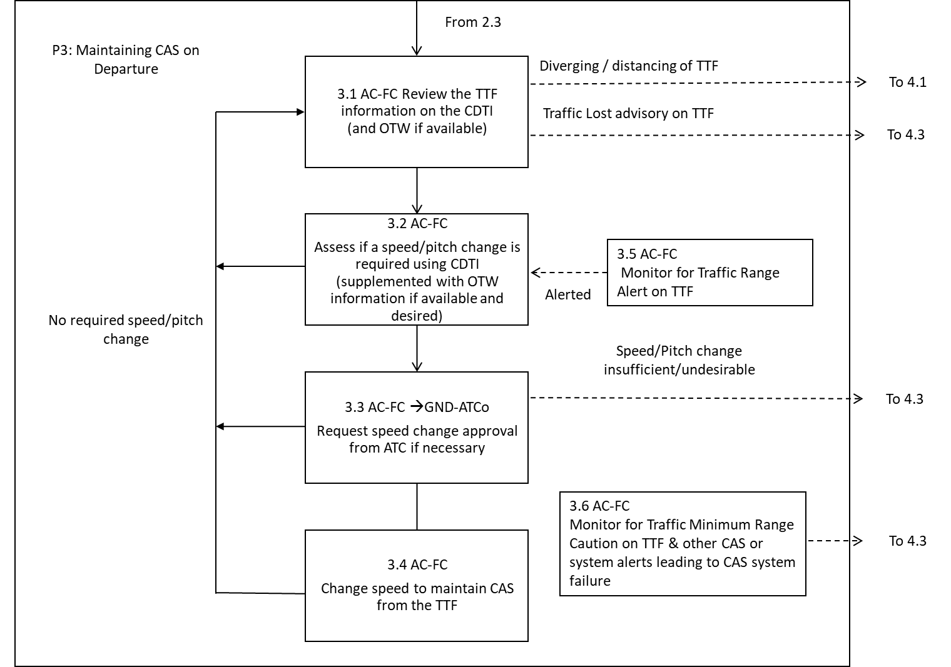

Figure 4‑3. Maintaining CAS-D during the Departure (Phase 3)

## Cancellation (Phase 4)

There are several conditions that end the CAS operation, both from ATC and the flight deck.

ATC will cancel the CAS-D operation and communicate the cancellation to the flight crew when one of the following conditions are met:

* The CAS-D aircraft has achieved standard separation; *or*
* the CAS-D aircraft leaves TRACON airspace; *or*
* the lead aircraft is and will remain on a diverging course as per FAA JO 7110.65 para. 5-5-7 or para. 5-8-3; *or*
* operational necessity.

The flight crew will cancel the CAS-D operation and communicate the cancellation to ATC when one of the following conditions are met:

* The avionics has a failure alert; *or*
* the CAS-D aircraft climbs above 10,000ft msl[7]; *or*
* operational necessity.

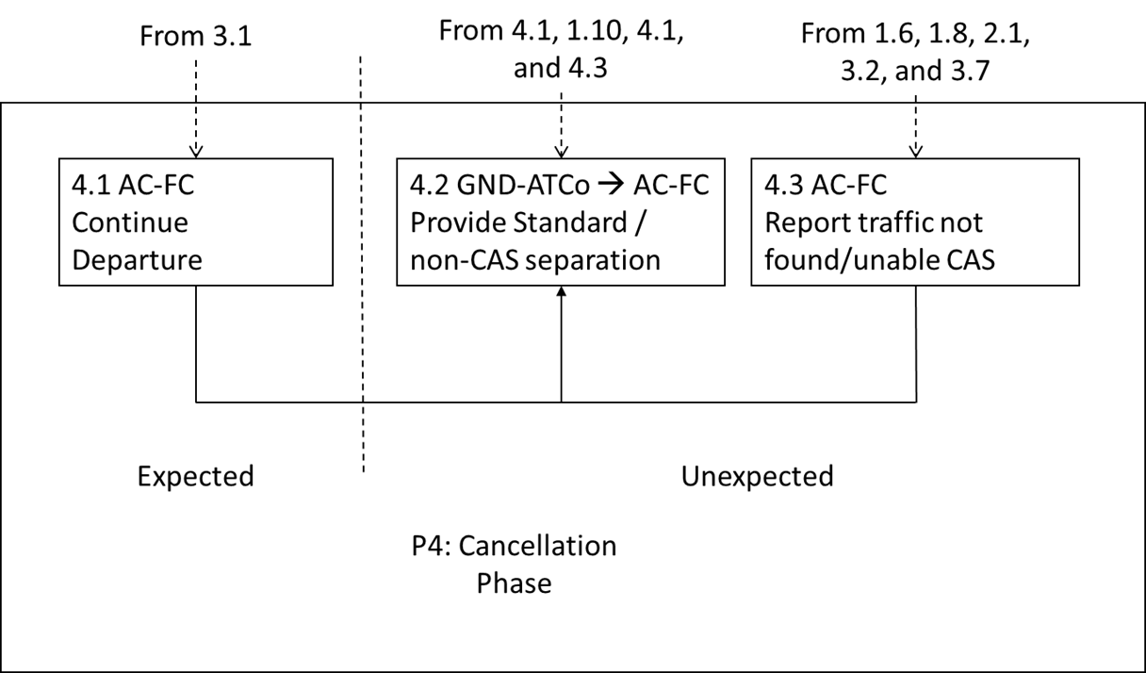

Figure 4‑4. Cancellation (Phase 4)

## Abnormal Modes

While rare, there are conditions that may prevent the flight crew from continuing a CAS-D operation. Examples of these conditions include avionics issues, such as, loss of lead aircraft ADS-B Out, loss of CAS-D capability, avionics alert messages and situational issues, such as, flight crew inability to sufficiently reduce airspeed to avoid an overtake event. When the flight crew is unable to continue with the CAS-D operation for any reason, they will contact an air traffic controller. The controller will issue instructions to the flight crew, as appropriate. Should any situation occur that affects the safety of flight, such as, a wake turbulence encounter or insufficient range behind the lead aircraft, the flight crew will apply current day contingency procedures and advise ATC.

# Sample Scenario

This section contains an example scenario of a CAS-D operation.

Prior to takeoff, the tower controller identifies the CAS aircraft, AAL151 and once the departure sequence is confirmed, communicates to AAL151 to designate the Lead Aircraft using the Flight ID (UAL256).

The flight crew of the CAS aircraft uses the Lead Aircraft Flight ID to “designate” UAL256 via the CDTI. Once UAL256 is designated, the CDTI will provide an "on-ground/in-air" status for the pilots. The flight crew then advises the controller of the designation of UAL256, as shown in Fig. 5-1.

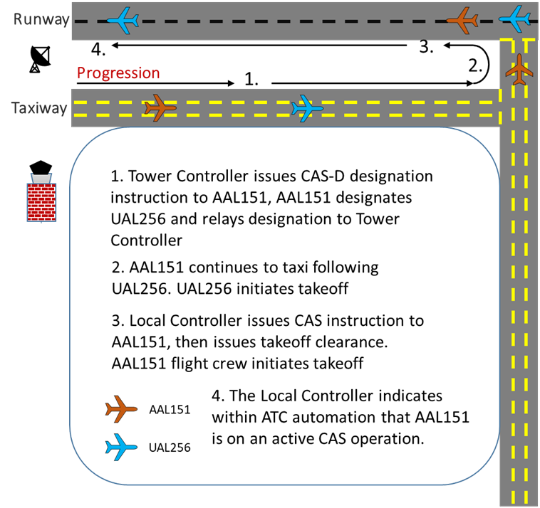

Figure 5‑1 CAS-D Initiation

The local controller clears UAL256 for takeoff. Once UAL256 has begun their takeoff roll, the local controller issues a “*line-up and wait*” instruction to AAL151. Once UAL256 is six-thousand feet down the runway and airborne, the local controller issues the CAS instruction (“*follow traffic*”) and takeoff clearance to AAL151. AAL151 begins the takeoff roll, and once airborne, the AAL151 flight crew is authorized to use the CDTI information to perform CAS-D following UAL256 utilizing the additional information provided on the CDTI including but not limited to the ground speed, range, ground speed differential, and flight identification. The flight crew task is mainly flying the departure profile while retracting the landing gear and flaps on schedule. The flight crew monitors the differential ground speed, distance and range information as the lead aircraft continues to accelerate, increasing the distance between the aircraft pair. Since the distance continues to increase and standard separation occurs relatively quickly, the time required to conduct CAS-D is minimal. The departure controller monitors the spacing of the aircraft pair for any significant issues, intervening if deemed necessary, but allows the flight crew to conduct CAS-D operation from the lead aircraft.

As depicted in Fig. 5-2, the flight crew of the AAL151 maintains CAS from UAL256 until one of the cancellation conditions listed in Section 4.4 is met. Standard separation between the CAS and Lead aircraft typically occurs within 10 NM of the departure end of the runway, dependent on the respective aircraft’s speed differential. In this scenario, the departure controller issues a new vector to AAL151 and cancels the CAS operation. The flight crew of AAL151 confirms the new clearance and deselects UAL256 from the CDTI, canceling the CAS-D operation.

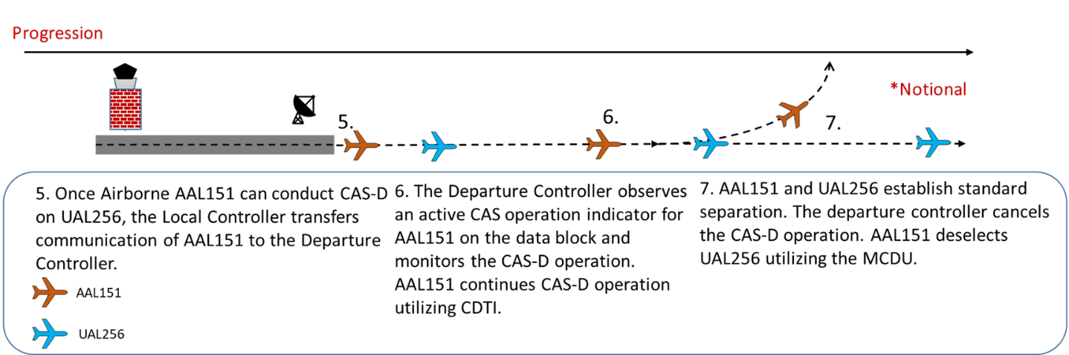

Figure 5‑2 CAS-D Operation and Cancellation

###### Acronyms

|  |  |
| --- | --- |
| ACSS | Aviation Communication & Surveillance Systems, LLC |
| ADS-B | Automatic Dependent Surveillance – Broadcast |
| AIRS | ADS-B In Retrofit Spacing |
| CAS-D | CDTI Assisted Separation on Departure |
| CDTI | Cockpit Display of Traffic Information |
| CAVS | CDTI Assisted Visual Separation |
| ERAM | En Route Automation Modernization |
| FAA | Federal Aviation Administration |
| FDIO | Flight Data Input/Output |
| IM | Interval Management |
| IMC | Instrument Meteorological Conditions |
| NAS | National Airspace System |
| NextGen | Next Generation Air Transportation System |
| NM | Nautical Mile |
| OTW | Out The Window |
| STARS | Standard Terminal Automation Replacement System |
| TBFM | Time Based Flow Management |
| TFDM | Terminal Flight Data Manager |
| TFMS | Traffic Flow Management System |
| TRACON | Terminal Radar Approach Control |
| VMC | Visual Meteorological Conditions |

###### Phase Tables

Tables associated with the Phase Diagrams modelling the various phases are shown in this appendix.

The following convention is used to indicate whom or what is responsible for the task:

* GND-Pro = A task performed specifically by the ground processing equipment
* GND-ATCo = A task performed specifically by the Air Traffic Controller, this may be the Tower or TRACON controller.
* GND = A task performed either by ground processing equipment or by Air Traffic Controller or by a combination of both
* AC-Av = A task performed specifically by the aircraft avionics
* AC-FC = A task performed specifically by the aircraft flight crew
* AC = A task performed either by the aircraft avionics or by the flight crew or by a combination of both

The list of required Information on Ground (IG), which must be available for display to the controller, is:

* IG01 – CAS aircraft Flight ID
* IG02 – General traffic situation
* IG03 – TTF and CAS Aircraft horizontal position (to assess applicability conditions)
* IG04 – TTF and CAS Aircraft altitude (to monitor the operation)
* IG05 – TTF and CAS Aircraft direction (to monitor the operation)
* IG06 – TTF and CAS Aircraft ground speed (to monitor the operation)
* IG07 – TTF and CAS Aircraft type (to be used in the traffic information by the controller and to address configurations subject to wake turbulence)
* IG08 – TTF aircraft Flight ID
* IG09 – Airport cloud base and visibility

*Note: The requirements for IG01 to IG09 are not changed from today’s operations.*

The following information should be available for display to the controller:

* IG10 – CAS capability status

The list of required Information in Air (IA) which must be available to the flight crew (for all ADS-B Out equipped traffic except when specified differently in the tables below) is:

* IA01 – Relative horizontal position (i.e., range and relative bearing)
* IA02 – Altitude (Relative altitude required. Barometric corrected pressure altitude and absolute pressure altitude are optional) or On Ground Status
* IA03 – Flight ID
* IA04 – Ground track
* IA05 – Vertical tendency
* IA06 – Qualification status for CAVS
* IA07 – OTW information on the TTF
* IA08 – TTF flight ID received from the controller
* IA09 – Ground speed information related to the TTF

*Note: The differential ground speed must be displayed at the minimum when the CAS Aircraft and the TTF are in-trail of each other, defined when the relative track angle between the aircraft is less than 20 degrees. Both the CAS Aircraft and TTF ground speeds must be continuously displayed.* (RTCA DO-317C, 2020)

* IA11 – Digital read-out of the horizontal range to the TTF

*Note: The differential ground speed and the horizontal range must be displayed in the Forward Field of View.*

* IA12 – Advisory indicating that the TTF is no longer qualified to support CAS
* IA13 – Traffic Range Alert indicating that the horizontal range to the TTF falls below a value selected by the flight crew. It is an advisory level alert.
* IA14 – Traffic Minimum Range Caution indicating that the CDTI can no longer be used without OTW visual contact with the TTF

|  |
| --- |
| **Phase 1 – TTF Identification** |
| **Objective** – The controller provides the TTF Flight ID to the flight crew of the CAS aircraft for identification. The flight crew looks at the CDTI to identify then designate the TTF. After having designated the TTF, the flight crew reports designation to the controller. If identification or designation is not achieved, the flight crew informs the controller, continues the CDTI search and reports to the controller when designation is eventually achieved. |

Table B‑1. TTF Identification Phase (Controller Initiative)

| **ID** | **Description** | **Domain** | **Information Needed** | **Conditions for Transfer to Next Action** | **Next** |
| --- | --- | --- | --- | --- | --- |
| 1.1 | Assess applicability conditions for instruction to perform CAS | GND-ATCo | IG01 – CAS aircraft Flight ID  IG02 – General traffic situation  IG03 – TTF and CAS Aircraft horizontal position  IG04 – TTF and CAS Aircraft altitude or air/ground status  IG06 – TTF and CAS Aircraft ground speed  IG09 – CAS capability status if available  IG10 – Airport cloud base and visibility  IG11 – TTF flight ID | Applicability conditions satisfied | 1.2 |
| Applicability conditions not satisfied | 4.2 |
| 1.2 | Provide TTF information to the CAS Aircraft | GND-ATCo  🡪  AC-FC | IG01 – CAS aircraft flight ID  IG07 – TTF and CAS Aircraft type  IG11 – TTF flight ID  (optionally IG3, IG4, IG5, IG6, IG07, and IG8) | Information provided | 1.3 |
| 1.3 | Designate TTF on CDTI using flight ID, and any other information, provided by the controller | AC-FC | IA01 – Relative horizontal position (all displayed ADS-B traffic)  IA02 – Altitude or “on ground” status (all displayed ADS-B traffic)  IA03 – Flight ID (all displayed ADS-B traffic)  IA04 – Ground track (all displayed ADS-B traffic)  IA05 – Vertical tendency (all displayed ADS-B traffic)  IA06 – Qualification status for CAS (traffic corresponding to TTF)  IA08 – TTF flight ID received from the controller | TTF identified & designated | 1.7 |
| TTF not identified, and additional time needed | 1.4 |
| TTF not identified, and lead is in question | 1.5 |
| 1.4 | Report “Looking” or “Negative contact” | AC-FC  🡪  GND-ATCo | - | Communication occurred | 1.6 |
| 1.5 | Confirm TTF flight ID with ATC | AC-FC  🡪  GND-ATCo | IA08 – TTF flight ID received from the controller | Communication occurred | 1.6 |
| 1.6 | Search for TTF on CDTI using flight ID, and any other information, provided by the controller |  | IA01 – Relative horizontal position (all displayed ADS-B traffic)  IA02 – Altitude or “on ground” status (all displayed ADS-B traffic)  IA03 – Flight ID (all displayed ADS-B traffic)  IA04 – Ground track (all displayed ADS-B traffic)  IA05 – Vertical tendency (all displayed ADS-B traffic)  IA06 – Qualification status for CAS (traffic corresponding to TTF)  IA08 – TTF flight ID received from the controller | TTF identified & designated | 1.7 |
| Traffic not Identified on CDTI | 4.3 |
| 1.7 | Report TTF designated | AC-FC  🡪  GND-ATCo | - | Communication occurred | 1.8 |
| 1.8 | Re-assess applicability conditions if necessary | GND-ATCo | IG01 – CAS aircraft flight ID  IG02 – General traffic situation  IG03 – TTF and CAS Aircraft horizontal position  IG04 – TTF and CAS Aircraft altitude or “on ground” status  IG06 – TTF and CAS Aircraft ground speed  IG10 – Airport cloud base and visibility  IG11 – TTF flight ID | Applicability conditions satisfied | 2.1 |
| Applicability conditions not satisfied | 4.2 |

|  |
| --- |
| **Phase 2 – Instruction for maintaining CAS from the TTF** |
| **Objective** – The controller issues the instruction for maintaining CAS from the TTF. The flight crew either accepts or refuses the instruction. |

Table B‑2. Instruction for Maintaining CAS from the TTF Phase

| **ID** | **Description** | **Domain** | **Information Needed** | **Conditions for Transfer to Next Action** | **Next** |
| --- | --- | --- | --- | --- | --- |
| 2.1 | Issue the Takeoff clearance and Instruct the CAS aircraft to conduct CAS from the TTF | GND-ATCo  🡪  AC-FC | IG01 – CAS aircraft flight ID | Communication occurred | 2.2 |
| Unable | 4.3 |
| 2.2 | Read back Takeoff clearance and CAS instruction | AC-FC 🡪  GND-ATCo | - | Communication occurred | 2.4 |
| 2.3 | Conduct Takeoff | AC-FC | - | Takeoff initiated | 3.1 |

|  |
| --- |
| **Phase 3 – Conducting CAS on takeoff** |
| **Objective** – The flight crew flies the departure while maintaining CAS from the TTF. |

Table B‑3 Maintaining CAS on the Departure Phase

| **ID** | **Description** | **Domain** | **Information Needed** | **Conditions for Transfer to Next Action** | **Next** |
| --- | --- | --- | --- | --- | --- |
| 3.1 | Review the TTF information on the CDTI (and OTW if available) | AC-FC | IA01 – Relative horizontal position (TTF)  IA02 – Altitude (TTF)  IA04 – Ground track (TTF)  IA05 – Vertical Tendency (TTF)  IA07 – OTW information on the TTF  IA09 – Ground speed information related to the TTF  IA11 – Digital read-out of the horizontal range to the TTF  IA12 – Advisory alert indicating that the TTF is no longer qualified to support CAS  IA13 – Range indication advisory  IA14 – Traffic Minimum Range Caution | Diverging / distancing of TTF | 4.1 |
| Traffic Lost advisory on TTF | 4.3 |
| 3.2 | Assess if a speed/pitch change is required using CDTI (supplemented with OTW information if available and desired) | AC-FC | IA01 – Relative horizontal position (TTF)  IA02 – Altitude (TTF)  IA04 – Ground track (TTF)  IA05 – Vertical Tendency (TTF)  IA07 – OTW information on the TTF  IA09 –Ground speed information related to the TTF  IA11 – Digital read-out of the horizontal range to the TTF  IA13 – Traffic Range Alert | No required change | 3.1 |
| Required speed/pitch change | 3.3 |
|  |  |
| 3.4 | Change speed to manage the distance/altitude from the TTF | AC-FC | - | Speed change made | 3.1 |
| 3.5 | Monitor for Traffic Range Alert on TTF | AC-FC | IA13 – Traffic Range Alert | Alerted | 3.2 |
| 3.6 | Monitor for Traffic Minimum Range Caution on TTF & other CAS or system alerts leading to CAS system failure | AC-FC | IA14 – Traffic Minimum Range Caution | Alerted | 4.3 |

|  |
| --- |
| **Phase 4 – Cancellation of CAS** |
| **Objective** – The flight crew flies the departure while canceling CAS from the TTF. |

Table B-4 Cancelation of CAS

| **ID** | **Description** | **Domain** | **Information Needed** | **Conditions for Transfer to Next Action** | **Next** |
| --- | --- | --- | --- | --- | --- |
| 4.1 | Continue Departure | AC-FC |  | Departure Continued | 4.2 |
| 4.2 | Provide Standard/ non-CAS separation | GND-ATCo | IG01 – Trail aircraft flight identification  IG02 – General traffic situation  IG03 – Lead and trail aircraft horizontal position  IG05 – Lead and trail aircraft direction  IG06 – Lead and trail aircraft ground speed | Action to provide standard / non-CAS separation indicated | N/A |
| 4.3 | Report Traffic not found / unable CAS | AC-FC |  | Communication occurred | 4.2 |

###### References

Bone, R. (2022). *CDTI Assisted Separation (CAS) on Departure from Same Runway.* FAA, American Airlines, ACSS, NextGen Project.

FAA, American Airlines, ACSS, and NextGen Project. (2022). *ADS-B In Retrofit Spacing (AIRS) CDTI Assisted Separation (CAS) Single Runway Operational Description Version 4.0.*

Federal Aviation Administration. (2020). *TSO-C195c - Avionics Supporting Automatic Dependent Surveillance – Broadcast (ADS-B) Aircraft Surveillance Applications (ASA).* Federal Aviation Administration.

Perez, B. (2023). *Cockpit Display of Traffic Information (CDTI) Assisted Separation on Approach (CAS-A) Operational Description.*

RTCA DO-317C. (2020). *DO-317C: Minimum Operational Performance Standards (MOPS) for Aircraft Surveillance Applications.*

1. The weather conditions that require ATC to suspend the use of pilot-applied visual separation are often counter-intuitive. The ceiling minima must be above the initial assigned altitude of the departure to allow for continuous visual surveillance throughout the initial climb-out. This altitude can be as high as 17,000 ft.
2. Also known as “call sign”; i.e., “American Four Fifty-Six” for AAL456.
3. . The “Designate” instruction is initially given to allow the CAS aircraft flight crew to identify and designate the lead aircraft for the CAVS application. The CAS instruction is issued in Phase 2 in section 4.2.
4. In this document, Flight ID and Aircraft ID may be used interchangeably. In general, FAA controllers are shown the Aircraft ID from flight plan information, where flight crews can only see the Flight ID being broadcast via ADS-B.
5. Per (RTCA DO-317C, 2020); the surveillance distance is based on surveillance quality.
6. If the speed issued by the controller will prevent the flight crew from maintaining pilot-applied separation, they should advise the controller.
7. From training, the CAS flight crew will know that they can disengage their avionics for the CAS Operation above 10,000ft msl. No further communication with the controller is required to confirm cancellation.