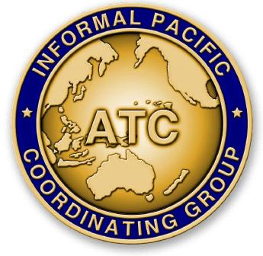
THE FORTY-EIGHTH MEETING OF THE
INFORMAL PACIFIC ATC COORDINATING GROUP
(IPACG/48)

FAA Northwest Mountain Regional Office - Des Moines, Washington
September 25 - 28, 2023

Agenda Item X: Category

Title of Paper

(Presented by Organization Name)
SUMMARY

- Introduction

- Discussion

- Conclusion

  - The meeting is invited to note the information provided.

