Flight Service – Remote Communications Outlet (RCO) Reduction FAQ

FAA Goals for Flight Service
- Expand use of modern technologies to support safety
- Optimize service delivery processes
- Eliminate redundancies and underutilized activities

Why is FAA reducing RCO coverage?
Flight Service currently operates 936 frequencies across the U.S., Hawaii, and Puerto Rico. In the 1980s, daily requests exceeded 22,000; today, fewer than 300 occur—a 99% decline due to technological advancements like mobile apps and FIS-B. These changes allow pilots to access critical information without radio communication, with no impact on safety.
CONUS Inflight Contacts Calendar Years 1988 - 2025
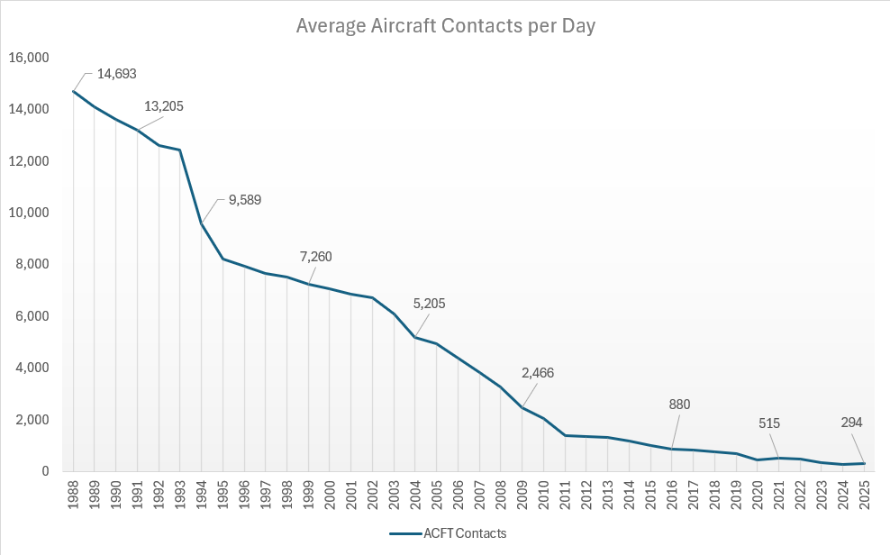
The FAA has previously streamlined RCO infrastructure (2017 and 2023). This phased reduction aligns resources with demand, saves approximately $4.8 million annually, and avoids costly upgrades to legacy systems.

How will I know which frequencies will remain and which ones will be decommissioned?
Updated lists will be available on the FAA website and can be found here: Active CONUS FS Frequencies. Changes will appear in Chart Supplements, Sectionals, Enroute charts, and via NOTAMs, as they occur.

Will 122.2 be eliminated?
No. Of the 262 retained RCOs, 113 will continue using 122.2.

What coverage can I expect?
Coverage maps at 2,500’ AGL and 5,000’ AGL are posted on the FAA website: (FS Home Page - Service Volumes)

When will frequencies be removed?
Leidos will discontinue monitoring the identified frequencies on September 3, 2026.

Does Flight Service attend aviation events?
Yes. Flight Service will participate in various pilot seminars, fly-ins, and forums in 2026 to provide updates and answer questions.

How are updates communicated?
Through FAA Safety Briefing, FAAST Blast messages, and collaboration with organizations like AOPA, EAA, etc, as well as via NOTAM and updates to the Chart Supplements, Sectionals, and Enroute charts.

Is pilot feedback considered?
Yes. Based on stakeholder input, FAA adopted this phased approach to RCO decommissioning. Pilots can provide feedback at events or via FAA Feedback

