

**FAA  
 William J. Hughes Technical Center**

challenges and complexities in

Agile principles

Perspectives on Defining Agile, Changing Culture,

and Building Metrics

September 21, 2022

Columb Higgins, Verification and Validation Strategies and Practices Branch, FAA

Ann McDonald, Volpe National Transportation Systems Center, DOT

Noreen Miller, Verification and Validation Strategies and Practices Branch, FAA

Angela Moore, Verification and Validation Strategies and Practices Branch, FAA

William J. Hughes Technical Center

Atlantic City International Airport, New Jersey 08405

**Table of Contents**

1 Introduction 1

2 Presentations 2

2.1 Managing Requirements in an Agile Framework 2

2.1.1 Discussion 3

2.2 Defining Relationships as the NAS Evolves 4

2.2.1 Discussion 5

2.3 Agile as Active Collaboration 6

2.3.1 Discussion 7

2.4 Shifting Left/Right in Development and Culture 8

2.4.1 Discussion 9

3 Major Issues and Challenges 10

3.1 Defining Agile 10

3.1.1 Agile Characteristics 10

3.1.2 When are we Done? 11

3.1.3 Agile Versus Waterfall Development 12

3.2 Culture Change 13

3.2.1 Right-Sized Teams 13

3.2.2 Communication Breakdown 13

3.2.3 Training how you Implement 14

3.3 Developing the Right Metrics 14

3.3.1 Meaningful Metrics 14

3.3.2 Validating Metrics 15

3.3.3 Data-Driven Metrics 16

4 Interactive Sessions 16

5 Summary and Conclusions 17

Appendix A — Acronym List 18

**List of Figures**

Figure 1. Managing Requirements in an Agile Framework 3

Figure 2. “The Importance of Making Mistakes” Video 4

Figure 3. Defining Relationships as the NAS Evolves 5

Figure 4. Is this Agile? 6

Figure 5. Shifting Left and Right on the Developmental ‘V’ 9

Figure 6. Agile Definition (Ambler 2013) 11

Figure 7. Polling Results 16

# Introduction

This paper is based on discussions held during the 17th Annual Verification and Validation (V&V) Summit Technical Interchange Meeting (TIM). The FAA William J. Hughes Technical Center’s (WJHTC) V&V Strategies and Practices Branch (ANG-E5A) conducted the V&V Summit from September 21–22, 2022 at the National Aerospace Research and Technology Park (NARTP). The summit was conducted in a hybrid format with in-person attendees at NARTP and others participating remotely via Zoom. Approximately 260 people attended the summit remotely and in person. Speakers and presentations delved into concepts, strategies, and proven methods addressing the summit’s theme: “Enabling Dynamic Innovation with Rigor.” A critical objective of the summit was to provide a collaborative environment for convergence: the assembling of different ideas from different groups to contribute knowledge and context to a complex idea so that commonalities and similarities become visible, and synthesis of understanding may occur. The goal of the TIM was to present and discuss challenges and lessons learned around the summit theme, followed by a roundtable dialogue and discussion on the challenges, problem statements, best practices, useful methods, and lessons learned. This white paper details the TIM presentations, discussions, and findings.

The TIM was conducted in-person on the afternoon of September 21, 2022. Approximately 30 people were in attendance for the TIM at the NARTP. Subject Matter Experts (SMEs) discussed the challenges and complexities inherent within agile principles and practices, and moderators led brief discussions after each presentation seeking discovery and clarification on the topic. After a short break, attendees took part in a roundtable dialogue and discussion based on the presentations.

The TIM was moderated by John Frederick, Manager, ANG-E5A; and Ann McDonald, Program Analyst, Aviation Systems Engineering, Volpe National Transportation Systems Center. The following SMEs made presentations during the TIM:

* Kelly Curran, Division Chief, Aviation Systems Engineering, Volpe National Transportation Systems Center, Department of Transportation (DOT)
* Kimberly Gill, Manager, National Airspace System (NAS) Enterprise Architecture & Requirements Services Division, ANG-B1, FAA
* William S. Hayes, Principal Engineer, Carnegie Mellon University (CMU) Software Engineering Institute (SEI)
* Ian M. Levitt, Principal Engineer, Air Traffic Management eXploration (ATM-X) Urban Air Mobility (UAM) Airspace subproject, National Aeronautics and Space Administration (NASA)

This white paper captures thoughts and suggestions made during TIM presentations and discussion. Accordingly, this document does not represent official FAA policy or proposals for policy. Nor does it represent official policy of the SME’s organizations. The purpose of this document is to provide progressive perspectives and stimulate practical discussion within the community regarding agile principles and practices through the convergence of new and diverse concepts.

NOTE: To access presentations, double click on the figure image. To view video, hold Control and click on the image.

# Presentations

Mr. Frederick opened the TIM by welcoming everyone present and outlining the agenda. He said presenters were tasked with offering a thought, challenge, or lesson learned based on the concept of “Agile.” After each presentation, moderators would lead discovery to investigate and clarify the topic. After a break, attendees would then circle back and revisit ideas. He said the goal of the TIM and this white paper is to capture how attendees understand the problem.

## Managing Requirements in an Agile Framework

Kelly Curran is Division Chief for Aviation Systems Engineering at the DOT’s John A. Volpe National Transportation Systems Center. She has more than 20 years’ experience in aviation, has been a project manager in the Aviation Safety Management Systems Division, and is project manager for FAA’s Systems Safety Management Transformation program. She leads the Office of Research and Innovative Technology’s Software Continuous Improvement Program initiative, ensuring the Volpe Center attains and maintains a Capability Maturity Model Integration (CMMI) Level 3 certification. Before coming to the DOT Volpe Center in 2015, Ms. Curran was a project manager supporting the U.S. Coast Guard in operational business requirement development. She served as an officer in the U.S. Navy and as an Officer and Aircraft Commander responsible for the mission and safety of a crew on the P-3 Orion aircraft deployed in the Middle East and Far East in support of the Global War on Terrorism. She has flown the C-12 King Air, SH-3 Sea King helicopter, and SH-60B Seahawk helicopter, among other aircraft.

Ms. Curran talked about managing requirements when using agile practices, as well as some of the challenges Volpe has addressed during its work with the FAA. Volpe works with the FAA’s Technical Management and Integration Team (AJM-132), which is responsible for requirements management, configuration management, and risk management. Volpe is located in Cambridge, Mass., and serves as a federal resource providing multimodal, multidisciplinary transportation expertise.

Ms. Curran offered the following challenge: how do you implement an agile framework and still manage requirements under the FAA Acquisition Management System (AMS)? She said the AMS framework is primarily “waterfall-esque” and provides policy and guidance for end-to-end services, facilities, and infrastructure for the FAA. Final Requirements Documents are part of that process and one of the deliverables. Once you get through Investment Analysis, how do you continually add agile into that kind of a model?

Ms. Curran said part of the problem is cultural. A lot of acquisition practices define scope early. They define successes and when a program is done. That reality, along with acquisition and appropriation constraints, can lead to challenges when becoming more agile (see Figure 1).

“One of the things we’re looking at is that waterfall has a fixed scope, and variables of resources, time, and quality,” she said. “Whereas agile flips it on its head and looks at fixed resources, time, and quality, but the requirements and scope become your estimation. So the key is traceability. We want to be able to trace the requirements, so the AJM Office and Volpe have started to go forward and look at how we can do a hybrid approach.”

Figure 1. Managing Requirements in an Agile Framework

Ms. Curran said a hybrid approach would follow AMS process guidance but allow for a more iterative, cyclic, agile-type requirements management. Volpe is CMMI Maturity Level 3 certified for process improvement and quality control. When you overlay CMMI and agile, you have the tools to support it and a roadmap, she said. Volpe and AJM-132 have found success with defining requirements and then going into the agile lifecycle (i.e., development sprints). Because requirements are defined through the AMS process, teams need to make sure they are constantly tracing back to those, bringing in stakeholders, and using a change management process.

“We look at a change management retrospective,” she said. “A lot of times we find the terminology is a challenge. We talk to people who say I do agile, I don’t do requirements. Really you do have requirements, you’re just calling them something else. It’s a backlog. You’re (refining) your backlog; you’re doing retrospectives. A lot of time it’s through tools, through Jira or other tools you can use to manage it. It’s not that traditional documentation.”

She said that with agile, it is helpful to use the term “discipline” more than “rigor.” Teams do not want to be inflexible, she said, but they want to be disciplined in how they approach things. She said scalability with agile is a big plus.

### Discussion

Moderators opened discussion at the conclusion of Ms. Curran’s presentation. The first question was how to define agile.

“That’s one of the challenges,” Ms. Curran said. “For me, when I think of agile I’m thinking of a process that is iterative, often looking at requirements and then applying resources in a time box to accomplish those items and then looking back and seeing what did you do well? Do you have to reevaluate and then double back again and address that? To me, it’s early and often review of what you’re doing and resetting your goals as you go.”

A follow-up question asked whether agile development and agile testing are one and the same. Ms. Curran said the theory behind them should be the same, but the application is different. Mr. Frederick said the TIM goes beyond just agile development and is more focused on understanding and applying agile philosophies and principles.

[](https://vimeo.com/274455250)Another question referred to a video shown during the morning session of the V&V Summit entitled “The Importance of Mistakes,” which animated a portion of a John Cleese speech on the same topic (see Figure 2). In the video, Cleese tells the story of Gordon the Guided Missile. There can be two different approaches to sending the guided missile out to hit its target: either plan everything out and give the missile its target before firing, or ask it along the way how it is doing. The guided missile has a direction and a setting when it is fired, which could be called the scope. Mr. Frederick said that in a traditional waterfall program, the distant target would be the point of aim. The team would measure itself against hitting the bullseye, expecting the possibility of being off center or missing entirely. However, by asking along the way and correcting course, it may appear the team is “making mistakes,” but they are actually learning by doing. They are adjusting so they hit the bullseye.

Figure 2. “The Importance of Making Mistakes” Video

## Defining Relationships as the NAS Evolves

Kimberly Gill is Manager of the NAS Enterprise Architecture & Requirements Services Division (ANG-B1). Her division has three branches providing Enterprise Systems Engineering services across FAA organizations in the areas of Requirements, Enterprise Architecture Modeling, Information/Data Management and Systems Engineering guidance, as well as support to NAS programs. Her division also maintains the FAA’s Systems Engineering Manual and leads the Systems Engineering Forum, providing networking opportunities for FAA Systems Engineering organizations.

Ms. Gill has 35 years of Systems Engineering experience. She joined the FAA in 1991 testing and fielding Air Traffic Control (ATC) radar equipment at more than 400 locations across the country. She then took on the roles of program manager and systems engineering manager, replacing technologically obsolete surveillance and weather equipment for several FAA programs with budgets exceeding $1 billion. Prior to joining the FAA, Ms. Gill worked supporting the Office of Naval Intelligence, Department of Interior, and Martin Marietta.

Ms. Gill talked about the importance of defining relationships and changing organizational culture in order to adopt agile principles and practices (see Figure 3). Models and tooling will also be critical to make things go faster in a digital environment. She said digital will be foundational to agile practices when it comes to automated systems engineering. It is hard to switch tools when you have an entire model of the NAS, so even if you find a tool that can absorb all your data in a meaningful way it can still be a lot of hands-on work. It has to be made clear that some of these underlying tools enable innovation and allow for engineering to be done quicker.

Figure 3. Defining Relationships as the NAS Evolves

“We do have an opportunity with the automation evolution strategy to pull it together by exemplifying what these things mean in real life with a real concept that we’re trying to tell,” she said. “I’m hoping that besides just changing the AMS, we’re also looking to change our tooling in the FAA.”

The way enterprises go about interacting with stakeholders also has to change. She said the FAA should have an institutionalized stakeholder engagement plan. That will be important moving into an agile world where stakeholders, including testers, have to work together to make incremental success stories. In a stakeholder engagement plan, teams should have a specific cadence with associated schedules for each stakeholder. Stakeholders are not created equal, Ms. Gill said, so when they come to the table it is probably going to be different depending on who it is.

“I’m talking about logisticians, technicians, the end user,” she said. “Someone is going to lead at different parts of the lifecycle. You have to make sure that everyone understands when they are not going to be the lead anymore and they’re willing to pass the torch.”

Ms. Gill said there also have to be escalation rules for disagreements. It is not all about process; it is also about personalities. There has to be an agreement amongst the team and stakeholder on when to escalate disagreements, and both have to understand that nothing bad will happen to those who do not get their way. There should also be a process for turnover in stakeholder representatives. It is counterproductive to have a stakeholder representative agree to one thing, but then have to argue the same point when that representative is replaced.

### Discussion

Mr. Frederick opened discussion after the presentation, saying that part of the problem is how to move organizations culturally and change their mindsets. Training will be a big part of that. It is important to instill a common mindset across the organization. Quoting author Peter Drucker — “Culture eats strategy for breakfast” — Mr. Frederick said that if the culture is not there, you can write process for as long as you want but nothing will change.

Ann McDonald said it would be helpful to have an enterprise-wide tool that everyone can work on, not just pockets or silos within the FAA. Then teams would have to be trained on the tool. That is a huge undertaking, but it would get to the root cause of a lot of misunderstandings, misconceptions, and missed requirements.

Attendees discussed cloud-type access tools for various teams and stakeholders. One of the challenges some branches have had is tracing enterprise-level requirements and mapping them to program requirements that may or may not change. Under different agile build-by-build verifications, sometimes a requirement is not fully verified or only partially verified. Teams need to be able to trace those capabilities and ask whether they are headed in the right direction for success.

## Agile as Active Collaboration

William S. Hayes is a Principal Engineer at CMU/SEI where he leads the Agile Transformation Team. In this role, he leads a team of senior engineering and research staff who work to transform agile implementation concepts for diverse and novel applications in military, government, and highly restrictive contexts. He has 30 years of experience at SEI where he works with software development organizations around the world.

Mr. Hayes’ current focus is on the acquisition, development, and sustainment of large-scale embedded weapons systems. Mr. Hayes helps large Department of Defense programs align personnel across communities of government oversight and industrial providers. His past work includes a collaboration with NASA’s Independent Verification and Validation (IV&V) organization, where he was called on to help adapt the discipline of IV&V to the new incremental development approach used for software delivered to NASA. This collaboration yielded an agile approach to performing V&V for the Orion Multi-Purpose Crew Vehicle.

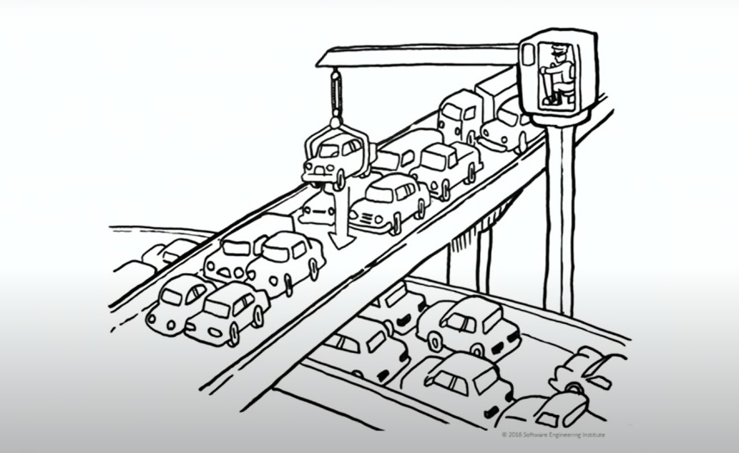Mr. Hayes began by showing the image in Figure 4. The image is inspired by the work of Daniel Vacanti, author of “Actionable Agile Metrics for Predictability: An Introduction.” Vacanti posits that just because there are 40 feet of extra pavement, it does not mean it is a good idea for a car to be there.

Figure 4. Is this Agile?

“I can take a small piece of the work from one team and crane it down to another team,” Mr. Hayes said. “Is the purpose to cover the pavement or to make the traffic flow?” An over-emphasis on resource utilization is often a key barrier to agility. Packing everyone’s schedule with work, like filling the road with cars, will tend to slow things down in the end.

Mr. Hayes spoke about how agile organizations manage dependencies. He said that many organizations look at dependencies as a set of fixed constraints. Organizations that are successful view that both sides of a dependency have to operate together in a system where they succeed or fail together.

“I might find a way to blame you in this game of schedule chicken because your side of the dependency was the one that was late this time. This kind of cultural history that exists in a lot of our organizations is a barrier,” he said. “Dependency means we collaborate. Otherwise, we are going to let the whole enterprise down.”

One of the main symptoms of a traditional waterfall approach is nothing is visible until everything is done. Enterprises tend to wait until integration tests to understand the individual contributors to the capability of the system because they do not have another way of doing it. Often, this comes about because of the nature of the organizational structure, Mr. Hayes said. Dependencies exist on either side of boundaries, and capabilities are similarly sequestered by this boundary.

“So we don’t get to see any of the individual elements in terms of fully tested functional capabilities until they’re mashed together,” Mr. Hayes said. “That happens so late in time and there are so many unpredictable things that can come about because we have not bothered to walk across the hall and talk to each other.”

Mr. Hayes also touched on metrics, and said metrics in general are viewed by some from a defensive posture. Once a stakeholder is happy with a graphic or PowerPoint showing metrics, the team can go back to the real work. Successful agile organizations consume data closer to the point where work is performed, rather than building a large data set entirely intended for an external audience.

### Discussion

Ms. McDonald opened discussion after the presentation by asking Mr. Hayes what is the biggest challenge he has seen in moving to agile. He said that many organizations tend to focus on adopting terminology and agile ceremonies without changing the way they perform the detailed technical work. Instantiating the methods as if they are templates to be filled out can lead them to miss the intended benefits.

Mr. Frederick said one of the challenges in adopting agile practices is setting up contracts. An agile contract should be collaborative and include shared risk. “How do you work collaboratively with a contractor or vendor where you’re sharing risk as opposed to that waterfall position where the waterfall program runs into problems, the contractor gets their incentive, then the FAA has all the risk?” he asked.

Mr. Hayes said there are people who believe they can do a “fire-and-forget contract.” If they can get you to sign, then you have assumed all the risk. If the program fails, the agency that let that contract is in just as much trouble as any contractor and is blamed. The public is let down no matter who gets the blame.

“This isn’t a problem that can be solved by clever contracts,” Mr. Hayes said. “It needs to be solved by the way you relate to one another, the channels of communication you have, and the level of system knowledge available on each side. You’re forming a business relationship when signing a contract. That has to be about the technical work being done. The greatest predictor of success is how well informed is the government about what it is the contractor is supposed to do. Without that knowledge, course correcting is very difficult.”

Mr. Frederick touched on metrics and developing a framework for adopting an agile practice. At the acquisition level, if you are setting up an agile framework for the whole acquisition then you are going to have metrics for what you want to accomplish. You need good and valid metrics, and need to V&V your metrics to make sure they are meaningful because if they are not then you are changing trajectory based on flawed metrics. Even the metrics themselves have to be agile, Mr. Frederick said. That is a challenge for people in waterfall development.

## Shifting Left/Right in Development and Culture

Dr. Ian Levitt is a Principal Engineer within NASA’s ATM-X UAM Airspace subproject, focused on the research of complex enterprise systems that enable a high operational tempo for future UAM airspace users operating safely and cooperatively within shared airspace. Prior to joining NASA in 2020, he worked with the FAA Office of NextGen’s Portfolio Management and Technology Development Office (ANG-C) at WJHTC. Early in his more than 15-year career at the FAA, Dr. Levitt led international research, standards, and certification efforts in the area of Automatic Dependent Surveillance–Broadcast technologies and applications. Involvement in this early work led to further research and collaboration across multiple disciplines in what came to be defined as Trajectory-Based Operations (TBO) in the NAS.

In his last 4 years with the FAA, Dr. Levitt supported NextGen's TBO Integrated Workplan by closing gaps in the FAA's ability to conduct the integrated Research, Development, Test, and Evaluation (RDT&E) that is required to operationalize the FAA's TBO investments starting with research, through acquisition, and into the field. His contributions culminated in leadership of the TBO Integrated Test Environment Live Flight Test event in 2019, which brought multiple organizations and their TBO capabilities together to execute six experimental operations in flight and under ATC onboard the Boeing 777-200 ecoDemonstrator.

Dr. Levitt opened his presentation with a slide showing a developmental “V” and when faults are typically introduced, when they are typically found, and the increasing cost to fix faults the later they are found (see Figure 5). He said it is shocking how many errors persist until it becomes too expensive to fix them. Elements of the “V” have to shift both left and right, he said.

“It’s the difference between where you find errors and where you introduce your errors,” he said.

Dr. Levitt said a common theme across the V&V Summit and the TIM is that agile principles and practices will require changes not just to processes or laws, but organizational culture. People need to understand what they are doing in the context of what everyone else is doing so decisions can be pushed as far down the chain as possible. “Let the brilliance of your workforce solve the problems,” he said.

Figure 5. Shifting Left and Right on the Developmental ‘V’

“Everyone has their own perspective, their own language,” Dr. Levitt said. “How many different perspectives can you bring to bear? The more angles you can look at it, the better the solution. You don’t need the final answer right away, but you do need to communicate the problem across domains.”

It is important to get metrics right on a contractual basis to measure success, he said. Metrics also need to mean something to everybody.

“There’s agility in that,” Dr. Levitt said. “You’re not so locked in. How do we identify who the whole community is and bring them together in a sufficient critical mass so that government, industry, suppliers, are all pointed in the same direction?”

### Discussion

Mr. Frederick opened discussion, saying that metrics have to mean the same thing for everybody. If everyone has the same rule set and values and understanding of what agile is and what the mission is, then they will be heading in the same direction.

Mr. Hayes said that enterprises like the FAA and NASA exist for the common good. Success means that the people who live in an area served by a given system are freer to move more about the country.

A participant asked whether institution- or enterprise-wide metrics are somewhat antagonistic to the agile process. Sometimes institutional metrics can “silo” you in. Problems persist so far down the chain because teams make the process fit institutionalized metrics. The example of military readiness reports was given, in which every model development is smashed into metrics spoken at the congressional level. Such practices can inhibit an organization’s ability to transition to agile types of processes.

Dr. Levitt said it is important that everyone agree to a common goal. Mr. Frederick said it is an institutional problem. In some cases, the metrics are causing you to do the wrong thing. If we are going to institute new processes or new ways of development, then there might be more appropriate metrics that allow you to distill down to the most important things you need to focus on.

Mr. Hayes said it is all about value to the user. In software, can the user get to the thing he or she needs in fewer screens? Does it crash less often? For weapons systems, is a new weapons system something our enemies fear? How do we measure that?

“It’s daunting,” Mr. Hayes said. “Responsible use of public funds, that’s a little more tangible. How do we move the needle on those intangibles per unit of public funds used? That can be a pretty compelling top-level measure.”

Ms. Gill said metrics have to be shared across different stakeholders. The FAA measures delays, collisions, runway incursions, etc. The FAA can do one thing on its side but if it is not considering what airports or airlines are measuring, they can come around and undo what the FAA did. It is important to go to root cause analysis.

# Major Issues and Challenges

After a short break, TIM participants took part in a roundtable discussion to clarify major issues and challenges brought up in the previous presentations. Discussion focused on three major areas: 1) defining agile, 2) culture change, and 3) developing the right metrics.

## Defining Agile

Defining agile can be difficult, as different people have different ideas of what it means. However, there were some consistent characteristics of agile principles and practices raised throughout the TIM.

### Agile Characteristics

* During an interactive session led by Angela Moore, participants used interactive polling software to define what agile meant to them. The following terms were most commonly identified:
* Iterative
* Adaptive
* Discipline
* Flexible
* Collaborative
* Communication
* Multidisciplinary
* Ms. Moore said there are many myths and notions about what Agile is, how it is applied, whether a framework is needed, and, if so, which one. Some myths include:
* **Agile is not necessarily faster.**  Using an iterative process, teams hone in on customer requirements more efficiently but this may not necessarily shorten the overall project timeline.
* **Agile does not necessarily reduce documentation.** Actually, scope, content, and frequency of documentation may be different from conventional large documentation efforts at the end of a milestone.
* Agile done poorly can circumvent controls that are in place. Agile done well uses interdisciplinary teams that leverage their expertise early and often to build a system.
* Agile is more necessary than ever given the pace of change. We are no longer in an era where we can say what the user needs 4 years from now. This is a period of rapid transformation across the whole enterprise.
* **Agile is about management of uncertainty.**
* **Figure out a way to learn by doing along the way and adjust so that you hit the target.**
* Agile is iterative. Like Gordon the Guided Missile (see Figure 2), it always asks “How am I doing?”
* **If you judge everything based on the maximum ignorance point, you are going to be off target.**
* Mr. Hayes offered the following definition for agile software development (see Figure 6).

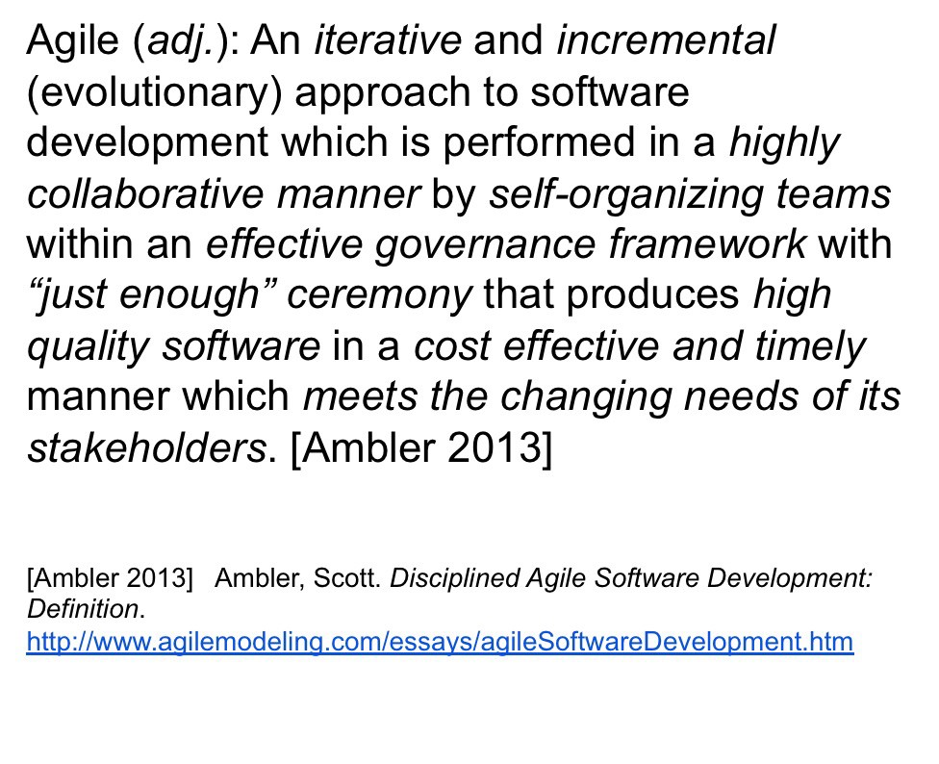

Figure 6. Agile Definition (Ambler 2013)

### When are we Done?

* Agile embraces the notion that we don’t understand at the beginning when we are going to get to the end.
* **Agile seeks permission to wait to decide until we know more.**
* Agile is a trajectory, not a destination.
* How do you do something to which you do not know the answer? That can be a daunting challenge. Picture building a custom home. You know what features you want, but you do not know what the layout looks like yet. But by continuously working with an architect, engineer, etc. you get to the final product.
* **Agile seeks to buy down risk.**
* Agile is an iterative process. Ms. Curran said a hybrid-agile approach often looks at requirements, then applies resources in a time box to accomplish those items, and finally looks back and determines what you did well.
* **Agile involves early and often reviews of what you are doing, and possibly resetting your goals as you go.**

### Agile Versus Waterfall Development

* Mentalities common to waterfall development have to change to implement Agile. Mr. Frederick said a waterfall acquisition tries to avoid change and sometimes punishes change. “You’re already committed to it,” he said. “You signed it. You can’t re-baseline. If you’re re-baselining it means you’ve got a problem.”
* **Agile teams have to be built for change.**
* Ms. Gill said enterprises need to look at changing acquisition systems. Otherwise, it is going to be very challenging to make agile work from an acquisition perspective. “Right now, we can give people a pile of requirements and they start chipping away at them in an agile manner,” she said, “but I don’t think that’s really solving our problems when it comes to the time it takes us to make a decision.
* **Agile acquisition can feed into agile software development.**
* Mr. Frederick cautioned against using “hybrid” or “agile” terms as a crutch. If hybrid means you set up in a waterfall and then move into agile, you are going to have problems because your contract and requirements are not set up that way. “What I’ve seen in some cases are two different flavors. Some start out saying they’re going to do agile development but they’re a waterfall acquisition, or they start out as a waterfall acquisition and they have development stability issues and then they say the only way we can recover is if we iterate and do small releases. Basically, they are using it as a way to recover.”
* **If you’re not truly adopting agile practices, you won’t get the benefit.**
* Dr. Levitt said the trick is to find out what is cultural and what is legal. Some risk aversion is cultural. “If you’re agile with your research all the way, then when you do get to your requirements you should have squeezed out a lot of uncertainty,” he said. “You can (focus on managing only) what you need to manage in your production phase, where things cost a lot more.”

## Culture Change

Enterprises will need to change their organizational culture in order to adopt agile principles and practices. Speakers emphasized smaller teams, greater communication, and better training as ways to affect culture change.

### Right-Sized Teams

* Agile teams should be smaller and self-empowered.
* **Mr. Hayes said the psychological safety needed in an organization to nurture self-empowered teams is fairly rare. A servant-leader approach is valuable.**
* Along with being self-empowered, teams need to be equally empowered. There need to be equal stakeholders at the table.
* **If only one entity has all the power, then scope, requirements, metrics, and verification will be slanted in their favor.**
* **Many times, whoever has the money controls the direction. But what is best for the end user?**
* Teams need to emphasize soft-side skills too. Ms. Gill said effective teams do the following:
* Celebrate internal milestones with the whole team
* When rewards are given, make it public so that team members understand why they or others are being recognized
* Conduct team-building exercises
* Conduct training
* Teams do not want to be inflexible, but they need to be disciplined in how they approach things.
* There has to be an agreement amongst the team and stakeholders on when to escalate disagreements. Both have to understand that nothing bad will happen to those who do not get their way.
* **It is not all about process. It is also about personalities.**

### Communication Breakdown

* When teams get too large, natural communication channels break down.
* Teams and stakeholder groups need to be comfortable communicating with each other. Organizations should not prevent groups from talking to each other for the sake of perceived independence.
* Communication needs to be early and often. Look to communicate and be transparent with sponsoring organizations.
* **Communication within and between teams is crucial.**
* Ms. Gill asked whether enterprises like the FAA should start requiring stakeholder engagement plans. It could help, but it would be one more thing on the AMS checklist.
* It is counterproductive to inundate people with new words that are not well defined, internally in the FAA or externally in text books. People need to understand relationships.
* Misconceptions of agile and traditional AMS processes can be barriers to communication and people on either side shut down. Ms. Curran said they do not need to be mutually exclusive.
* **How do we bring a common language together?**

### Training how you Implement

* Money has to be put into agile training, and training has to be done the way an organization wants to implement.
* **Defining the implementation plan may seem hard…like saying we have to figure everything out right now…but we don’t.**
* Train on the use of tools and techniques for utilizing agile underneath AMS processes.
* Train in change management, how to address new methodologies, and tools instead of generic training.
* **But just training people on tools is counterproductive. If you give people a hammer, they are going to want to hit things.**
* Valuable training does not just provide information, it provides perspective. People need to understand the “why” so they are equipped to address new issues with appropriate responses.
* **To impact culture, you want to impact behavior. Perspective feeds behavior.**

## Developing the Right Metrics

Organizations use what they believe are valid and validated metrics. But in an agile process, who owns the metrics? What supports them? If something changes along the way, can metrics change?

### Meaningful Metrics

* Metrics need to measure and be motivated by the benefit of the public or end user.
* Are institution- or enterprise-wide metrics antagonistic to the agile process? Sometimes institutional metrics can “silo” you in.
* **Problems can persist because teams make the process fit institutionalized metrics.**
* **Teams need to define success and find the right metrics to measure it.**
* Metrics have to be shared across different stakeholders.
* **Metrics have to mean the same thing for everybody.**
* **There has to be a common root cause analysis and ownership of the metrics.**
* Agile User Story: I need the system to do something in particular because I need this outcome. Why don’t we specify metrics that way?
* Capability-based assurance follows the risk and uncovers insights about how this capability is coming to maturity using an incremental approach.
* It is a matter of granularity, application, and some translation. If you decompose the need properly at each level, you will have certain characteristics at each level that you need to measure. “You give assurance to the overall system that you’ve contributed the right values, right measurements for each of the components,” Ms. Moore said. “As someone drills down they can look and see what the inputs are for each of those metrics. We know we don’t want collisions so we need certain separation standards in place; we need certain behaviors in place. What are those things that we measure?”
* It is important that everyone agree to a common goal. If new processes or new ways of development are instituted, there might be more appropriate metrics to distill down to the most important things.

### Validating Metrics

* You need good and valid metrics, and need to V&V your metrics to make sure they are meaningful. Even the metrics themselves have to be agile.
* **If the metrics are not valid, you can hit every mark and still fail.**
* Like measuring vital signs, a patient’s temperature can come back within an acceptable threshold, but he or she could still have high blood pressure.
* **You are measuring the wrong thing and using it the wrong way.**
* **They might be valid metrics, but applied incorrectly.**
* Michael Konyak highlighted that we must ask “how am I doing?” along the way as an agile method. We assume the metrics are the optimal measure because we built to them. How do we get away from that?
* In an agile process, who owns the metrics? Are we afraid to make changes or go to the boss to change requirements or adopt new metrics?

### Data-Driven Metrics

* Being able to test everything is impossible. One participant noted “We’re always testing samples. How do we use the metrics to inform how we’re going to take representative samples and then use those samples to make sure our metrics are correct?”
* **Does keeping raw data mean we can create more metrics?**
* The higher up you go in an enterprise, the more complex the data. We need the ability to really understand data. The way to get there is not by analyzing all data of what went wrong, but analyzing all the things that went right and characterizing what success is.
* Stakeholders have to presume good faith and have a common perspective. As soon as we lose those, metrics become counterproductive~~.~~
* **Sometimes, context matters even more than the raw data.**

# A breakdown of polling participants at the TIM.Interactive Sessions

As part of the TIM, Ms. Moore distributed three dynamic polls to those in attendance. The polls were inspired by the real-time conversation about challenges to Agile implementation. The purpose of polling was to collect from all participants their perspective on which agile characteristics should be embedded in its definition, the importance of agile to innovation, and the tools needed to successfully implement agile. See Figure 7 for a breakdown of poll participation.

Figure 7. Polling Results

# Summary and Conclusions

The 17th Annual V&V Summit TIM developed and informed ideas and values around the concept of Agile and what it means for the Test and Evaluation community. Defining a single way of doing Agile may not be possible—or even counterproductive—but establishing a set of principles and best practices provides a roadmap for future discussion and implementation. A majority of the discussion focused on various definitions, needed culture change, and building metrics for Agile. Speakers did an excellent job discussing the issues and engaging participants in discussion after each presentation, expanding on challenges, problem statements, best practices, useful methods, and lessons learned.

A key takeaway from the TIM and associated discussions at the V&V Summit is that Agile principles and practices can be difficult to define, and even harder to institute, but federal agencies, industry, and academia will increasingly adopt these principles and practices as more complex systems of systems and indeterminate systems are developed. These institutions and enterprises, in whole or in part, will have to adapt how they develop scope, requirements, and metrics when doing Agile. Most importantly, they will have to change their organizational culture, embracing increased communication and stakeholder engagement; creating smaller, more empowered teams; and conducting iterative product deliveries/releases. When done well, agile principles and practices will move decision points away from the “maximum point of ignorance” and narrow the cone of uncertainty as development continues.

The TIM built off the V&V Summit theme of “Enabling Dynamic Innovation with Rigor.” The summit explored the increasing need to be dynamic, flexible, and agile while maintaining a rigorous and disciplined approach to innovation. Mr. Frederick said innovation is always disruptive. It requires organizations to continually alter perspectives and methods. But healthy organizations are open to change and are adept at transforming business and technical strategies to be successful in a world with warp-speed technology.

# Appendix A — Acronym List

AI Artificial Intelligence

AJM-132 FAA Technical Management and Integration Team

AMS Acquisition Management System

ANG-B1 NAS Enterprise Architecture & Requirements Services Division

ANG-C Portfolio Management and Technology Development Office

ANG-E5A V&V Strategies and Practices Branch

ATC Air Traffic Control

CMMI Capability Maturity Model Integration

CMU/SEI Carnegie Mellon University Software Engineering Institute

DOT Department of Transportation

IV&V Independent Verification and Validation

NARTP National Aerospace Research and Technology Park

NAS National Airspace System

NASA National Aeronautics and Space Administration

RDT&E Research, Development, Test, and Evaluation

SME Subject Matter Expert

TBO Trajectory-Based Operations

TIM Technical Interchange Meeting

V&V Verification and Validation

WJHTC William J. Hughes Technical Center