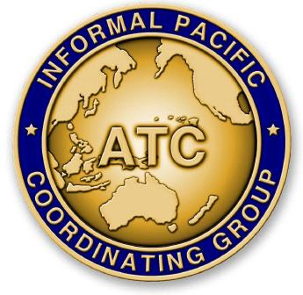
THE FORTY-EIGHTH MEETING OF THE
INFORMAL PACIFIC ATC COORDINATING GROUP
(IPACG/48)

FAA Northwest Mountain Regional Office - Des Moines, Washington
September 25 - 28, 2023

Agenda Item X: Category

Title of Paper

(Presented by Organization Name)
SUMMARY

- Introduction

- Discussion

- Action by the meeting
  - [State action requested] i.e. The meeting is requested to conduct/agree to/consider etc.

