Chapter 7

F-35A DEMONSTRATION MANEUVERS

***Section 7A---General Information***

**7.1. General.**  Maneuvers described in this document are used for training and flown in F-35A aerial demonstrations as the complete aerobatic demonstration profile. Aerobatic maneuvers are included in this grouping, and as such treat this profile as a standard Single Ship Tactical Demonstration profile. Abnormal procedures are written for each maneuver. If the entry conditions are not met for any maneuver, the pilot recovers to wings-level flight and transitions to the next maneuver. Certain maneuvers require the pilot to transmit airspeed and/or altitude to a safety observer.

The ground safety observer confirms parameters are good, monitors the demonstration pilot’s flight path, engine performance, and visually clears the demonstration area for traffic. The safety observer directs an abort when parameter limits are exceeded. Following each maneuver, and before clearing the show line to reposition for the next maneuver, the pilot ensures any descent has been stopped and the aircraft is in a level or climbing attitude with the flight path marker at or above the horizon. Limiter pulls are defined as stick full aft with the nose wheel steering button depressed to reach the CLAW limit (maximum AOA allowable).

Lift limit pulls are defined as pulls targeting but not exceeding 35° AOA. The vertical is defined as 80-90° nose high (NH) or 80-90° nose low (NL). The jet’s “waterline” is defined as where the nose of the aircraft is pointing. The abbreviation “A/R” for a parameter means “as required” and “N/A” means “not applicable”. A “staged show” is defined as an aerobatic box that is not geographically collocated with the airfield from which the jet is parked such as an over water show.

**7.1.1. Pyrotechnics (Pyro).**  Pyro is authorized for a Wall of Fire during the high speed pass. Only ICAS-approved personnel will be permitted to utilize pyro. The following maximum Net Explosive Weights (NEW) will be used (all NEWs in this instruction are TNT equivalent). For the Wall of Fire, the maximum NEW is dependent on the length of the wall. The maximum wall length is 2000 linear feet, and the maximum NEW is 20 pounds (spread out evenly). No more than 1 pound NEW will be used for each 100 linear feet of wall.

The following items will be briefed by the demonstration pilot and the shooter in charge (SIC), in person, prior to each performance: (1) Exact dimensions of the pyrotechnics area and the magnitude of explosives being used. (2) Aircraft/pyro de-confliction plan. (3) Demonstration profile and sequence of pyro (Wall of Fire). (4) Forecast wind and effects on pyro. (5) Communications plan. (6) Knock-it-off (KIO) procedures. (7) Fire hazards and fire department response plan. (8) FOD potential and effects.

**7.1.2. Flares.** The F-35 demonstration is authorized to use flares during performances at civilian airfields. Prior coordination and approval needs to be obtained from the airshow director, and standard airshow firefighting equipment and personnel need to be present during flare use for all demonstrations. For demonstrations at military airfields, flare use will be in accordance with local airfield regulations. If no regulations exist, usage will be in accordance with this guidance and in coordination with the airshow director. Flares will be expended during the performance so as to remain within the aerobatic box.

Training flares (MJU-61 or equivalent) will be used for all demonstrations. An individual qualified in arming, de-arming, and storage of flares will be present for all airshows where flares will be used. Flares are authorized for use during the High Alpha Half Cuban, High Speed Quick Climb, Inverted to Inverted, Pedal Turn, Square Loop, Slow Speed, and Tac Pitch maneuvers. Aircraft loaded with flares will not be used as a static display.

**7.2. Aircraft Configuration and Fuel Requirements.** The profile is flown in a standard configuration aircraft. Taking off with less than full fuel is authorized. Fuel load considerations include: divert requirements, cable availability, and density altitude. Typical fuel loads at engine start are: full fuel for a staged show, 14,500 pounds for a high show, and 12,000 pounds for a low show. All nose low maneuvers were designed to recover above 500’ AGL even in the event of a jet malfunction that relegates the aircraft to only 4Gs, 20° AOA, and MIL power. 4Gs and 20° AOA are available even with an FCS POWER LIMIT Caution.

**7.3. Airspeed and G Limits.** In accordance with aircraft operating limits (AOLs), not to exceed 0.95 M.

**7.4. Show line Restrictions.** The majority of the F-35A demonstration is flown on the 1,500-foot show line. Maneuvers not conforming to FAA Order 8900.1, Volume 3, Chapter 6, require approval via the FAA AFS-800 Maneuver Package approval process.

**7.5. Airspace and Runway Requirements.** Required airspace for the F-35A is 6,000 feet AGL and normally a five-mile radius from show center horizontally. The minimum dimensions of the aerobatic box are 3,000 feet wide, 6,000 feet long, and 6,000 feet AGL. If the FAA has waived a show line to closer than 1,500 feet, the aerobatic box may be less than 3,000 feet wide, provided there is at least 1,200 feet from either the primary or secondary show line. Minimum runway length and width is 8,000 feet x 75 feet (7,000 feet with compatible departure end arresting gear available).

**7.6. Weather Requirements.** Weather limits for the high show profile are a ceiling of at least 6K’ AGL (5K’ AGL if pedal turn rotation is reduced to 180° of turn), three miles ground and five miles in-flight visibility with a discernible horizon. Ceiling required for the low profile is 1,500 feet, three miles ground visibility and five miles inflight visibility with a discernible horizon. Cloud clearance for each maneuver is based on waived airspace (clear of clouds) and require adjustment if using VFR rules. Plan maneuvers to maintain VMC throughout the show sequence.

**7.7.  High Density Altitude Demonstrations.** The parameters in this profile are written for density altitudes ranging between 2,000’ - 7,999’ MSL.  For density altitudes 5,000 – 7,999’ MSL, the same parameters may be used, but adjust engine start fuel load such that the high show is started with 11,500 pounds of gas or less.  For 8,000’ MSL density altitudes or greater, adjust PARAMETER LIMITS in accordance with the following:  add 1,000’ and 25 KCAS to any number marked with an asterisk in the TARGET PARAMETERS and PARAMETER LIMITS section

**7.8. Demonstration Maneuver Profiles.**

7.8.1. High Show

7.8.1.1. Max Afterburner Takeoff To High-Alpha Half Cuban 8

7.8.1.2. Weapons Bay Doors Pass

7.8.1.3. High Speed To Max Climb

7.8.1.4. Min Radius Turn To High Alpha Loop

7.8.1.5. Dedication Pass

7.8.1.6. Inverted To Inverted Roll Flat Pass

7.8.1.7. Pedal Turn

7.8.1.8. Square Loop

7.8.1.9. Slow Speed To Split-S Reposition

7.8.1.10. Opposing Rolls Flat Pass

7.8.1.11. Tactical Pitch

7.8.2. Low Show

7.8.2.1. Max Afterburner Takeoff To Level Cuban 8

7.8.2.2. Weapons Bay Doors Pass

7.8.2.3. High Speed

7.8.2.4. Min Radius Turn

7.8.2.5. Dedication Pass

7.8.2.6. Inverted To Inverted Roll Flat Pass

7.8.2.7. Slow Speed

7.8.2.8. Opposing Rolls Flat Pass

7.8.2.9. Tactical Pitch

**7.9. Reposition Maneuvers.** Reposition maneuvers may be flown in either direction at any time during the flight sequence A/R. IAW FAA regulations, 90° of bank may be exceeded during repositions (if required). The standard repositioning maneuver is of a climbing check turn away from the show line, a 270° roll away from the crowd (i.e. roll left to turn right), and then a descending turn back toward the show line while setting up for the next maneuver.

***Section 7b----High Profile***

**7.10. Max Afterburner Takeoff To High-Alpha Half Cuban 8.**

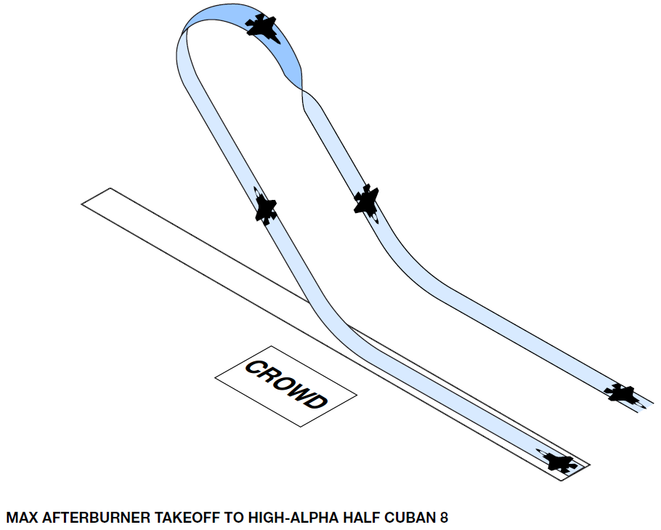

|  |  |  |  |  |  |
| --- | --- | --- | --- | --- | --- |
| TARGET PARAMETERS | | | | | |
| Altitude AGL | Airspeed KCAS | Power Setting | | Pull | |
| Entry N/A | *350 | MAX | | LIMITER | |
| Pull *2,000’ | 250 | MAX | | LIMITER | |
| Apex *4,000’ | 75 | MAX | | LIMITER | |
| Exit 500’ | A/R | A/R | | N/A | |
| PARAMETER LIMITS | | | | | |
| Altitude AGL | Airspeed KCAS  MIN/MAX | | Power Setting | | Pull |
| Entry Min N/A | 300 / N/A | | MAX | | N/A |
| Pull Min *1,700’ | 200 / N/A | | MAX | | N/A |
| Apex Min *3,500’ | 50 / N/A | | MAX | | N/A |
| Exit Min 400’ | 150 / N/A | | MAX | | N/A |

7.10.1. **Maneuver Description:** Select MAX AB at brake release and check engine conditions on the roll. Rotate at tech order speed and begin climb. Confirm gear is retracted and the light is extinguished in the gear handle. Accelerate in MAX AB with a positive rate of climb until passing show center and on the 1,500’ show line. At 350 KCAS execute a 5-7G pull to 60° NH. Hold 60° NH (waterline) until passing 2,000’ AGL then execute a limiter pull until 60-75° NL inverted while ensuring at least 150 KCAS passing the vertical NH. Neutralize pitch stick and roll towards the crowd with full lateral stick until upright. A slight on crowd heading crossing angle is normal which requires a slight bank away from the crowd during the recovery to arrive at show center on the 500’ line. Level off approaching show center at 500’ AGL using dive recovery rules without the perception of squaring the bottom of the recovery.

Approaching waterline on the horizon inverted, altitude and airspeed parameters are radioed to the safety observer. “On top 4.5, 75”, for example, correspond to 4,500’ AGL and 75 KCAS. With at least the PARAMETER LIMITS met, a response of “send it” is radioed to the pilot. Otherwise, “abort, abort, airspeed” or “abort, abort, altitude” is radioed to the pilot at which time the pilot aborts the maneuver.

For a staged show, enter the aerobatic box from behind and over the crowd in MAX AB (NTE .95M), perpendicular to the show line and at 1K’ AGL (or 1K’ above the highest obstacle within 2K’ laterally, where applicable). At show center, roll 270 degrees left or right and then execute an idle power 270 degree left or right turn to reposition for the initial maneuver. Following the staged entry maneuver and in the aerobatic box, planned/minimum altitude numbers become 300’/200’ AGL respectively for the entry to the follow on maneuver.

**7.10.2. Abnormal Procedure:** If airspeed decays to less than 150 KCAS during any vertical NH maneuver, recover by commanding full forward stick and maintaining MAX AB. If the AB fails to light before the pull to vertical is initiated, abort the maneuver. If the AB blows out during the vertical climb, abort the maneuver and execute a nose high recovery. If the AB blows out at any time inverted, abort and roll wings level.

**7.11. Weapons Bay Doors Pass.**

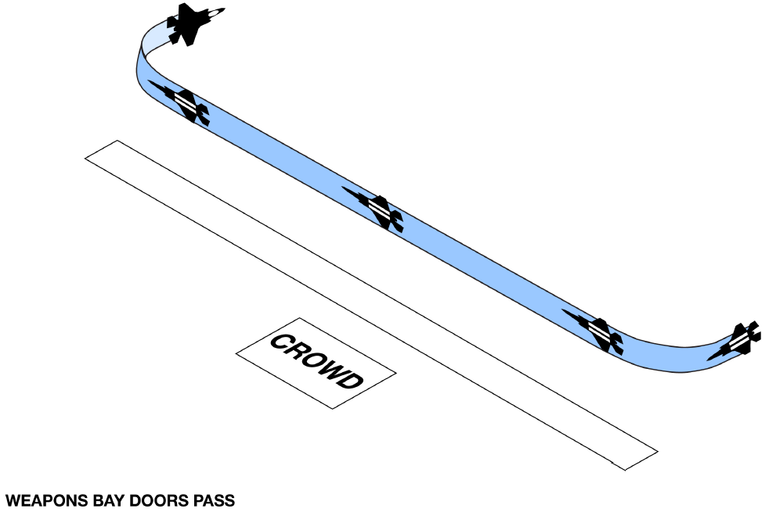

|  |  |  |  |  |  |
| --- | --- | --- | --- | --- | --- |
| TARGET PARAMETERS | | | | | |
| Altitude AGL | Airspeed KCAS | Power Setting | | Bank | |
| Entry 300’ | 300 | A/R | | 75 | |
| Exit 300’ | 300 | A/R | | 75 | |
| PARAMETER LIMITS | | | | | |
| Altitude AGL | Airspeed KCAS  MIN/MAX | | Power Setting | | Bank |
| Entry Min 200’ | 250 / 350 | | A/R | | 90 |
| Exit Min 200’ | 250 / 350 | | A/R | | 90 |

7.11.1. Maneuver **Description:** Enter at a 30-45° angle off in front of the show line and set and maintain 300 KCAS and 300’AGL. While wings level and approaching the 1500’ show line, open the weapons bay doors, then bank away from the crowd to maintain airspeed, altitude and apex no closer than the 500’ show line. Select MAX AB at show center then close the weapons bay doors approximately 3 seconds later and roll out. Use of top pedal to maintain altitude A/R is permitted.

Abort the pass if the doors don’t open normally and symmetrically.

**7.12. High Speed to Max Climb**.

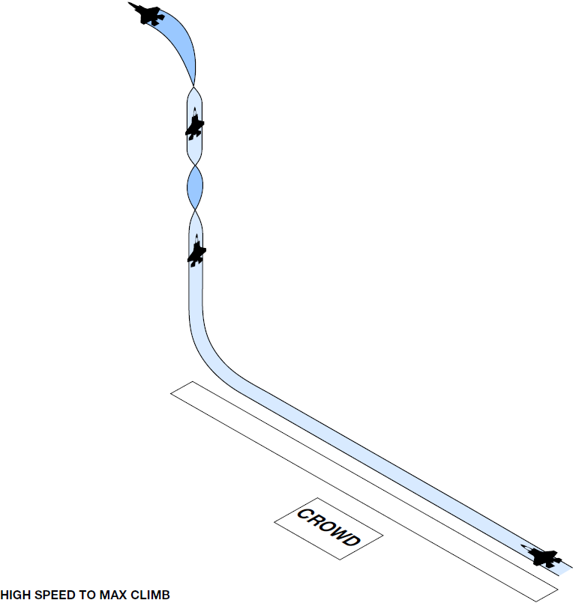

|  |  |  |  |  |  |
| --- | --- | --- | --- | --- | --- |
| TARGET PARAMETERS | | | | | |
| Altitude AGL | Mach | Power Setting | | Pull | |
| Entry 300’ | 0.94 | Min AB | | N/A | |
| Pull 300’ | 0.94 | MAX | | 7.5G | |
| Exit Ceiling– 3,500’  (TFR or WX, NLT 11,500’) | A/R | IDLE | | LIMITER | |
| PARAMETER LIMITS | | | | | |
| Altitude AGL | Mach  MIN/MAX | | Power Setting | | Pull |
| Entry Min 200’ | 0.8 / 0.95 | | A/R | | 9G |
| Pull Min 200’ | 0.8 / 0.95 | | A/R | | 9G |
| Exit Apex < Ceiling | N/A / N/A | | A/R | | 9G |

7.12.1. **Maneuver Description:** Enter on the 500’ show line at 300’ AGL, .94M, and MIN AB (as little as 70% ETR may be all that’s required to hold .94M at sea level density altitudes). Just prior to the end of the show line, execute a symmetric pull not to exceed 7.5Gs to the vertical NH while selecting MAX AB. Once vertical NH, unload, and execute a 360° aileron roll with pure lateral stick. NLT 3,500’ below the waivered airspace or weather ceiling but not later than 11,500’ AGL, roll 180° and begin a nose high recovery not to exceed 7.5Gs. Execute a spiraling descent using idle / speed brake A/R to set up for the next maneuver.

7.12.2. Abnormal **Procedures:** Discontinue AB if .95M is reached. If the AB blows out during the vertical climb, abort the maneuver and execute a nose high recovery.

**7.13. Min Radius Turn To High Alpha Loop.**

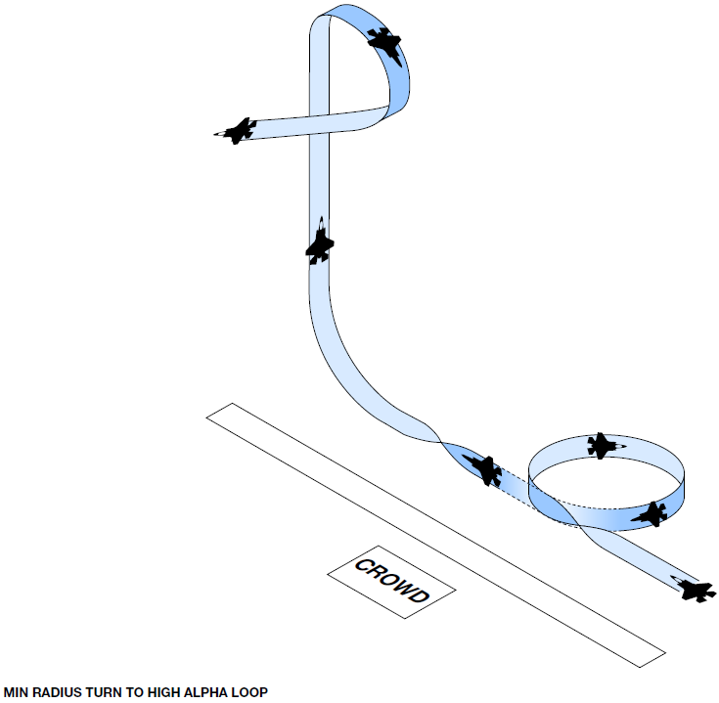

|  |  |  |  |  |  |
| --- | --- | --- | --- | --- | --- |
| TARGET PARAMETERS | | | | | |
| Altitude AGL | Airspeed KCAS | Power Setting | | Pull | |
| Entry 500’ | 430 | MAX | | 5-7G | |
| Exit 500’ | 350 | MAX | | 5-7G | |
| Pull 500’ | *350 | MAX | | 5-7G | |
| Vertical *3,200’ | 250 | MAX | | LIMITER | |
| Apex *4,700’ | 75 | MAX | | LIMITER | |
| Exit 500’ | A/R | A/R | | N/A | |
| PARAMETER LIMITS | | | | | |
| Altitude AGL | Airspeed KCAS  MIN/MAX | | Power Setting | | Pull |
| Entry Min 400’ | 350 / 450 | | A/R | | 7.5G |
| Exit Min 400’ | 250 / 450 | | MAX | | 7.5G |
| Pull Min 400’ | *325 / 450 | | MAX | | 7.5G |
| Vertical Min *2,700’ | 150 / N/A | | MAX | | LIMITER |
| Apex Min *4,000’ | 50 / 300 | | MAX | | LIMITER |
| Exit Min 400’ | 150 / N/A | | MAX | | N/A |

7.13.1. Maneuver **Description:** Enter on the 500’ show line at 500’ AGL and 430 KCAS. Select MAX AB and pull to maintain 400-430 KCAS through the first 180° of turn with a 1.5° NH flight path marker (FPM) to make the turn appear level. Tighten turn for second 180° to end on the 1500’ show line utilizing a 1.5° NL FPM. Approaching show center, unload and roll wings level, accelerate A/R to 350KCAS and initiate a 5-7G pull to the vertical NH. At 3.2K’ AGL and at least 150 KCAS, execute a limiter pull through to wings level, upright, and 30-45° NL. Neutralize pitch stick to break the alpha, regain at least 150 KCAS, and fly a lift limit recovery A/R.

On top challenge/response required IAW paragraph 8A.

7.13.2. **Abnormal Procedures:** Abort the maneuver if the AB blows out at any time. Throttle modulate if the aircraft accelerates at 7.5 Gs. If the aircraft descends below 400’ AGL during the min radius turn or the airspeed decays below 250 KCAS, abort the maneuver by climbing and clearing the show line with a MAX AB, lift limit pull. Abort the high alpha loop into a nose high recovery (stick full forward) if airspeed decays to below 150 KCAS prior to reaching 3.2K’ AGL in the vertical.

**7.14. Dedication Pass.**

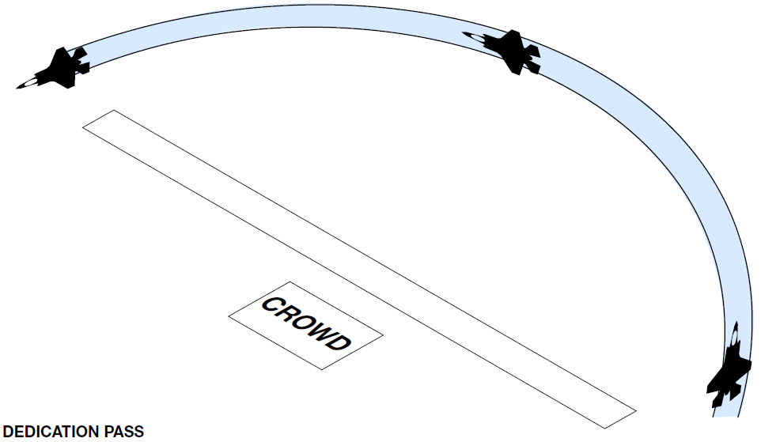

|  |  |  |  |  |  |
| --- | --- | --- | --- | --- | --- |
| TARGET PARAMETERS | | | | | |
| Altitude AGL | Mach | Power Setting | | Pull | |
| Entry 300’ | 0.65-0.94 | MAX | | A/R | |
| Exit 300’ | 0.65-0.94 | MAX | | A/R | |
| PARAMETER LIMITS | | | | | |
| Altitude AGL | Airspeed / Mach  MIN/MAX | | Power Setting | | Pull |
| Entry Min 200’ | 0.5 / 0.95 | | A/R | | 7.5G |
| Exit Min 200’ | 0.5 / 0.95 | | A/R | | 7.5G |

7.14.1. **Maneuver Description:** Enter from behind the crowd, approximately 2-3 miles from show center, and on a 30-45° cut. Maintain beyond 500’ horizontally from the crowd at all times. Upon reaching a corner marker and at 300’ AGL, roll the aircraft into a level arcing pass using 75° of bank. Select MAX AB until past the show line or until .94M is anticipated (then set MIN AB). Use of top pedal to maintain altitude A/R is permitted.

7.14.2. **Abnormal Procedures:** Discontinue AB if .95M is reached.

**7.15. Inverted To Inverted Roll Flat Pass.**

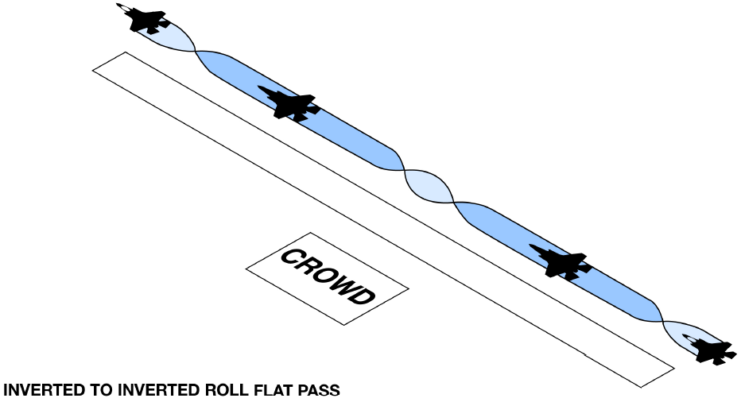

|  |  |  |  |  |  |
| --- | --- | --- | --- | --- | --- |
| TARGET PARAMETERS | | | | | |
| Altitude AGL | Airspeed KCAS | Power Setting | | Pull | |
| Entry 300’ | 400 | A/R | | A/R | |
| Exit 500’ | 400 | A/R | | A/R | |
| PARAMETER LIMITS | | | | | |
| Altitude AGL | Airspeed KCAS  MIN/MAX | | Power Setting | | Pull |
| Entry Min 200’ | 325 / 475 | | MIL | | A/R |
| Exit Min 200’ | 325 / 475 | | MIL | | NTE 5° NL |

7.15.1. **Maneuver Description:** Enter on the 1500’ show line at 300’ AGL and 400 KCAS. Approaching the aerobatic box, execute an energy sustaining pull to 5-10° NH FPM and then neutralize the stick. Roll inverted away from the crowd with pure lateral stick. Bunt to -1G to maintain approximately 5° NH FPM flight for 3-5 seconds. Approaching show center, execute a pure lateral stick 360° roll until once again wings level inverted. Bunt to -1G to maintain level flight for another 3-5 seconds or until approaching the end of the aerobatic box. Roll with pure lateral stick back upright, past wings level, with angle of bank as desired to reposition away from the show line. Alternate the direction of each roll during this maneuver. Use caution for the “push-pull”, negative to positive G physiological effect.

7.15.2. **Abnormal Procedures:** Abort the maneuver, roll wings level, and perform a lift limit pull to clear the show line if airspeed decays below 325 KCAS, or if the aircraft descends below 400’ AGL at more than 5° NL.

**7.16. Pedal Turn.**

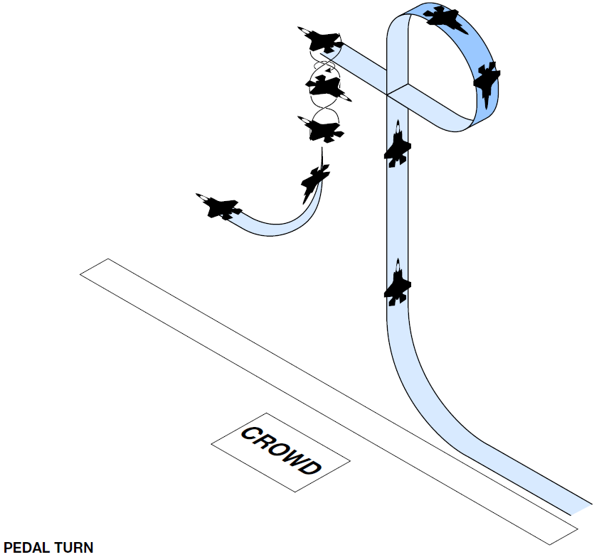

|  |  |  |  |  |  |
| --- | --- | --- | --- | --- | --- |
| TARGET PARAMETERS | | | | | |
| Altitude AGL | Airspeed KCAS | Power Setting | | Pull | |
| Entry 1000’ | *420 | MAX | | 5-7G | |
| Vertical NH *4,000’ | 325 | MAX | | LIMITER | |
| Recovery *2,500’ | N/A | MAX | | A/R | |
| PARAMETER LIMITS | | | | | |
| Altitude AGL | Airspeed KCAS  MIN/MAX | | Power Setting | | Pull |
| Entry min N/A | *400 / 475 | | MAX | | 7.5G |
| Vertical NH min *3,500’ | 150 / N/A | | MAX | | LIMITER |
| Recovery min *2,250’ | 150 / N/A | | MAX | | LIFT LIMIT |

7.16.1. **Maneuver Description:** Enter on the 3,000’ show line at 500’ AGL and 420 KCAS. Select MAX AB approaching show center and execute a 5-7G pull to the vertical NH. Passing 4K’ AGL, perform a limiter pull. With the nose through the vertical NL, maintain full aft stick, while commanding full lateral stick and full pedal in the direction of the crowd. Hold full controls for 360° of turn, but initiate recovery no later than 2.5K’ AGL by commanding neutral stick and neutral pedal to arrest the pedal turn. With rotation stopped, execute a lift limit pull A/R to complete the recovery.

WX Flex: A 6K’ AGL ceiling is required for the full maneuver as written. For ceilings < 6K’ AGL, but at or above the high show minimum of 5K’ AGL, modify the maneuver as follows:

Execute the entry pull at 400 KCAS (380 KCAS min) and the vertical NH pull at 2,750’ AGL (2K’ AGL min). Complete just 180° of pedal turn into the crowd.

At the “On top” radio call from the pilot, a radio response of “[degrees of turn]” is made by the safety observer IAW the brief for the ceiling conditions. For example, with a 5.2K’ AGL ceiling, an “On top 4.9, 95” call, would be responded to with “180”. Additionally, an “abort, abort” call should be made from the safety observer if the stated degrees of rotation is exceeded.

7.16.2. **Abnormal Procedures:** If the AB does not light, do not initiate the entry pull up. If the AB blows out in the vertical, abort the maneuver and execute a nose high recovery. No matter the orientation, a 35° AOA recovery will be initiated at 2.5K’ AGL to arrest sink rate and clear the show line. Should the AB fail during the pedal turn, recover the aircraft to level flight.

**7.17. Square Loop.**

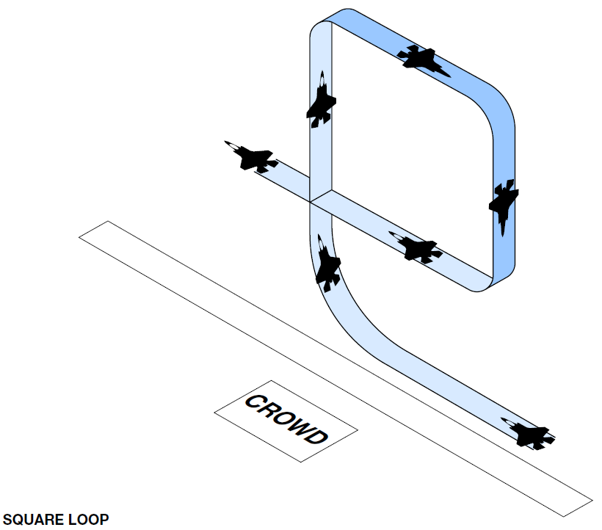

|  |  |  |  |  |  |
| --- | --- | --- | --- | --- | --- |
| TARGET PARAMETERS | | | | | |
| Altitude AGL | Airspeed KCAS | Power Setting | | Pull | |
| Entry 500’ | *370 | MAX | | 5-7G | |
| 2nd Pull *3,200’ | 250 | MAX | | LIMITER | |
| 3rd Pull *4,800’ | 175 | MAX | | LIMITER | |
| Recovery *3,250’ | 235 | MAX | | LIMITER | |
| Exit 1000’ | A/R | MAX | | LIFT LIMIT | |
| PARAMETER LIMITS | | | | | |
| Altitude AGL | Airspeed KCAS  MIN/MAX | | Power Setting | | Pull |
| Entry 400’ | *325 / 420 | | MAX | | 7.5G |
| 2nd Pull *2,700’ | 150 / N/A | | MAX | | LIMITER |
| 3rd Pull *3,700’ | 100 / 250 | | MAX | | LIMITER |
| Recovery *3,000’ | 150 / 250 | | MAX | | LIMITER |
| Exit 400’ | 150 / N/A | | MAX | | LIFT LIMIT |

7.17.1. **Maneuver Description:** Enter on the 1,500’ show line at 500’ AGL and 370 KCAS. Select MAX AB approaching show center and execute a 5-7G pull to the vertical NH. Maintain vertical climb until 3.2K’ AGL. Execute a limiter pull and set min-AB to bring the aircraft nose inverted. Gradually push full forward stick as the FPM approaches the horizon and track inverted along the 1,500’ show line for 3-5 seconds.

A slight descent is normal even with the stick full forward. Do not extend the inverted flight in attempts to correct show center positioning and use caution for the “push-pull”, negative to positive G physiological effect. Above 3.7K’ AGL and less than 250 KCAS, execute a limiter pull to 90° NL. Aggressively push to ensure nose tracks in the vertical NL. NLT 3,250’ AGL or 250KCAS, whichever occurs first, execute a limiter pull in MAX AB to return the waterline to the horizon, then continue with a lift limit pull to complete the recovery. On top challenge/response required IAW paragraph 8A **just prior** to the 3rd pull.

7.17.2. **Abnormal Procedures:** If the AB fails to light before the pull to vertical is initiated, abort the maneuver. If the AB blows out during the vertical climb, or the jet decelerates below 150 KCAS prior to 3K’ AGL, abort the maneuver and execute a nose high recovery. If the AB blows out at any time inverted, the altitude falls to below 3.7K’ AGL, or the airspeed is outside of the 100-250 KCAS window, abort and roll wings level. Once 90° NL, do not delay any recovery below 3K’ AGL and utilize a lift limit pull to minimize altitude loss in the recovery if required.

**7.18. Slow Speed To Split-S Reposition.**

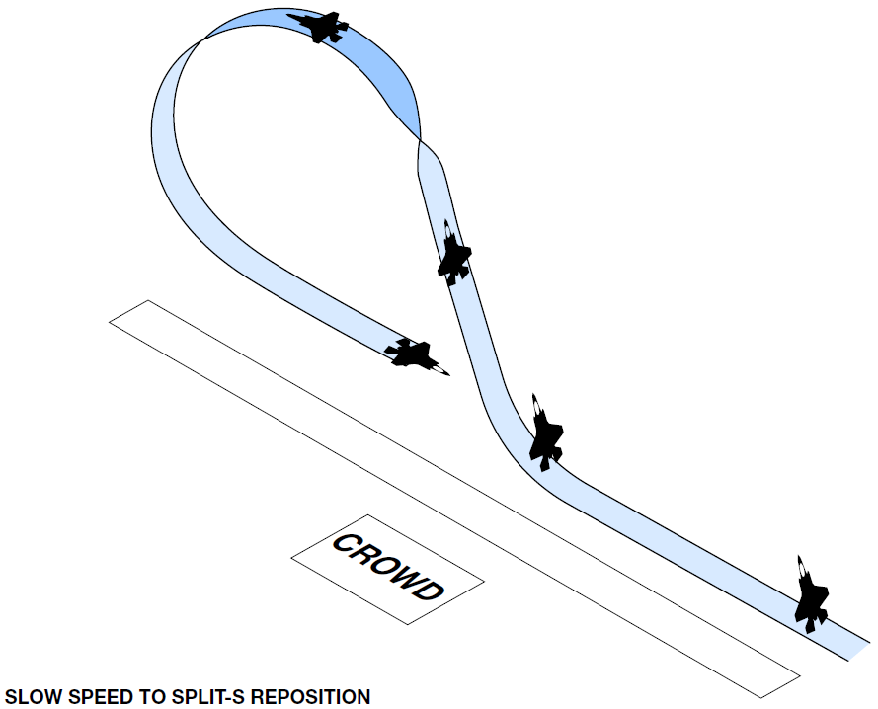

|  |  |  |  |  |  |
| --- | --- | --- | --- | --- | --- |
| TARGET PARAMETERS | | | | | |
| Altitude AGL | AOA | Power Setting | | Pull | |
| Entry 1,000’ | 30-35 | A/R | | A/R | |
| Exit 500’ | 27-32 | A/R | | A/R | |
| PARAMETER LIMITS | | | | | |
| Altitude AGL | AOA MIN/MAX | | Power Setting | | Pull |
| Entry Min 400’ | N/A / 40 | | A/R | | A/R |
| Exit Min 400’ | N/A / 40 | | A/R | | A/R |

**Split-S Reposition Parameters**

|  |  |  |  |
| --- | --- | --- | --- |
| TARGET PARAMETERS | | | |
| Altitude AGL | Airspeed KCAS | Power Setting | Pull |
| Inverted *4,000’ | 150 | MAX | LIFT LIMIT |
| Exit 300’ | A/R | MAX | A/R |
| PARAMETER LIMITS | | | |
| Altitude AGL | Airspeed KCAS  MIN/MAX | Power Setting | Pull |
| Inverted Min *3,500’ | 100 / 300 | A/R | LIMITER |
| Exit Min 200’ | 150 / .94M | A/R | LIFT LIMIT |

7.18.1. **Maneuver Description:** Enter the maneuver at 1K’ AGL, 30-35° AOA, 0.6NM from show center, on the 500’ show line, and ETR to maintain a -1K to -1.5K feet per minute descent. Use ETR to arrest descent rate NLT show center and stabilize the aircraft at 500’ AGL. Airspeed in level flight is approximately 110-120 KCAS. At the safety observers “show center” call, which should occur roughly two-thirds of the way down the show line, select MAX AB and allow the aircraft to climb and gradually accelerate to and maintain 175 KCAS. This results in a climb angle of roughly 50-55° NH on the waterline. While climbing, check approximately 5° away from the crowd with lateral stick to move to the 1,500’ show line. Passing 3,500’ AGL roll inverted (full lateral stick toward crowd) and execute a lift limit pull. Do not exceed 250 KCAS until the nose is through 90° NL. Level off using dive recovery rules without the perception of squaring the bottom of the recovery. G should build slowly and linearly up to but not exceed 4Gs in the recovery.

On top challenge/response required IAW paragraph 8A. Additionally, “check 5 L/R” phraseology should be used by the safety observer to correct show line errors during the slow speed pass and subsequent climb to the Split-S.

7.18.2. **Abnormal Procedures:** If 40° AOA is exceeded or if the aircraft descends below 400’ AGL, select MAX AB, terminate the maneuver, and execute a lift limit pull A/R. If the AB blows out or if the inverted pull through window isn’t achieved, abort the maneuver, roll to the nearest horizon and clear the show line with a lift limit pull. If the aircraft is not on the extended show line for the next maneuver, make a correction after the nose is through at least the vertical NL.

**7.19. Opposing Rolls Flat Pass.**

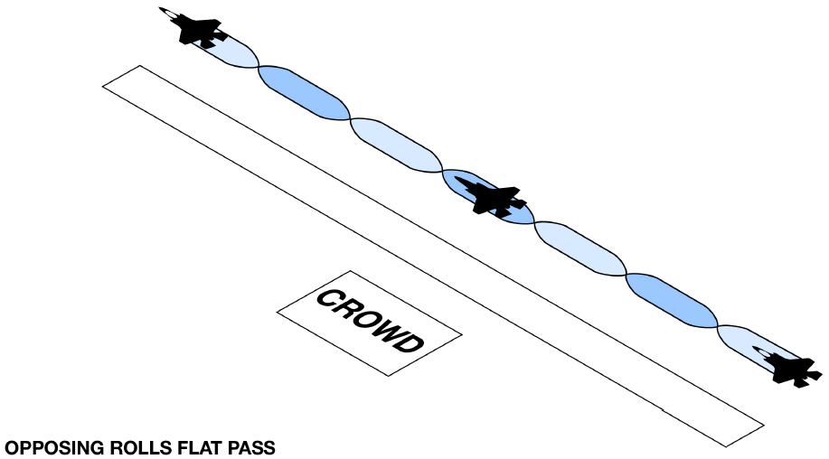

|  |  |  |  |  |  |
| --- | --- | --- | --- | --- | --- |
| TARGET PARAMETERS | | | | | |
| Altitude AGL | Airspeed KCAS | Power Setting | | Pull | |
| Entry 300’ | 400 | A/R | | A/R | |
| Exit 500’ | 400 | A/R | | A/R | |
| PARAMETER LIMITS | | | | | |
| Altitude AGL | Airspeed KCAS  MIN/MAX | | Power Setting | | Pull |
| Entry Min 200’ | 325 / 475 | | MIL | | A/R |
| Exit Min 200’ | 325 / 475 | | MIL | | NTE 5° NL |

7.19.1. **Maneuver Description:** Enter on the 1500’ show line at 300’ AGL and 400 KCAS. Approaching the aerobatic box, execute an energy sustaining pull to 5-10° NH FPM and then neutralize the stick. Roll 360° into the crowd with pure lateral stick, pause, and repeat two more times alternating roll direction each time.

7.19.2. **Abnormal Procedures:** Abort the maneuver, roll wings level, and perform a lift limit pull to clear the show line if airspeed decays below 325 KCAS, or if the aircraft descends below 400’ AGL at more than 5° NL.

**7.20. Tactical Pitch.**

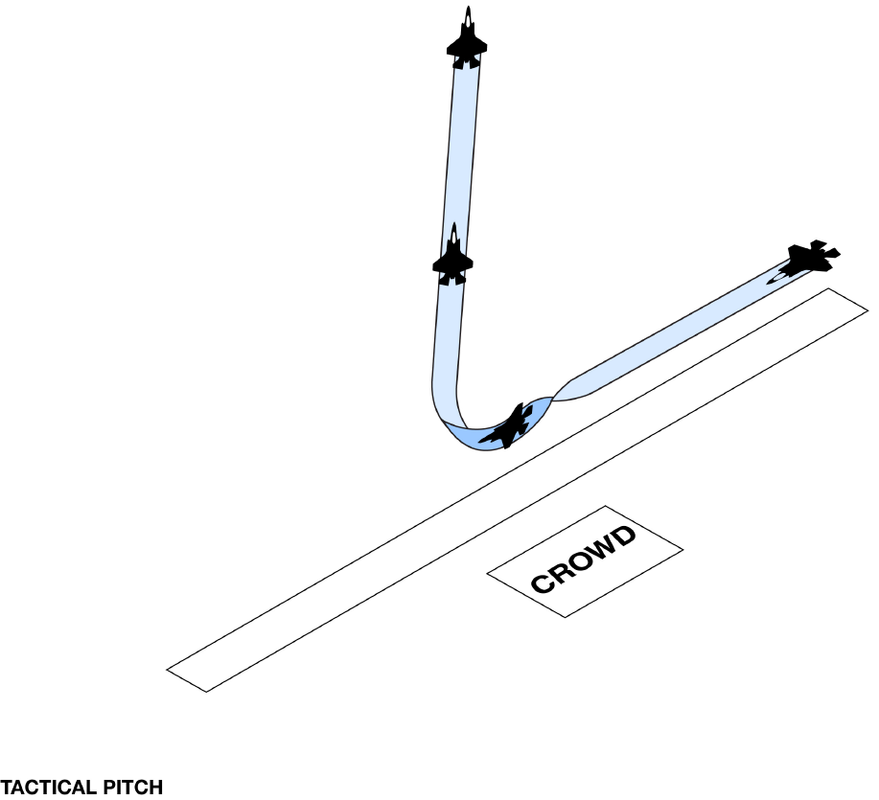

|  |  |  |  |  |  |
| --- | --- | --- | --- | --- | --- |
| TARGET PARAMETERS | | | | | |
| Altitude AGL | Airspeed KCAS | Power Setting | | Pull | |
| Entry 300’ | 320 | MAX | | LIMITER | |
| NH RCVY 2,500’ | 150 | MAX | | A/R | |
| PARAMETER LIMITS | | | | | |
| Altitude AGL | Airspeed KCAS  MIN/MAX | | Power Setting | | Pull |
| Entry Min 200’ | 275 / 375 | | MAX | | N/A |
| NH RCVY Min 1,000’ | 125 / N/A | | MAX | | N/A |

7.20.1. **Maneuver Description:** Enter on the 500’ show line, 300’ AGL, and 320 KCAS. Select MAX AB, set 45° of bank, and perform a limiter pull for 120-135° of turn. Roll out using full lateral stick and then (high show only) smoothly pull to set approximately 75° of pitch on the waterline demonstrating the jet’s ability to climb out after an aggressive change in nose position. Terminate the maneuver with a nose high recovery.

7.20.2. **Abnormal Procedures:** If the airspeed decays below 125 KCAS in the NH climb, abort the maneuver by rolling wings level and commanding full forward stick (A/R) until less than 30° of pitch and then accelerate away from the show line. The entire maneuver can be executed in MIL power if required.

***Section 7C----Low Profile***

**7.21. Max Afterburner Takeoff to Level Cuban 8.**

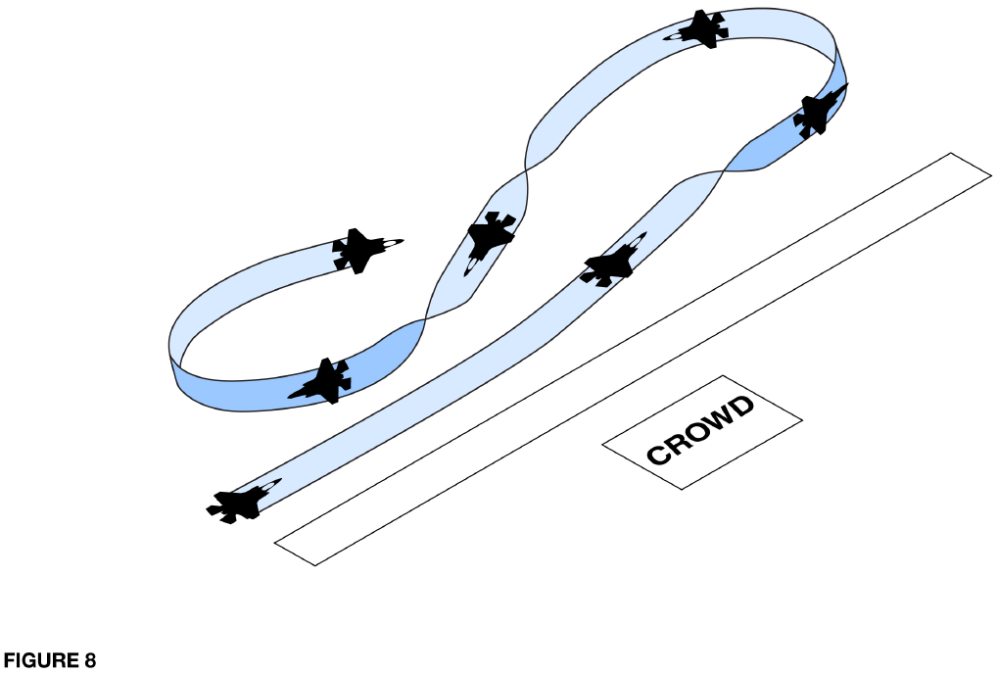

|  |  |  |  |  |  |
| --- | --- | --- | --- | --- | --- |
| TARGET PARAMETERS | | | | | |
| Altitude AGL | Airspeed KCAS | Power Setting | | Pull | |
| Entry NA | 325 | MAX | | A/R | |
| Turn Reversals 500’ | 430 | MAX | | A/R | |
| Exit 500’ | 430 | MAX | | A/R | |
| PARAMETER LIMITS | | | | | |
| Altitude AGL | Airspeed KCAS  MIN/MAX | | Power Setting | | Pull |
| Entry NA | 250 / 475 | | MAX | | 7.5G |
| Turn Reversals 400’ | 250 / 475 | | MAX | | 7.5G |
| Exit 400’ | 250 / 475 | | MAX | | 7.5G |

7.21.1. **Maneuver Description:** Select MAX AB at brake release and check engine conditions on the roll. Confirm gear is retracted and the light is extinguished in the gear handle. Accelerate in MAX AB with a positive rate of climb until approaching the end of the aerobatic box and on the 500’ show line (1,500’ show line is okay if that’s where the runway is).

At a minimum of 325 KCAS (430 KCAS optimal) set 75° of bank and begin an energy sustaining turn away from the crowd. Once past the 1,500’ show line, bank angle can be increased to capture and maintain 500’ AGL. After 225° of turn (pull A/R to end on a 45 degree cut to the show line), unload and drive towards show center and join the ground track of the 1,500’ show line. Approaching the end of the aerobatic box and on the 1,500’ show line, perform a second, level, 225° turn to again end on a 45 degree cut to the show line. Complete the maneuver by turning to once again join the 1,500’ show line heading in the same direction as takeoff.

Staged show entry IAW paragraph 8A.

7.21.2. **Abnormal Procedures:** Abort the maneuver, roll wings level, and perform a lift limit pull to clear the show line if airspeed decays below 250 KCAS or aircraft descends below 400’ AGL.

**7.22. Weapons Bay Doors Pass.**

**7.23. High Speed.**

**7.24. Min Radius Turn.**

**7.25. Dedication Pass.**

**7.26. Inverted To Inverted Roll Flat Pass.**

**7.27. Slow Speed.**

**7.28. Opposing Rolls Flat Pass.**

**7.29. Tactical Pitch.**