UNAPPROVED PARTS NOTIFICATION  SUSPECTED UNAPPROVED PARTS PROGRAM OFFICE, AVS-20  13873 PARK CENTER ROAD, SUITE 165  HERNDON, VA 20171 |  | U.S. Department  of Transportation  Federal Aviation  Administration
UPNs are posted on the Internet at http://www.faa.gov/aircraft/safety/programs/sups/upn/ |  | No. 2004-00036  September 28, 2005
Mailed by: FAA, AIR-140, P.O. Box 26460, Oklahoma City, OK 73125

AFFECTED PARTS
Cargo unit load devices (ULDs) contoured to fit Boeing 707, 727, and DC-8 aircraft.

PURPOSE
The purpose of this notification is to advise all aircraft owners, operators, manufacturers, maintenance organizations, and parts distributors regarding ULDs misrepresented as having been produced under Federal Aviation Administration (FAA) Technical Standard Order (TSO) C90 and in compliance with National Aerospace Standard (NAS) 3610.

BACKGROUND
Information received during an FAA suspected unapproved parts investigation revealed the sale of unapproved ULDs with falsified data tags. The ULDs originated from IDF, S.A., a company located in Guatemala, and were distributed by Apparel Transportation, Inc., a subsidiary of Crowley Logistics, Inc (Crowley). Crowley is located in Jacksonville, FL 32203-2110. The source of the falsified data tags is unknown. Of the 202 ULDs discovered through the investigation, all but 19 have been located.

The falsified data tags identified the ULDs as manufactured by C&J Enterprises, 4086 Limaburg Road, Hebron, “JY” (rather than “KY”) 41048 and identified the part number as “CJE” (rather than “CJE-90”). Some tags also lacked the date of manufacture and burn rate information that TSO-C90 and NAS 3610 require to be displayed. (See Figures 1 and 2 for falsified and authentic data tags.)

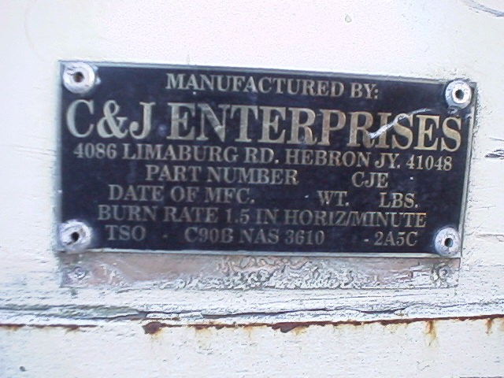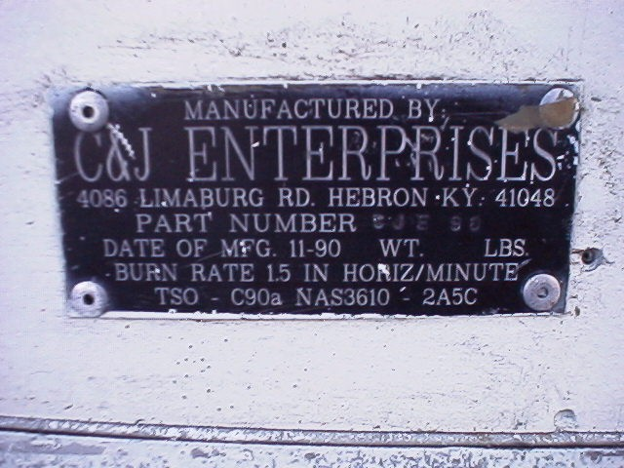

Figure 1. Falsified Data Tag Figure 2. Authentic Data Tag

Additionally, ULDs that have been manufactured to meet TSO-C90 and NAS 3610 specifications have the fiberglass shell attached to the aluminum pallet with an aluminum shell assembly attaching strip. Use of aluminum strips eliminates the possibility of dissimilar metal corrosion between the attaching assembly strip and the pallet. Many of the unapproved ULDs revealed steel shell attaching strips that caused extensive corrosion on the containers.

RECOMMENDATIONS
Regulations require that type-certificated products conform to their type design. Aircraft owners, operators, maintenance organizations, and parts distributors should inspect their aircraft, aircraft records, and/or part inventories for fiberglass ULDs that have been sold by IDF, S.A. or distributed by Apparel Transportation, Inc. Referenced ULDs installed on aircraft should be inspected for conformity to type design. If any are found in existing stock, it is recommended that the ULD be quarantined to prevent installation until a determination can be made regarding each ULD’s eligibility for installation.

FURTHER INFORMATION
Further information concerning this investigation may be obtained from the FAA International Field Office (IFO) given below. The FAA would appreciate any information concerning the discovery of the above-referenced ULDs from any source, the means used to identify the source, and the actions taken to remove the containers from service.

This notice originated from the FAA Miami IFO, 8600 NW 36th Street, Miami, FL 33166, telephone (305) 716-3500, fax (305) 716-3515; and was published through the FAA Suspected Unapproved Parts Program Office, AVS-20, telephone (703) 668-3720, fax (703) 481-3002.

