CIP/PREAPPLICATION DATA SHEET

AIRPORT: EXAMPLE | LOCAL PRIORITY:________ | UPDATED: December, 1994
WORK ITEM: East Apron Reconstruction

SKETCH:
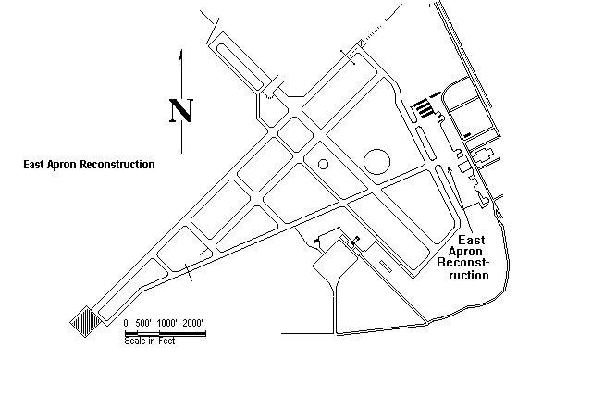
JUSTIFICATION:
The East Ramp supports all general aviation (GA), business and Part 135 operators. The existing asphalt is deteriorating. It is severely cracked and weathered and the PCI index of 40. The entire apron needs major reconstruction.

SPONSOR SIGNATURE:___________________________________DATE:_______________

COST ESTIMATE: | Item (Excavation, Paving, etc.)

ADMINISTRATION: | $ 500 | 1 Construction | $ 824,500 | 4: | $
ENGINEERING: | $ 100,000 | 2: | $ | 5: | $
INSPECTION: | $ 750,000 | 3: | $ | TOTAL: | $1,000.000
ADO USE:
PREAPP  NO:_________ | GRANT  NO:__________ | NPIAS  CODE:________ |  | WORK  CODE:________ | FAA  PRIOR:_______ | FED $_________

CIP/PREAPPLICATION DATA SHEET

AIRPORT: |  | LOCAL PRIORITY: |  | UPDATED:
WORK ITEM:
SKETCH:

JUSTIFICATION:

SPONSOR SIGNATURE:_______________________________________________DATE:_______________

COST ESTIMATE: | Item (Excavation, Paving, etc.)

ADMINISTRATION: | $ |  | 1: |  | $ |  | 4: |  | $
ENGINEERING: | $ |  | 2: |  | $ |  | 5: |  | $
INSPECTION: | $ |  | 3: |  | $ |  | TOTAL: |  | $
ADO USE:
PREAPP  NO: | GRANT  NO: | NPIAS  CODE: |  | WORK  CODE: | FAA  PRIOR: | FED $

CIP/PREAPPLICATION DATA SHEET

AIRPORT: |  | LOCAL PRIORITY: |  | UPDATED:
WORK ITEM:
SKETCH:

JUSTIFICATION:

SPONSOR SIGNATURE:_______________________________________________DATE:_______________

COST ESTIMATE: | Item (Excavation, Paving, etc.)

ADMINISTRATION: | $ |  | 1: |  | $ |  | 4: |  | $
ENGINEERING: | $ |  | 2: |  | $ |  | 5: |  | $
INSPECTION: | $ |  | 3: |  | $ |  | TOTAL: |  | $
ADO USE:
PREAPP  NO: | GRANT  NO: | NPIAS  CODE: |  | WORK  CODE: | FAA  PRIOR: | FED $

CIP/PREAPPLICATION DATA SHEET

AIRPORT: |  | LOCAL PRIORITY: |  | UPDATED:
WORK ITEM:
SKETCH:

JUSTIFICATION:

SPONSOR SIGNATURE:_______________________________________________DATE:_______________

COST ESTIMATE: | Item (Excavation, Paving, etc.)

ADMINISTRATION: | $ |  | 1: |  | $ |  | 4: |  | $
ENGINEERING: | $ |  | 2: |  | $ |  | 5: |  | $
INSPECTION: | $ |  | 3: |  | $ |  | TOTAL: |  | $
ADO USE:
PREAPP  NO: | GRANT  NO: | NPIAS  CODE: |  | WORK  CODE: | FAA  PRIOR: | FED $

CIP/PREAPPLICATION DATA SHEET

AIRPORT: |  | LOCAL PRIORITY: |  | UPDATED:
WORK ITEM:
SKETCH:

JUSTIFICATION:

SPONSOR SIGNATURE:_______________________________________________DATE:_______________

COST ESTIMATE: | Item (Excavation, Paving, etc.)

ADMINISTRATION: | $ |  | 1: |  | $ |  | 4: |  | $
ENGINEERING: | $ |  | 2: |  | $ |  | 5: |  | $
INSPECTION: | $ |  | 3: |  | $ |  | TOTAL: |  | $
ADO USE:
PREAPP  NO: | GRANT  NO: | NPIAS  CODE: |  | WORK  CODE: | FAA  PRIOR: | FED $

