**ASCENT COE Notice of Funding Opportunity (COE-2016-42)**

**Project Title:** Acoustical Model of Mach Cut-off Flight

**FAA Project Manager:** Bao Tong ([bao.tong@FAA.gov](mailto:bao.tong@FAA.gov))

**Nominal Funding Level:** $150,000

**Period of Performance:** 18 months

**Deadline for response to this NFO:** April 15, 2016

**Project Description**:

A major effort by the International Civil Aviation Organization (ICAO) Committee on Aviation for Environmental Protection (CAEP) Working Group 1 (WG1) on Noise technical Issues, is to develop future noise standards for supersonic aircraft within the scope of current policy. Several aviation manufacturers, including Gulfstream Aerospace, Lockheed Martin, and Boeing, are tailoring their aircraft designs for emission of a low sonic boom noise signature. This “passive” design approach is aligned with the WG1 standards development role and the substantial research invested into low-boom aircraft design that has been reported over the past decade.

More recently, Aerion Corporation, a supersonic jet designer, has announced plans to pursue an alternative approach. This manufacturer is proposing an aircraft that will cruise at speeds between Mach 1.4 and 1.6—over water, claiming that the sonic boom would not be problematic there. Where supersonic speed is prohibited, the jet would cruise at speeds up to Mach 0.99. Alternatively, to avoid booming observers at the surface, the designer proposes to cruise at speeds up to Mach 1.2 while operating within a phenomenon called “Mach cut-off.” Aerion has announced plans for a Mach cut-off capable aircraft and proposes a first flight in 2021 with projected certification for 2023.

Mach cut-off refers to certain operational conditions where the sonic boom does not reach the ground (e.g. flight at Mach numbers <1.15 and an elevation >35,000 feet in the standard atmosphere as shown in the flight envelope provided[1]). In the upward refracting atmosphere, shockwaves emanating from the aircraft are bent upward, away from the ground’s surface due to variations in the sound speed profile, as depicted in the ray-shock diagram[2].

Although the phenomenon of Mach cut-off has been studied in the past, the potential magnitude of acoustic impact on the ground is not well understood. Due to dynamically changing flight paths, local atmospheric conditions, and ground topography, the risk of unintentionally emitting a conventional sonic boom and/or other noise exists. Residual noise emissions have been recorded for intended Mach cut-off operations, but additional data is needed to further validate the theory.

In order to support the understanding of Mach cut-off, the following research needs are to be addressed:

* Development of an Acoustical Model for Mach cut-off flight:
  + Determine appropriate metrics to measure Mach cut-off and its associated noise impact
  + Model how Mach cut-off signatures are influenced by atmospheric conditions and aircraft flight configurations
* Sensitivity analysis:
  + Quantify the margin of error for the key factors (e.g., flight dynamics of speed and altitude, typical ranges of local atmospheric profiles and ground topography along the flight path, etc.) for Mach cut-off to occur
* Evaluate existing or future technologies (e.g., weather forecasting, acoustic soundings, avionics, etc.) that can make Mach cut-off feasible in mitigating sonic boom signatures

The researchers are encouraged to (a) collaborate among universities and stakeholders; b) maximize the use of cost share opportunities and resources available; c) focus consideration as it relates to research gaps identified in the supersonic roadmap; d) avoid duplication of efforts; and e) prepare a final report summarizing the analyses tasks. This may include reporting supporting measurements and program codes in both electronic and hard copy formats.

Notices of intent received before COB on April 15, 2016 will be evaluated and one team will be requested to provide a full length proposal for further evaluation and possible funding to carry out the work.

**SUPPLEMENTAL INFO:**

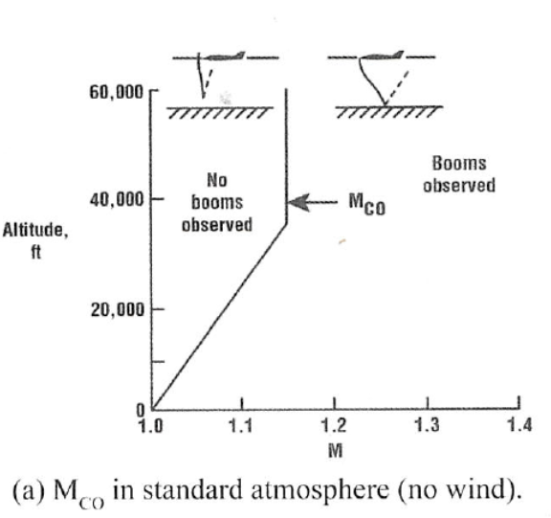Reference 1 image.

Mach cut-off Operational Flight Envelope

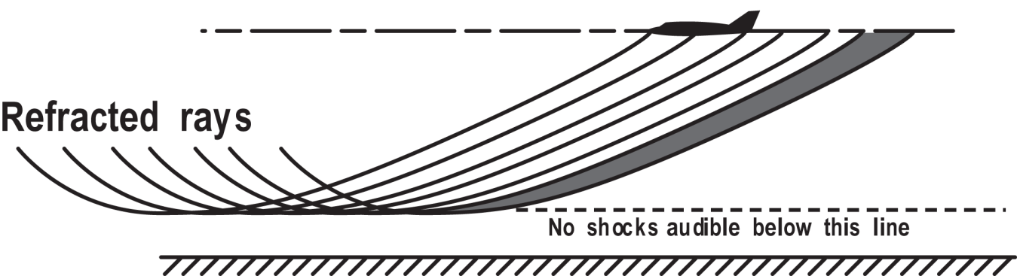Reference 2 image.

Mach cut-off phenomenon as depicted by the (acoustical) ray-shock diagram showing the upward refraction effect

1. D. Maglieri and K. Plotkin, “Sonic Boom,” Aeroacoustics of Flight Vehicles: Theory and Practice, Vol. 1: Noise Sources, H. Hubbard, Ed. NASA Ref. Pub. 1258, Vol. 1, WRDC Tech. Rept. 90-3052 (1991).
2. D. Maglieri et al., “Sonic Boom: Six Decades of Research,” NASA/SP-2014-622 (2014), page 138-139.