**NAS Operations Subcommittee Homework on Long-Term R&D Priorities**

Debby Kirkman, MITRE

High priority, long term R&D needs include the following:

* Data Integrity (Andy Lacher)
* Training in a Changing Environment
* Increasingly Autonomous Systems
* General Aviation Safety (Valerie)
* Operational and Equipage Diversity
* Alternative Fuels and Energy Sources

**1. Data Integrity**

As automation continues to increase in the aviation system, there has been an exponential growth in the volume of electronic data associated with aviation operations. This data is generated, processed, and stored in a highly distributed systems which includes air traffic management automation, airline automation, aircraft avionics, and a variety of commercial vendors. These distributed systems are interconnected via a variety of air and ground networks. Ensuring the integrity of this diverse data set from unintentional errors, accidental corruption, and deliberate spoofing is important to ensure the reliability of aviation operations.

**2. Training**

*Roles and responsibilities*

Aviation roles and responsibilities are evolving. New jobs have been identified, for example, in Air Traffic Control: capacity manager, flow contingency provider, separation manager, and trajectory manager. How should these jobs be designed? What decision aids will be needed to support full 4DT operations, dynamic flow corridors, reduced oceanic separation, and dynamic flight trajectories? How should the persons filling these jobs be trained? What about the next generation of tech ops? How should these personnel be trained to maintain both legacy and advanced aviation systems?

*Generational differences*

Three generations will continue to work side by side in Air Traffic Control, aircraft certification, aircraft and aviation system inspection and maintenance, as well as air crew. Baby boomers (born between 1946 and 1964) have very strong work ethics and need to advance. Gen Xers (born between 1965 and 1980) enjoy work but emphasize work-life balance. Millennials aka Gen Y (born after 1980) rely on technology and think they should be able to work at any time and in any place. There is little research on how to design work flows among these diverse groups or tailor decision support and other job aids for each group. This lack of knowledge is exacerbated by the changes in the Air Traffic Controller population in which Baby boomers will retire opening positions for 10,200 new hires in this decade. In addition to controllers, it is expected that there will be 69,000 new pilots in North America between 2012 and 2031 and 92,500 new technicians in the same time period. How can these all be trained efficiently and effectively?

*Humans and automated systems*

Sensor technologies are greatly improving thus enabling ever expanding capabilities. Examples are Equivalent Visual Operations made possible by synthetic vision systems, runway incursion warning systems using GPS, autoland for General Aviation, and augmented vision systems for Air Traffic Towers. How should users be trained to use these systems, detect and recover from system failures, and maintain currency for operating in degraded modes? There are currently 42 aviation mega cities (those that handle more than 10,000 long haul passengers per day) in the world. Eleven of these are in the United States. How will controllers handling these airports be trained on interacting with new aircraft not designed in the United States or Europe and with pilots for whom English is only secondary language and cultural differences abound?

**3. Increasingly Autonomous Systems**

Advances in computer processing, sensors, networking, and other technologies are enabling the aviation system to continue to augment the human decision-maker with sophisticated automation. As technology evolves, systems are moving increasingly towards autonomy where the “machine” is intelligent: perceiving, deciding, learning, etc. often without human engagement. With increasingly autonomous systems, the outputs can vary with identical inputs and functionality is determined not just by design but by current and past circumstances.

These increasingly autonomous systems have the potential to improve safety and reliability, reduce costs, and enable new missions. However, deploying increasingly autonomous systems is not without risk. Ensuring reliable automation continues to be deployed is especially critical to civil aviation given the very high standard for safety and the potential risk to public safety that occurs whenever the performance of new civil aviation technologies or systems fall short of expectations.

Ensuring that these sophisticated non-deterministic and adaptive software systems can be trusted and remain resilient to a range of expected and unanticipated circumstances is a concern. Our current mechanisms and policies for oversight and certification of these systems to ensure they operate robustly in safety-critical situations are not keeping pace with technology advancements and will not scale to the complexity of evolving automation technologies. We may require revisions to certification processes as well as new techniques for verification, validation, test and evaluation that can generate the data necessary for a safety determination. We may require new software and system architectures that ensures that the authority of an increasingly autonomous systems matches the level of robustness which has been able to be determined.

**4. General Aviation (GA) safety and operations**

Reduction of the General Aviation (GA) accident rate is a top priority for the Federal Aviation Administration (FAA).

*Size of the problem*

GA accounts for 96% of all aviation accidents and 97% of all fatal aviation accidents (Figure 1-1, National Transportation Safety Board (NTSB), 2012). It has been estimated that the average annual cost of GA accidents in the United States is $1.64 B (Sobieralski, 2013). There are many unanswered questions hampering the FAA’s efforts to reduce the GA accident rate.

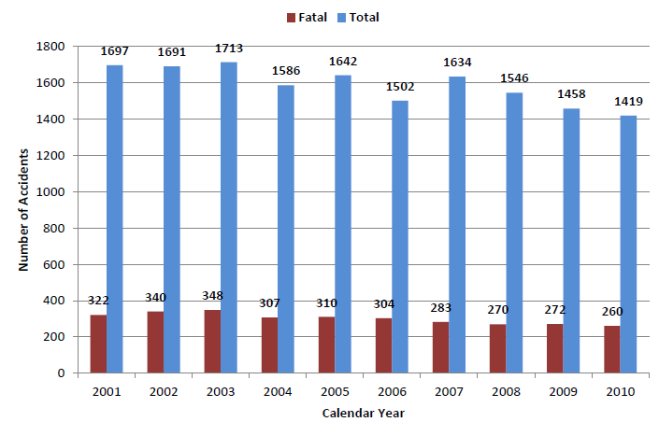

Figure 1‑1. Total and Fatal General Aviation Accidents, 2001 – 2010 (NTSB, 2012, p. 33)

*Research*

The General Aviation Joint Steering Committee (GAJSC, 2012), based on an analysis of fatal GA accident data from 2001 through 2010, made safety enhancement (SE) recommendations. How should these SEs be implemented for greatest effect on the accident rate? Of the 1,259 accidents during that period, 40.2% were due to loss of control. The GAJSC recommended that the FAA focus on the approach and landing phase of flight to reduce the accident rate. But what about the other 59.8% of the accidents? Where is the research to mitigate the causes of those accidents?

*References*

General Aviation Joint Steering Committee Loss of Control Work Group Approach and landing final report September 1, 2012.

National Transportation Safety Board Review of U.S. civil aviation accidents (NTSB/ARA-12/01). Washington, DC: National Transportation Safety Board, October 2012.

Sobieralski, J.B. The cost of general aviation accident in the United States. Transportation Research Part A 47 (2013) 19 – 27.

**5. Operational and Equipage Diversity**

The National Airspace System is becoming increasingly diverse in the types of aircraft that operate in the airspace, flight performance characteristics, and the level of sophistication of those airframes with respect to CNS/ATM capabilities. As this diversity is introduced, it increases the difficulty and complexity of human tasks associated with managing the safety of flight. New entrants, such as commercial space vehicles or unmanned aircraft systems (UAS) are prime examples of the vast differences in flight performance characteristics, and continuing developments in avionics are increasing the sophistication possible for individual aircraft operations. Wbithout a strategy for accommodating this diversity, safety risks can be introduced, new entrants (and the associated economic drivers) may be shut out of some airspace, and investment in innovative avionics that provide societal benefits may be deferred without assurance that those capabilities can be used in the NAS.

Over the coming decade, the FAA will need to make a significant research investment in understanding how to manage this operational and fleet diversity. Areas of research include understanding how controller and traffic flow managers jobs’ need to change in the presence of diverse fleets or capabilities, automation adaptability and support capabilities, training requirements, safety considerations, use of service levels, etc.

**6. Certification of Aircraft Energy Sources**

Even though the existing aircraft fleet is almost homogeneous, driven uniformly by fossil fuels, certification of a new energy source is a laborious process involving compliance with dozens of standards.  Certifying an unleaded avgas, for example, is now under way but may take as long as 11 years.  Certification of drop-in synthetic fuels is in process, but it is only one stage in the evolution of aviation.  The fleet of the future will be much less uniform, possibly powered by liquid hydrogen, fuel cells, novel batteries, or even-more-radical technologies.

The coming shift away from fossil fuels should be encouraged for many reasons, ranging from economics to environmental protection to public health.  Completely-new energy technologies are difficult enough to develop that forced compliance with an inappropriate regulatory regime could stifle useful invention.  Over the next ten years, FAA should conduct research, beginning at an abstract level, into the essential components of a regulatory environment that ensures that the air transportation system increases in safety and efficiency without impeding innovation from unexpected directions.