**Supplemental Application Guidance for Unguided Suborbital Launch Vehicles**

**Attachment 3 - Risk Analyses**

Draft - 08/15/98

**General**

1. An applicant shall determine the casualty expectation risk for all populated areas outside the impact hazard area in accordance with the definitions, input, methodology, and output prescribed below. Refer to Figure 3-1.
2. As part of the casualty expectation risk calculation, an applicant shall determine the impact probability of hitting populated areas.

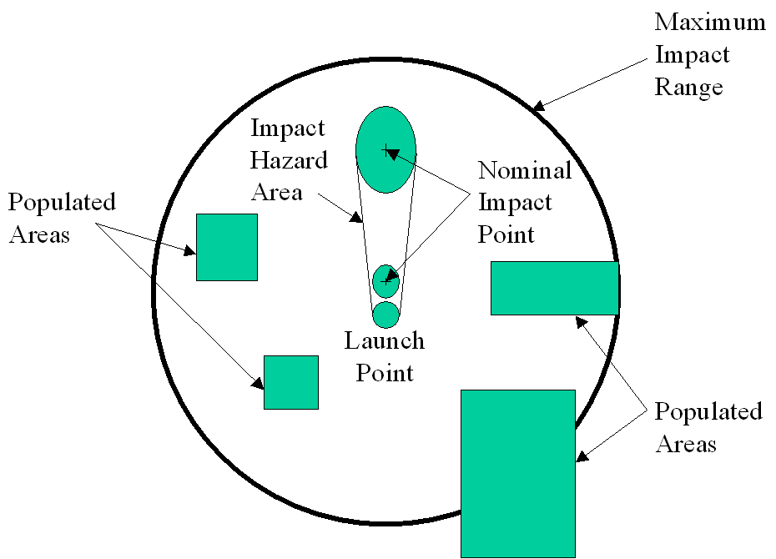Figure 3-1. Populated Areas ([enlarge](https://www.faa.gov/about/office_org/headquarters_offices/ast/licenses_permits/launch_reentry/reusable/safety/guidelines/sag_uslv/media/fig_2.gif))

**Input**

The following inputs are required to complete the risk analyses.

1. Vehicle failure data: The applicant shall use a probability of failure (Pf) = 0.5. Given a failure, the applicant shall use a probability of occurrence (Po) of launch vehicle impact outside the impact hazard area of 0.15.
2. Vehicle dispersion. The range and cross range impact dispersion information from Attachment 1.
3. Trajectory impact data: Latitude and longitude of each launch vehicle stage or ejected components nominal impact point from Attachment 1.
4. Lethal Area: The lethal area produced by both nominal debris and failure debris is required. For the lethal area of an inert suborbital launch vehicle, an applicant may use the launch vehicle length plus 2 ft. times the largest vehicle diameter plus 2 ft. for nominal debris. For a vehicle failure, the applicant shall use the vehicle length times the largest vehicle diameter multiplied by 10. The safety factor of 10 is to account for a one foot radius applied about each piece produced from vehicle breakup.
5. Population Data: The total population within a populated area (N) and the total landmass area within the populated area (A) is required. Population data may be obtained as follows:
6. Launch area - U.S. Census data is available at the census block group level.
7. Downrange area - World population data is available from:  
     
   Carbon Dioxide Information Analysis Center (CDIAC)  
   Oak Ridge National Laboratory  
   Oak Ridge, TN 37830-6335  
   Database - Global Population Distribution (1990), Terrestrial Area and Country  
   Name Information on a One by One Degree Grid Cell Basis (DB1016 (8-1996)

**Methodology**

1. An applicant shall depict the maximum impact range area and the impact hazard area on a chart that shows public areas. No public areas are allowed inside the impact hazard area.
2. Casualty Expectancy (EC). For populated public areas between the impact hazard area and maximum impact range boundary, an applicant shall compute the casualty expectation (EC) by solving the following equation for each populated area exposed and for each piece of debris:  
     
   Casualty Expectation EC = Σ [Pi ⋅ AL ⋅ Pd]  
   where:

* Pi is the probability of impact for each populated area;
* AL is the lethal area of the debris;
* Pd is population density of the populated area.

1. Compute the probability of impact inside the populated area by:  
     
   Pi = Pf ⋅ Po ⋅ AP/AO3σ  
   where:

* Pf is the probability of failure;
* Po is the probability of occurrence (0.15);
* AP is the area of the populated area;
* AO3σ is the area inside the circle defined by maximum range radius, minus the area inside the impact hazard area

1. An applicant may subdivide a computation sector that contains a sparsely populated area and densely populated area by first computing the dense area. The next step is to subtract the dense area from the total sector area and then compute the EC from the remaining population and the remaining area as a subsector.
2. The result of the casualty expectation must be no greater than 30x10-6. If the result is greater, the proposed launch is unacceptable.

**Output**

For each of the risk analysis defined above, the applicant shall document the methodology used, the source of input data, a calculation sample for each analysis and the results of the mission EC and land impact probability.