**Supplemental[[1]](https://www.faa.gov/about/office_org/headquarters_offices/ast/licenses_permits/launch_reentry/reusable/safety/guidelines/sag_uslv/" \l "footnote1) Application Guidance for Unguided Suborbital Launch Vehicles**

Draft - 08/15/98

**Attachments**

* [Attachment 1](https://www.faa.gov/about/office_org/headquarters_offices/ast/licenses_permits/launch_reentry/reusable/safety/guidelines/sag_uslv/attachment1/)
* [Attachment 2](https://www.faa.gov/about/office_org/headquarters_offices/ast/licenses_permits/launch_reentry/reusable/safety/guidelines/sag_uslv/attachment2/)
* [Attachment 3](https://www.faa.gov/about/office_org/headquarters_offices/ast/licenses_permits/launch_reentry/reusable/safety/guidelines/sag_uslv/attachment3/)
* [Attachment 4](https://www.faa.gov/about/office_org/headquarters_offices/ast/licenses_permits/launch_reentry/reusable/safety/guidelines/sag_uslv/attachment4/)

In order to assist applicants proposing to launch unguided suborbital launch vehicles (USLV's), AST has prepared guidance material that specifically addresses the unique safety issues associated with these vehicles. This document, "Supplemental Application Guidance for Unguided Suborbital Launch Vehicles" (Supplemental Guidance), follows this preface. It provides guidance material for applicants to comply with AST's regulations at 14 C.F.R. Chapter III.

The regulations at 14 C.F.R. parts 413 and 415 are specifically applicable to launch license applications. Applicants should read and follow those parts carefully. Applicants should use the following supplemental guidance for complying with subpart F of part 415, which covers the safety review portion of an application review, for proposals to launch a launch vehicle from a launch site not operated by a federal launch range.

The supplemental guidance document outlines what the FAA considers safe launch operations for USLVs. Because it is intended to cover all applications to launch unguided suborbital launch vehicles, **the FAA expects that not all provisions will apply to all launch proposals**. The nature of the proposed launch and the location of the proposed launch site play a major role in what is required to ensure safety. For example, the ship impact criteria would not apply to inland launches.

**The FAA anticipates that applicants may have alternative methods to ensure safety.** Applicants should work with AST during pre-application consultation to address the applicant's specific launch proposal, including any alternative methods to perform certain analyses and conduct certain operations. The FAA will approve launches that meet an equivalent level of safety.

**Flight Safety Goal**

A licensee should preclude a launch vehicle impact that might endanger human life or cause damage to property. This is done through safety analyses, to determine limitations on launch operations, and through operational procedures.

**General**

The following supplemental material is applicable to all proposals to launch unguided suborbital launch vehicles (USLV's). It is written for the wide range of launch proposals the FAA expects to see from applicants launching USLV's, including CATS prize participants. It is, therefore, comprehensive in scope.[2](https://www.faa.gov/about/office_org/headquarters_offices/ast/licenses_permits/launch_reentry/reusable/safety/guidelines/sag_uslv/#footnote2) The material is based on standard practices used in the unguided suborbital launch vehicle industry to protect public safety.

Due to the general nature of these requirements, applicants must use pre-application consultation to tailor their applications to the unique aspects of their proposals. The complexity of the license process is proportional to the complexity of the public safety issues involved with an applicant's proposed launch. The greater the potential exposure of the public (people and property), the greater the scope of the safety demonstration that will be required.

The material that follows begins with the FAA's minimum flight safety criteria by which all launch proposals will be judged. These are followed by license application requirements - an outline of what an application should contain in order to demonstrate to the FAA that the flight safety criteria have been satisfied. Lastly, four attachments are included to provide technical guidance to applicants.

1 Supplemental to AST regulations at 14 C.F.R. Chapter III.  
2 Note that no criteria is included for toxic materials. Launch proposals that involve toxic hazards will be reviewed on a case-by-case basis.

**Flight Safety Criteria**

The FAA will not approve a launch unless an applicant has demonstrated that the following flight safety criteria are met:

1. Public Expected Casualty (Ec): The collective public risk shall not exceed an estimated casualty (Ec) of 30 x 10 -6 per launch.
2. Ship Impact: For flight over water, the probability of impacting a vessel (Pi) shall not exceed 1 x 10 -5 per launch.
3. Aircraft Impact: The probability of impacting an aircraft shall not exceed 1 x 10 -7 per launch.
4. Overflight/Impact on Public Land: Public land is land other than land owned by the applicant or land for which the applicant has attained written agreements with the land owner for exclusive use for the proposed launch.
   1. No public land overflight or impact shall occur within an impact hazard area (defined below).
   2. No non-launch participants may be within the impact hazard area.
5. An impact hazard area is defined as two circles and straight lines connecting the circles at tangent points to the circles. The first circle, with origin at the launch vehicle's launch point, has a radius of 1 nautical mile. The second circle, with an origin at the nominal no wind impact point of the last launch vehicle stage, has a radius of 3 σ (sigma) of the nominal trajectory as defined in [Attachment 1](https://www.faa.gov/about/office_org/headquarters_offices/ast/licenses_permits/launch_reentry/reusable/safety/guidelines/sag_uslv/attachment1/).
6. Collision Avoidance (COLA): No launch shall take place with a predicted point-of-closest-approach between the launch vehicle and an inhabitable spacecraft in earth orbit of less than two hundred kilometers.
7. Wind Weighting: An applicant launching an unguided suborbital launch vehicle with sufficient energy for the launch vehicle, or any component thereof, to reach public lands, shall base launcher azimuth and elevation settings on measured launch day wind conditions at the launch site so that the launch vehicle's final stage will impact at its predicted nominal impact point. A wind weighting procedure shall be used to determine launcher azimuth and elevation settings based on the results of a trajectory analysis that employs winds measured near the time of launch.
8. Recovery: All launch vehicle components that impact on public land, as defined in (4) above, as a result of a mishap, must be recovered.
9. Vehicle Stability: A proposed launch vehicle shall have a rigid body stability of at least 2.0 calibers throughout powered flight, i.e. the center of pressure (Cp) shall be located behind the center of gravity (Cg) and the distance between the center of pressure and the center of gravity divided by the largest frontal diameter of the launch vehicle shall be at least 2.0.
10. Maximum Nominal (no wind) Launch Angles: No launch angle limits (i.e. launcher azimuth and elevation settings) are imposed if an applicant's proposed launch vehicle does not have sufficient energy for the launch vehicle, or any component thereof, to reach populated areas (see Figure 1).

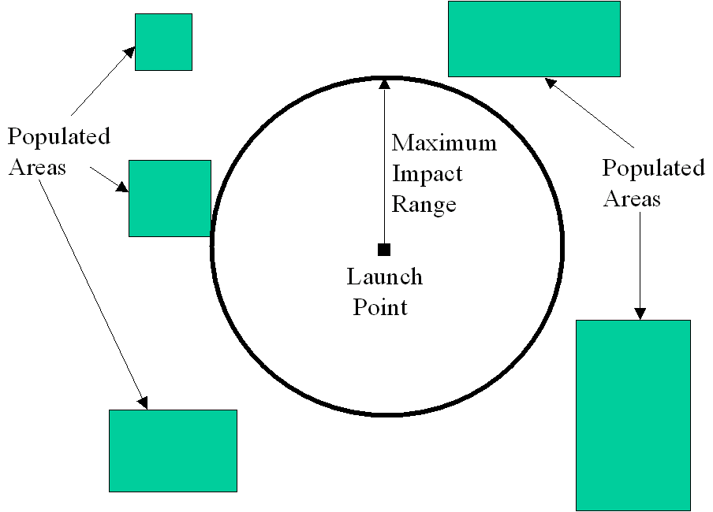Figure 1. Allowable Maximum Range Condition

Applicants whose proposed launch vehicle has sufficient energy for the launch vehicle, or any component thereof, to reach populated areas (see Figure 2) shall comply with the following launch angle limits:

* The maximum nominal elevation angle shall not exceed 84°, and will be determined based on the proximity of population at the launch site.
* The nominal azimuth limits shall be the azimuth sector that contains no populated areas within the impact hazard area.

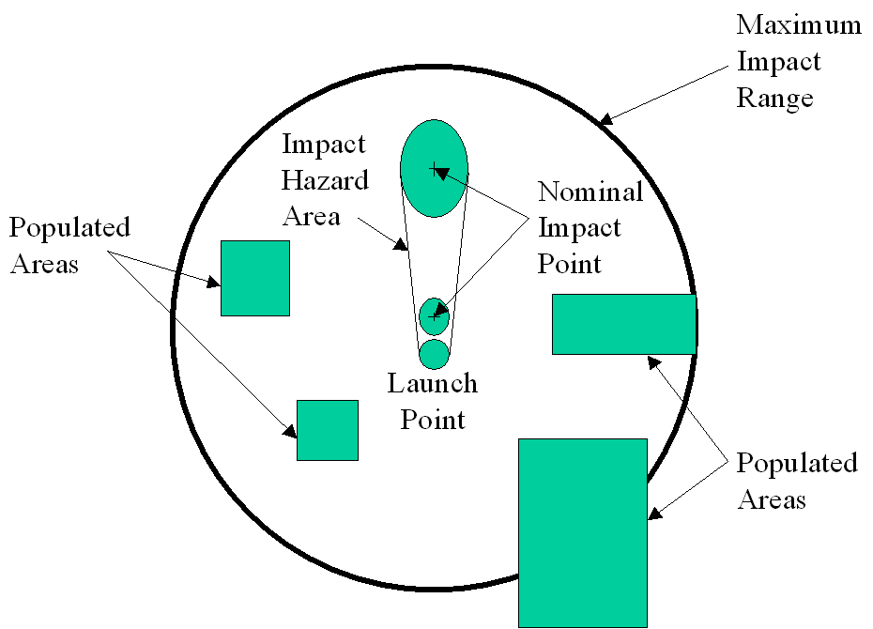Figure 2. Restricted Launch Angle Condition

**Application Requirements**

In order to demonstrate to the FAA that the applicant can meet the flight safety criteria above, an applicant shall include in its application a description of the launch vehicle design, including its structure, physical dimensions and weight, propulsion systems, safety critical systems, and the location of the vehicle's Cp in relation to its Cg. An applicant shall also include the analyses listed in (1), (2), and (3) below, including the items listed in the "output" sections of Attachments [1](https://www.faa.gov/about/office_org/headquarters_offices/ast/licenses_permits/launch_reentry/reusable/safety/guidelines/sag_uslv/attachment1/), [2](https://www.faa.gov/about/office_org/headquarters_offices/ast/licenses_permits/launch_reentry/reusable/safety/guidelines/sag_uslv/attachment2/), and [3](https://www.faa.gov/about/office_org/headquarters_offices/ast/licenses_permits/launch_reentry/reusable/safety/guidelines/sag_uslv/attachment3/). An applicant shall include the applicant's operational constraints and procedures in accordance with (4) below, and the flight safety plan in accordance with (5) below.

1. **Trajectory/dispersion analysis**  
     
   An applicant shall develop a nominal trajectory, a maximum impact range boundary, and three sigma vehicle impact dispersions in accordance with the definitions, input, methodology, and output described in [Attachment 1](https://www.faa.gov/about/office_org/headquarters_offices/ast/licenses_permits/launch_reentry/reusable/safety/guidelines/sag_uslv/attachment1/).
2. **Hazard area analyses**

* An applicant shall calculate hazard areas for a nominal mission, to include:
* Impact hazard area, in accordance with [Attachment 2](https://www.faa.gov/about/office_org/headquarters_offices/ast/licenses_permits/launch_reentry/reusable/safety/guidelines/sag_uslv/attachment2/).
* Ship hazard areas, in accordance with [Attachment 2](https://www.faa.gov/about/office_org/headquarters_offices/ast/licenses_permits/launch_reentry/reusable/safety/guidelines/sag_uslv/attachment2/).
* Aircraft hazard areas, in accordance with [Attachment 2](https://www.faa.gov/about/office_org/headquarters_offices/ast/licenses_permits/launch_reentry/reusable/safety/guidelines/sag_uslv/attachment2/). This will satisfy flight safety criteria number 3.
* A Collision Avoidance Analysis (COLA) in accordance with [Attachment 2](https://www.faa.gov/about/office_org/headquarters_offices/ast/licenses_permits/launch_reentry/reusable/safety/guidelines/sag_uslv/attachment2/).

1. **Risk analyses**  
     
   An applicant shall perform an overflight risk analysis to determine the expected public casualty (Ec) of the proposed launch in accordance with [Attachment 3](https://www.faa.gov/about/office_org/headquarters_offices/ast/licenses_permits/launch_reentry/reusable/safety/guidelines/sag_uslv/attachment3/). Unless an applicant can demonstrate otherwise, the risk analysis should be based on a probability of failure of 50% (Pf = 0.5).
2. **Operational constraints and procedures**  
     
   An applicant shall provide the operational constraints and procedures necessary to ensure a safe flight, to include:

* Launch angle limits - constraints on launch angles (e.g. nominal azimuth and elevation angles, and actual azimuth and elevation settings).
* Weather constraints - constraints on allowable launch time weather, to include maximum wind, wind variability limits, visibility, and lightning potential.
* Wind weighting procedures, in accordance with [Attachment 4](https://www.faa.gov/about/office_org/headquarters_offices/ast/licenses_permits/launch_reentry/reusable/safety/guidelines/sag_uslv/attachment4/).
* Ship surveillance procedures, as required, for near coast ship traffic, as agreed upon with the U.S. Coast Guard.
* Air traffic control coordination procedures, worked out with the applicable FAA regional office or Air Route Traffic Control Center (ARTCC).
* Collision Avoidance (COLA) procedures, if required.
* Launch vehicle recovery procedures.

1. **Flight Safety Plan**  
     
   An applicant shall describe the measures used to conduct a proposed flight safely. A flight safety plan shall be used by launch personnel as a working document during launch operations, and shall include:

* Maximum impact range area.
* Predicted nominal impacts.
* Impact dispersions.
* Impact hazard area.
* Aircraft and Ship hazard areas.
* Launch angle limits.
* Weather constraints.
* The measurement of winds.
* Responsibilities of flight safety personnel.
* Other items necessary for launch personnel.

1. **Post-Launch Report**  
     
   A licensee shall provide to the FAA a post-launch report within 30 days of flight, to include:

* Actual impact location of all impacting stages/ejected components.
* A comparison of actual versus predicted nominal performance.
* Investigation results of a launch anomaly.